**山东大学（威海）**

**超市进销存管理系统前端文档**

**年级：2022级**

**专业：人工智能**

**作者：李俊锐**

**学号：202200800567**

**指导老师：姜秀娥**

**日期：2024.6.21**

# 目录

目录 2

成果展示 4

首页 4

登录功能 4

销售员功能展示 6

销售员个人中心界面 6

销售记录查看 7

退货记录查看 7

待处理订单查看 8

退货申请 9

退出登录 11

采购员功能展示 12

个人中心 12

进货采购记录查看 13

退货记录查看 13

采购商品 14

退货 15

添加商品 16

管理员功能展示 16

个人中心界面 16

信息管理模块 17

查询统计 21

库存管理 26

系统管理 30

直接下单功能 32

客户退货 37

代码展示 42

CSS 43

grid.css 43

index.css 50

jquery.jqzoom.css 59

style.css 64

test2.css 204

xiadan.css 220

Templates 235

addGoods.html 235

bygoods.html 245

caigouph.html 255

employ.html 266

goods.html 282

goods1.html 295

gys.html 306

index.html 320

jhd.html 338

jiesuan.html 345

khxx.html 354

login.html 367

login1.html 379

pandian.html 388

passwordupdate.html 395

person_center1.html 407

person_center2.html 413

person_center3.html 418

redeal.html 428

register.html 435

reregoods.html 438

rightupdate.html 445

rustock_seek.html 457

salereturn_seek.html 471

seek_sale.html 484

stockcheck.html 497

stockupdate.html 511

thd.html 524

tishi.html 531

tishi2.html 532

tishi3.html 534

tishi4.html 536

tk.html 537

tkd.html 540

tuigoods.html 549

tuistock_seek.html 557

xiadan.html 571

xiadan2.html 577

xiaoshouph.html 585

xsd.html 596

app.py 603

# 成果展示

## 首页

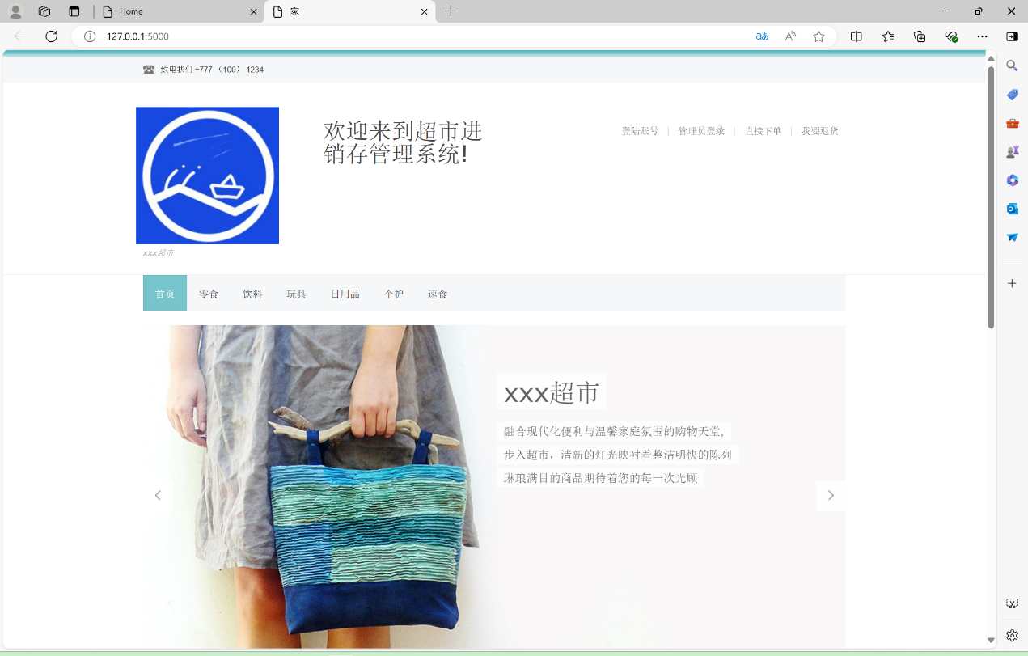

## 登录功能

点击登陆账号进入员工的登陆界面，销售员和采购员从此登录。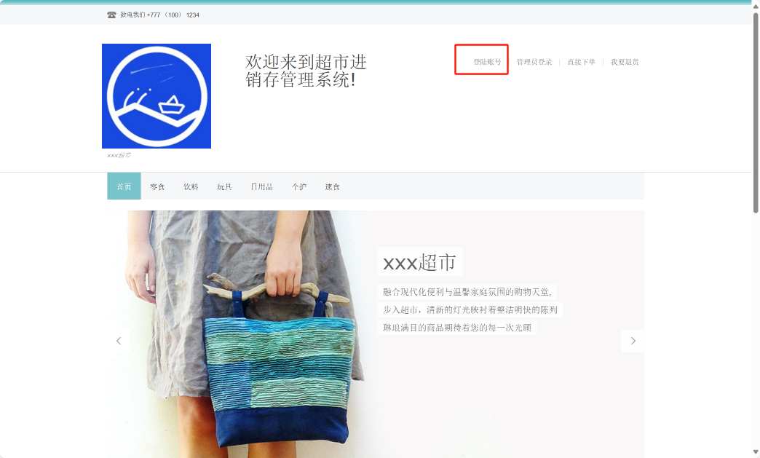

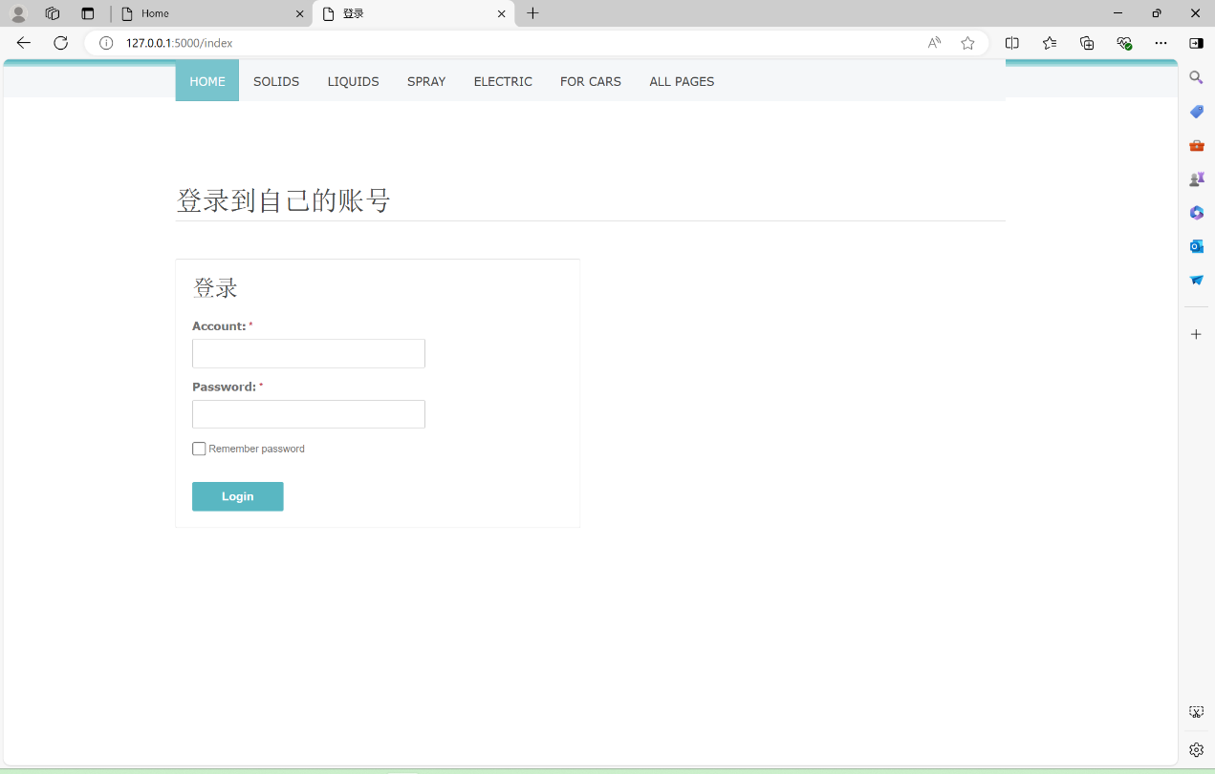

点击管理员登陆可以进入管理员登陆界面

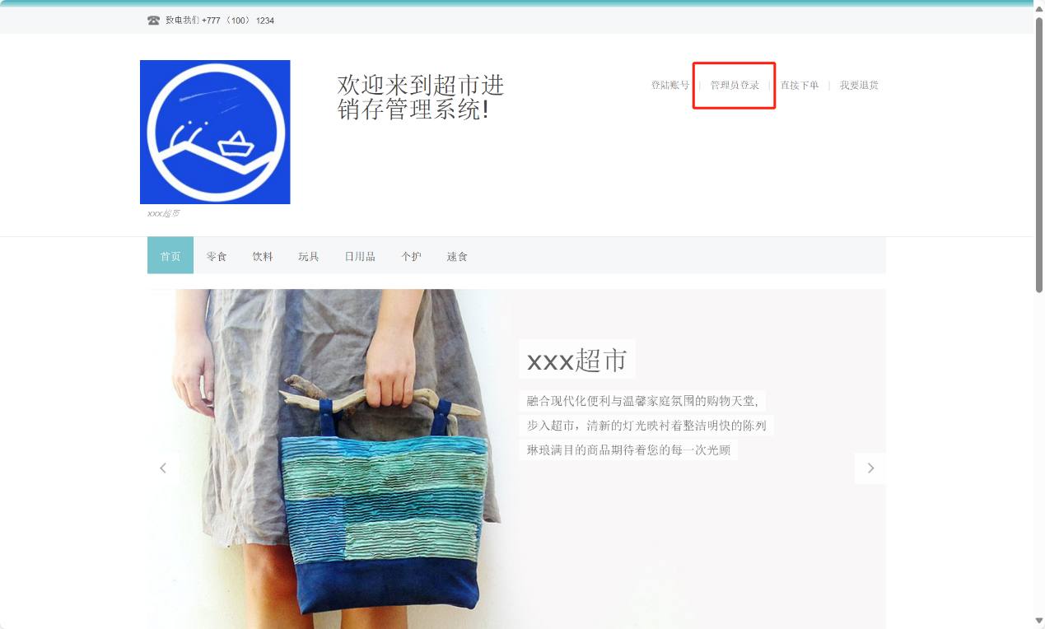

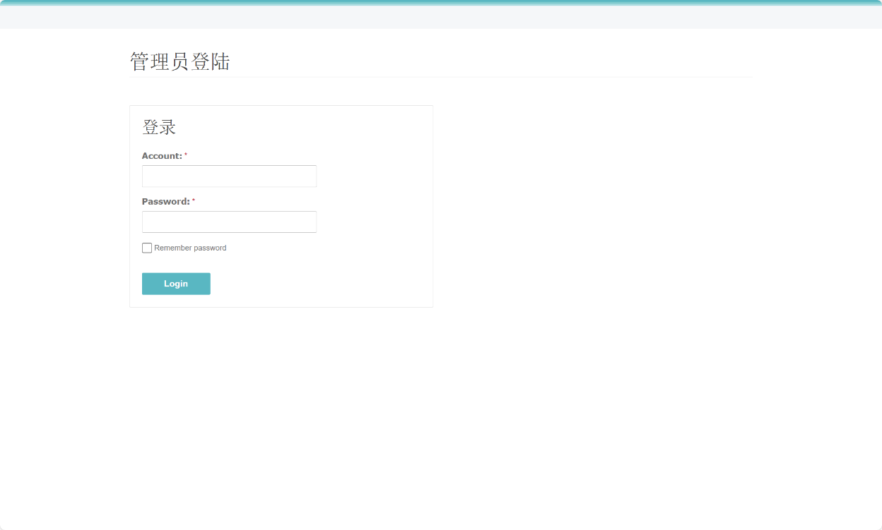

## 销售员功能展示

### 销售员个人中心界面

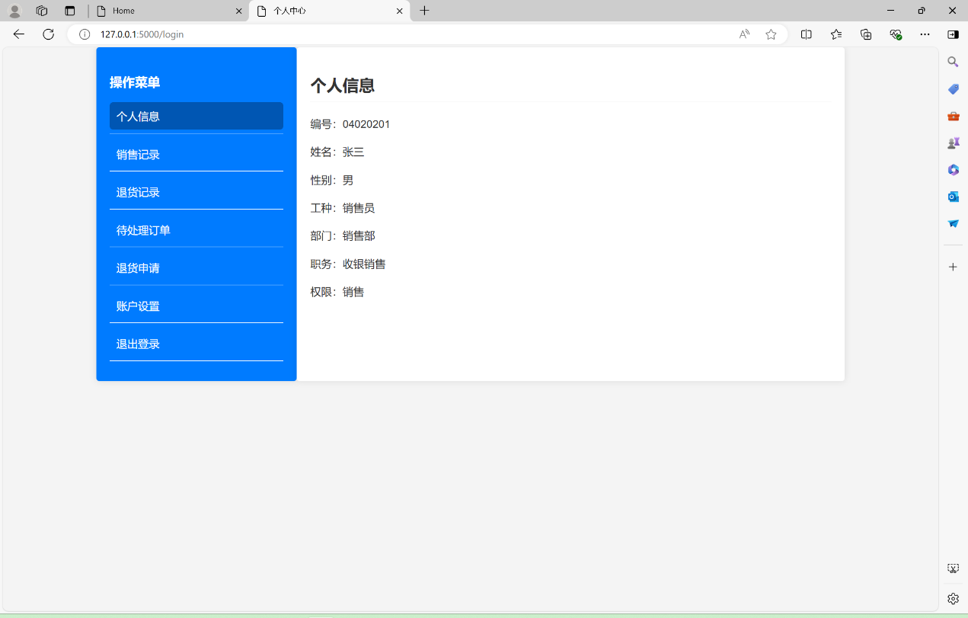

### 销售记录查看

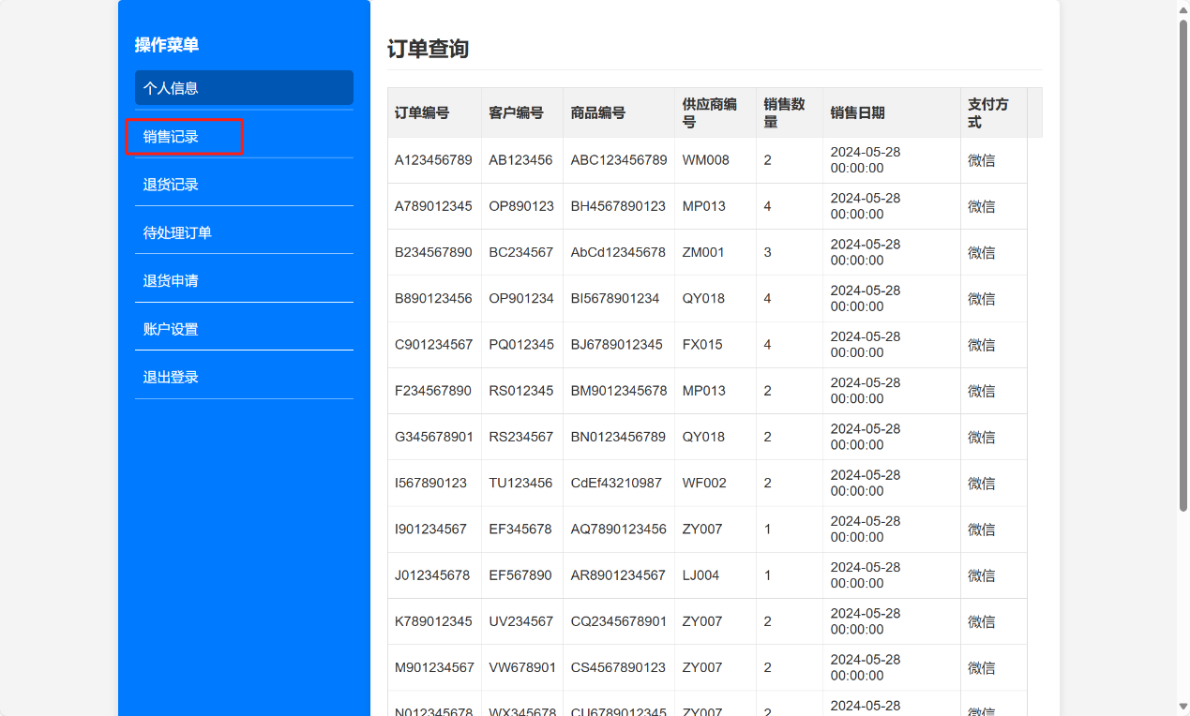

### 退货记录查看

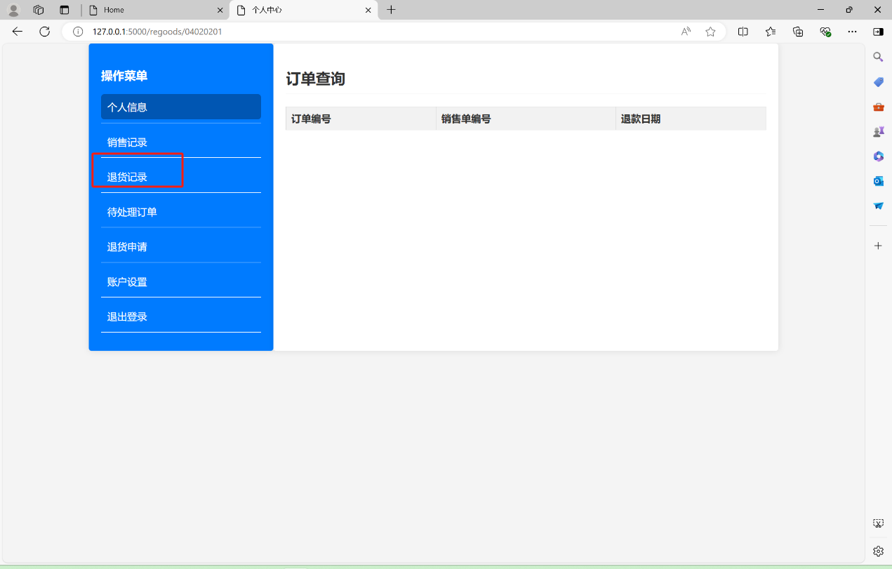

此时还没有退货记录，等后面展示客户下单退货功能时将会详细说明。

### 待处理订单查看

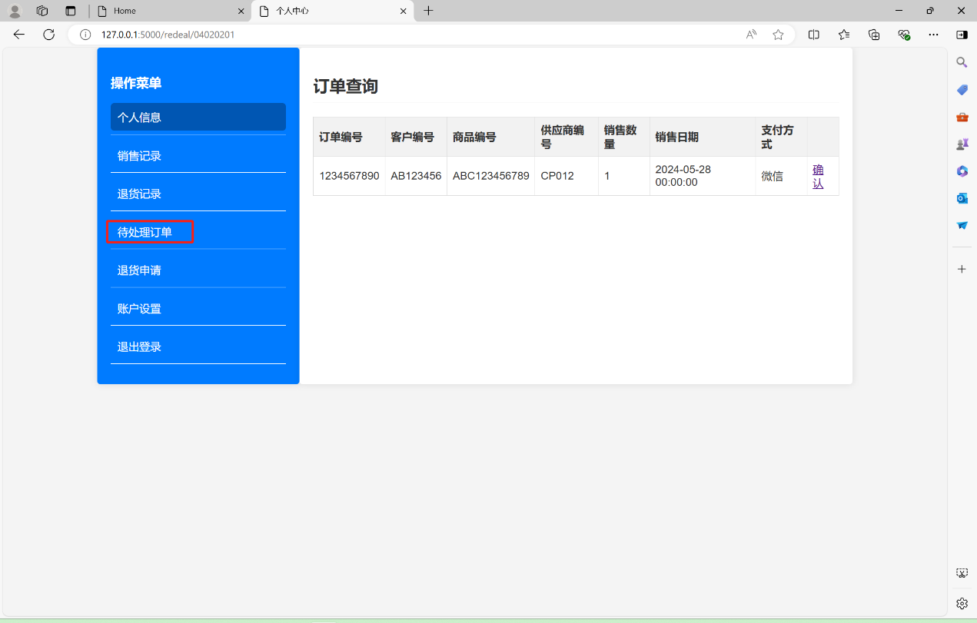

点击确认后，该订单将会从待处理订单中删除，并出现在销售记录中。

请留意订单编号和客户编号等信息。

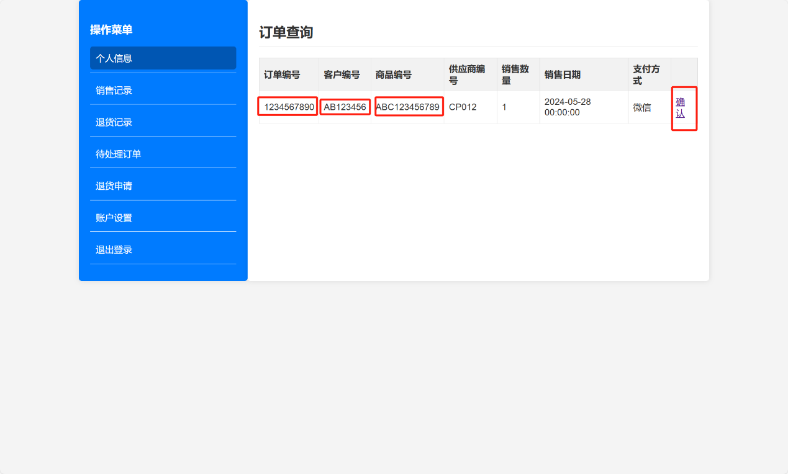

点击确认后：

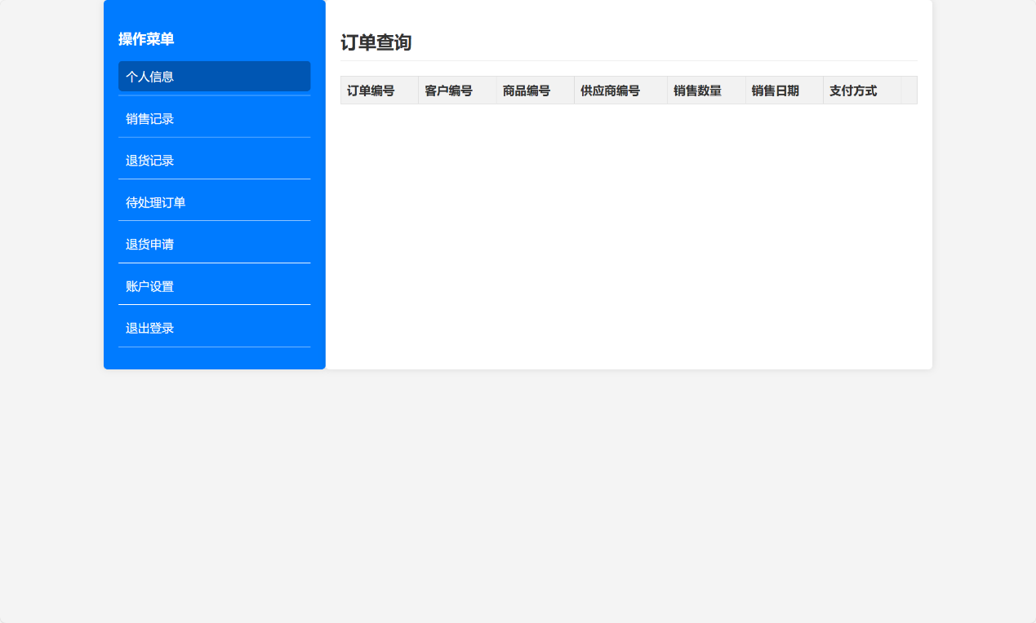

待处理订单变为空，可以在销售单中查询到刚刚确认的订单：

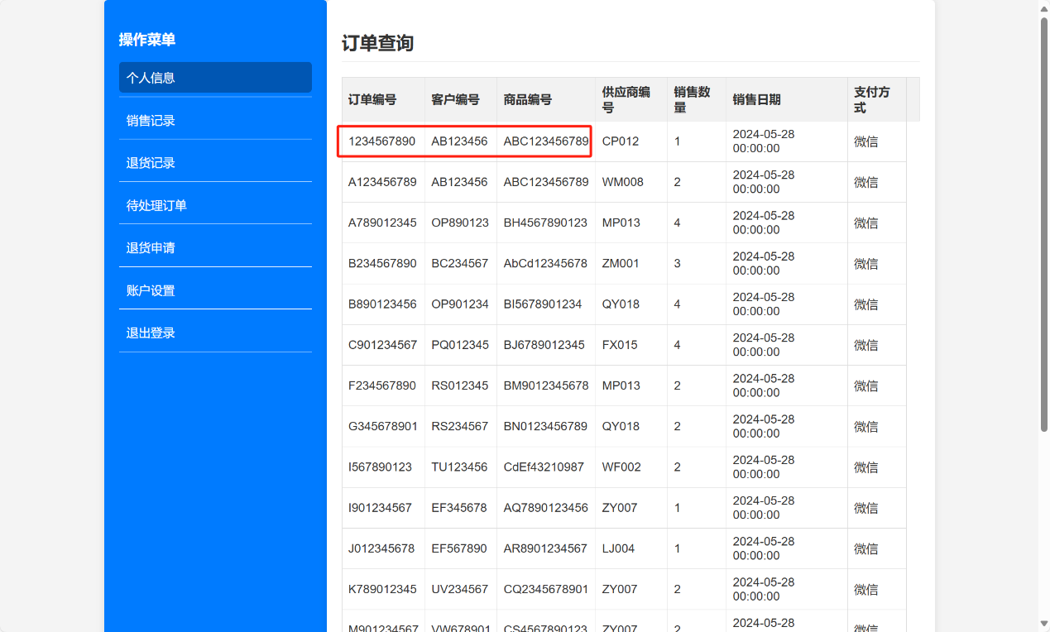

### 退货申请

在退货申请中可以查看由自己确认的销售单中的相应的退货单列表。

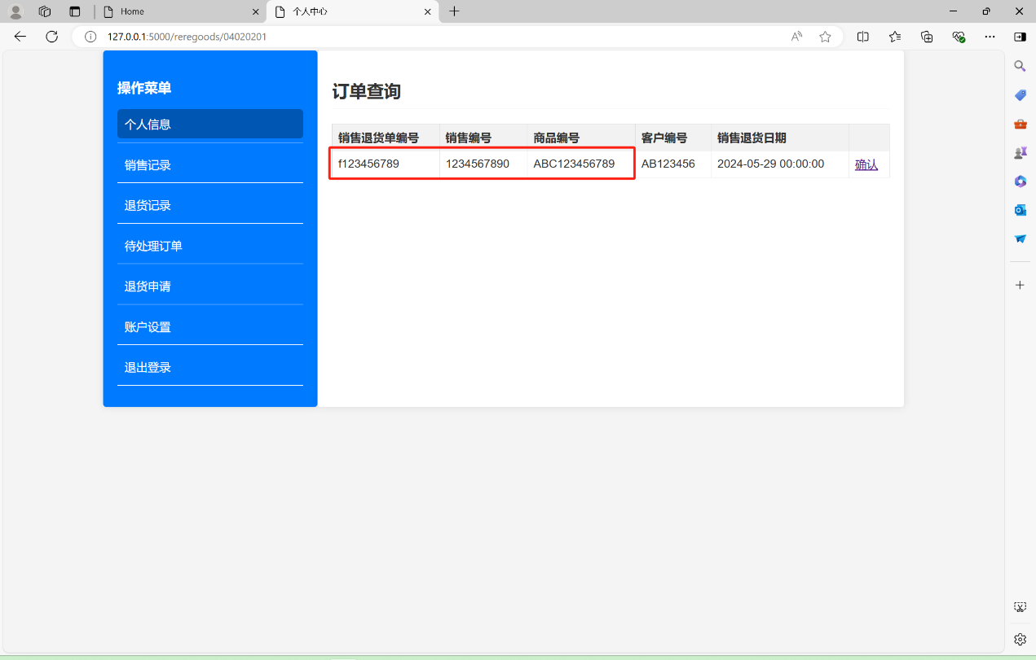

点击确认后，可以在退货记录中查询到相关信息。

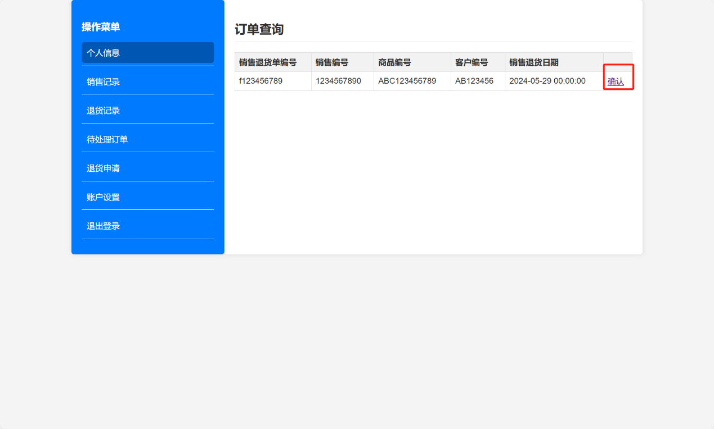

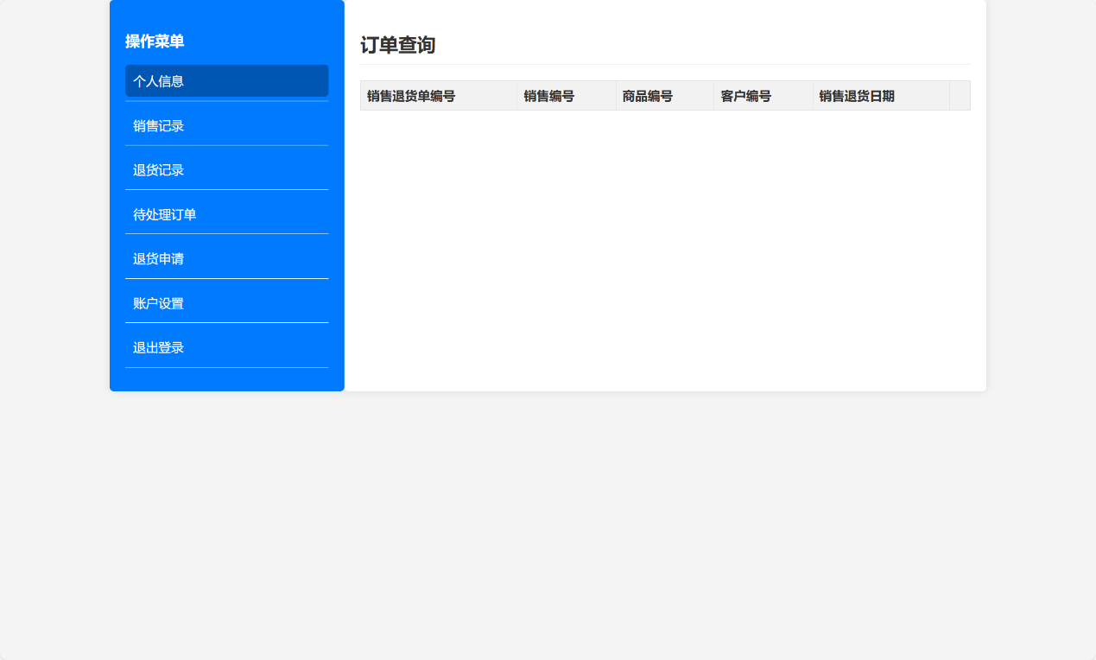

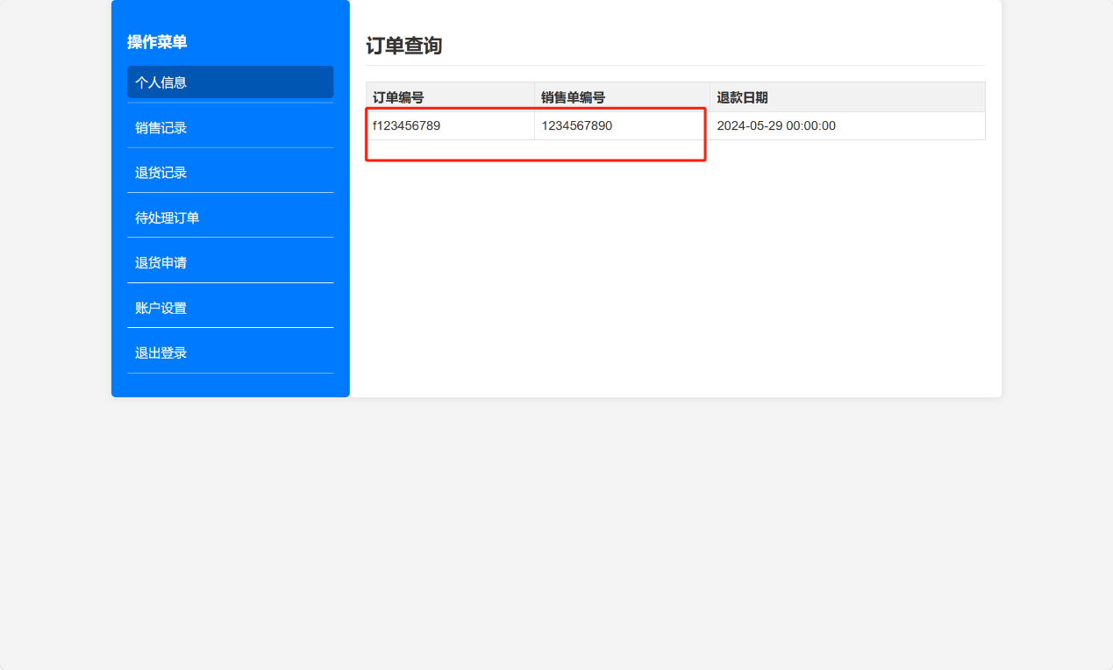

### 退出登录

点击退出登录可以回到首页。

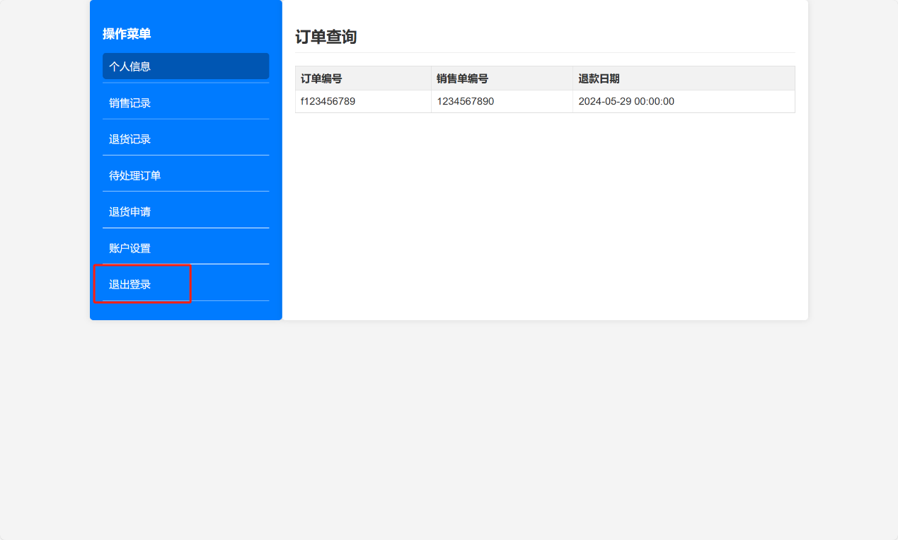

## 采购员功能展示

### 个人中心

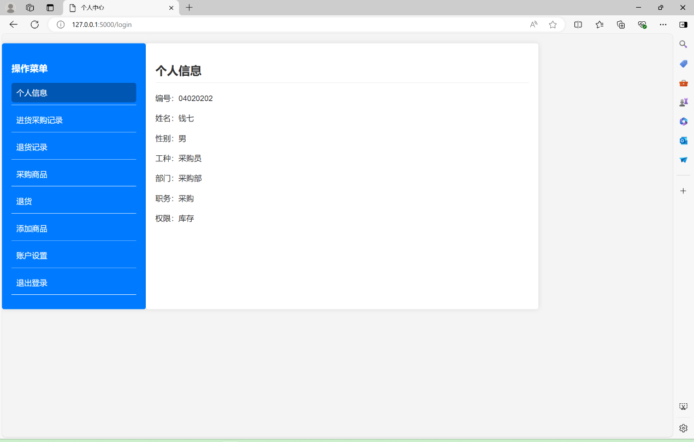

### 进货采购记录查看

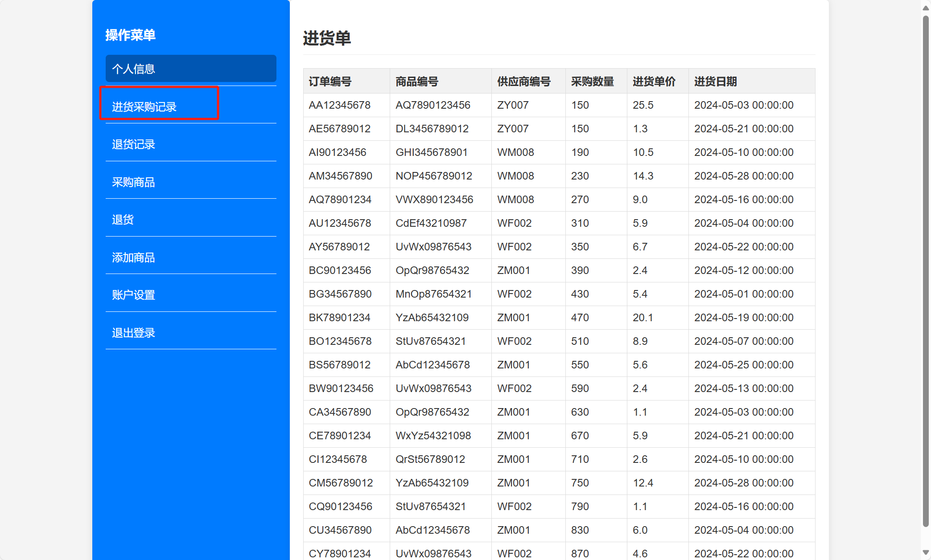

### 退货记录查看

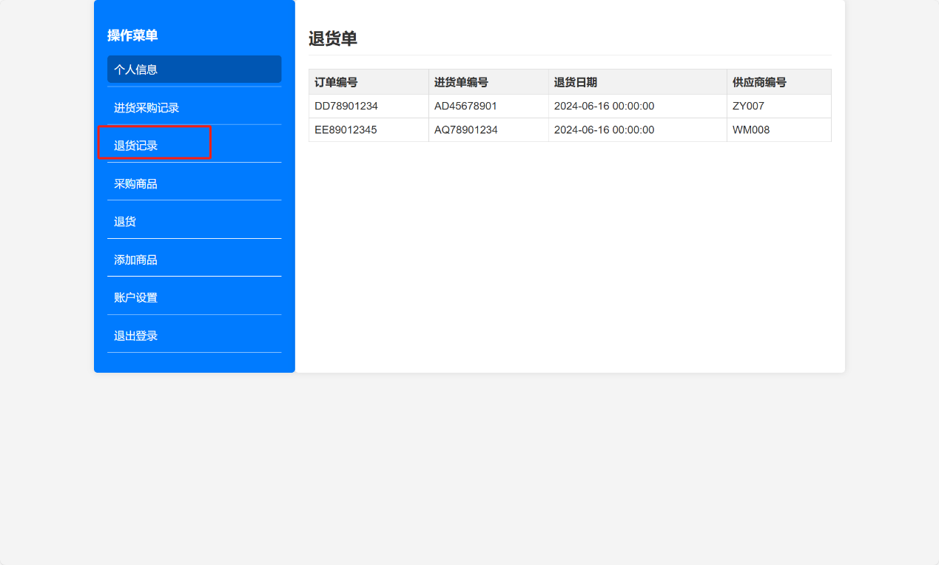

### 采购商品

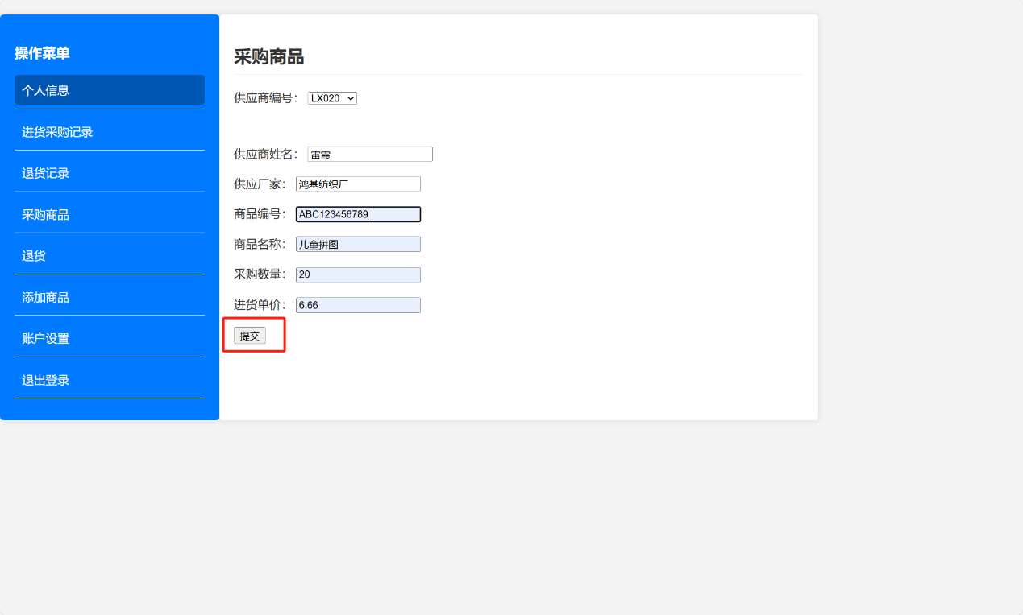

点击提交后，可以看到相应的记录出现在进货采购记录里面。

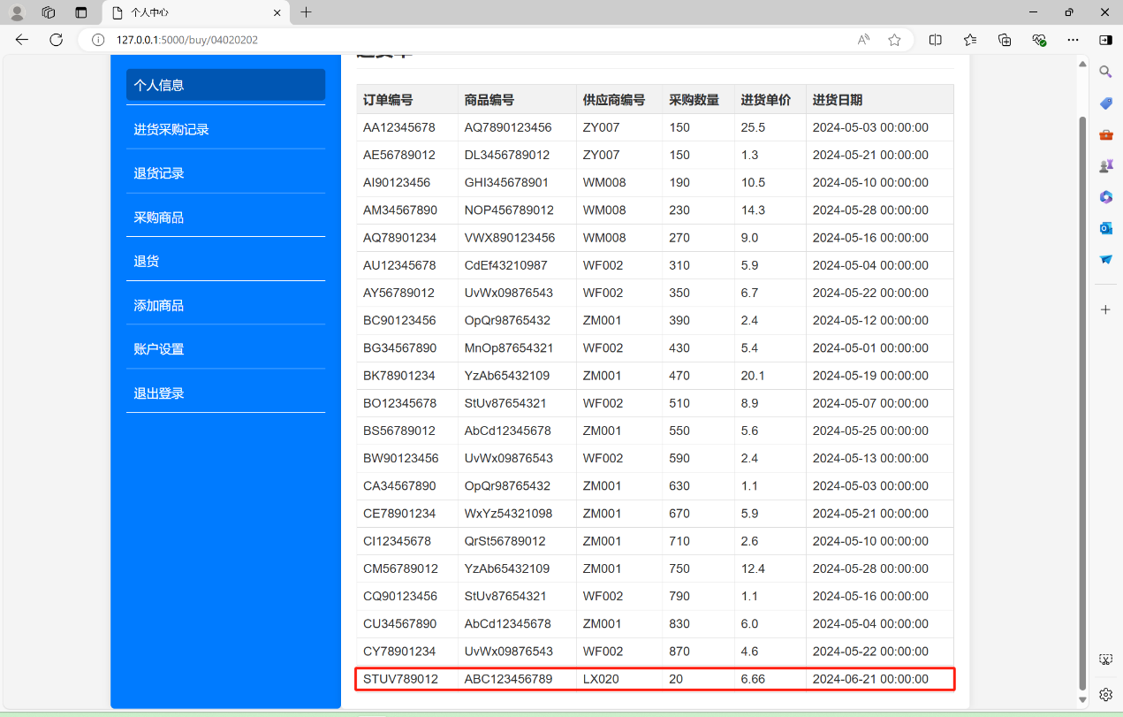

### 退货

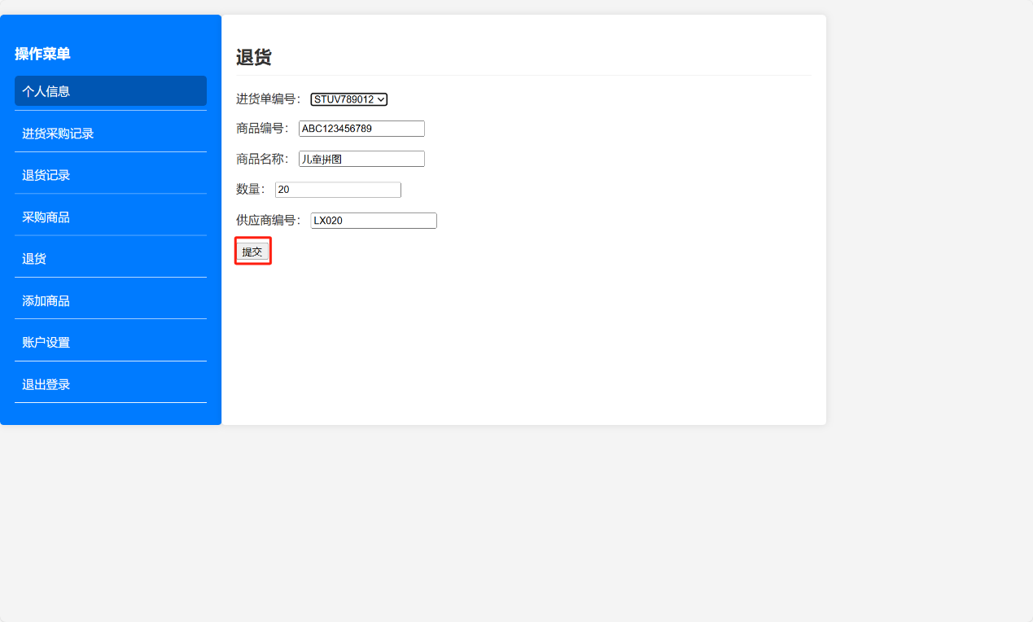

点击提交后，可以在退货记录里面查看到该条记录。

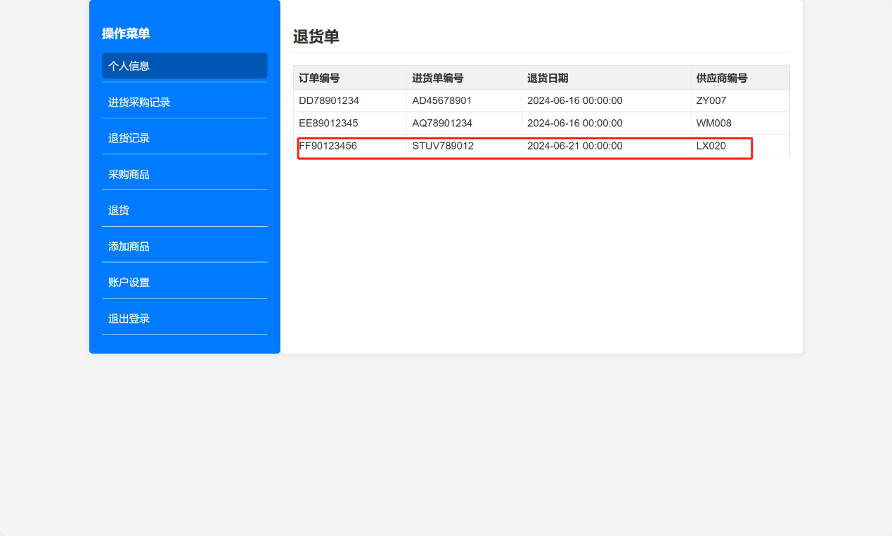

### 添加商品

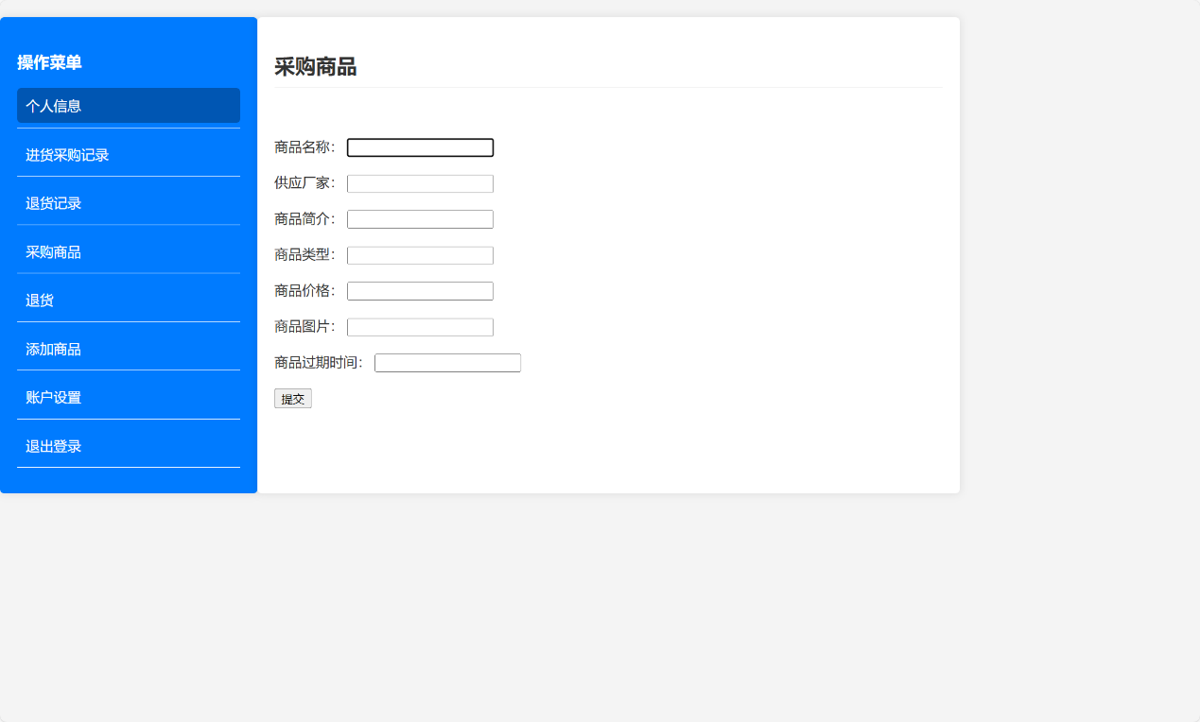

点击提交后，会添加相应记录到商品列表。

## 管理员功能展示

### 个人中心界面

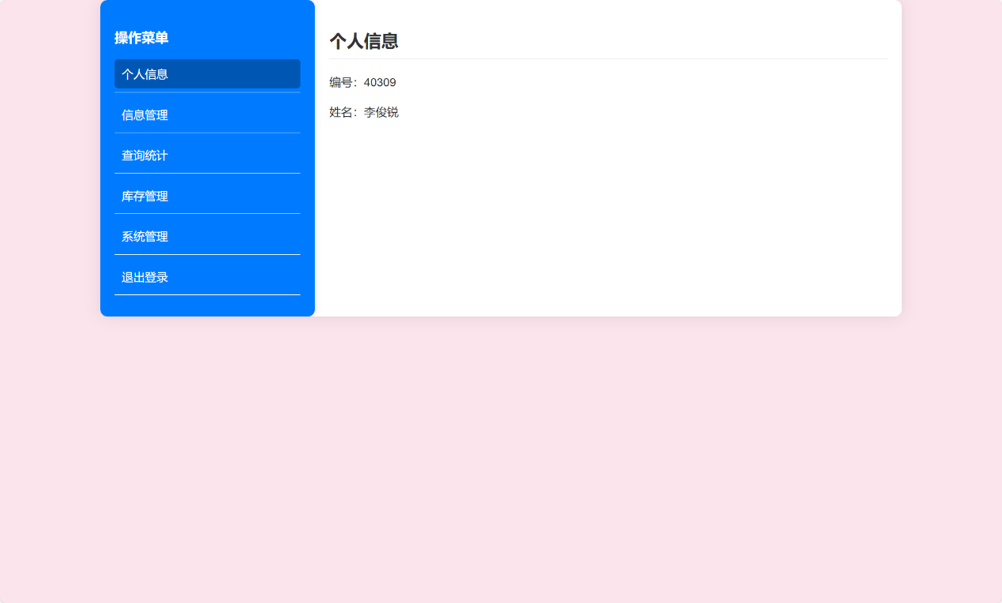

### 信息管理模块

#### 客户信息管理

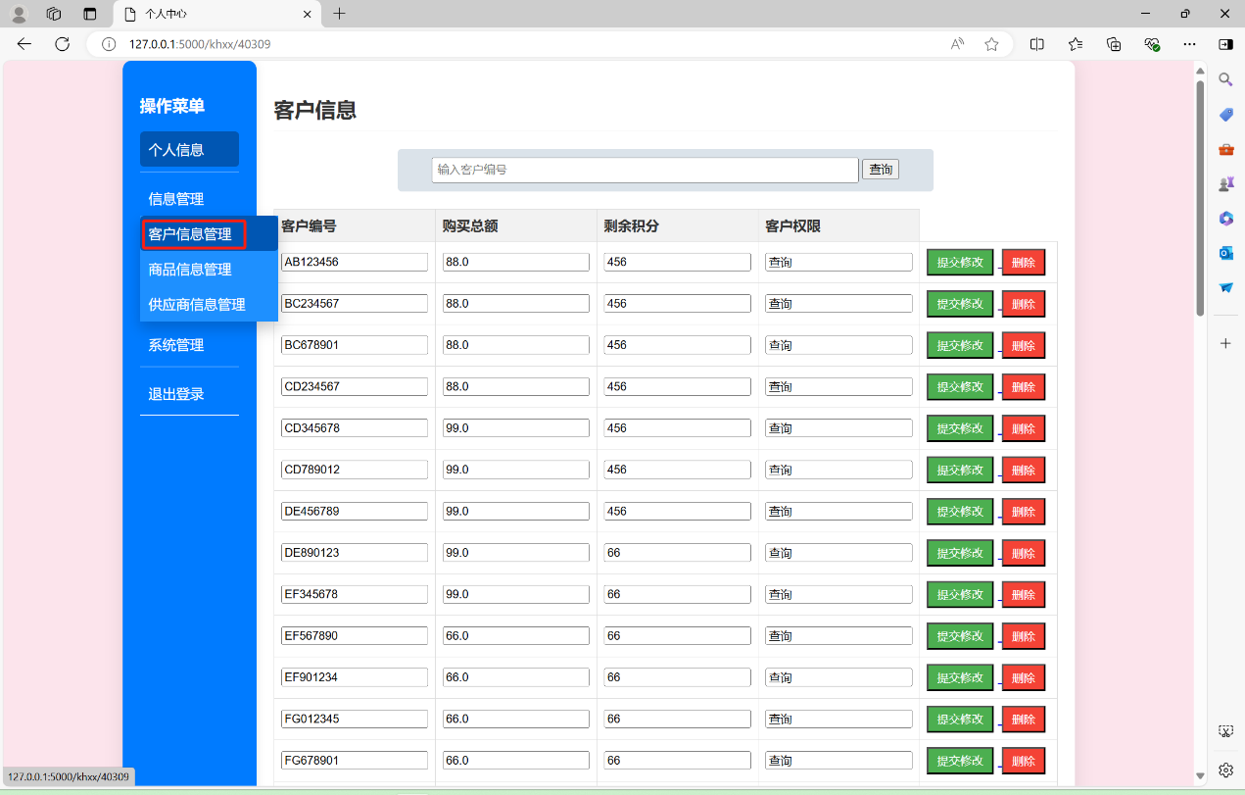

在上面的搜索框可以查询相关的信息，如图：

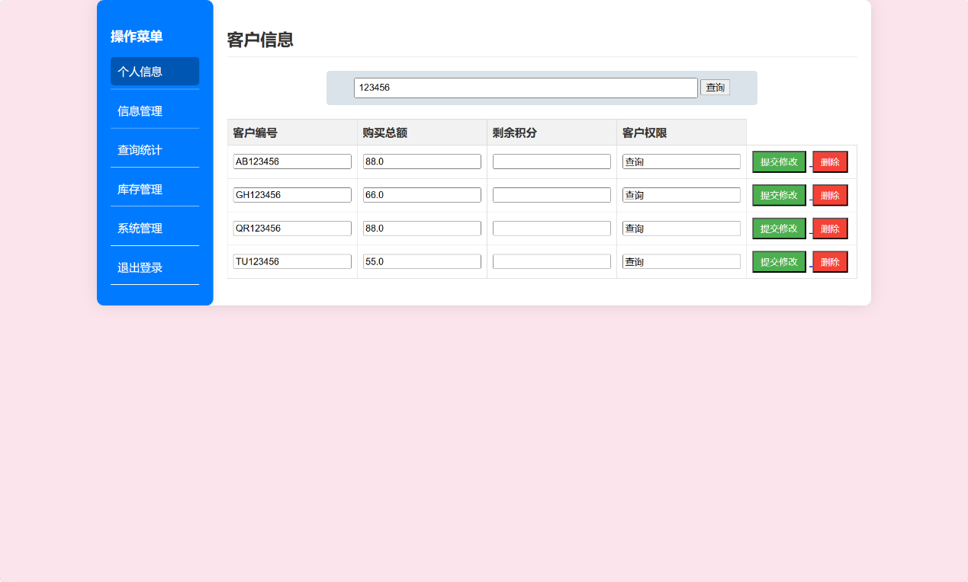

点击修改即可修改客户信息，例如讲客户编号AB123456的客户的购买总额改为8888，并点击提交修改：

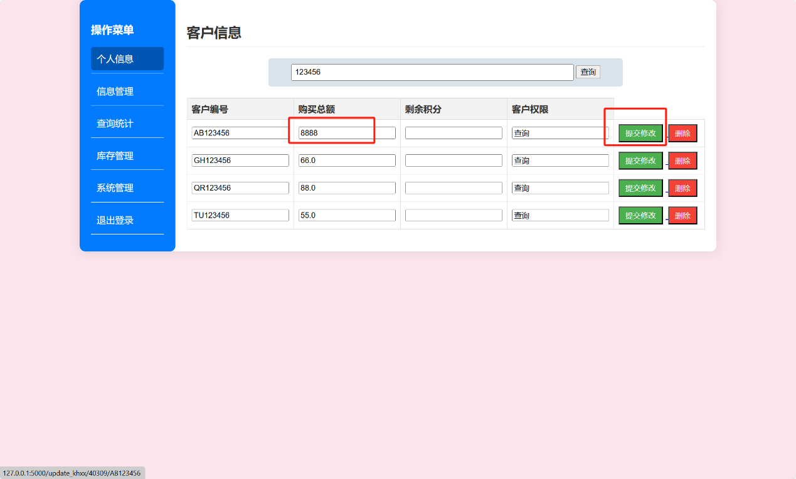

我们再次查询就可以看到，编号为AB123456的客户的购买总额变成了8888。

点击删除，我们就会发现，查询该客户便无法查到相应结果了：

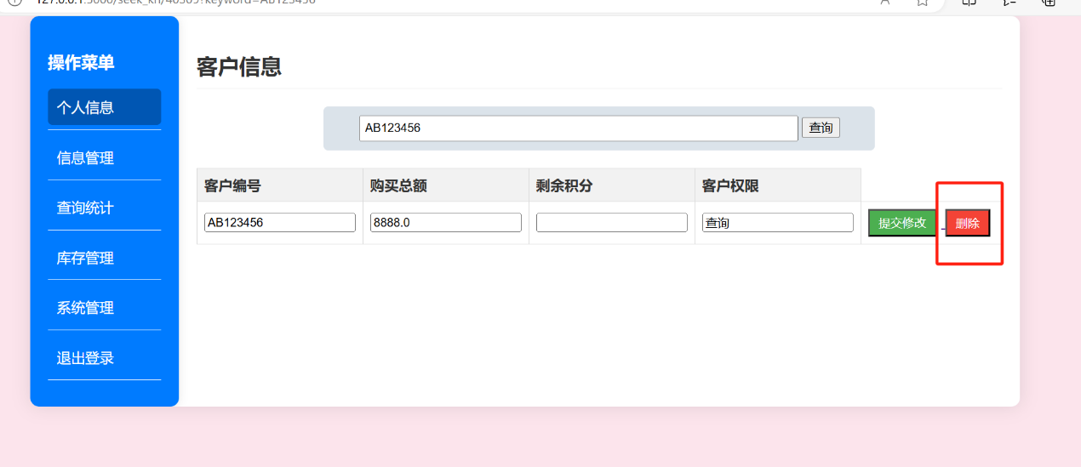

有下图可以明显看出，查询AB123456的结果为空，说明该条客户信息被删除。

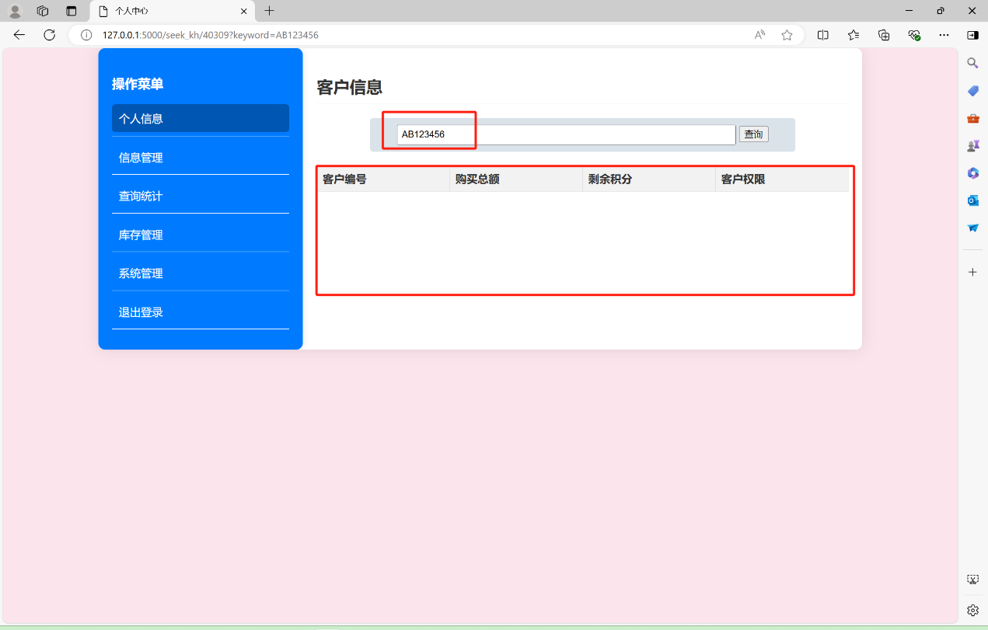

#### 商品信息管理

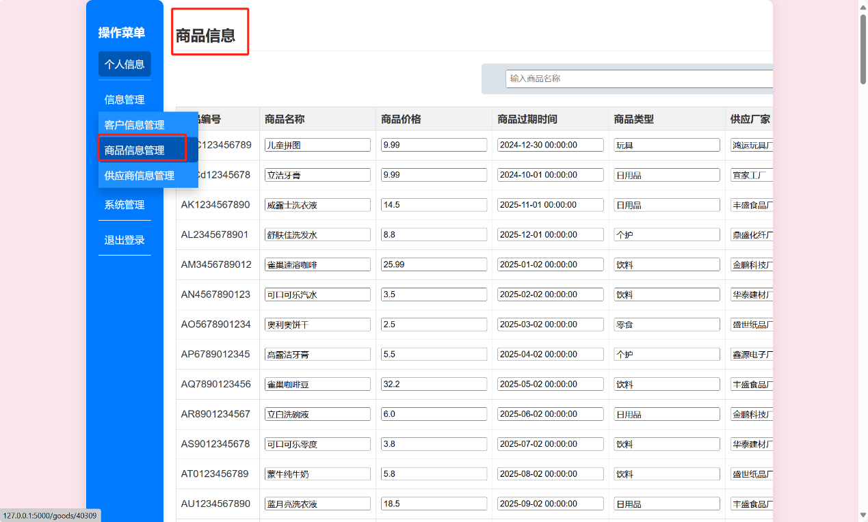

这是个可以滑动的窗口，窗口剩余部分长下图这样：

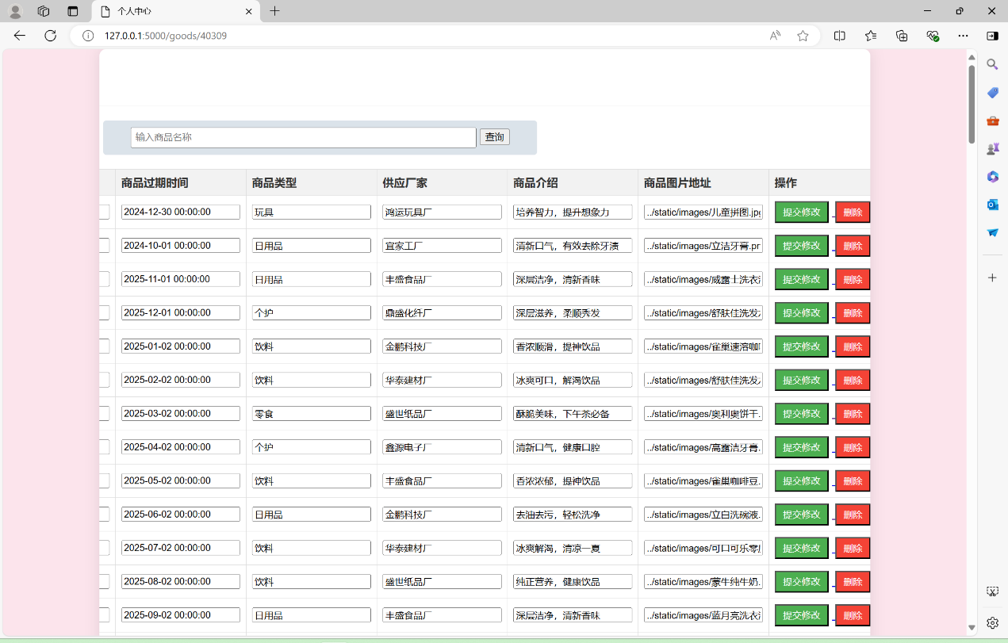

该部分与客户信息管理部分一样，可以对商品信息进行删除、修改和查询。

#### 供应商信息管理

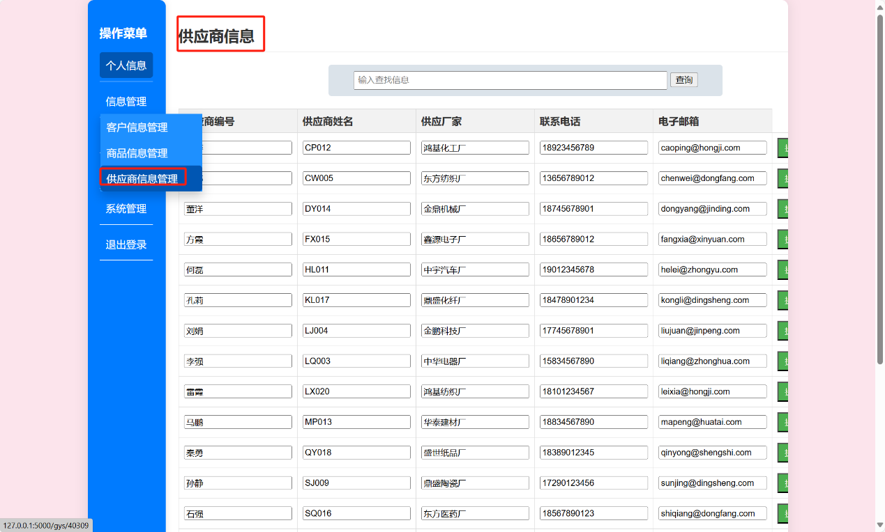

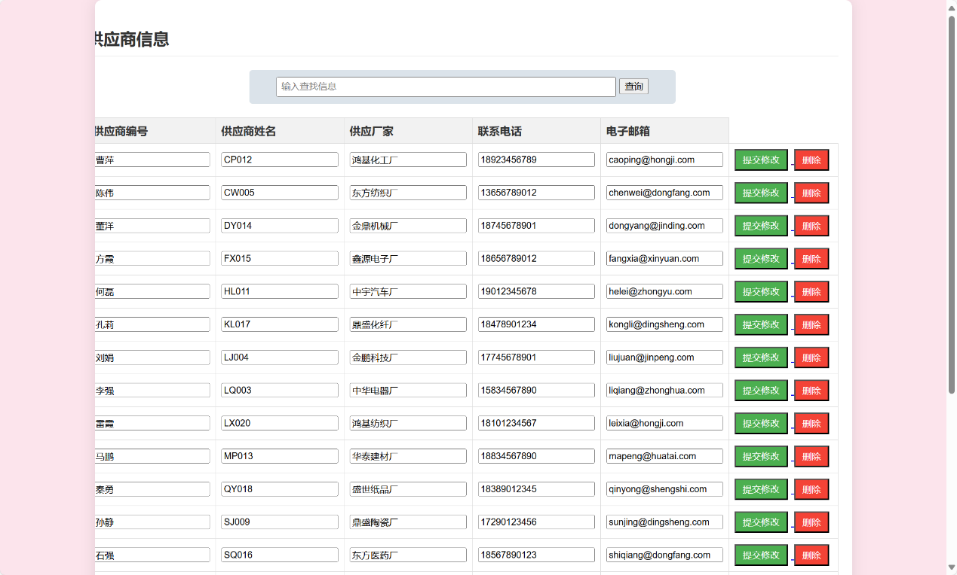

与商品信息一样，该页面同样也可以进行对供应商信息的修改、删除、查询的操作。

### 查询统计

#### 销售查询

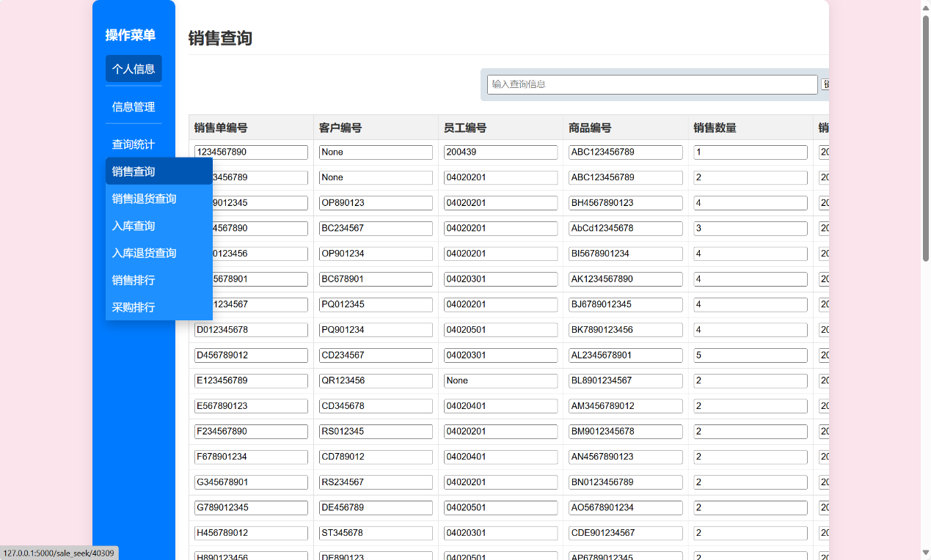

该页面可以对销售单进行查询。

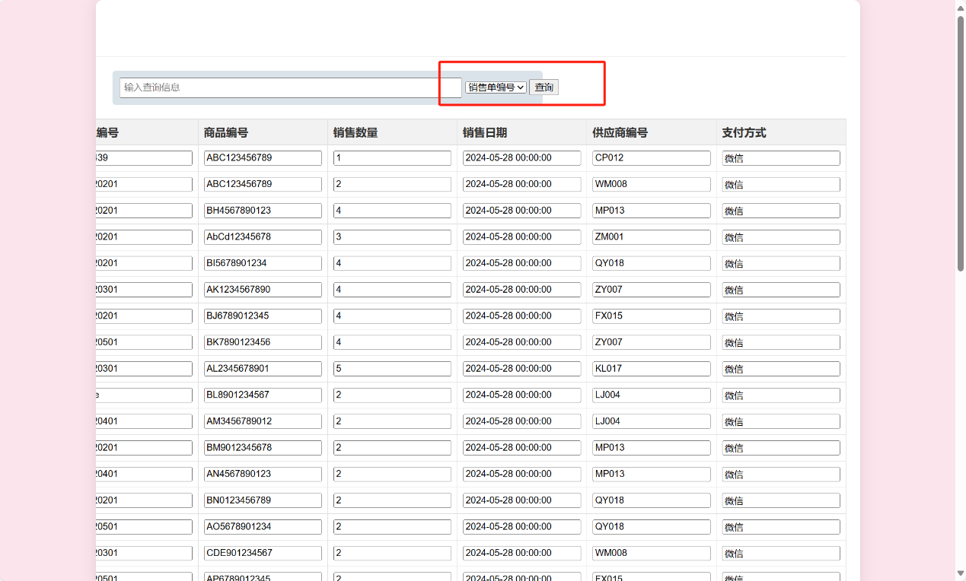

在此处可以选择查询的方式，例如按照员工编号查询：

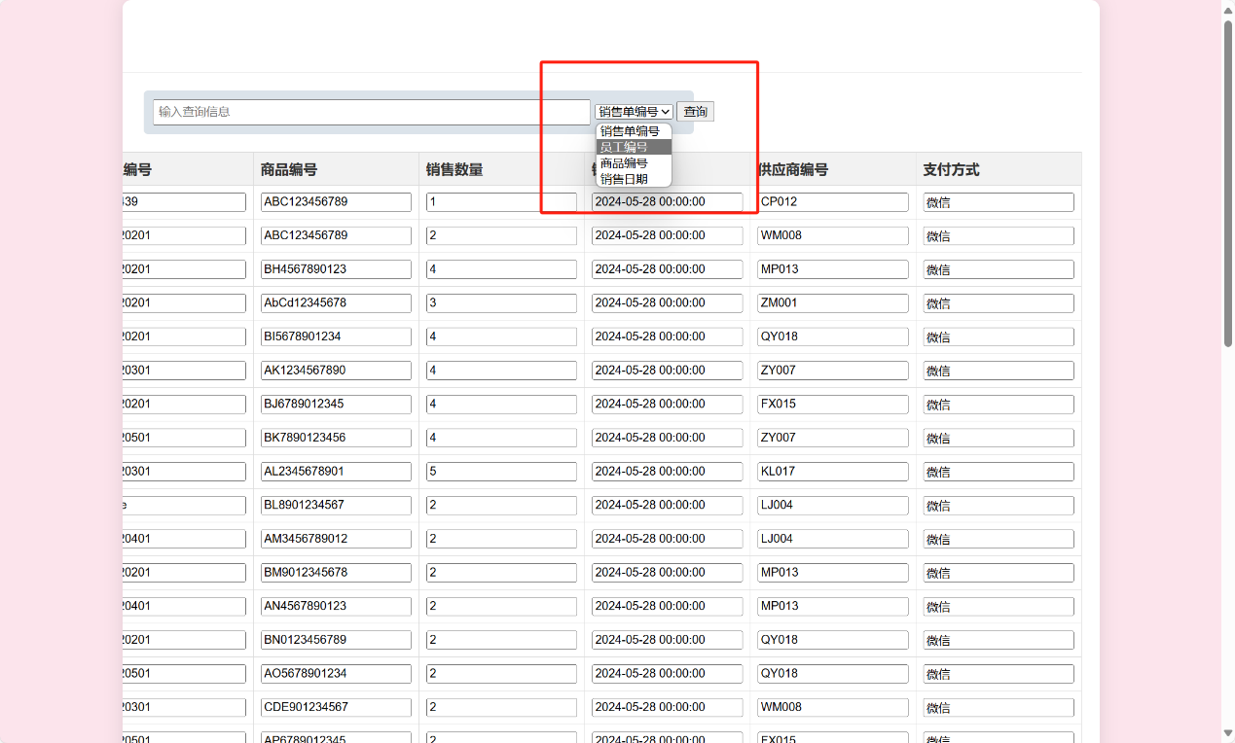

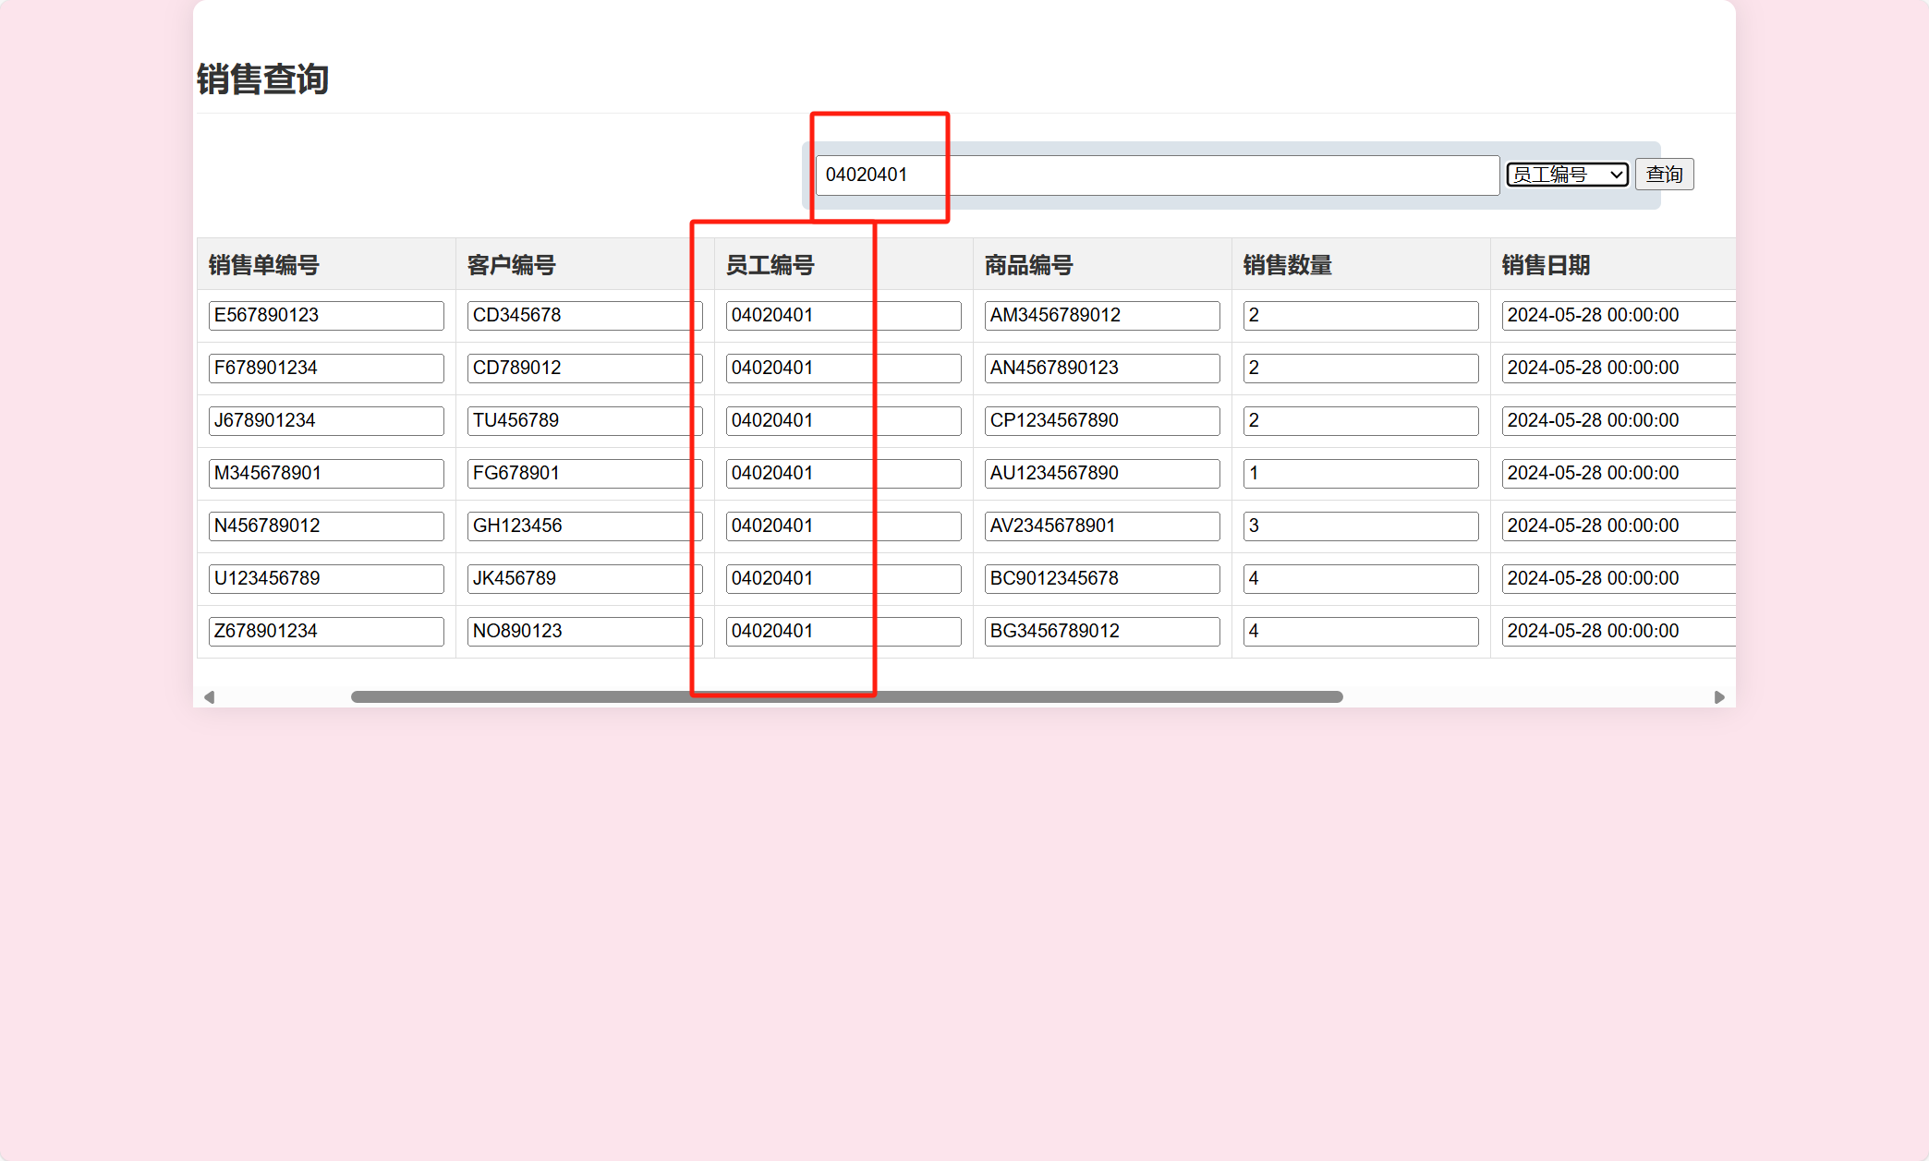

由上图可以看到结果均为员工编号为04020401的员工所销售的销售单。

#### 销售退货单查询

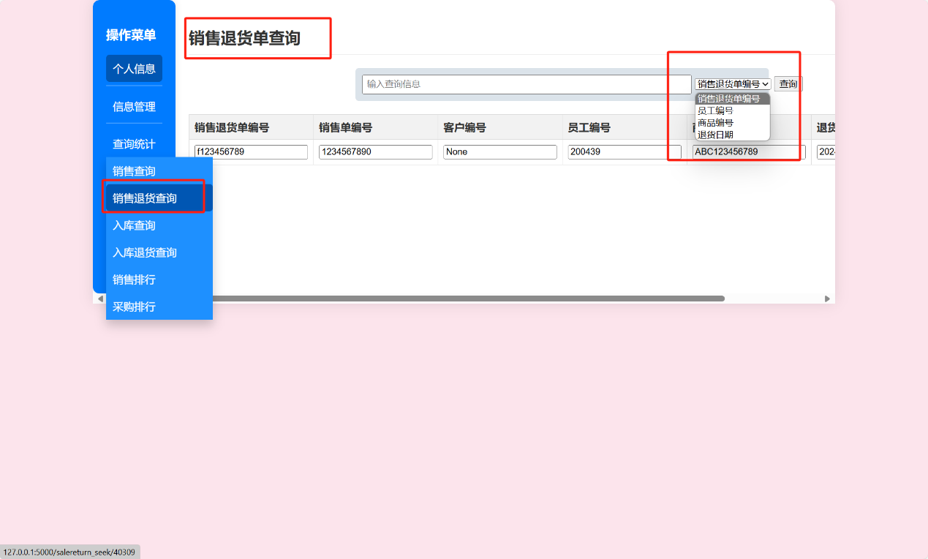

与销售单查询一样，可以按张多种方式查询。

#### 入库查询

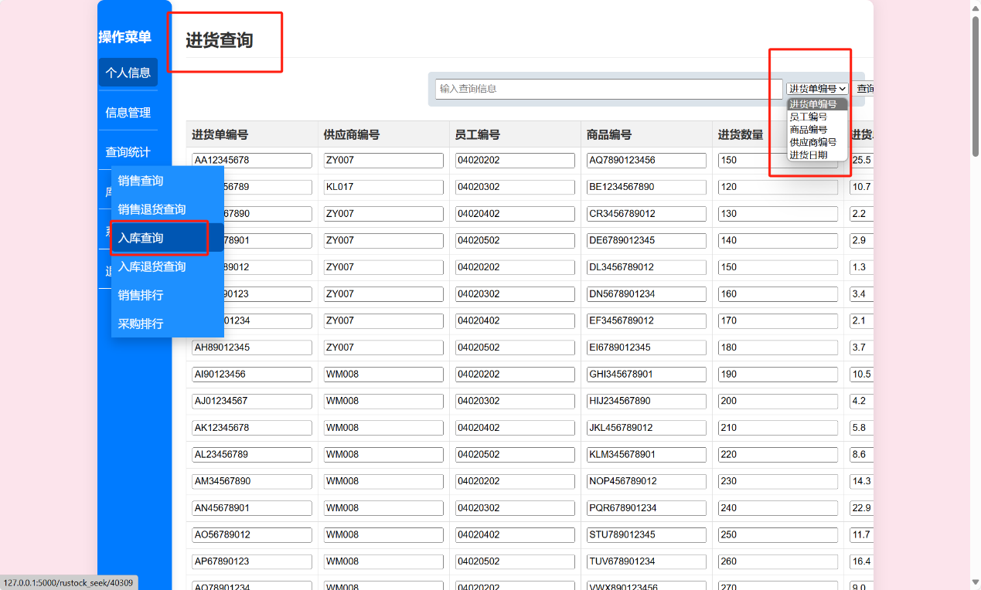

入库即是进货。

#### 入库退货查询

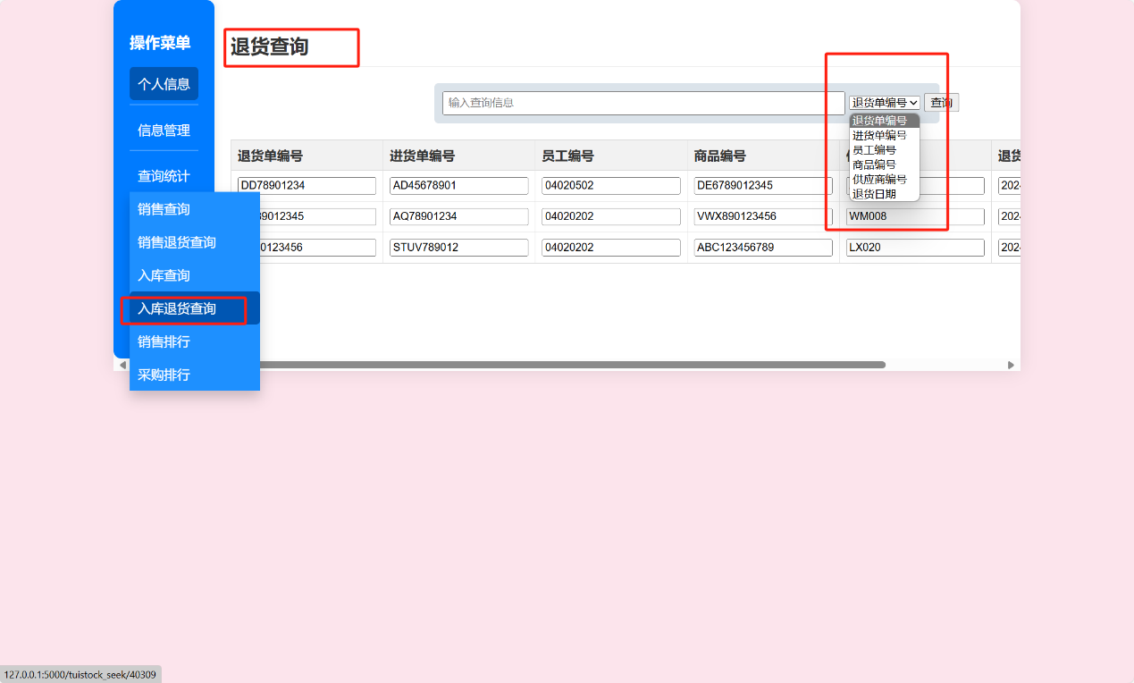

#### 销售排行

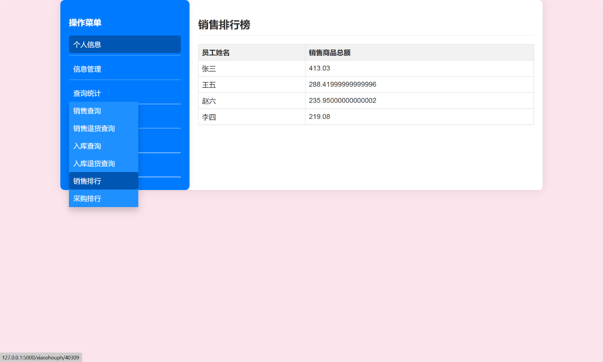

#### 采购排行

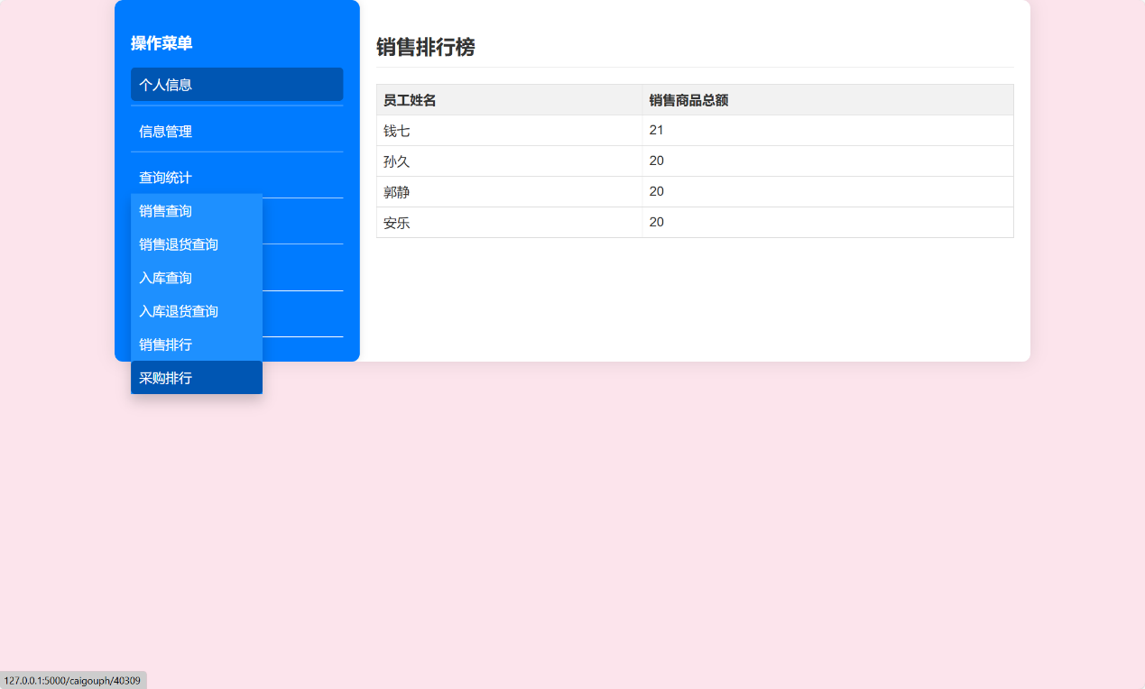

### 库存管理

#### 库存盘点

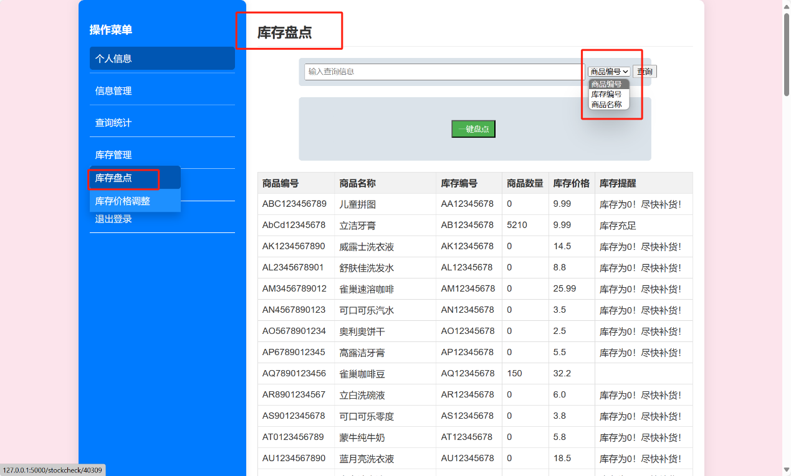

上方的搜索框可以按照多种方式查询，点击一键盘点，可以跳转的提示页面，查看库存情况。

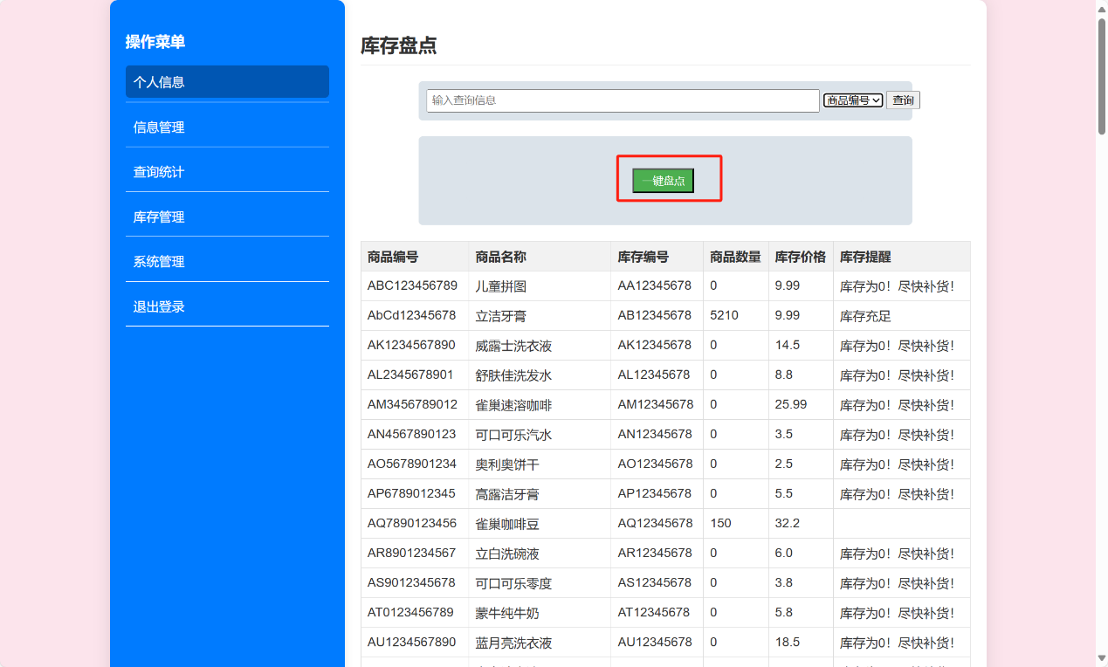

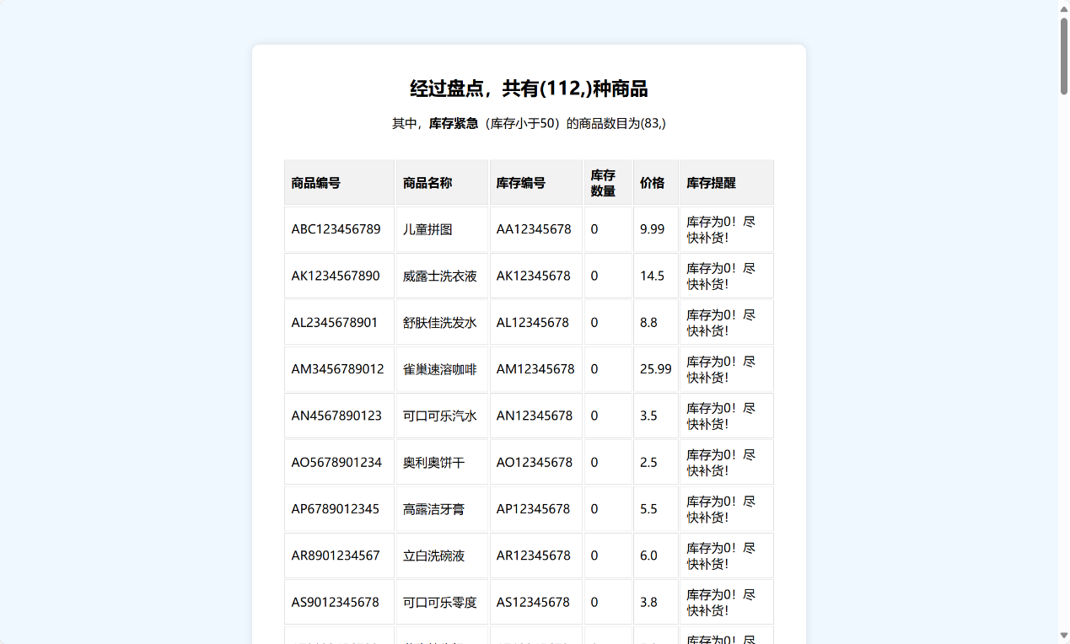

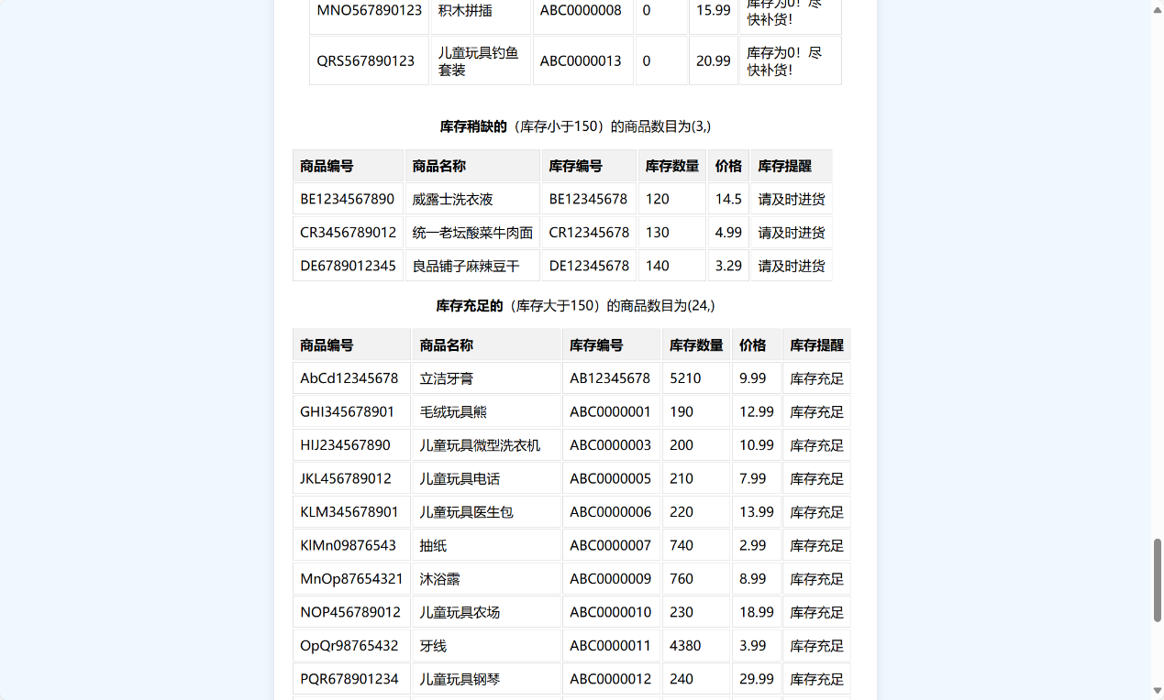

可以看到，库存盘点的情况如上。

#### 库存价格调整

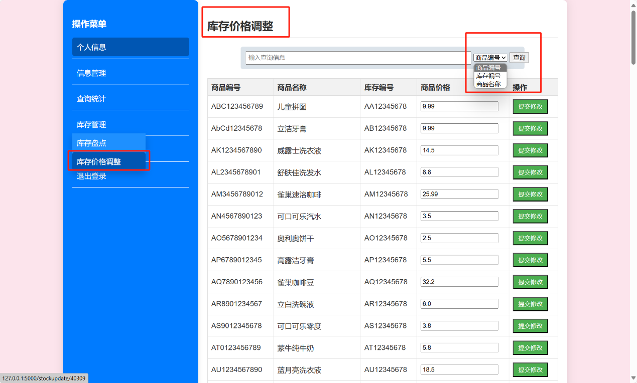

上方可以按照不同的方式查询库存。

此界面可以用于修改商品价格，例如将第一个价格改为66.99：

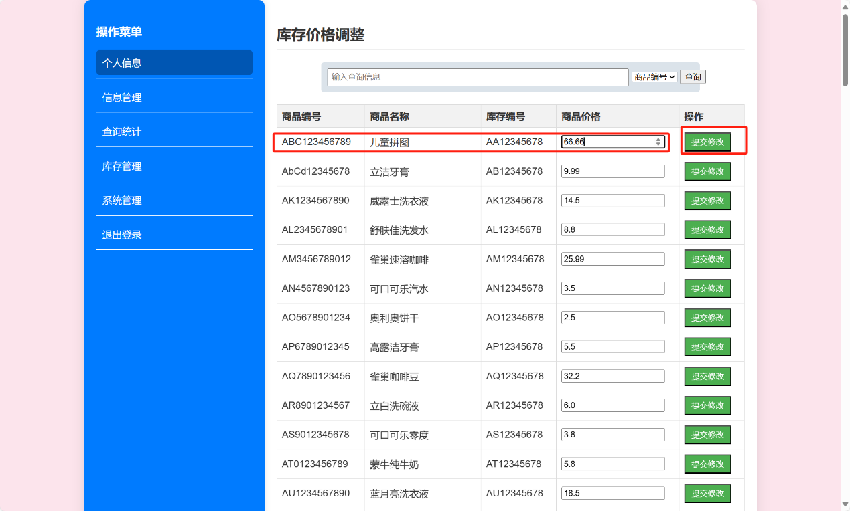

点击提交修改，再次查询后可以看到在该界面商品价格发生变化：

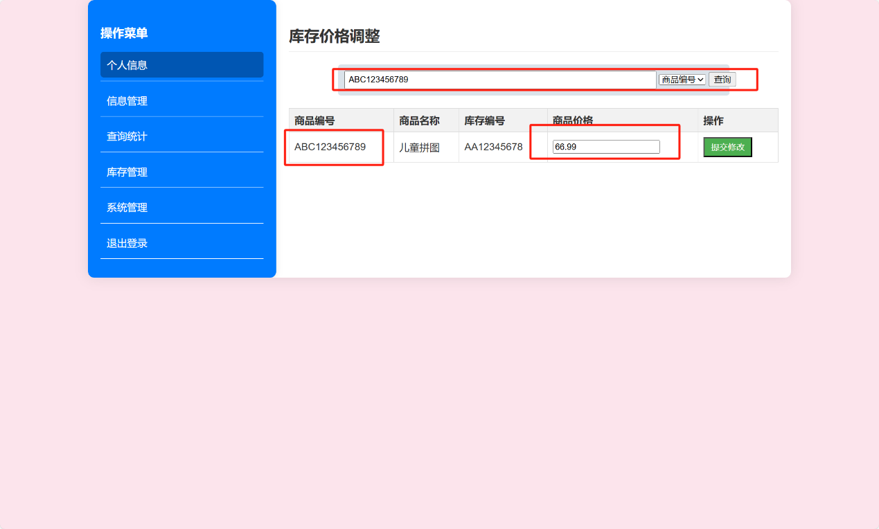

回到之前商品查询界面，查看该商品价格，可以看到也相应的发生了改变：

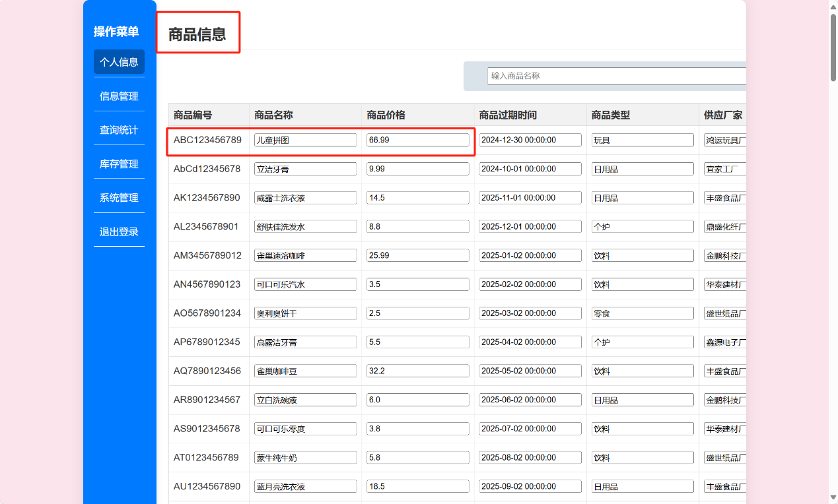

### 系统管理

#### 员工信息

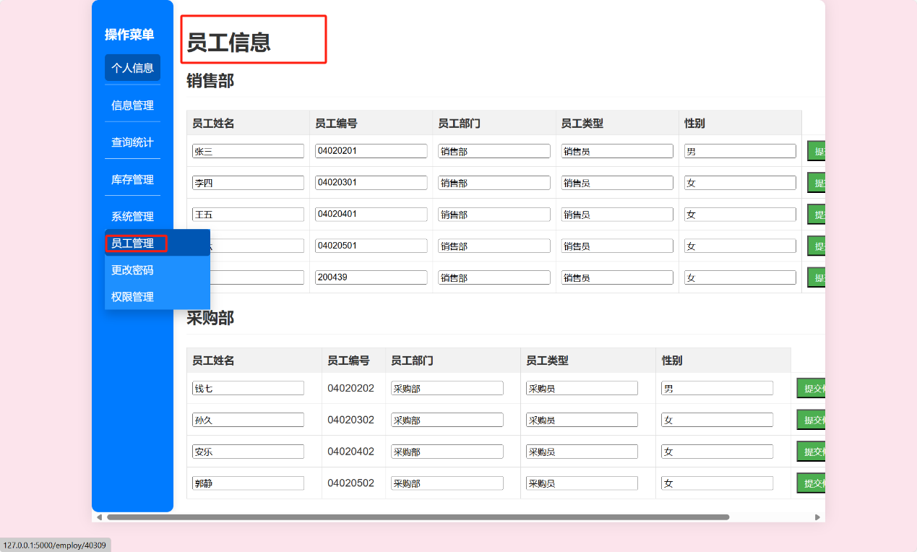

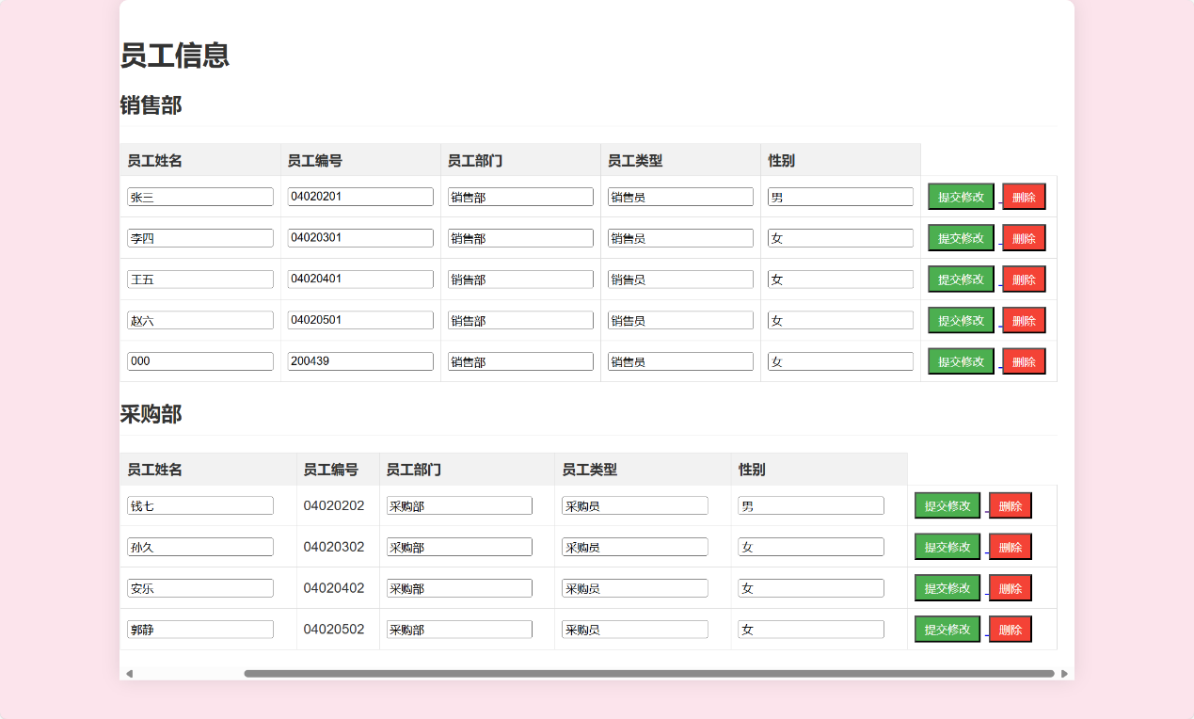

该界面可以修改、删除和查看员工的信息。

#### 更改密码

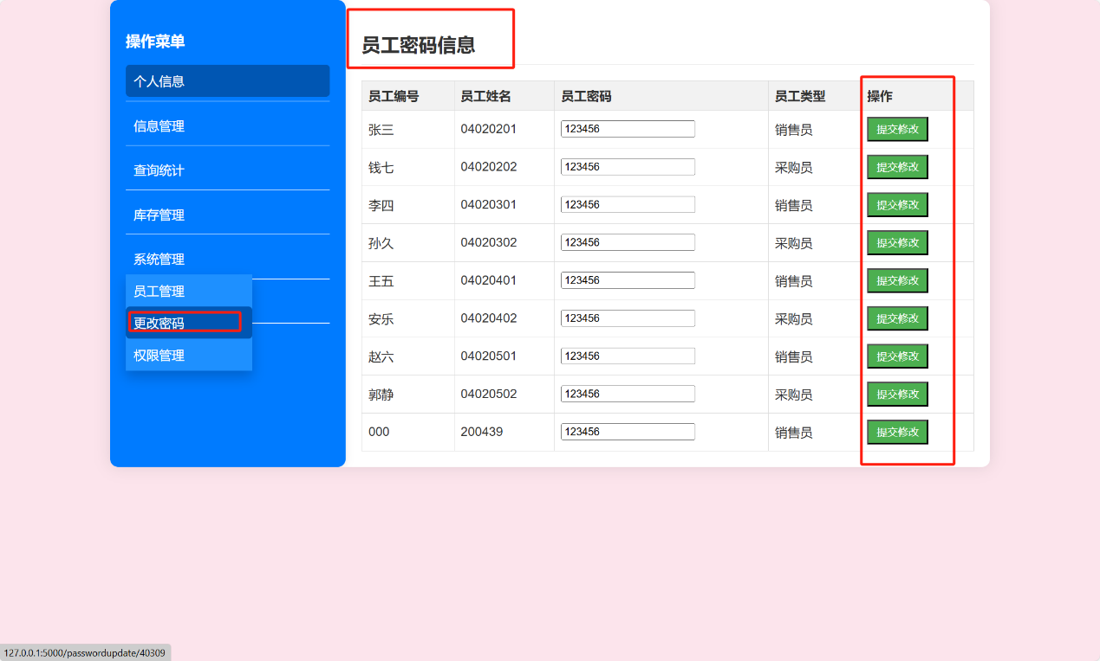

该界面可以修改员工的密码。

#### 权限管理

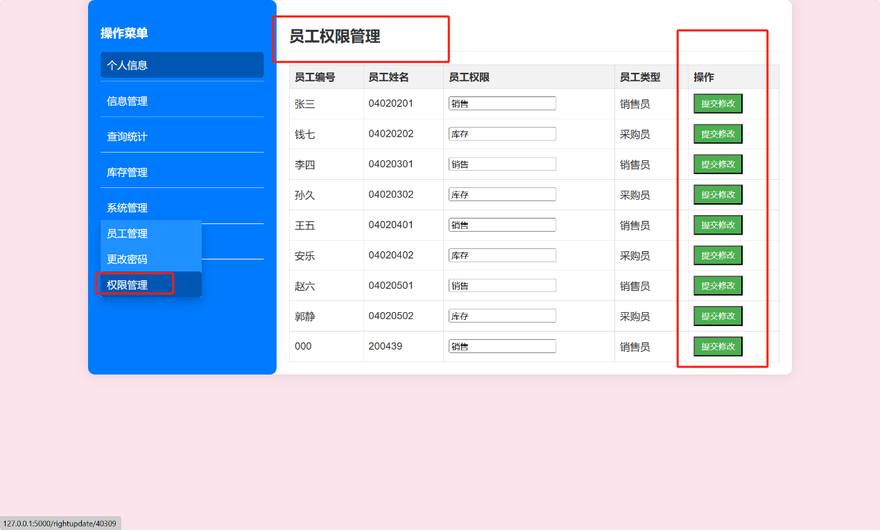

#### 退出登录

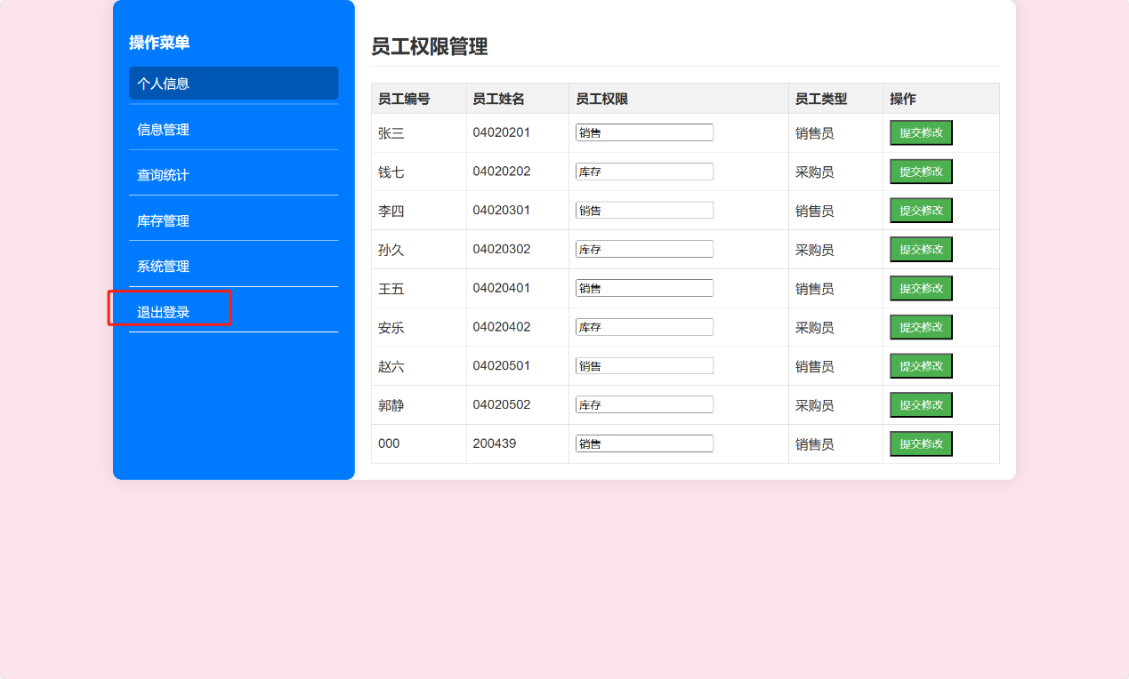

点击退出登录可以直接回到首页。

## 直接下单功能

客户可以直接点击首页的直接下单：

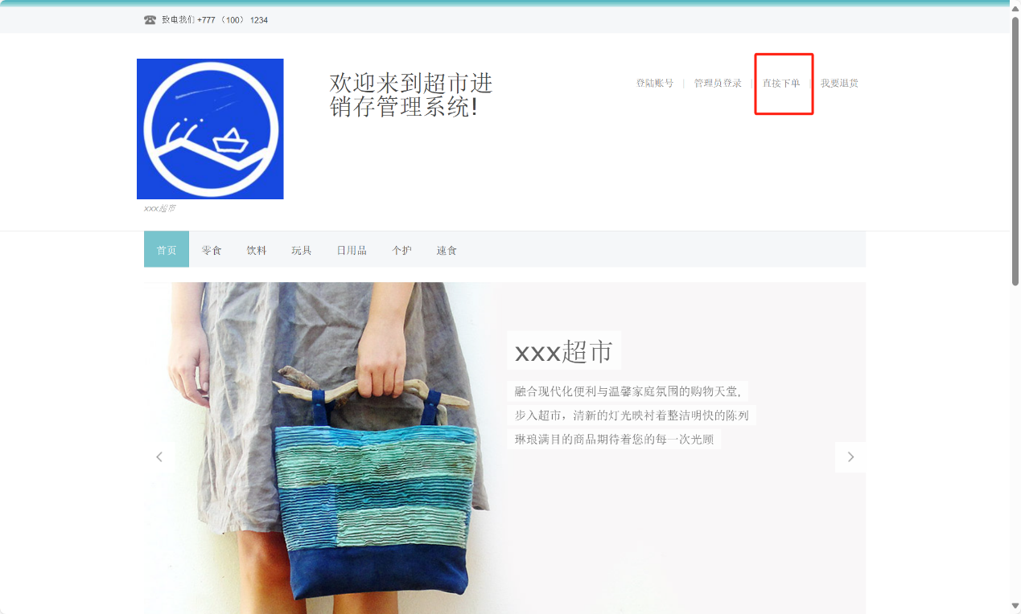

点击之后进入搜索商品的界面：

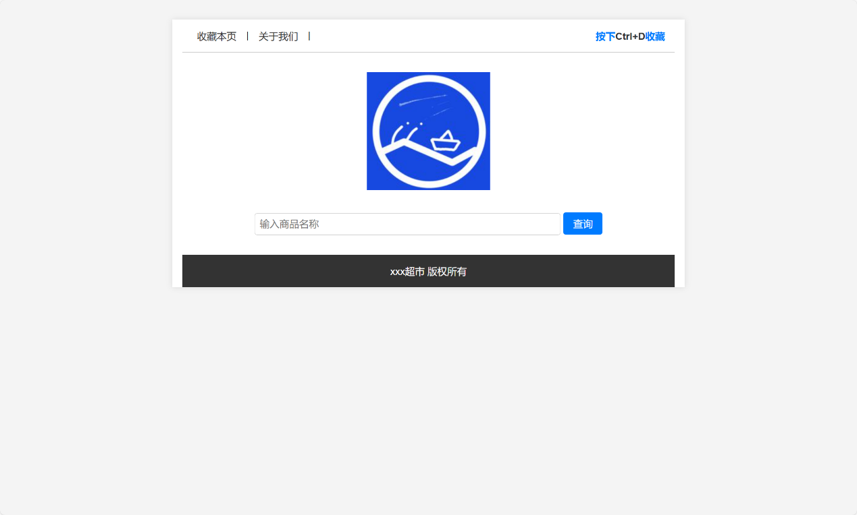

点击搜索可以搜索到相关的商品，例如：

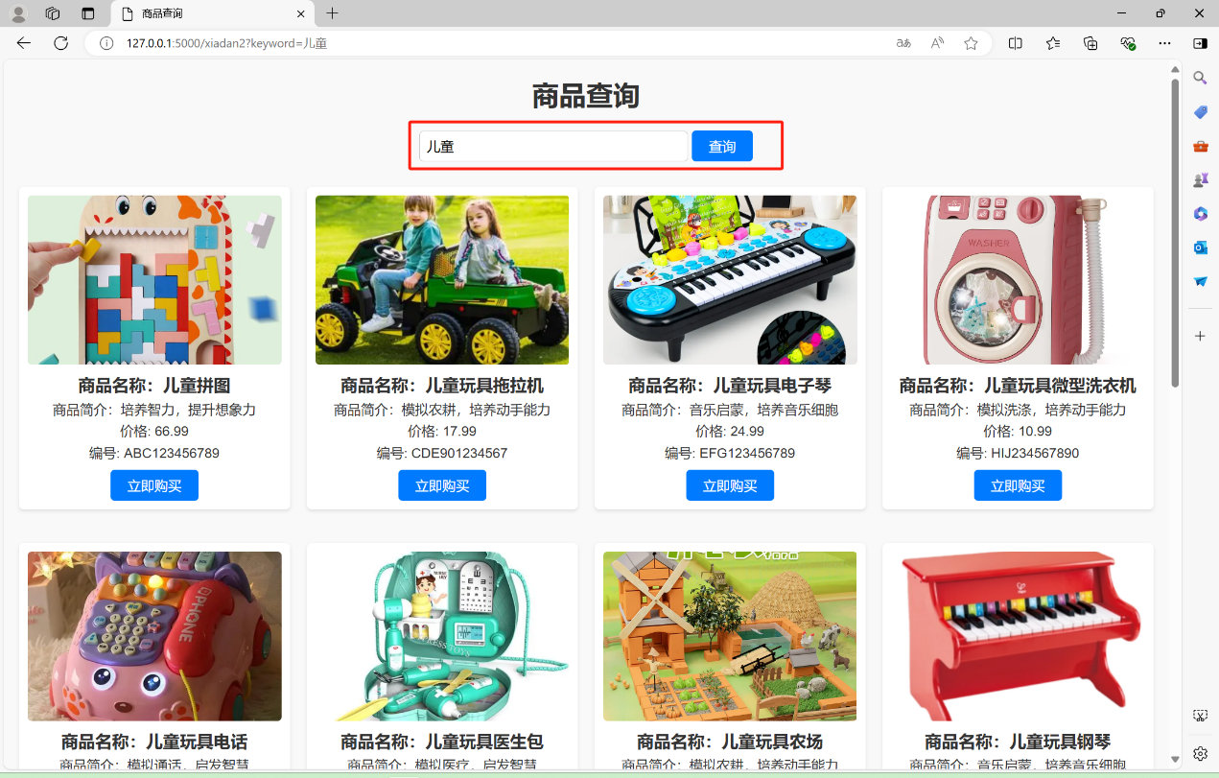

在该界面客户可以选择喜欢的商品，点击立即购买可以去支付界面：

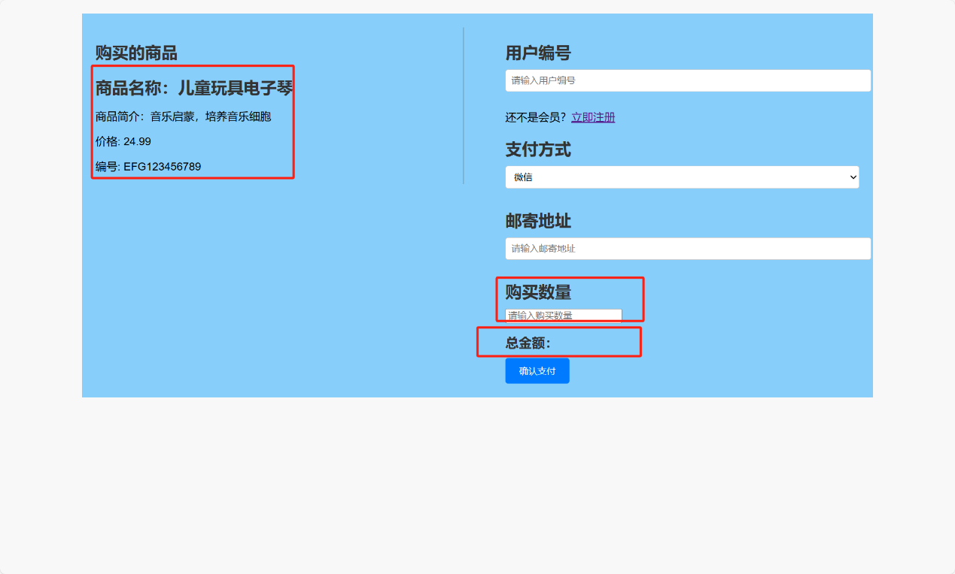

填入不同的购买数量，总金额会发生相应的变化，如下图所示：

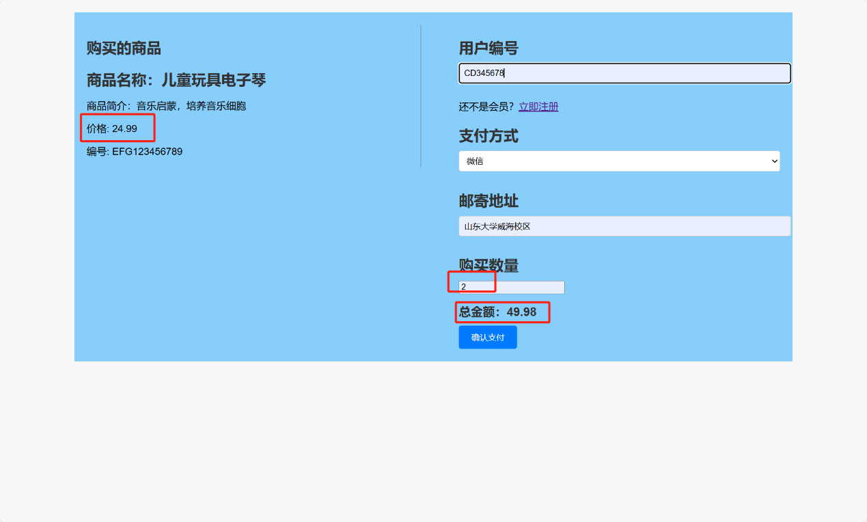

注意，如果是新客户，可以点击立即注册注册会员账号，没有会员是无法完成线上下单的操作的！！

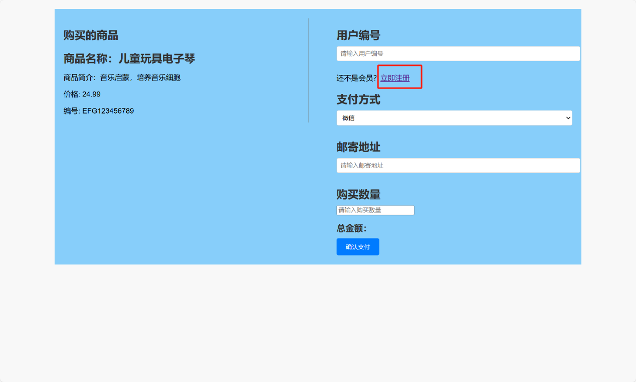

注册界面如下：

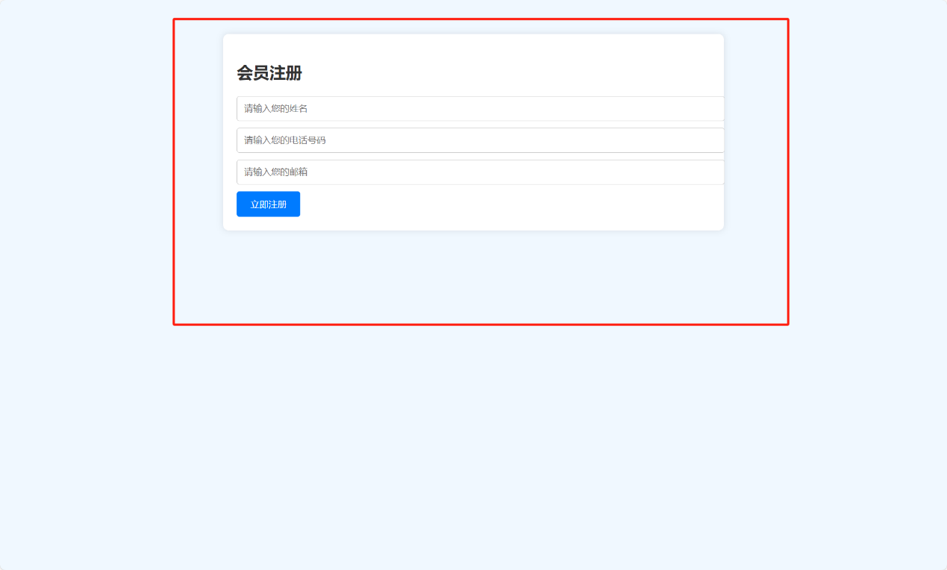

点击确认支付，此处在我的代码中分了2种情况，一种是未选择使用积分支付，另一种是选择积分组合支付，如果选择积分组合支付，则会有两种情况，一种是积分不足，一种是积分充足。不用积分支付的订单可以累计积分，使用了积分的订单无法累计积分。此处给不使用购买的示例：

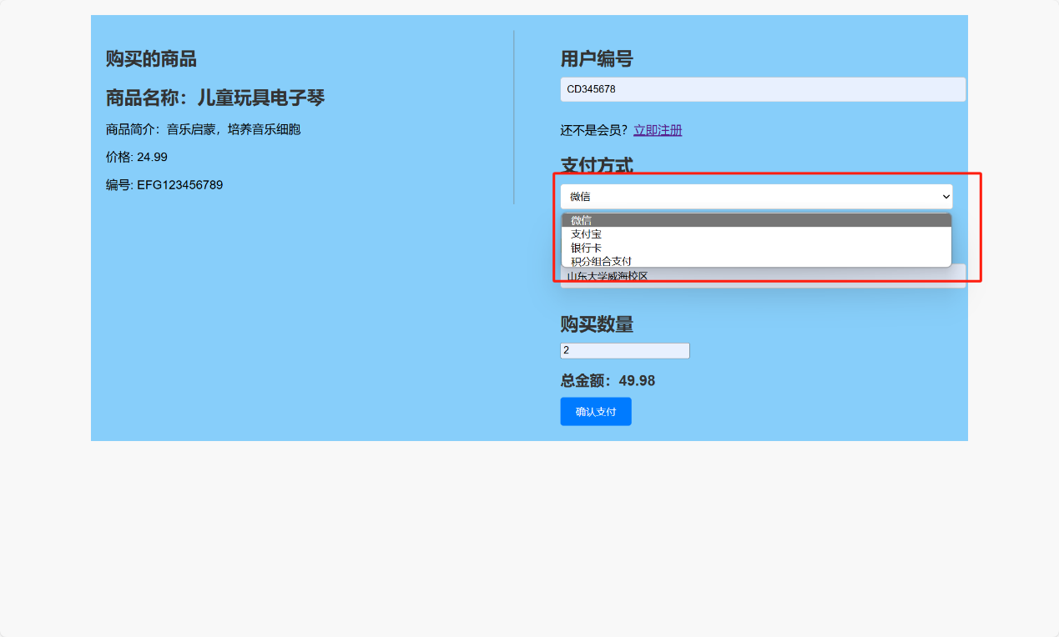

此处使用微信支付，点击确认支付后：

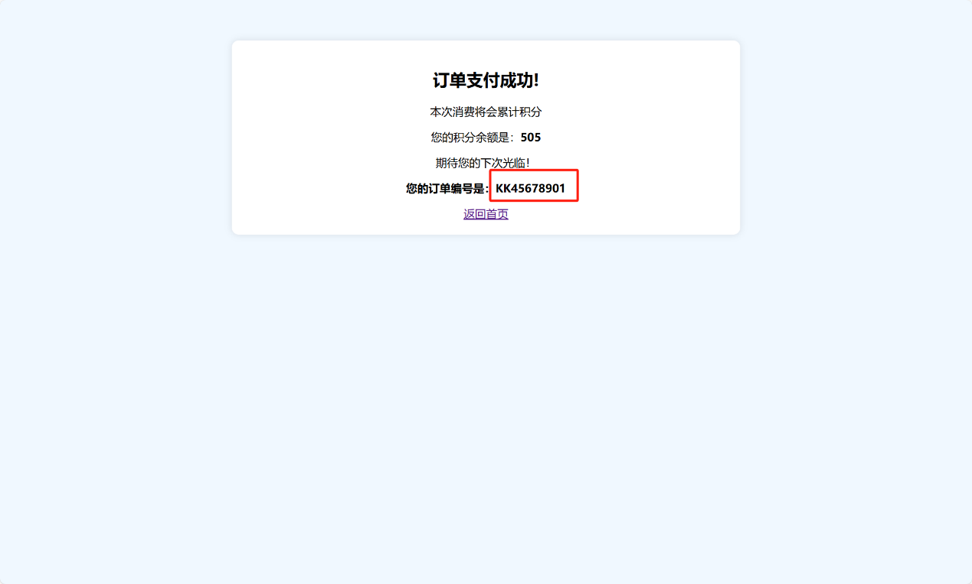

记住此订单编号，我们点击返回首页，登录销售员账号确认该销售订单，接着才可以演示客户的退货功能。

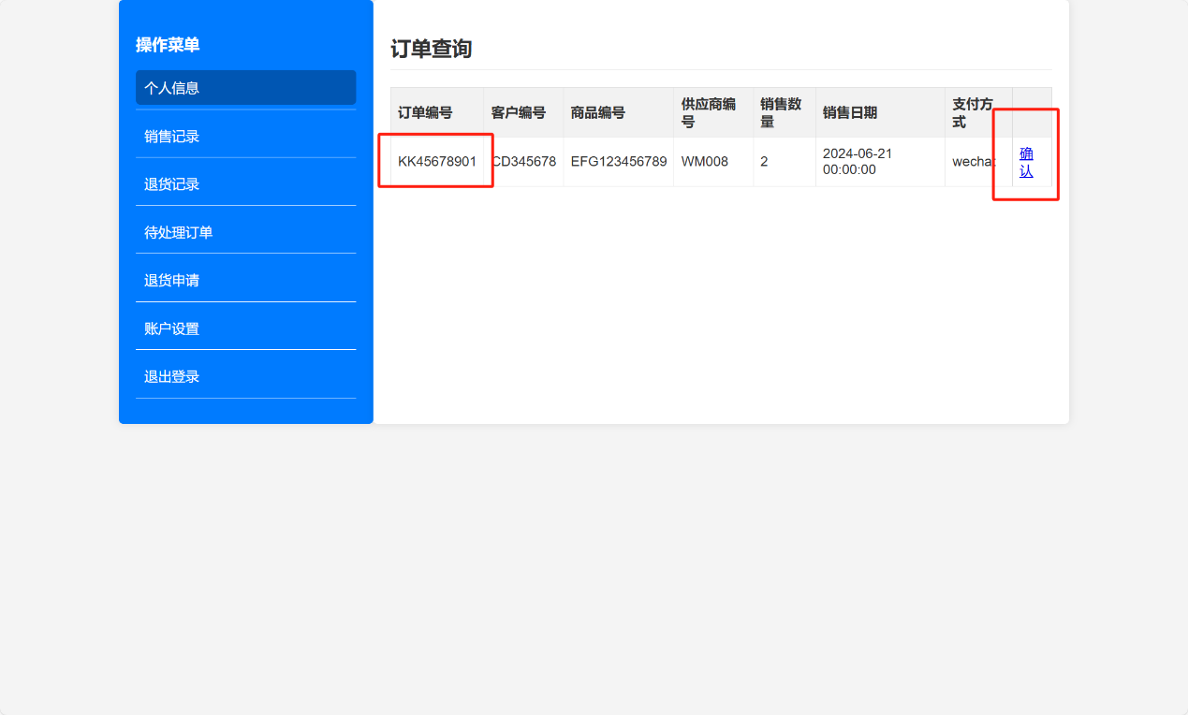

## 客户退货

点击确认后，我们点击退出登录返回首页，再点击我要退货：

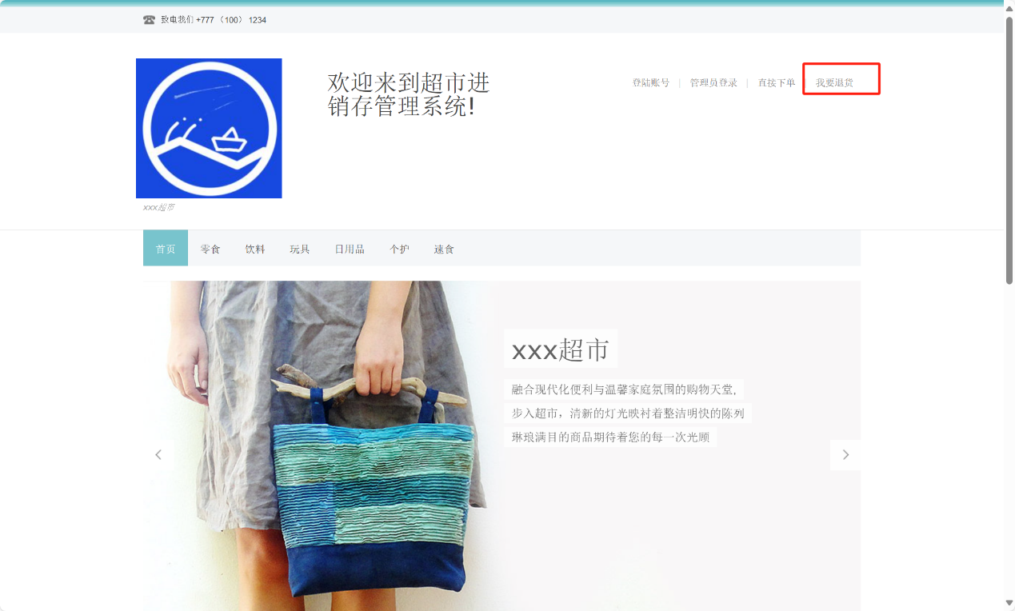

点击之后：

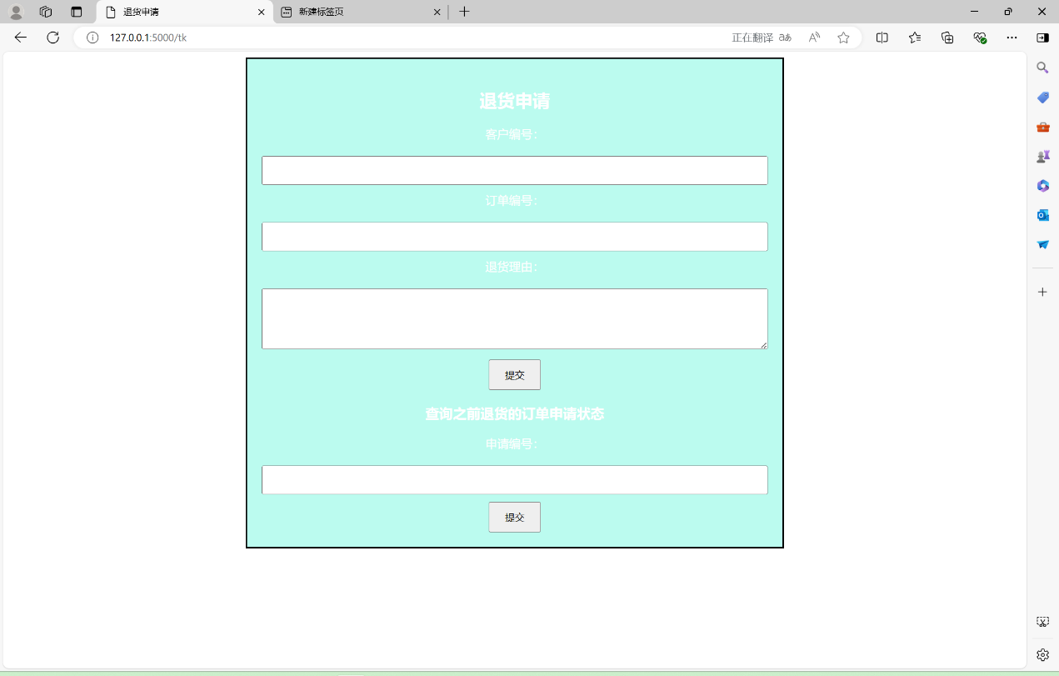

我们先提交退货申请：

将客户信息和订单编号填写正确：

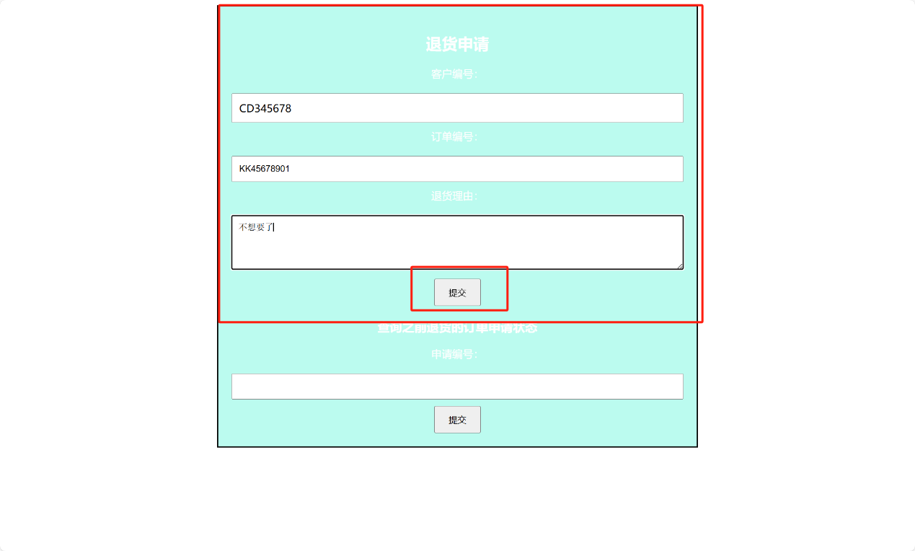

提交之后进入提示界面：

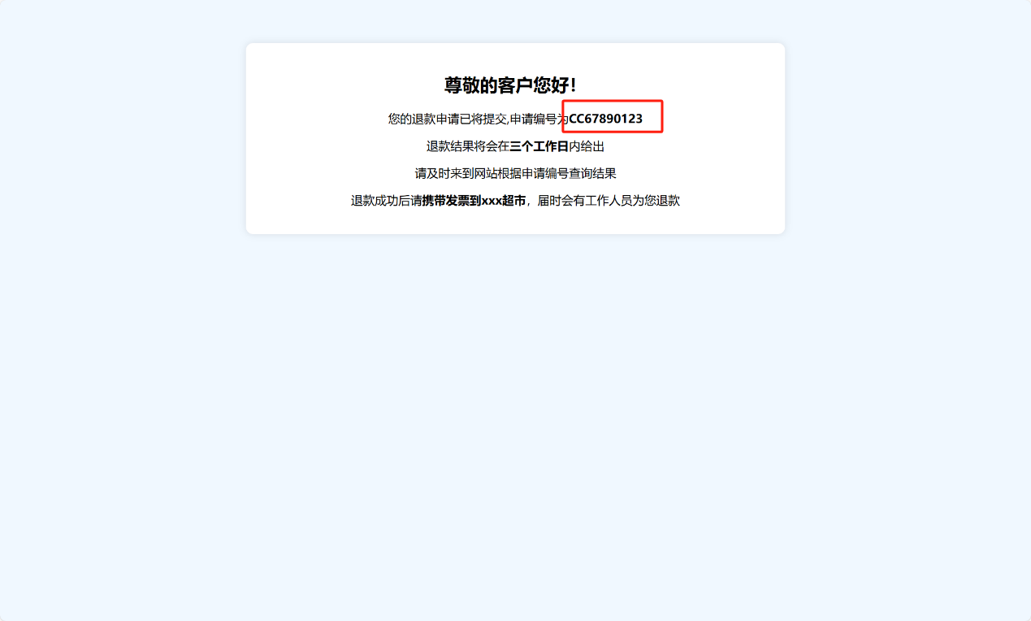

记住这个编号，我们返回退货申请界面来查询一下该退货订单信息：

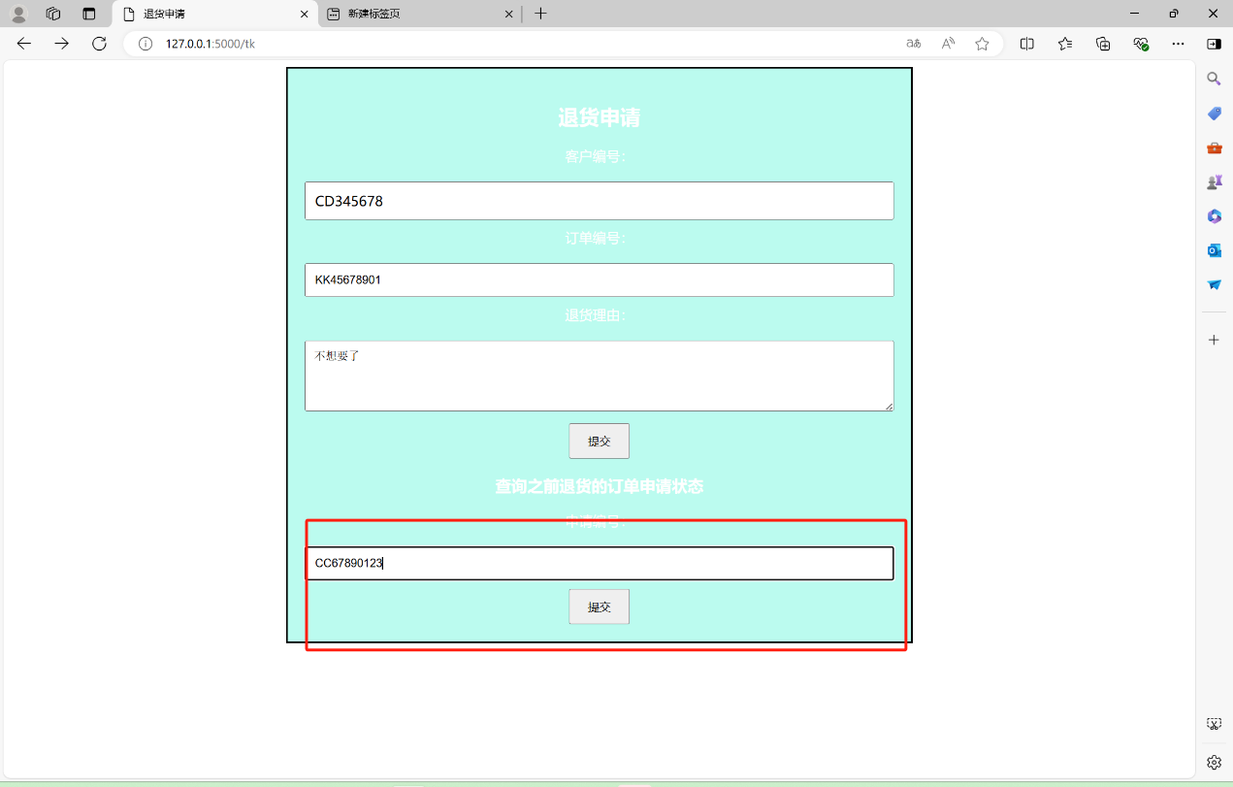

点击提交可以查看退货单的状态：

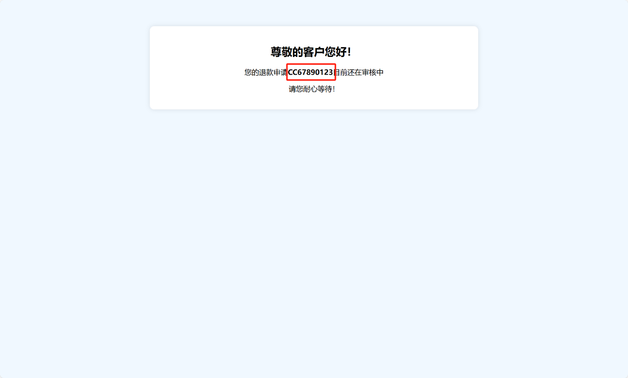

我们返回首页，登录一个销售员账号，确认该退货申请：

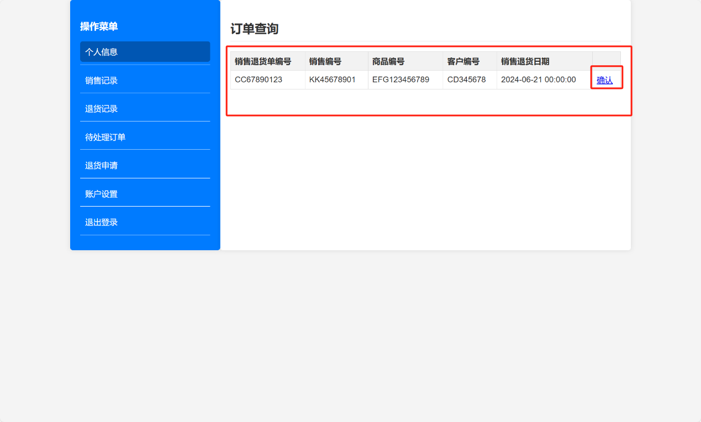

再到退货申请界面查询该订单的信息：

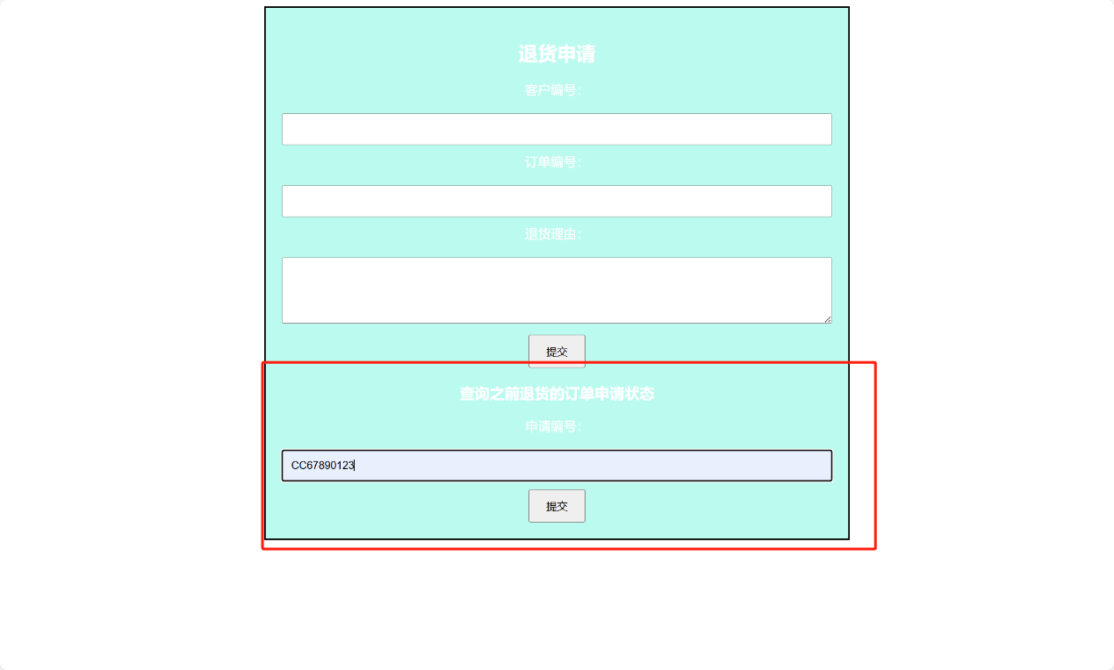

再次查询可以看到申请被通过了：

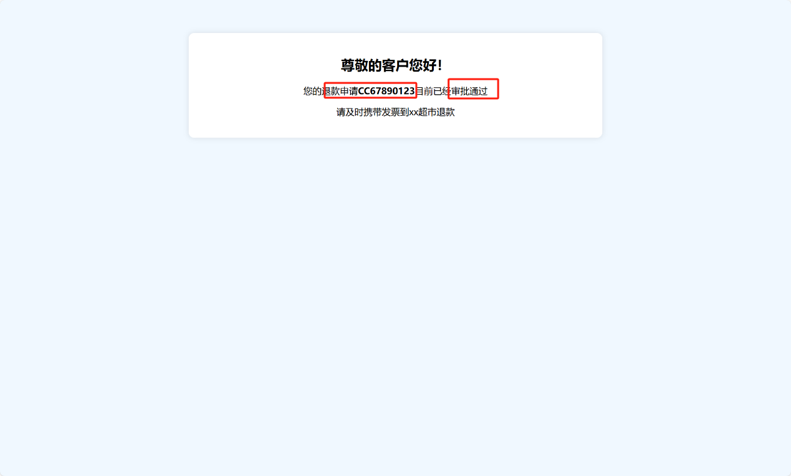

# 代码展示

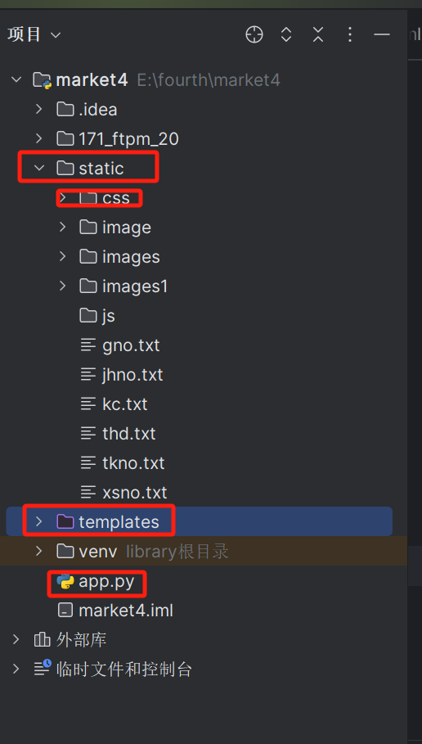

如图所示，我的代码集中放在了static下的css、和templates（存放html文件）、app.py（后端逻辑代码）。接下来我将按照css文件夹、templas文件夹、app.py文件的顺序展示代码。

## CSS

### grid.css

body {  
 min-width: 960px;  
}  
  
/* =Containers -----------------------------------------------------------------*/  
.container_12  
{  
 margin-left: auto;  
 margin-right: auto;  
 width: 1008px;  
}  
  
/* =Grid >> Global -------------------------------------------------------------*/  
.grid_1,  
.grid_2,  
.grid_3,  
.grid_4,  
.grid_5,  
.grid_6,  
.grid_7,  
.grid_8,  
.grid_9,  
.grid_10,  
.grid_11,  
.grid_12 {  
 display: inline;  
 float: left;  
 margin-left: 12px;  
 margin-right: 12px;  
}  
  
.push_1, .pull_1,  
.push_2, .pull_2,  
.push_3, .pull_3,  
.push_4, .pull_4,  
.push_5, .pull_5,  
.push_6, .pull_6,  
.push_7, .pull_7,  
.push_8, .pull_8,  
.push_9, .pull_9,  
.push_10, .pull_10,  
.push_11, .pull_11 {  
 position: relative;  
}  
  
/* =Grid >> Children (Alpha ~ First, Omega ~ Last) -----------------------------*/  
.alpha {margin-left: 0;}  
.omega {margin-right: 0;}  
  
/* =Grid >> 12 Columns ---------------------------------------------------------*/  
.container_12 .grid_1 {width: 60px;}  
.container_12 .grid_2 {width: 144px;}  
.container_12 .grid_3 {width: 228px;}  
.container_12 .grid_4 {width: 312px;}  
.container_12 .grid_5 {width: 396px;}  
.container_12 .grid_6 {width: 480px;}  
.container_12 .grid_7 {width: 564px;}  
.container_12 .grid_8 {width: 648px;}  
.container_12 .grid_9 {width: 732px;}  
.container_12 .grid_10 {width: 816px;}  
.container_12 .grid_11 {width: 900px;}  
.container_12 .grid_12 {width: 984px; position: relative;}  
  
/* =Prefix Extra Space >> 12 Columns -------------------------------------------*/  
.container_12 .prefix_1 {padding-left: 84px;}  
.container_12 .prefix_2 {padding-left: 168px;}  
.container_12 .prefix_3 {padding-left: 252px;}  
.container_12 .prefix_4 {padding-left: 336px;}  
.container_12 .prefix_5 {padding-left: 420px;}  
.container_12 .prefix_6 {padding-left: 504px;}  
.container_12 .prefix_7 {padding-left: 588px;}  
.container_12 .prefix_8 {padding-left: 672px;}  
.container_12 .prefix_9 {padding-left: 756px;}  
.container_12 .prefix_10 {padding-left: 840px;}  
.container_12 .prefix_11 {padding-left: 924px;}  
  
/* =Suffix Extra Space >> 12 Columns --------------------------------------------*/  
.container_12 .suffix_1 {padding-right: 84px;}  
.container_12 .suffix_2 {padding-right: 168px;}  
.container_12 .suffix_3 {padding-right: 252px;}  
.container_12 .suffix_4 {padding-right: 336px;}  
.container_12 .suffix_5 {padding-right: 420px;}  
.container_12 .suffix_6 {padding-right: 504px;}  
.container_12 .suffix_7 {padding-right: 588px;}  
.container_12 .suffix_8 {padding-right: 672px;}  
.container_12 .suffix_9 {padding-right: 756px;}  
.container_12 .suffix_10 {padding-right: 840px;}  
.container_12 .suffix_11 {padding-right: 924px;}  
  
/* `Push Space >> 12 Columns ---------------------------------------------------*/  
.container_12 .push_1 {left: 84px;}  
.container_12 .push_2 {left: 168px;}  
.container_12 .push_3 {left: 252px;}  
.container_12 .push_4 {left: 336px;}  
.container_12 .push_5 {left: 420px;}  
.container_12 .push_6 {left: 504px;}  
.container_12 .push_7 {left: 588px;}  
.container_12 .push_8 {left: 672px;}  
.container_12 .push_9 {left: 756px;}  
.container_12 .push_10 {left: 840px;}  
.container_12 .push_11 {left: 924px;}  
  
/* `Pull Space >> 12 Columns ----------------------------------------------------*/  
.container_12 .pull_1 {left: -84px;}  
.container_12 .pull_2 {left: -168px;}  
.container_12 .pull_3 {left: -252px;}  
.container_12 .pull_4 {left: -336px;}  
.container_12 .pull_5 {left: -420px;}  
.container_12 .pull_6 {left: -504px;}  
.container_12 .pull_7 {left: -588px;}  
.container_12 .pull_8 {left: -672px;}  
.container_12 .pull_9 {left: -756px;}  
.container_12 .pull_10 {left: -840px;}  
.container_12 .pull_11 {left: -924px;}  
  
.clear {  
 clear: both;  
 display: block;  
 overflow: hidden;  
 visibility: hidden;  
 width: 0;  
 height: 0;  
}  
.clearfix:before,  
.clearfix:after {  
 content: "\0020";  
 display: block;  
 overflow: hidden;  
 visibility: hidden;  
 width: 0;  
 height: 0;  
}  
.clearfix:after {clear: both;}  
.clearfix {zoom: 1;}

### index.css

* {  
 margin: 0px;  
 padding: 0px;  
 list-style: none;  
}  
  
#bigbox {  
 width: 1280px;  
 margin: 0 auto;  
}  
  
#title {  
 position: relative;  
 width: 100%;  
 height: 150px;  
 background-image: url(../image/background.jpg);  
}  
  
#logo {  
 color: #fff;  
 margin-left: 140px;  
 font-size: 24px;  
 padding-top: 50px;  
}  
  
#logo p {  
 margin-bottom: 10px;  
}  
  
#logo span {  
 color: #868797;  
 font-size: 14px;  
 margin-left: 10px;  
}  
  
#title ul {  
 position: absolute;  
 width: 630px;  
 right: 140px;  
 top: 0px;  
 display: flex;  
 font-size: 13px;  
}  
  
#title ul li {  
 display: flex;  
 color: #fff;  
 line-height: 150px;  
 width: 90px;  
 background: url('../image/background.jpg') no-repeat left bottom;  
}  
  
#title ul li p {  
 width: 100%;  
 text-align: center;  
}  
  
#bannner {  
 width: 1000px;  
 font-size: 0;  
 margin: 0 auto;  
}  
  
#bannner img {  
 width: 1000px;  
}  
  
#main {  
 position: relative;  
 display: flex;  
 width: 1000px;  
 margin: 0 auto;  
}  
  
#main_left {  
 width: 230px;  
}  
  
.clear {  
 width: 100%;  
 background-color: #E3E3E3;  
 height: 18px;  
}  
  
.left_title {  
 background: url('../image/background.jpg') no-repeat left;  
}  
  
.left_title p {  
 color: #fff;  
 font-size: 14px;  
 line-height: 40px;  
 padding-left: 30px;  
}  
  
.left_title_msg {  
 background: url('../image/background.jpg') no-repeat left;  
}  
  
.left_title_msg p {  
 line-height: 30px;  
 font-size: 12px;  
 color: #323231;  
 padding-left: 55px;  
}  
  
.come {  
 width: 100%;  
 background-color: #ECECEC;  
 padding-top: 18px;  
 padding-bottom: 18px;  
}  
  
.come p {  
 margin-left: 20px;  
 margin-right: 20px;  
 font-size: 12px;  
 line-height: 24px;  
}  
  
#main_right {  
 width: 770px;  
}  
  
#main_right_title {  
 background: url('../image/background.jpg') no-repeat left;  
 height: 40px;  
}  
  
#main_right_title p {  
 font-size: 12px;  
 line-height: 38px;  
 margin-left: 40px;  
 font-weight: 550;  
}  
  
#neirong {  
 width: 734px;  
 height: 416px;  
 background-color: #fff;  
 color: #545454;  
 font-size: 13px;  
 padding-left: 18px;  
 padding-right: 18px;  
 padding-top: 20px;  
}  
  
#neirong span {  
 font-weight: 550;  
}  
  
#neirong h4 {  
 color: #545454;  
}  
  
.suojin {  
 text-indent: 14px;  
}  
  
#neirong img {  
 float: right;  
 right: 0px;  
 margin-top: -10px;  
}  
  
#footer {  
 width: 1000px;  
 background-image: url(../image/headbg.jpg);  
 color: #fff;  
 text-align: center;  
 margin: 0 auto;  
 font-size: 14px;  
 line-height: 30px;  
 padding-top: 30px;  
 padding-bottom: 30px;  
}  
  
#footer span {  
 margin-left: 10px;  
 margin-right: 10px;  
}  
  
#bottom {  
 width: 1000px;  
 margin: 0 auto;  
}  
  
#bottom {  
 text-align: center;  
 background-color: #fff;  
 line-height: 40px;  
 font-size: 13px;  
}  
  
#bottom span {  
 font-weight: 550;  
}

### jquery.jqzoom.css

.zoomPad{  
 height: 294px;  
 position:relative;  
 float:left;  
 z-index:99;  
 cursor:crosshair;  
}  
.zoomPreload{  
 -moz-opacity:0.8;  
 opacity: 0.8;  
 filter: alpha(opacity = 80);  
 color: #333;  
 font-size: 12px;  
 font-family: Tahoma;  
 text-decoration: none;  
 border: 1px solid #CCC;  
 background-color: white;  
 padding: 8px;  
 text-align:center;  
 background-image: url(../images1/loading.gif);  
 background-repeat: no-repeat;  
 background-position: 43px 30px;  
 z-index:110;  
 width:90px;  
 height:43px;  
 position:absolute;  
 top:0px;  
 left:0px;  
 * width:100px;  
 * height:49px;  
}  
.zoomPup{  
 overflow:hidden;  
 background-color: #FFF;  
 -moz-opacity:0.6;  
 opacity: 0.6;  
 filter: alpha(opacity = 60);  
 z-index:120;  
 position:absolute;  
 border:1px solid #CCC;  
 z-index:101;  
 cursor:crosshair;  
}  
.zoomOverlay{  
 position:absolute;  
 left:0px;  
 top:0px;  
 background:#FFF;  
 /*opacity:0.5;*/  
 z-index:5000;  
 width:100%;  
 height:100%;  
 display:none;  
 z-index:101;  
}  
  
.zoomWindow{  
 position:absolute;  
 left:360px**!important**;  
 top:40px;  
 background:#FFF;  
 z-index:6000;  
 height:auto;  
 z-index:10000;  
 z-index:110;  
}  
.zoomWrapper{  
 position:relative;  
 border:1px solid #999;  
 z-index:110;  
}  
.zoomWrapperTitle{  
 display:block;  
 background:#999;  
 color:#FFF;  
 height:18px;  
 line-height:18px;  
 width:100%;  
 overflow:hidden;  
 text-align:center;  
 font-size:10px;  
 position:absolute;  
 top:0px;  
 left:0px;  
 z-index:120;  
 -moz-opacity:0.6;  
 opacity: 0.6;  
 filter: alpha(opacity = 60);  
}  
.zoomWrapperImage{  
 display:block;  
 position:relative;  
 overflow:hidden;  
 z-index:110;  
}  
.zoomWrapperImage img{  
 border:0px;  
 display:block;  
 position:absolute;  
 z-index:101;  
}  
  
.zoomIframe{  
 z-index: -1;  
 filter:alpha(opacity=0);  
 -moz-opacity: 0.80;  
 opacity: 0.80;  
 position:absolute;  
 display:block;  
}

### style.css

/*********  
 * Fonts *  
 *********/  
@font-face {  
 font-family: Bitter;  
 src: url(../../171_ftpm_20/fonts/Bitter.eot)  
}  
@font-face {  
 font-family: Bitter;  
 src: url(../../171_ftpm_20/fonts/Bitter.ttf);  
}  
@font-face {  
 font-family: Bitter-Bold;  
 src: url(../../171_ftpm_20/fonts/Bitter-Bold.eot)  
}  
@font-face {  
 font-family: Bitter-Bold;  
 src: url(../../171_ftpm_20/fonts/Bitter-Bold.ttf);  
}  
@font-face {  
 font-family: Bitter-Italic;  
 src: url(../../171_ftpm_20/fonts/Bitter-Italic.eot)  
}  
@font-face {  
 font-family: Bitter-Italic;  
 src: url(../../171_ftpm_20/fonts/Bitter-Italic.ttf);  
}  
@font-face {  
 font-family: Segoeui;  
 src: url(../../171_ftpm_20/fonts/Segoeui.eot)  
}  
@font-face {  
 font-family: Segoeui;  
 src: url(../../171_ftpm_20/fonts/Segoeui.ttf);  
}  
@font-face {  
 font-family: Segoeui-Bold;  
 src: url(../../171_ftpm_20/fonts/Segoeui-Bold.eot)  
}  
@font-face {  
 font-family: Segoeui-Bold;  
 src: url(../../171_ftpm_20/fonts/Segoeui-Bold.ttf);  
}  
@font-face {  
 font-family: Segoeui-Italic;  
 src: url(../../171_ftpm_20/fonts/Segoeui-Italic.eot)  
}  
@font-face {  
 font-family: Segoeui-Italic;  
 src: url(../../171_ftpm_20/fonts/Segoeui-Italic.ttf);  
}  
  
*{padding:0;margin:0; border:0 none;}  
html, body, div, span, applet, object, iframe,  
h1, h2, h3, h4, h5, h6, p, blockquote, pre,  
a, abbr, acronym, address, big, cite, code,  
del, dfn, em, font, img, ins, kbd, q, s, samp,  
small, strike, strong, sub, sup, tt, var,  
b, u, i, center,  
dl, dt, dd, ol, ul, li,  
fieldset, form, label, legend,  
table, caption, tbody, tfoot, thead, tr, th, td {  
 margin: 0;  
 padding: 0;  
 border: 0;  
 outline: 0;  
 font-size: 100%;  
 vertical-align: baseline;  
 background: transparent;  
}  
article, aside, audio, canvas, command, datalist, details, embed, figcaption, figure, footer, header, hgroup, keygen, meter, nav, output, progress, section, source, video {display:block}  
mark, rp, rt, ruby, summary, time {display:inline}  
ul{list-style: none}  
a {text-decoration:underline; color: #59b7c2;}  
a:hover,a:active {text-decoration:none;}  
nav a{text-decoration: none}  
b,strong{font-family: Segoeui-Bold, Arial, Verdana, serif;}  
p, b, li, strong{font-size:13px; line-height: 20px;}  
hr{background: #e0e0e0;height: 1px}  
h1,h2,h3,h4,h5,h6 {  
 font-family: Bitter, Myriad Pro, Verdana, serif;  
 font-weight: normal;  
 color: #444;  
 line-height: 1;  
 padding-bottom: 23px;  
}  
h1{font-size: 32px;}  
h2{font-size: 27px}  
h3{font-size: 23px;}  
h4{font-size: 20px;}  
h5{font-size: 17px;}  
h6{font-size: 14px;}  
  
/*********  
 * Forms *  
 *********/  
/*** checkbox ***/  
.niceCheck{  
 width: 16px;  
 height: 17px;  
 overflow: hidden;  
 display: inline-block;  
 cursor: pointer;  
 background: url(../images1/check-bg.png) left top no-repeat;  
}  
.niceChecked {background-position: left bottom;}  
.niceCheck input {margin-left: -20px**!important**;}  
/*** radio ***/  
.niceRadio {  
 width: 16px;  
 height: 17px;  
 overflow: hidden;  
 display: inline-block;  
 cursor: pointer;  
 background: url(../images1/radio-bg.png) left top no-repeat;  
}  
.radioChecked {background-position: left bottom;}  
.niceRadio input {margin-left: -20px;}  
/*** select ***/  
select,  
.selectBox {  
 display: inline-block;  
 position: relative;  
 height: 33px;  
 padding-left: 10px;  
 font:normal 12px/33px Segoeui, Arial, Verdana, serif;  
 color: #444;  
 text-decoration: none**!important**;  
 background: #fff;  
 border: 1px solid #ccc;  
 border-radius: 2px;  
 -moz-border-radius: 2px;  
 -khtml-border-radius: 2px;  
 behavior: url(PIE.htc);  
}  
.selectBox:hover {  
 color: #000;  
 text-decoration: none;  
}  
.selectBox-label {  
 padding: 0 30px 0 0px;  
}  
.selectBox-arrow {  
 position: absolute;  
 left: auto;  
 right: 0px;  
 top: 0px;  
 width: 32px;  
 height: 33px;  
 overflow: hidden;  
 cursor: pointer;  
 background: url(../images1/select-button.png) 50% 50% no-repeat #f5f7f9;  
}  
.selectBox-arrow:hover {background: url(../images1/select-button.png) 50% 50% no-repeat #eff7ff;}  
.selectBox-dropdown-menu {  
 position: absolute;  
 list-style: none;  
 font:normal 12px/33px Segoeui, Arial, Verdana, serif;  
 color: #777;  
 background: #fff;  
 margin: 0;  
 padding: 0;  
 border: 1px solid #ccc;  
}  
.selectBox-dropdown-menu li {  
 display: block;  
}  
.selectBox-dropdown-menu li a {  
 display: block;  
 padding: 0 2px 0 10px;  
 margin: 0;  
 color: #777;  
 text-decoration: none;  
 cursor: pointer;  
}  
.selectBox-dropdown-menu li+li a {border-top: 1px solid #e0e0e0;}  
.selectBox-dropdown-menu li a:hover {  
 color: #444;  
 text-decoration: none;  
 background: #eff7ff;  
}  
/*** button ***/  
button,  
input[type="submit"]{  
 height: 35px;  
 display: block;  
 background: #59b7c2;  
 color: #fefefe;  
 text-align: center;  
 font:normal 11px Segoeui, Myriad Pro, Verdana, serif;  
 border-radius: 2px;  
 -moz-border-radius: 2px;  
 -khtml-border-radius: 2px;  
 behavior: url(PIE.htc);  
 cursor: pointer;  
}  
button:hover,  
input[type="submit"]:hover{  
 background: #2ab4c4;  
 box-shadow: 0px 0px 2px #2ab4c4;  
 -moz-box-shadow: 0px 0px 2px #2ab4c4;  
 -webkit-box-shadow: 0px 0px 2px #2ab4c4;  
}  
button.click,  
input[type="submit"].click,  
input[type="submit"]:focus{  
 background: #2baab9;  
 box-shadow: inset 0px 0px 10px #1d8d9b;  
 -moz-box-shadow: inset 0px 0px 10px #1d8d9b;  
 -webkit-box-shadow: inset 0px 0px 10px #1d8d9b;  
}  
/*** Input **/  
input[type="email"],  
input[type="text"]{  
 height: 33px;  
 padding: 0 10px;  
 border: 1px solid #ccc;  
 color: #777;  
 border-radius: 2px;  
 -moz-border-radius: 2px;  
 -khtml-border-radius: 2px;  
 behavior: url(PIE.htc);  
}  
input[type="email"]:focus,  
input[type="text"]:focus,  
textarea:focus{  
 outline:none;  
 border: 1px solid #59b7c2;  
 box-shadow: 0px 0px 4px #59b7c2;  
 -moz-box-shadow: 0px 0px 4px #59b7c2;  
 -webkit-box-shadow: 0px 0px 4px #59b7c2;  
}  
/*** textarea **/  
textarea{  
 height: 83px;  
 padding: 5px 10px;  
 border: 1px solid #ccc;  
 color: #777;  
 border-radius: 2px;  
 -moz-border-radius: 2px;  
 -khtml-border-radius: 2px;  
 behavior: url(PIE.htc);  
}  
/*** Block Quotes **/  
.blockquote{  
 padding: 0 0 0 59px;  
 background: url(../images1/bg_blockquote.png) no-repeat 8px 4px;  
}  
blockquote{  
 border-left: 1px solid #e0e0e0;  
 padding: 0 0 0 25px;  
 color: #444;  
 font:italic 16px/25px Bitter-Italic, Myriad Pro, Verdana, serif;  
}  
/*** IMG ***/  
.alignleft,  
.alignright{  
 border: 1px solid #e0e0e0;  
 margin: 0 25px 25px 0;  
 float: left;  
 border-radius: 2px;  
 -moz-border-radius: 2px;  
 -khtml-border-radius: 2px;  
 behavior: url(PIE.htc);  
}  
.alignright{  
 margin: 0 0 25px 25px;  
 float: right;  
}  
.aligncenter{  
 display: block;  
 text-align: center;  
 margin: 0 auto;  
}  
.alignleft img,  
.alignright img{  
 padding: 8px 8px 4px;  
}  
.img_description{  
 font:italic 12px/17px Bitter-Italic, Myriad Pro, Verdana, serif;  
 color: #777;  
 width: 206px;  
 padding: 5px 10px;  
 text-align: center;  
 border-top:1px solid #e0e0e0;  
}  
/*** Table ***/  
table{  
 width: 100%;  
 margin: 20px 0;  
 text-align: center;  
 border-collapse: collapse;  
 border-top: 1px solid #e0e0e0;  
 font:normal 12px Segoeui, Arial, Verdana, serif;  
}  
td{  
 height: 49px;  
 vertical-align: middle;  
 border-bottom: 1px solid #e0e0e0;  
 border-collapse: collapse;  
}  
th{  
 height: 49px;  
 vertical-align: middle;  
 border-bottom: 1px solid #a8dade;  
 font:normal 13px Bitter, Myriad Pro, Verdana, serif;  
}  
td.bg, th.bg{background: #f7f7f7;}  
  
/*************  
 * Structure *  
 *************/  
body{  
 margin: 0 auto;  
 color:#444;  
 background: #fff;  
 font:normal 13px/20px Segoeui, Arial, Verdana, serif;  
 background: url(../images1/bg_header.png) repeat-x center top;  
}  
.surely{  
 color: #c3293a;  
 margin: 0 3px;  
 vertical-align: top;  
}  
  
/*******  
 * Top *  
 *******/  
#top{  
 height: 45px;  
}  
.phone_top{  
 padding: 0 0 0 24px;  
 margin: 9px 0 0 0;  
 background: url(../images1/bg_phone_top.png) no-repeat left center;  
 font:normal 11px/36px Segoeui, Arial, Verdana, serif;  
}  
.welcome{  
 margin: 9px 0 0 0;  
 color: #777;  
 font:normal 12px/36px Bitter, Myriad Pro, Verdana, serif;  
}  
.welcome a{text-decoration: none}  
.welcome a:hover{text-decoration: underline}  
.valuta, .lang{float: right;}  
.valuta ul, .lang ul{list-style: none;}  
.valuta ul li, .lang ul li{float: left;}  
.valuta ul li a,  
.lang ul li a{  
 margin: 9px 0 0 1px;  
 width: 27px;  
 height: 36px;  
 background: #e6e9ed;  
 color: #444;  
 display: block;  
 text-align: center;  
 float: left;  
 line-height: 36px;  
 text-decoration: none;  
}  
.valuta ul li.curent a,  
.lang ul li.curent a{  
 margin: 0px 0 0 1px;  
 padding: 9px 0 0 0;  
 background: #59b7c2**!important**;  
 color: #fff;  
 text-decoration: none;  
 font:bold 11px/36px Segoeui-Bold, Arial, Verdana, serif;  
 float: left;  
}  
.lang{margin: 0 23px 0 0}  
.lang ul li a{  
 width: 36px;  
 font:normal 11px/36px Segoeui, Arial, Verdana, serif;  
}  
.lang ul li a:hover,  
.valuta ul li a:hover{  
 background:#d5e4f1;  
 text-decoration: none;  
}  
.valuta ul li.curent a{font:bold 13px/36px Bitter-Bold, Arial, Verdana, serif;}  
.valuta ul li a{font:normal 13px/36px Bitter, Arial, Verdana, serif;}  
  
/**********  
 * Header *  
 **********/  
header#branding{  
 width: 100%;  
 height:125px;  
 margin: 35px 0 0 0;  
}  
#site_logo{  
 margin: 0 0 0 -10px;  
 padding: 0;  
}  
#site_description{  
 font:italic 11px/16px Bitter-Italic, Myriad Pro, Verdana, serif;  
 color: #aaa;  
}  
form.search{margin: 16px 0 0 0;}  
form.search .entry_form{  
 width: 193px;  
 height: 33px;  
 padding: 0 25px 0 8px;  
 border: 1px solid #ccc;  
 color: #777;  
 background: url(../images1/bg_search.png) no-repeat 204px center;  
 border-radius: 2px;  
 -moz-border-radius: 2px;  
 -khtml-border-radius: 2px;  
 behavior: url(PIE.htc);  
 font:normal 12px Segoeui, Arial, Verdana, serif;  
}  
form.search input.entry_form:hover{  
 border: 1px solid #afafaf;  
 background: url(../images1/bg_search_h.png) no-repeat 204px center;  
}  
form.search input.entry_form:focus{  
 outline:none;  
 border: 1px solid #59b7c2;  
 box-shadow: 0px 0px 4px #59b7c2;  
 -moz-box-shadow: 0px 0px 4px #59b7c2;  
 -webkit-box-shadow: 0px 0px 4px #59b7c2;  
}  
#cart_nav{  
 width: 102px;  
 float: right;  
}  
#cart_nav li{position: relative}  
#cart_nav a.cart_li{  
 float: right;  
 display: block;  
 padding: 0 2px 0 27px;  
 margin: 16px 0 0 2px;  
 width: 71px;  
 height: 35px;  
 color: #444;  
 text-align: center;  
 text-decoration: none;  
 font:normal 11px/35px Segoeui, Arial, Verdana, serif;  
 background: url(../images1/bg_cart_nav.png) no-repeat 10px 50% #f1f3f5;  
 border-radius: 2px;  
 -moz-border-radius: 2px;  
 -khtml-border-radius: 2px;  
 behavior: url(PIE.htc);  
}  
#cart_nav a:hover.cart_li,  
#cart_nav li:hover a.cart_li{  
 color: #fefefe;  
 text-align: center;  
 text-decoration: none;  
 background: url(../images1/bg_cart_nav_h.png) no-repeat 10px 50% #59b7c2;  
}  
.cart_li + ul.cart_cont{  
 display: none;  
 position: absolute;  
 right: 0;  
 top: 50px;  
 padding: 20px;  
 background: #fff;  
 border: 1px solid #e0e0e0;  
 box-shadow: 0px 0px 4px #e0e0e0;  
 -moz-box-shadow: 0px 0px 4px #e0e0e0;  
 -webkit-box-shadow: 0px 0px 4px #e0e0e0;  
 border-radius: 2px;  
 -moz-border-radius: 2px;  
 -khtml-border-radius: 2px;  
 behavior: url(PIE.htc);  
 z-index: 11;  
}  
.cart_li + ul.cart_cont p{font:normal 13px/24px Bitter, Myriad Pro, Verdana, serif;}  
li:hover .cart_li + ul.cart_cont{display: block;}  
.cart_li + ul.cart_cont li{  
 border-top: 0 none;  
 padding: 10px 0;  
 width: 270px;  
}  
.cart_li + ul.cart_cont li+li+li{border-top: 1px solid #e0e0e0;}  
.cart_li + ul.cart_cont li.no_border{  
 border: 0 none;  
 padding: 0;  
 width: 270px;  
}  
.cart_cont .prev_cart{  
 display: block;  
 float: left;  
 width: 56px;  
 height: 56px;  
 text-align: center;  
 background: #f7f7f7;  
 border: 1px solid #e0e0e0;  
 border-radius: 2px;  
 -moz-border-radius: 2px;  
 -khtml-border-radius: 2px;  
 behavior: url(PIE.htc);  
}  
.cart_cont .cart_vert{  
 width: 56px;  
 height: 56px;  
 display: table-cell;  
 vertical-align: middle;  
 //display:block;  
 //height:auto;  
 //margin-top: expression((28-parseInt(offsetHeight)/2) <0 ? "0" : 28-(parseInt(offsetHeight)/2) +'px') ;  
}  
.copyrights{text-indent:-9999px;height:0;line-height:0;font-size:0;overflow:hidden;}  
.cart_cont .prev_cart img{  
 max-width: 42px;  
 max-height: 42px;  
}  
.cart_cont .cont_cart{  
 float: left;  
 width: 190px;  
 height: 56px;  
 padding: 0 0 0 10px;  
 font:normal 12px/17px Bitter, Arial, Verdana, serif;  
}  
.cart_cont .cont_cart h4{  
 color: #777;  
 font:normal 12px/17px Segoeui, Arial, Verdana, serif;  
 padding: 0;  
}  
.cart_cont .cont_cart .price{  
 color: #444;  
 margin: 10px 0 0 0;  
 font:normal 12px/17px Bitter, Arial, Verdana, serif;  
}  
.cart_cont .close{  
 float: left;  
 width: 11px;  
 height: 11px;  
 display: block;  
 background: url(../images1/close.png) no-repeat 0 0;  
}  
.cart_cont a.view_cart,  
.cart_cont a.checkout{  
 float: left;  
 width: 120px;  
 height: 34px;  
 display: block;  
 background: #59B7C2;  
 color: #fff;  
 text-align: center;  
 text-decoration: none;  
 font: normal 11px/34px Segoeui, Myriad Pro, Verdana, serif;  
 border-radius: 2px;  
 -moz-border-radius: 2px;  
 -khtml-border-radius: 2px;  
 behavior: url(PIE.htc);  
 cursor: pointer;  
}  
.cart_cont a.checkout{  
 background: #444;  
 margin: 0 0 0 10px;  
}  
.cart_cont a.view_cart:hover{  
 box-shadow: 0px 0px 2px #59B7C2;  
 -moz-box-shadow: 0px 0px 2px #59B7C2;  
 -webkit-box-shadow: 0px 0px 2px #59B7C2;  
}  
.cart_cont a.checkout:hover{  
 box-shadow: 0px 0px 2px #444;  
 -moz-box-shadow: 0px 0px 2px #444;  
 -webkit-box-shadow: 0px 0px 2px #444;  
}  
nav.private{  
 float: right;  
 margin: 16px 0 0 0;  
 font:normal 12px Segoeui, Arial, Verdana, serif;  
}  
nav.private ul{  
 list-style: none;  
}  
nav.private ul li{  
 float: left;  
 height: 35px;  
}  
nav.private ul li.separator{  
 color: #e0e0e0;  
 font-size: 14px;  
 line-height: 35px;  
 margin: 0 2px;  
 float: left;  
}  
nav.private ul li a{  
 position: relative;  
 float: left;  
 height: 35px;  
 padding: 0 10px;  
 margin: 0;  
 line-height: 35px;  
 color: #777;  
}  
nav.private ul li a:hover{  
 position: relative;  
 color: #fefefe;  
 background: #59b7c2;  
 text-decoration: none;  
 border-radius: 2px;  
 -moz-border-radius: 2px;  
 -khtml-border-radius: 2px;  
 behavior: url(PIE.htc);  
}  
  
/***************  
 * Nav primary *  
 ***************/  
#block_nav_primary{  
 width: 100%;  
 height: 50px;  
 border-top: 1px solid #e0e0e0;  
 margin: 0 0 20px 0;  
}  
#block_nav_primary .grid_12{background: #f5f7f9;}  
.primary ul li{  
 float: left;  
 position: relative;  
}  
.primary ul li a{  
 float: left;  
 height: 48px;  
 padding: 0 16px;  
 color: #444;  
 text-transform: uppercase;  
 font:normal 14px/50px Bitter, Myriad Pro, Verdana, serif;  
 border: 1px solid #f5f7f9;  
 background: #f5f7f9;  
}  
.primary ul li a:hover,  
.primary ul li:hover a{  
 border: 1px solid #c3d7e9;  
 background: #d5e4f1;  
 text-decoration: none;  
}  
.primary ul li.curent a{  
 color: #fff;  
 background: #78c4cd;  
 border: 1px solid #6fb7bf;  
}  
.primary ul ul.sub{display: none;}  
.primary ul li:hover > ul.sub{display: block;}  
.primary ul ul.sub{  
 position: absolute;  
 top: 48px;  
 left: 0;  
 z-index: 999;  
 background: #fff;  
 border: 1px solid #e0e0e0;  
 border-radius: 2px;  
 -moz-border-radius: 2px;  
 -khtml-border-radius: 2px;  
 behavior: url(PIE.htc);  
 box-shadow: 0px 0px 2px #e0e0e0;  
 -moz-box-shadow: 0px 0px 2px #e0e0e0;  
 -webkit-box-shadow: 0px 0px 2px #e0e0e0;  
}  
.primary ul ul.sub li a{  
 border: 0 none;  
 width: 210px;  
 height: 39px;  
 color: #777;  
 text-transform: capitalize;  
 font:normal 13px/39px Bitter, Myriad Pro, Verdana, serif;  
 background: #fff;  
}  
.primary ul ul.sub li+li a{border-top: 1px solid #e0e0e0;}  
.primary ul ul.sub li a:hover{background: #f5f7f9;}  
  
/**********  
 * Slider *  
 **********/  
#slider{  
 height: 480px;  
 margin: 0 0 0px 0;  
}  
.slid_text{  
 position: absolute;  
 top: 70px;  
 left: 495px;  
 color: #131313;  
}  
.slid_text .slid_title{  
 padding: 5px 0;  
 margin: 0 0 18px 0;  
}  
.slid_text .slid_title span{  
 padding: 5px 10px;  
 font-size: 36px;  
 background: #fff;  
 opacity: 0.7;  
 color: #222;  
}  
.slid_text p{  
 padding: 5px 0;  
 margin: 0 0 2px 0;}  
.slid_text p span{  
 padding: 5px 10px;  
 font-size: 16px;  
 background: #fff;  
 opacity: 0.7;  
 color: #222;  
}  
.slidprev,  
.slidnext{  
 position: absolute;  
 background: #fff;  
 height: 42px;  
 width: 42px;  
 cursor: pointer;  
 z-index: 10;  
 margin: 218px 0 0 0;  
 text-align: center;  
 font:bold 15px/42px Arial, Verdana, serif;  
 opacity: 0.85;  
 color: #444;  
}  
.slidprev span,  
.slidnext span{  
 display: block;  
 margin: 13px 0 0 16px;  
 width: 10px;  
 height: 15px;  
 background: url(../images1/bg_arows.png) no-repeat left top;  
 text-indent: -9999px;  
}  
.slidnext span{background: url(../images1/bg_arows.png) no-repeat right top;}  
.slidprev:hover span{background: url(../images1/bg_arows.png) no-repeat left bottom;}  
.slidnext:hover span{background: url(../images1/bg_arows.png) no-repeat right bottom;}  
.slidprev:hover,  
.slidnext:hover{  
 background: #444;  
 color: #fff;  
}  
.slidnext{margin: 218px 0 0 942px;}  
#myController{  
 margin: -40px 0 0 0;  
 position: absolute;  
 right: 20px;  
}  
#myController .control{  
 width: 20px;  
 height: 20px;  
 margin: 0 0 0 5px;  
 background: #fff;  
 float: left;  
 border-radius: 10px;  
 -moz-border-radius: 10px;  
 -khtml-border-radius: 10px;  
 behavior: url(PIE.htc);  
 cursor: pointer;  
 opacity: 0.6;  
}  
#myController .control span{  
 display: block;  
 width: 10px;  
 height: 10px;  
 margin: 5px 0 0 5px;  
 background: #222;  
 border-radius: 5px;  
 -moz-border-radius: 5px;  
 -khtml-border-radius: 5px;  
 behavior: url(PIE.htc);  
 opacity: 0.6;  
 text-indent: -9999px;  
}  
#myController .control.jFlowSelected{background: #4b5454;}  
#myController .control.jFlowSelected span{background: #d1dcde;}  
#myController .control:hover,  
#myController .control:hover span{  
 opacity: 1;  
}  
  
/***************  
 * Breadcrumbs *  
 ***************/  
.breadcrumbs{  
 clear: both;  
 height: 20px;  
 font:normal 18px/18px Segoeui, Arial, Verdana, serif;  
}  
.breadcrumbs a{  
 font:normal 11px/20px Segoeui, Arial, Verdana, serif;  
 color: #777;  
 text-decoration: none;  
 display: block;  
 float: left;  
}  
.breadcrumbs span{  
 display: block;  
 float: left;  
 margin: 0 5px;  
 color: #777;  
}  
.breadcrumbs a:hover{  
 color: #444;  
 text-decoration: underline;  
}  
.breadcrumbs .current{  
 font:normal 11px/20px Segoeui, Arial, Verdana, serif;  
 color: #999;  
 margin: 0;  
}  
  
/********  
 * Main *  
 ********/  
#main{margin: 50px 0 60px 0;}  
#main.home{margin: 24px 0 0 0;}  
#main.entire_width{margin: 80px 0 70px 0;}  
  
/***********  
 * Sidebar *  
 ***********/  
aside{margin: 0 0 45px 0}  
aside h3{  
 margin: 6px 0 15px;  
 padding: 0 0 17px 0;  
 border-bottom: 1px solid #e0e0e0;  
 color: #444;  
 font:normal 18px/18px Bitter, Myriad Pro, Verdana, serif;  
}  
aside h4{  
 margin: 10px 0 13px 0;  
 padding: 0 0 10px 0;  
 border-bottom: 1px solid #e0e0e0;  
 color: #444;  
 font:bold 13px/13px Segoeui, Arial, Verdana, serif;  
}  
/*** left_menu ***/  
.left_menu ul li{  
 height: 39px;  
 border-top: 1px solid #fff;  
}  
.left_menu ul li+li{  
 height: 39px;  
 border-top: 1px solid #eee;  
}  
.left_menu ul li a{  
 display: block;  
 color: #444;  
 height: 40px;  
 border: 0 none;  
 font:normal 13px/40px Segoeui, Arial, Verdana, serif;  
}  
.left_menu ul li:hover{  
 height: 39px;  
 background: #f5f7f9;  
 border-top: 1px solid #fff;  
 margin: 0 -6px;  
 padding: 0 6px;  
 line-height: 40px;  
}  
.left_menu ul li+li:hover a{  
 height: 39px;  
 background: #f5f7f9;  
 border: 0 none;  
 margin: 0 -6px;  
 padding: 0 6px;  
 line-height: 40px;  
}  
.left_menu ul li:hover + li{border-top: 1px solid #fff;}  
.left_menu ul li.current{  
 margin: 0 -6px;  
 padding: 0 6px;  
 height: 38px;  
 background: #7ac5ce;  
 border: 1px solid #71b9c1;  
}  
.left_menu ul li.current a{  
 display: block;  
 color: #fff;  
 height: 38px;  
 text-decoration: none;  
 font:bold 13px/40px Segoeui, Arial, Verdana, serif;  
}  
.left_menu ul li a span{color: #777;}  
.left_menu ul li.current a span{  
 color: #fff;  
 font-weight: normal  
}  
/*** what_new ***/  
#what_new div{  
 text-align: center;  
 padding: 0 10px;  
}  
#what_new img{  
 display: block;  
 margin: 0 auto 15px;  
}  
#what_new a{  
 text-decoration: none;  
 color: #444;  
 font:normal 12px/18px Segoeui, Arial, Verdana, serif;  
}  
#what_new .prise{  
 padding: 2px 0 0 0;  
 color: #2E8F9A;  
 font: normal 12px/18px Bitter, Arial, Verdana, serif;  
}  
#what_new a:hover{text-decoration: underline;}  
/*** shop_by ***/  
.currently_shopping{  
 padding: 15px 0;  
}  
.currently_shopping p{  
 color: #444;  
 font:normal 13px/13px Segoeui, Arial, Verdana, serif;  
 margin: 0 0 26px 0;  
}  
.currently_shopping li {  
 margin: 0px 0 8px 0;  
 font:bold 12px/11px Segoeui, Arial, Verdana, serif;  
 color: #59b7c2;  
}  
.currently_shopping ul{  
 padding: 0px 0 5px 0;  
 margin: 0 0 8px 0;  
 border-bottom: 1px solid #eee;  
}  
.currently_shopping li span{  
 margin: 0px 0 0px 0;  
 font-weight: normal;  
 color: #444;  
}  
.currently_shopping li .close {  
 float: left;  
 width: 11px;  
 height: 11px;  
 margin: 1px 8px 0 1px;  
 display: block;  
 background: url(../images1/close.png) no-repeat 0 0;  
}  
.currently_shopping .clear_all {  
 float: right;  
 font:normal 12px/12px Segoeui, Arial, Verdana, serif;  
 color: #777;  
 text-decoration: none;  
}  
.currently_shopping .clear_all:hover {opacity: 0.8;}  
#shop_by form.check_opt{padding: 0 0 12px 0;}  
#shop_by form.check_opt p{  
 color: #777;  
 font:normal 12px Segoeui, Arial, Verdana, serif;  
 margin: 0 0 6px 0;  
 min-height: 14px;  
}  
#shop_by form.check_opt span.niceCheck{ margin: 0px 5px 0px 0;}  
/*** specials ***/  
.specials li{padding: 10px 0;}  
.specials li+li{border-top: 1px solid #eee;}  
.specials li .prev{  
 width: 66px;  
 height: 66px;  
 padding: 2px;  
 text-align: center;  
 line-height: 0;  
 background: #f3f3f3;  
 display: table-cell;  
 vertical-align: middle;  
 //display:block;  
 //height:auto;  
 //margin-top: expression((35-parseInt(offsetHeight)/2) <0 ? "0" : 35-(parseInt(offsetHeight)/2) +'px') ;  
}  
.specials li .prev img{  
 max-width: 66px;  
 max-height: 66px;  
}  
.specials li .cont{  
 font:normal 12px/18px Segoeui, Arial, Verdana, serif;  
 display: table-cell;  
 padding: 5px 10px 0px;  
}  
.specials li .cont a{  
 font:normal 12px/18px Segoeui, Arial, Verdana, serif;  
 color: #444;  
 text-decoration: none;  
}  
.specials li .cont a:hover{color: #4ba6b1;}  
.specials li .cont .prise{  
 padding: 10px 0 0 0;  
 color: #2e8f9a;  
 font:normal 12px/18px Bitter, Arial, Verdana, serif;  
}  
.specials li .cont .prise .old{  
 padding: 0px 10px 0 0;  
 color: #777;  
 text-decoration: line-through;  
}  
input.vote{  
 margin: 16px 0 0 0;  
 width: 104px;  
 font:bold 14px/35px Segoeui-Bold, Arial, Verdana, serif;  
}  
#community_poll h4{border: 0 none;}  
#community_poll li{  
 height: 39px;  
 color: #777;  
 line-height: 39px;  
}  
#community_poll li+li{  
 border-top:1px solid #eee;  
}  
#community_poll li .niceRadio{  
 vertical-align: middle;  
 margin: 0 8px 0 0;  
}  
/*** compare_products ***/  
#compare_products ul{margin: 0 0 15px 0;  
}  
#compare_products li{  
 padding: 10px 0 10px 25px;  
 color: #777;  
}  
#compare_products li+li{border-top: 1px solid #eee;}  
#compare_products .close{  
 position: absolute;  
 width: 11px;  
 height: 11px;  
 margin: 5px 0px 0 -25px;  
 display: block;  
 background: url(../images1/close.png) no-repeat 0 0;  
}  
#compare_products button{  
 float: left;  
 margin: 0px 22px 0 0;  
 width: 128px;  
 font: bold 14px/35px Segoeui-Bold, Arial, Verdana, serif;  
}  
#compare_products a.clear_all{  
 float: left;  
 font: normal 12px/35px Segoeui, Arial, Verdana, serif;  
 color: #777;  
 text-decoration: none;  
}  
/*** newsletter_signup ***/  
#newsletter_signup p{  
 font:normal 13px/20px Segoeui, Arial, Verdana, serif;  
}  
#newsletter_signup .newsletter{padding: 30px 0 0 0;}  
#newsletter_signup .newsletter .your_email{  
 width: 206px;  
 height: 33px;  
 margin: 0 0 28px 0;  
 border: 1px solid #ccc;  
 color: #777;  
 background: #fff;  
 border-radius: 2px 0 0 2px;  
 -moz-border-radius: 2px 0 0 2px;  
 -khtml-border-radius: 2px 0 0 2px;  
 behavior: url(PIE.htc);  
}  
#newsletter_signup .newsletter #submit{  
 width: 135px;  
 height: 35px;  
 font:bold 14px/35px Segoeui-Bold, Arial, Verdana, serif;  
}  
/*** banners ***/  
#banners .arows{  
 width: 29px;  
 height: 29px;  
 margin: -4px 0 0px 6px;  
 line-height: 29px;  
}  
#banners .arows span{margin: 7px 0 0 10px;}  
#banners #list_banners{overflow: hidden;}  
#banners .banner{  
 float: left;  
 width: 226px;  
 height: 228px;  
 margin: 0px 0 0px 0px;  
 text-align: center;  
 border:1px solid #e0e0e0;  
 background: url(../images1/bg_banner.png) no-repeat center center;  
 border-radius: 2px;  
 -moz-border-radius: 2px;  
 -khtml-border-radius: 2px;  
 behavior: url(PIE.htc);  
}  
#banners .banner a{text-decoration: none;}  
#banners .banner .prev{  
 width: 226px;  
 height: 130px;  
 vertical-align: middle;  
 display: table-cell;  
 //display:block;  
 //height:auto;  
 //margin-top: expression((65-parseInt(offsetHeight)/2) <0 ? "0" : 65-(parseInt(offsetHeight)/2) +'px') ;  
}  
#banners .banner h2{  
 font: normal 28px/28px Bitter, Arial, Verdana, serif;  
 margin: 0;  
 padding: 0;  
 color: #444;  
}  
#banners .banner p{  
 font:normal 20px Segoeui, Arial, Verdana, serif;  
 margin: 0;  
 padding: 0;  
 color: #777;  
}  
/*** tags ***/  
#tags a{  
 color: #777;  
 font:normal 13px/26px Segoeui, Arial, Verdana, serif;  
 text-decoration: none  
}  
#tags a:hover{  
 color: #444;  
}  
#tags a.t1{font-size: 18px}  
#tags a.t2{font-size: 13px}  
#tags a.t3{font-size: 20px}  
#tags a.t4{font-size: 11px}  
#tags a.t5{font-size: 12px}  
#tags a.t6{font-size: 22px}  
#tags a.t7{font-size: 12px}  
#tags a.t8{font-size: 17px}  
#tags a.t9{font-size: 13px}  
#tags a.t10{font-size: 20px}  
#tags a.t11{font-size: 12px}  
#tags a.t12{font-size: 20px}  
#tags a.t13{font-size: 15px}  
#tags a.t14{font-size: 13px}  
#tags a.t15{font-size: 16px}  
#tags a.t16{font-size: 13px}  
#tags a.t17{font-size: 27px}  
  
/****************  
 * Sidebar right*  
 ****************/  
#checkout_progress{margin: 57px 0 0 0;}  
#checkout_progress ul{  
 list-style: none**!important**;  
 padding: 0**!important**;  
}  
#checkout_progress ul li{  
 height: 39px;  
 border-bottom: 1px solid #eee;  
 color: #444;  
 line-height: 39px;  
}  
#checkout_progress ul li a {  
 float: right;  
 padding: 0 0 0 16px;  
 background: url(../images1/edit.png) left center no-repeat;  
 color: #777;  
 text-decoration: none;  
}  
#checkout_progress ul li a:hover{opacity: 0.8}  
  
  
/***********  
 * Content *  
 ***********/  
  
#content ol,  
#content ul{  
 padding: 0 0 0 50px;  
 margin: 0 0 20px 0;  
}  
#content p{margin: 0 0 20px 0;}  
#content ul{list-style: disc}  
h1.page_title{  
 padding: 0 0 9px 0;  
 border-bottom: 1px solid #E0E0E0;  
}  
h1.post_title{  
 padding: 0 0 9px 0;  
 margin: 0 0 23px 0;  
 border-bottom: 1px solid #E0E0E0;  
}  
.options{  
 height: 59px;  
 border: 1px solid #e0e0e0;  
 border-top: 0 none;  
}  
.options .grid-list{  
 height: 59px;  
 float: left;  
}  
.options .grid-list a.grid,  
.options .grid-list a.list{  
 display: block;  
 height: 59px;  
 width: 59px;  
 float: left;  
 border-right: 1px solid #e0e0e0;  
}  
.options .grid-list a.grid:hover,  
.options .grid-list a.list:hover{  
 background: #eff7ff  
}  
.options .grid-list a.grid.curent,  
.options .grid-list a.list.curent{  
 background: #f5f7f9  
}  
.options .grid-list a.grid span,  
.options .grid-list a.list span{  
 margin: 21.5px 0 0 21.5px;  
 display: block;  
 width: 16px;  
 height: 16px;  
 background-image: url(../images1/grid_list.png);  
 opacity: 0.25;  
 text-indent: -9999px;  
}  
.options .grid-list a.list span{  
 background-position: right center;  
}  
.options .grid-list a.grid.curent span,  
.options .grid-list a.list.curent span{  
 opacity: 1;  
}  
.show,  
.sort{  
 float: right;  
 height: 35px;  
 margin-top: 12px;  
}  
.show{  
 padding: 0 12px;  
 border-left: 1px solid #e0e0e0;  
}  
.show .selectBox{  
 width: 66px;  
 padding-left: 10px;  
 margin: 0 5px;  
}  
.sort{  
 padding: 0 8px 0 0;  
}  
.sort .selectBox{  
 width: 106px;  
 padding-left: 10px;  
 margin: 0 5px;  
}  
.sort a.sort_up{  
 color: #444**!important**;  
 font:bold 20px Segoeui-Bold, Arial, Verdana, serif;  
 text-decoration: none**!important**;  
}  
.sort a:hover.sort_up{text-decoration: none;}  
  
.grid_product{  
 margin: 42px -12px 10px;  
 width: 756px;  
}  
.grid_product .product{margin-bottom: 32px;}  
.listing_product{  
 margin: 42px -1px 10px;  
 width: 734px;  
}  
.listing_product .product_li{  
 margin-bottom: 32px;  
 border:1px solid #e0e0e0;  
 border-radius: 2px;  
 -moz-border-radius: 2px;  
 -khtml-border-radius: 2px;  
 behavior: url(PIE.htc);  
}  
.listing_product .product_li .grid_3{margin-left: 0;}  
.listing_product .product_li .grid_2{margin-right: 0;}  
.listing_product .product_li .prev{  
 padding: 7px;  
 border-right: 1px solid #e0e0e0;  
}  
.listing_product .product_li .prev a{  
 height: 210px;  
 width: 210px;  
 padding: 0;  
 border: 0 none;  
 background: #f5f5f5;  
 text-align: center;  
 display: table-cell;  
 vertical-align: middle;  
 //display:block;  
 //height:auto;  
 //margin-top: expression((105-parseInt(offsetHeight)/2) <0 ? "0" : 105-(parseInt(offsetHeight)/2) +'px') ;  
}  
.listing_product .product_li .prev img{  
 max-height: 210px;  
 max-width: 210px;  
}  
.listing_product .product_li .entry_content{  
 padding: 20px 0 0 0;  
 height: 204px;  
 border-right: 1px solid #e0e0e0;  
}  
.listing_product .product_li .entry_content a{text-decoration: none;}  
.listing_product .product_li .entry_content h3.title{  
 font:normal 13px/20px Bitter, Arial, Verdana, serif;  
 padding: 0 0 15px 0;  
}  
.listing_product .product_li .entry_content .review{  
 height: 14px;  
 margin: 0 0 20px 0;  
 color: #777;  
 font:normal 11px/16px Segoeui, Arial, Verdana, serif;  
}  
.listing_product .product_li .entry_content .review a{  
 display: block;  
 float: left;  
 height: 14px;  
 width: 14px;  
 margin: 0 2px 0 0;  
 background: url(../images1/review.png) no-repeat 0 0 ;  
}  
.listing_product .product_li .entry_content .review a.plus,  
.listing_product .product_li .entry_content .review a:hover{  
 background-position: 100% 0;  
}  
.listing_product .product_li .entry_content .review span{margin: 0 0 0 6px ;}  
.listing_product .product_li .entry_content p{  
 color: #444;  
 font:normal 12px/18px Segoeui, Arial, Verdana, serif;  
 margin: 0 0 13px 0;  
}  
a.more{text-decoration: none;}  
a.more:hover{text-decoration: underline**!important**;}  
.listing_product .product_li .cart .price{  
 padding: 20px 0 0 0;  
 color: #2e8f9a;  
 font:normal 18px/18px Bitter, Myriad Pro, Verdana, serif;  
 margin: 0 0 20px 0;  
}  
.listing_product .product_li .cart .price .price_old{  
 padding: 5px 0 0 0;  
 color: #777;  
 font:normal 13px/13px Segoeui, Arial, Verdana, serif;  
 margin: 0;  
}  
.listing_product .product_li .cart a.bay{  
 display: block;  
 width: 120px;  
 height: 35px;  
 color: #fefefe;  
 text-align: center;  
 text-decoration: none;  
 font:bold 13px/35px Segoeui-Bold, Arial, Verdana, serif;  
 margin: 0 0 28px 0;  
 background: #59b7c2;  
 border-radius: 2px;  
 -moz-border-radius: 2px;  
 -khtml-border-radius: 2px;  
 behavior: url(PIE.htc);  
}  
.listing_product .product_li .cart a.bay:hover{  
 background: #2AB4C4;  
 box-shadow: 0px 0px 2px #2AB4C4;  
 -moz-box-shadow: 0px 0px 2px #2ab4c4;  
 -webkit-box-shadow: 0px 0px 2px #2AB4C4;  
}  
.listing_product .product_li .cart a.obn,  
.listing_product .product_li .cart a.like{  
 display: block;  
 float: left;  
 width: 52px;  
 height: 41px;  
 text-decoration: none;  
 margin: 0 0 0px 7px;  
 border-right: 1px solid #e0e0e0;  
 background: url(../images1/bg_obn.png) no-repeat 50% 50%;  
}  
.listing_product .product_li .cart a.like{  
 margin: 0;  
 border: 0 none;  
 background: url(../images1/bg_like.png) no-repeat 50% 50%;  
}  
.listing_product .product_li .cart a.obn:hover,  
.listing_product .product_li .cart a.like:hover{  
 background-color: #EFF7FF;  
}  
.pagination{  
 height: 39px;  
 border-top: 1px solid #e0e0e0;  
 border-bottom: 1px solid #e0e0e0;  
 text-align: center;  
}  
.pagination li{  
 display: inline-block;  
 border-right: 1px solid #e0e0e0;  
}  
.pagination li a,  
.pagination li span{  
 display: block;  
 height: 39px;  
 padding: 0 15px;  
 margin: 0 0 0 -3px;  
 color: #777;  
 font:normal 13px/39px Segoeui, Arial, Verdana, serif;  
 text-decoration: none;  
}  
.pagination li.prev a,  
.pagination li.next a{  
 font:normal 20px/32px Segoeui, Arial, Verdana, serif;  
 color: #444;  
}  
.pagination li.prev span,  
.pagination li.next span{  
 font:normal 20px/32px Segoeui, Arial, Verdana, serif;  
}  
.pagination li.next {border: 0 none;}  
.pagination li a:hover{  
 background: #eff7ff;  
 text-decoration: none;  
}  
.pagination li.curent a{  
 background: #f5f7f9;  
 color: #444;  
 font-weight: bold;  
 text-decoration: none;  
}  
.pagination_info{  
 margin: 15px 0**!important**;  
 color: #777;  
 text-align: center;  
 font:italic 11px/11px Segoeui-Italic, Arial, Verdana, serif;  
}  
  
  
  
  
  
  
  
  
  
/****************  
 * Product page *  
 ****************/  
.product_page{  
 margin: 41px -12px 0;  
 width: 756px;  
}  
.product_page .img_slid .sale {margin: -3px 0 0 -3px;}  
.product_page .img_slid .preview{  
 margin: 0 0 12px 0;  
 width: 294px;  
 height: 294px;  
 padding: 8px;  
 border: 1px solid #e0e0e0;  
 border-radius: 2px;  
 -moz-border-radius: 2px;  
 -khtml-border-radius: 2px;  
 behavior: url(PIE.htc);  
}  
.product_page .img_slid .prev_bg{  
 margin: 0;  
 width: 294px;  
 height: 294px;  
 background: #f3f3f3;  
 text-align: center;  
 display: table-cell;  
 vertical-align: middle;  
 //display:block;  
 //height:auto;  
 //margin-top: expression((147-parseInt(offsetHeight)/2) <0 ? "0" : 147-(parseInt(offsetHeight)/2) +'px') ;  
}  
.product_page .img_slid .prev_bg .zoomPad > img{  
 max-width: 294px;  
 max-height: 294px;  
}  
.product_page .img_slid .caroufredsel_wrapper{  
 width: 314px**!important**;  
 height: 70px**!important**;  
}  
.product_page .img_slid .pagination{  
 list-style: none**!important**;  
 padding:0 0 0 3px**!important**;  
 height: 70px**!important**;  
 margin: 0**!important**;  
 border:0 none**!important**;  
}  
.product_page .img_slid .pagination li{  
 float: left;  
 margin: 0 12px 0 0;  
 padding: 0 0 1px 0;  
 border: 0 none;  
 width: 68px;  
 height: 68px;  
}  
.product_page .img_slid .pagination li a{  
 border: 1px solid #e0e0e0;  
 padding: 2px;  
 float: left;  
 width: 64px;  
 height: 64px;  
 text-align: center;  
 background: #fff;  
}  
.product_page .img_slid .pagination li a.zoomThumbActive{border: 1px solid #ccc;}  
.product_page .img_slid .pagination li a:hover{background: none;}  
.product_page .img_slid .pagination li img{  
 max-width: 64px;  
 height: 64px;  
 text-align: center;  
}  
.product_page .img_slid .next_prev{  
 float: left;  
 width: 100%;  
 border-top:1px solid #e0e0e0;  
 margin: 12px 0 0 0;  
}  
.product_page .img_slid .next_prev .arows{  
 float: left;  
 width: 29px;  
 height: 29px;  
 margin: 12px 6px 0 0;  
 line-height: 29px;  
}  
.product_page .img_slid .next_prev .arows span{margin: 7px 0 0 10px;}  
.product_page .img_slid .next_prev #img_next.arows span{background: url(../images1/bg_arows.png) no-repeat right top;}  
.product_page .img_slid .next_prev #img_next.arows:hover span{background: url(../images1/bg_arows.png) no-repeat right bottom;}  
.product_page .entry_content p{margin-bottom: 20px}  
.product_page .entry_content .review{  
 height: 29px;  
 margin: 0 0 15px 0;  
 color: #777;  
 font:normal 11px/29px Segoeui, Arial, Verdana, serif;  
}  
.product_page .entry_content .review a{  
 display: block;  
 float: left;  
 height: 14px;  
 width: 14px;  
 margin: 6px 2px 0 0;  
 background: url(../images1/review.png) no-repeat 0 0 ;  
}  
.product_page .entry_content .review a.plus{  
 background-position: 100% 0;  
}  
.product_page .entry_content .review a.add_review{  
 display: block;  
 float: left;  
 height: 29px;  
 width: 118px;  
 margin: 0 0 0 10px;  
 text-align: center;  
 text-decoration: none;  
 color: #444;  
 font:normal 11px/29px Segoeui, Arial, Verdana, serif;  
 background: #f1f3f5;  
 border-radius: 2px;  
 -moz-border-radius: 2px;  
 -khtml-border-radius: 2px;  
 behavior: url(PIE.htc);  
}  
.product_page .entry_content .review a.add_review:hover{  
 background: #59B7C2;  
 box-shadow: 0px 0px 2px #59B7C2;  
 -moz-box-shadow: 0px 0px 2px #59B7C2;  
 -webkit-box-shadow: 0px 0px 2px #59B7C2;  
 color: #FEFEFE;  
}  
.product_page .entry_content .review span{  
 margin: 0 0 0 6px ;  
 float: left;  
}  
.product_page .entry_content .ava_price{  
 border-top: 1px solid #e0e0e0;  
 border-bottom: 1px solid #e0e0e0;  
 padding: 20px 0;  
 height: 40px;  
}  
.product_page .entry_content .ava_price .availability_sku{  
 float: left;  
 font:normal 12px/20px Segoeui, Arial, Verdana, serif;  
 color: #777;  
}  
.product_page .entry_content .ava_price .availability span{  
 color: #277127;  
 padding: 0 0 0 15px;  
 background: url(../images1/gal.png) no-repeat 2px 50%;  
}  
.product_page .entry_content .ava_price .sku span{color: #444;}  
.product_page .entry_content .ava_price .price{  
 float: right;  
 font:normal 18px/20px Bitter, Myriad Pro, Verdana, serif;  
 color: #2e8f9a;  
 text-align: right;  
}  
.product_page .entry_content .ava_price .price .price_old{  
 font:normal 13px/20px Segoeui, Arial, Verdana, serif;  
 color: #777;  
 text-decoration: line-through;  
}  
.product_page .entry_content .block_cart{  
 font:normal 13px/20px Segoeui, Arial, Verdana, serif;  
 color: #777;  
 margin: 25px 0 37px 0;  
}  
.product_page .entry_content .block_cart .obn_like{  
 float: left;  
 font:normal 12px/20px Segoeui, Arial, Verdana, serif;  
 color: #777;  
}  
.product_page .entry_content .block_cart .obn_like .obn a,  
.product_page .entry_content .block_cart .obn_like .like a{  
 display: block;  
 float: left;  
 margin: 4px 5px 0 0;  
 width: auto;  
 height: 12px;  
 padding: 0 0 0 17px;  
 background: url(../images1/bg_obn.png) no-repeat 0 50%;  
 font:normal 12px/12px Segoeui, Arial, Verdana, serif;  
 color: #777;  
 text-decoration: none;  
}  
.product_page .entry_content .block_cart .obn_like .like a{background: url(../images1/bg_like.png) no-repeat 0 50%;}  
.product_page .entry_content .block_cart .obn_like .obn a:hover,  
.product_page .entry_content .block_cart .obn_like .like a:hover{  
 opacity: 0.8  
}  
.product_page .entry_content .block_cart .cart{  
 width: 250px;  
 float: right;  
 font:normal 12px/20px Segoeui, Arial, Verdana, serif;  
 color: #777;  
}  
.product_page .entry_content .block_cart .cart .number{  
 float: right;  
 width: 27px;  
 margin: 0 -1px 0 0;  
 border-right: 0 none;  
 border-radius: 2px 0 0 2px;  
 -moz-border-radius: 2px 0 0 2px;  
 -khtml-border-radius: 2px 0 0 2px;  
 behavior: url(PIE.htc);  
 text-decoration: none;  
 position: relative;  
 z-index: 1;  
}  
.product_page .entry_content .block_cart .cart a.bay{  
 float: right;  
 display: block;  
 width: 120px;  
 height: 35px;  
 color: #fefefe;  
 text-align: center;  
 text-decoration: none;  
 font:bold 13px/35px Segoeui-Bold, Arial, Verdana, serif;  
 background: #59b7c2;  
 border-radius: 2px;  
 -moz-border-radius: 2px;  
 -khtml-border-radius: 2px;  
 behavior: url(PIE.htc);  
 position: relative;  
 z-index: 2;  
}  
.product_page .entry_content .block_cart .cart a.bay:hover{  
 background: #2AB4C4;  
 box-shadow: 0px 0px 2px #2AB4C4;  
 -moz-box-shadow: 0px 0px 2px #2ab4c4;  
 -webkit-box-shadow: 0px 0px 2px #2AB4C4;  
}  
.product_page .entry_content .block_cart .cart span{  
 float: right;  
 color: #707070;  
 line-height: 35px;  
 margin: 0 5px 0 0;  
}  
.product_page .entry_content .soc img{float: right}  
/*** Tab ***/  
#wrapper_tab{  
 margin: 39px 0 50px 0;  
 clear: both;  
}  
#wrapper_tab a.tab_link{  
 position: relative;  
 z-index: 1;  
 display: block;  
 float: left;  
 margin: 0 4px 0 0;  
 padding: 0 20px;  
 height: 33px;  
 color: #777;  
 font:normal 13px/34px Bitter, Myriad Pro, Verdana, serif;  
 text-decoration: none;  
 border: 1px solid #f1f3f5;  
 background: #f1f3f5;  
 border-radius: 2px 2px 0 0;  
 -moz-border-radius: 2px 2px 0 0;  
 -khtml-border-radius: 2px 2px 0 0;  
 behavior: url(PIE.htc);  
}  
#wrapper_tab a.tab_link:hover{  
 border: 1px solid #f7f7f7;  
 background: #f7f7f7;  
}  
#wrapper_tab.tab1 a.tab1,  
#wrapper_tab.tab2 a.tab2,  
#wrapper_tab.tab3 a.tab3{  
 cursor: default;  
 color: #444;  
 font:normal 13px/34px Bitter, Myriad Pro, Verdana, serif;  
 text-decoration: none;  
 border: 1px solid #e0e0e0;  
 border-bottom: 1px solid #fff;  
 background: #fff;  
 border-radius: 2px 2px 0 0;  
 -moz-border-radius: 2px 2px 0 0;  
 -khtml-border-radius: 2px 2px 0 0;  
 behavior: url(PIE.htc);  
 position: relative;  
 z-index: 3;  
}  
#wrapper_tab div.tab_body {  
 display:none;  
}  
#wrapper_tab.tab1 div.tab1,  
#wrapper_tab.tab2 div.tab2,  
#wrapper_tab.tab3 div.tab3{  
 display:block;  
 position: relative;  
 z-index: 2;  
 border-top: 1px solid #e0e0e0;  
 margin: -1px 0 0 0;  
 padding: 20px 0 0 0;  
}  
  
/*** Comments ***/  
.comments{  
 list-style: none**!important**;  
 margin: 0**!important**;  
 padding: 0**!important**;  
}  
.comments li .autor{  
 float: left;  
 color: #444;  
 font:normal 14px/21px Bitter, Myriad Pro, Verdana, serif;  
}  
.comments li time{  
 color: #777;  
 font:normal 12px/20px Segoeui, Arial, Verdana, serif;  
}  
.evaluation{  
 clear: both;  
 padding: 15px 0;  
}  
.evaluation .quality,  
.evaluation .price{  
 padding: 0 15px 0 0;  
 height: 14px;  
 float: left;  
 margin: 0 15px 0 0;  
 border-right: 1px solid #e0e0e0;  
 color: #777;  
 font-size: 12px;  
 line-height: 14px;  
}  
.evaluation .price{  
 border-right: 0 none;  
}  
.evaluation .quality strong,  
.evaluation .price strong{  
 float: left;  
 color: #777;  
 font-size: 12px;  
 line-height: 14px;  
 margin: 0 5px 0 0;  
}  
.evaluation .quality a,  
.evaluation .price a {  
 display: block;  
 float: left;  
 height: 14px;  
 width: 14px;  
 margin: 0px 2px 0 0;  
 background: url(../images1/review.png) no-repeat 0 0;  
}  
.evaluation .quality a.plus,  
.evaluation .price a.plus {  
 background-position: 100% 0;  
}  
.evaluation .quality a.plus_minus,  
.evaluation .price a.plus_minus {  
 background-position: 50% 0;  
}  
.comments li+li{  
 padding: 20px 0 0px 0;  
 border-top: 1px solid #e0e0e0;  
}  
.add_comments .evaluation{height: 50px;}  
.add_comments .evaluation .quality,  
.add_comments .evaluation .price{  
 padding: 0 15px 0 0;  
 height: 17px;  
 float: left;  
 margin: 0 15px 0 0;  
 border-right: 1px solid #e0e0e0;  
 color: #777;  
 font-size: 12px;  
 line-height: 14px;  
}  
.add_comments .evaluation .price{border: 0 none}  
.add_comments .evaluation .quality strong,  
.add_comments .evaluation .price strong{  
 margin: 0;  
 line-height: 17px;  
}  
.evaluation .quality .eva_num,  
.evaluation .price .eva_num{  
 position: absolute;  
 color: #999;  
 font:normal 11px/11px Segoeui, Arial, Verdana, serif;  
 margin: 21px 0 0 -11px;  
}  
.add_comments strong{  
 color: #707070;  
}  
.add_comments input[type="text"],  
.add_comments input[type="email"],  
.add_comments textarea{  
 margin: 10px 0 0 0;  
}  
.add_comments .nickname{float: left}  
.add_comments .your_review{float: right}  
.add_comments .nickname input,  
.add_comments .your_review input{  
 width: 314px;  
}  
.add_comments .text_review{margin: 30px 0 0 0;}  
.add_comments .text_review textarea{  
 height: 113px;  
 width: 710px;  
 margin: 10px 0 5px 0;  
}  
.add_comments .text_review i{  
 color: #777;  
 font-size: 12px;  
}  
.add_comments input[type="submit"]{  
 margin: 30px 0 0 0;  
 width: 172px;  
 font:bold 14px/35px Segoeui-Bold, Arial, Verdana, serif;  
}  
/*** Related Products ***/  
.related .c_header {  
 height: 50px;  
 margin: 0 12px 42px;  
 border-bottom: 1px solid #E0E0E0;  
}  
.related .c_header .grid_7{margin-left: 0}  
.related .c_header .grid_2{margin-right: 0}  
.related ul.list_product{  
 margin: 0;  
 padding: 0**!important**;  
 list-style: none**!important**;  
}  
  
/**************  
 * Login page *  
 **************/  
.new_customers{margin-top: 65px;}  
.new_customers p{margin-bottom: 30px**!important**;}  
.new_customers button.account{  
 width: 192px;  
 font: bold 14px/35px Segoeui-Bold, Myriad Pro, Verdana, serif;  
}  
form.registed{  
 margin: 45px 0 0 0;  
 padding: 19px;  
 border: 1px solid #e0e0e0;  
 border-radius: 2px;  
 -moz-border-radius: 2px;  
 -khtml-border-radius: 2px;  
 behavior: url(PIE.htc);  
}  
form.registed strong{  
 color: #707070;  
 font: bold 13px/13px Segoeui-Bold, Myriad Pro, Verdana, serif;  
}  
form.registed input[type="text"],  
form.registed input[type="email"]{  
 width: 255px;  
 margin: 5px 0 13px 0;  
}  
form.registed a.forgot{  
 font-size: 12px;  
 color: #777;  
 margin: 0 0 0 15px;  
 line-height: 35px;  
}  
form.registed .remember .niceCheck{  
 vertical-align: middle;  
}  
form.registed .remember span.rem{  
 font-size: 12px;  
 color: #777;  
 font:normal 12px/17px Segoeui, Arial, Verdana, serif;  
}  
form.registed .submit {  
 margin: 30px 0 0 0;  
 height: 35px;  
 color: #c3293a;  
 font:normal 12px/35px Segoeui, Arial, Verdana, serif;  
}  
form.registed .submit input[type="submit"]{  
 float: left;  
 margin:0 185px 0 0;  
 width: 108px;  
 font:bold 14px/35px Segoeui-Bold, Arial, Verdana, serif;  
}  
  
/*****************  
 * Shopping Cart *  
 *****************/  
table.cart_product{  
 margin: 39px 0;  
 color: #777;  
}  
table.cart_product .bg {color: #444;}  
table.cart_product th{  
 height: 49px;  
 padding: 0;  
}  
table.cart_product td{  
 height: auto;  
 vertical-align: top;  
 padding: 30px 0 0 0;  
}  
table.cart_product .images{width: 130px;}  
table.cart_product .name{  
 width: auto;  
 text-align: left;  
 padding: 0 20px;  
}  
table.cart_product .edit{  
 width: 90px;  
 color: #777;  
}  
table.cart_product .edit a{  
 padding: 0 0 0 16px;  
 background: url(../images1/edit.png) left center no-repeat;  
 color: #777;  
 text-decoration: none;  
}  
table.cart_product .edit a:hover{opacity: 0.8}  
table.cart_product .price{width: 115px;}  
table.cart_product .qty{width: 90px;}  
table.cart_product .subtotal{width: 110px;}  
table.cart_product .close{width: 50px;}  
table.cart_product a.close {  
 margin: 0 auto;  
 width: 11px;  
 height: 11px;  
 display: block;  
 background: url(../images1/close.png) no-repeat 0 0;  
}  
table.cart_product td.images{  
 padding: 20px 20px 20px 0;  
 vertical-align: middle;  
 text-align: center;  
 width: 110px;  
}  
table.cart_product td.images img{  
 max-height: 110px;  
 max-width: 110px;  
}  
table.cart_product td.name{  
 text-align: left;  
 padding: 30px 20px;  
}  
table.cart_product td.qty{padding: 20px 0 0 0;}  
table.cart_product td.qty input{  
 width: 30px;  
 font-size: 12px;  
}  
table.cart_product td.cart_but{  
 padding: 9px 0 10px 0;  
 height: 29px;  
}  
table.cart_product td.cart_but button.continue,  
table.cart_product td.cart_but button.update{  
 float: left;  
 padding: 0 20px;  
 height: 29px;  
 background: #f1f3f5;  
 border: 0 none;  
 color: #444;  
}  
table.cart_product td.cart_but button.update{float: right;}  
table.cart_product td.cart_but button.continue:hover,  
table.cart_product td.cart_but button.update:hover{  
 background: #59B7C2;  
 border: 0 none;  
 color: #fff;  
}  
table.cart_product td.cart_but button.continue span{  
 float: left;  
 margin: 1px 5px 0 0;  
 height: 11px;  
 width: 5px;  
 background: url(../images1/button_cart.png) left center no-repeat;  
 text-indent: -9999px;  
}  
table.cart_product td.cart_but button.update span{  
 float: left;  
 margin: 1px 5px 0 0;  
 height: 11px;  
 width: 9px;  
 background: url(../images1/button_cart.png) right center no-repeat;  
 text-indent: -9999px;  
}  
.bottom_block.estimate{  
 height: auto;  
 padding: 20px;  
}  
.bottom_block.estimate .selectBox{  
 width: 260px;  
 margin: 5px 0 0 0;  
}  
.bottom_block.estimate input[type="text"]{  
 width: 250px;  
 margin: 5px 0 0 0;  
}  
.bottom_block.estimate input[type="submit"]#get_estimate{  
 width: 150px;  
 margin: 5px 0 0 0;  
 font:bold 14px/35px Segoeui-Bold, Arial, Verdana, serif;  
}  
.bottom_block.discount,  
.bottom_block.total{  
 min-height: 195px;  
 padding: 20px 20px 0;  
}  
.bottom_block.discount input[type="text"]{  
 width: 250px;  
 margin: 5px 0 0 0;  
}  
.bottom_block.discount input[type="submit"]#apply_coupon{  
 width: 167px;  
 margin: 5px 0 0 0;  
 font:bold 14px/35px Segoeui-Bold, Arial, Verdana, serif;  
}  
.bottom_block.total{  
 text-align: right;  
}  
.bottom_block.total table.subtotal{  
 width: 100%;  
 margin: 0;  
 text-align: right;  
 border-collapse: collapse;  
 border: 0 none;  
 font: normal 13px/17px Segoeui, Arial, Verdana, serif;  
 color: #777;  
}  
.bottom_block.total table.subtotal td{  
 height: 27px;  
 vertical-align: top;  
 border-bottom: 0 none;  
 border-collapse: collapse;  
}  
.bottom_block.total table.subtotal .grand_total{  
 font:normal 18px/18px Bitter, Myriad Pro, Verdana, serif;  
 color: #444;  
}  
  
.bottom_block.total table.subtotal td.price{  
 width: 105px;  
 color: #2e8f9a;  
}  
.bottom_block.total button.checkout{  
 margin: 20px 0;  
 padding: 0 5px 0 0;  
 float: right;  
 width: 255px;  
 height: 55px;  
 font:bold 14px/55px Segoeui-Bold, Arial, Verdana, serif;  
 background-image: url(../images1/bg_chackout.png);  
 background-position: 225px 48%;  
 background-repeat: no-repeat;  
}  
.bottom_block.total a{color: #777;}  
#following .c_header h5{  
 padding: 0;  
 line-height: 50px;  
}  
  
/**************  
 * Contact Us *  
 **************/  
.adress{  
 padding: 45px 0 0 0;  
 color: #444;  
}  
.adress h3{  
 padding: 25px 0 20px 0;  
 font-size: 18px;  
 color: #444;  
}  
.adress p{  
 margin: 0px 0 23px 0**!important**;  
 font-size: 12px;  
 color: #444;  
}  
.adress p span{color: #777;}  
form.contact {  
 margin: 45px 0 0 0;  
 padding: 19px;  
 border: 1px solid #E0E0E0;  
 border-radius: 2px;  
 -moz-border-radius: 2px;  
 -khtml-border-radius: 2px;  
 behavior: url(PIE.htc);  
}  
form.contact .name{float: left;}  
form.contact .email{float: right;}  
form.contact input[type="text"],  
form.contact input[type="email"]{  
 width: 255px;  
 margin: 5px 0 20px 0;  
}  
form.contact textarea{  
 width: 585px;  
 height: 103px;  
 margin: 5px 0 35px 0;  
}  
form.contact input[type="submit"]{  
 width: 115px;  
 margin: 0px 0 0px 0;  
 font:bold 14px/35px Segoeui-Bold, Arial, Verdana, serif;  
}  
form.contact .field {  
 margin: 0px 0 0 0;  
 height: 35px;  
 width: 140px;  
 float: right;  
 color: #C3293A;  
 font: normal 12px/35px Segoeui, Arial, Verdana, serif;  
}  
  
/********************  
 * Compare Products *  
 ********************/  
table.compare{  
 text-align: center;  
 border-top: 0 none;  
}  
table.compare td{  
 text-align: center;  
 padding: 15px 20px;  
 height: auto;  
 color: #444;  
}  
table.compare tr .desc{  
 padding: 15px 0 020px;  
 width: 160px;  
 color: #444**!important**;  
 font:bold 14px/14px Bitter-Bold, Myriad Pro, Verdana, serif**!important**;  
 text-align: left;  
 vertical-align: top;  
}  
table.compare tr.close_top td{padding: 14px 0 6px;}  
table.compare tr.close_top a.close {  
 margin: 0 auto;  
 width: 11px;  
 height: 11px;  
 display: block;  
 background: url(../images1/close.png) no-repeat 0 0;  
}  
table.compare tr.images a{  
 display: block;  
 width: 110px;  
 height: 110px;  
 padding: 4px;  
 margin: 0 auto 0;  
 border: 1px solid #e0e0e0;  
 background: #fff;  
 border-radius: 2px;  
 -moz-border-radius: 2px;  
 -khtml-border-radius: 2px;  
 behavior: url(PIE.htc);  
}  
table.compare tr.images a div{  
 display: block;  
 width: 110px;  
 height: 110px;  
 background: #f3f3f3;  
}  
table.compare tr.images img{  
 max-width: 110px;  
 max-height: 110px;  
}  
table.compare tr.prise td{  
 color: #2e8f9a;  
 font:normal 18px/18px Bitter, Myriad Pro, Verdana, serif;  
}  
table.compare tr.prise td .price_old{  
 color: #777;  
 font:normal 14px/20px Segoeui, Arial, Verdana, serif;  
 text-decoration: line-through;  
}  
table.compare tr.availbility td{color: #277127;}  
table.compare tr.rating td .quality{  
 width: 80px;  
 padding: 0;  
 height: 14px;  
 margin: 0 auto;  
}  
table.compare tr.rating td .quality a {  
 display: block;  
 float: left;  
 height: 14px;  
 width: 14px;  
 margin: 0px 2px 0 0;  
 background: url(../images1/review.png) no-repeat 0 0;  
}  
table.compare tr.rating td .quality a.plus {background-position: 100% 0;}  
table.compare tr.rating td .quality a.plus_minus {background-position: 50% 0;}  
table.compare tr.description td{  
 text-align: left;  
 font-size: 12px;  
}  
table.compare tr.add_cart td button.add{  
 margin: 0 auto;  
 width: 120px;  
 font:bold 12px/35px Segoeui-Bold, Arial, Verdana, serif;  
}  
table.compare tr.close_botttom td{  
 padding: 6px 0 49px;  
 border: 0 none;  
}  
table.compare tr.close_botttom a.close {  
 margin: 0 auto;  
 width: 11px;  
 height: 11px;  
 display: block;  
 background: url(../images1/close.png) no-repeat 0 0;  
}  
  
/************  
 * Page-404 *  
 ************/  
.left_404{text-align: center;}  
.left_404 h1.text_404{  
 font:bold 100px/70px Bitter-Bold, Myriad Pro, Verdana, serif;  
 color: #59b7c2;  
}  
.left_404 h6{color: #999;}  
  
/************  
 * Checkout *  
 ************/  
#checkout_info{margin-top: 42px;}  
#checkout_info ul.checkout_list{  
 padding: 0**!important**;  
 list-style: none**!important**;  
}  
ul.checkout_list li{margin: 0 0 10px 0;}  
ul.checkout_list li .list_header{  
 display: block;  
 height: 49px;  
 padding: 0 20px;  
 margin: 0;  
 color: #999;  
 font:normal 18px/49px Bitter, Myriad Pro, Verdana, serif;  
 background: #f5f7f9;  
 border: 1px solid #e0e0e0;  
 border-radius: 2px;  
 -moz-border-radius: 2px;  
 -khtml-border-radius: 2px;  
 behavior: url(PIE.htc);  
 text-decoration: none;  
}  
ul.checkout_list li a.list_header{cursor: pointer;}  
ul.checkout_list li .list_header .number{  
 float: right;  
 color: #bec0c2;  
 font:bold 24px/45px Bitter-Bold, Myriad Pro, Verdana, serif;  
  
}  
ul.checkout_list li .list_body{display: none;}  
ul.checkout_list li.active .list_header{  
 color: #444;  
 border-bottom: 1px solid #f5f7f9;  
 border-radius: 2px 2px 0 0;  
 -moz-border-radius: 2px 2px 0 0;  
 -khtml-border-radius: 2px 2px 0 0;  
 behavior: url(PIE.htc);  
}  
ul.checkout_list li.active .list_body{  
 display: block;  
 padding: 20px;  
 color: #999;  
 font:normal 18px/49px Bitter, Myriad Pro, Verdana, serif;  
 border: 1px solid #e0e0e0;  
 border-top:0 none;  
 border-radius: 0 0 2px 2px;  
 -moz-border-radius: 0 0 2px 2px;  
 -khtml-border-radius: 0 0 2px 2px;  
 behavior: url(PIE.htc);  
 text-decoration: none;  
}  
ul.checkout_list li.active .list_body form{  
 width: 334px;  
 float: left;  
 color: #444;  
 font:normal 12px/20px Segoeui, Arial, Verdana, serif;  
}  
ul.checkout_list li.active .list_body form.login{float: right;}  
ul.checkout_list li.active .list_body form h3{  
 font:normal 16px/16px Bitter, Myriad Pro, Verdana, serif;  
 padding: 0 0 10px 0;  
 margin: 0 0 10px 0;  
 border-bottom: 1px solid #e0e0e0;  
}  
ul.checkout_list li.active .list_body form.checkout_or ul.radio{  
 padding: 0 0 0 30px**!important**;  
 list-style: none**!important**;  
}  
ul.checkout_list li.active .list_body form.checkout_or ul.radio li{  
 line-height: 17px;  
 margin: 0 0 2px 0;  
}  
ul.checkout_list li.active .list_body form.checkout_or ul.radio .niceRadio{vertical-align: middle;}  
ul.checkout_list li.active .list_body form.checkout_or input[type="submit"]{  
 width:132px;  
 font:bold 14px/35px Segoeui-Bold, Arial, Verdana, serif;  
}  
form.registed strong{  
 color: #707070;  
 font: bold 13px/13px Segoeui-Bold, Myriad Pro, Verdana, serif;  
}  
ul.checkout_list li.active .list_body form.login input[type="text"],  
ul.checkout_list li.active .list_body form.login input[type="email"]{  
 width: 312px;  
 margin: 5px 0 13px 0;  
}  
ul.checkout_list li.active .list_body form.login strong{color: #707070;}  
ul.checkout_list li.active .list_body form.login .remember{color: #777;}  
ul.checkout_list li.active .list_body form.login .remember .niceCheck{vertical-align: middle;}  
ul.checkout_list li.active .list_body form.login a.forgot{  
 float: right;  
 font-size: 12px;  
 color: #777;  
 margin: 0 0 0 15px;  
 line-height: 17px;  
}  
ul.checkout_list li.active .list_body form.login .submit {  
 margin: 35px 0 0 0;  
 height: 35px;  
 color: #c3293a;  
 font:normal 12px/35px Segoeui, Arial, Verdana, serif;  
}  
ul.checkout_list li.active .list_body form.login .submit input[type="submit"]{  
 float: left;  
 margin:0 100px 0 0;  
 width: 108px;  
 font:bold 14px/35px Segoeui-Bold, Arial, Verdana, serif;  
}  
  
/*************  
 * Blog Post *  
 *************/  
article.post{  
 padding: 0 0 26px 0;  
}  
article.post+article.post{border-top: 1px solid #e0e0e0;}  
article.post h2.title_article{margin-top:23px;}  
article.post h2 a{  
 color: #444;  
 text-decoration: none;  
 font:normal 20px/20px Bitter, Myriad Pro, Verdana, serif;  
}  
article.post .footer_article{  
 padding: 0px 0 0 0;  
 height: 25px;  
 color: #777;  
 font:italic 12px/25px Segoeui-Italic, Arial, Verdana, serif;  
}  
article.post .footer_article .number_c{  
 float: right;  
 width: 26px;  
 height: 25px;  
 text-align: center;  
 color: #777;  
 font:normal 13px/20px Segoeui, Arial, Verdana, serif;  
 background: url(../images1/n_com.png) left top no-repeat;  
}  
article.view_post{border-bottom: 1px solid #e0e0e0;}  
  
/*****************  
 * Comments blog *  
 *****************/  
.comments_blog{margin: 38px 0 38px 0;}  
.comments_blog .comments li{  
 min-height: 85px;  
 border-top: 0 none**!important**;  
 border-bottom: 1px solid #e0e0e0;  
}  
.comments_blog .comments .avatar{  
 float: left;  
 height: 85px;  
 width: 85px;  
 margin: 0 22px 22px 0;  
}  
.comments_blog .comments p{margin-top: 5px**!important**;}  
  
/**************  
 * Top button *  
 **************/  
#top_button{margin: 0 0 65px 0}  
.button_block{  
 display: block;  
 width: 312px;  
 height: 101px;  
 padding: 0px 0px 0px 0px;  
 color: #777;  
 border: 1px solid #e0e0e0;  
 border-radius: 2px;  
 -moz-border-radius: 2px;  
 -khtml-border-radius: 2px;  
 behavior: url(PIE.htc);  
 text-decoration: none;  
}  
.button_block img{  
 border-radius: 2px;  
 -moz-border-radius: 2px;  
 -khtml-border-radius: 2px;  
 behavior: url(PIE.htc);  
}  
a:hover.button_block{  
 border: 1px solid #ccc;  
 text-decoration: none  
}  
.best_price{background: url(../images1/best_price.png) no-repeat 13px 50%}  
.new_smells{background: url(../images1/new_smells.png) no-repeat 13px 50%}  
.only_natural{background: url(../images1/only_natural.png) no-repeat 13px 50%}  
  
/************  
 * Carousel *  
 ************/  
.carousel{margin: 0 0px 70px;}  
.carousel .c_header{  
 height: 50px;  
 margin: 0 12px 42px;  
 border-bottom: 1px solid #e0e0e0;  
}  
.carousel .c_header .grid_10{margin-left:0;}  
.carousel .c_header .grid_2{margin-right:0; }  
.carousel .c_header h2{  
 margin: 9px 0 0 0;  
 font-size: 24px;  
}  
.arows{  
 display: block;  
 float: right;  
 width: 41px;  
 height: 41px;  
 text-align: center;  
 text-decoration: none;  
 background: #f1f3f5;  
 margin: 0px 0 0 8px;  
 color: #444;  
 font: bold 15px/41px Arial, Verdana, serif;  
 opacity: 0.85;  
}  
a:hover.arows{  
 background: #444;  
 color: #fff;  
 text-decoration: none  
}  
.arows span{  
 display: block;  
 margin: 13px 0 0 16px;  
 width: 10px;  
 height: 15px;  
 text-indent: -9999px;  
 background: url(../images1/bg_arows.png) no-repeat left top;  
}  
.arows.next span{background: url(../images1/bg_arows.png) no-repeat right top;}  
.arows:hover span{background: url(../images1/bg_arows.png) no-repeat left bottom;}  
.arows.next:hover span{background: url(../images1/bg_arows.png) no-repeat right bottom;}  
.list_product{  
 padding: 2px 0 0 0  
}  
.list_product li{  
 position: relative;  
 height: 320px;  
 float: left;  
}  
.product:hover{  
 border: 1px solid #59b7c2;  
 box-shadow: 0px 0px 4px #59b7c2;  
 -moz-box-shadow: 0px 0px 4px #59b7c2;  
 -webkit-box-shadow: 0px 0px 4px #59b7c2;  
}  
.product{  
 width: 226px**!important**;  
 height: 316px;  
 overflow: hidden;  
 border: 1px solid #e0e0e0;  
 border-radius: 2px;  
 -moz-border-radius: 2px;  
 -khtml-border-radius: 2px;  
 behavior: url(PIE.htc);  
}  
img.sale{  
 position: absolute;  
 margin: -4px 0 0 -4px;  
 z-index: 999;  
}  
.product .prev{  
 width: 210px;  
 height: 210px;  
 margin: 8px 0 10px 8px;  
 text-align: center;  
 background: #fafafa;  
}  
.product .prev a{  
 width: 210px;  
 height: 210px;  
 text-align: center;  
 display: table-cell;  
 vertical-align: middle;  
 //display:block;  
 //height:auto;  
 //margin-top: expression((105-parseInt(offsetHeight)/2) <0 ? "0" : 105-(parseInt(offsetHeight)/2) +'px') ;  
}  
.product .prev img{  
 max-width: 210px;  
 max-height: 210px;  
}  
.product h3.title{  
 height: 43px;  
 padding: 3px 8px 0;  
 margin: 0px;  
 font:normal 13px/18px Bitter, Myriad Pro, Verdana, serif;  
 color:#777;  
 border-bottom: 1px solid #e0e0e0;  
}  
.product .cart .price{  
 float: left;  
 height: 40px;  
 width: 81px;  
 padding: 1px 8px 0;  
 margin: 0px;  
 font:normal 12px/18px Bitter, Myriad Pro, Verdana, serif;  
 color:#2e8f9a;  
 border-right: 1px solid #e0e0e0;  
}  
.product .cart .price .vert{  
 height: 40px;  
 display: table-cell;  
 vertical-align: middle;  
 //display:block;  
 //height:auto;  
 //margin-top: expression((20-parseInt(offsetHeight)/2) <0 ? "0" : 20-(parseInt(offsetHeight)/2) +'px') ;  
}  
.product .cart .price .price_old{  
 color:#777;  
 font:normal 11px/18px Segoeui, Arial, Verdana, serif;  
 text-decoration: line-through;  
 margin: 0px 0 0 0;  
}  
.product .cart .obn,  
.product .cart .like,  
.product .cart .bay{  
 width: 42px;  
 display: block;  
 float: left;  
 height: 41px;  
 margin: 0px;  
 border-right: 1px solid #e0e0e0;  
}  
.product .cart .obn{background: url(../images1/bg_obn.png) no-repeat 50% 50%;}  
.product .cart .like{background: url(../images1/bg_like.png) no-repeat 50% 50%;}  
.product .cart .bay{  
 background: url(../images1/bg_bay.png) no-repeat 50% 50% #f5f7f9;  
 border: 0 none;  
}  
.product .cart a:hover.obn,  
.product .cart a:hover.like,  
.product .cart a:hover.bay{  
 background-color: #eff7ff;  
}  
  
/******************  
 * Content bottom *  
 ******************/  
#content_bottom{margin: 0 0 70px 0;}  
.bottom_block{  
 padding: 15px 20px 5px;  
 min-height: 280px;  
 line-height: 18px;  
 background: #f5f7f9;  
}  
.bottom_block h3{  
 margin: 0;  
 font:normal 18px/18px Bitter, Myriad Pro, Verdana, serif;  
}  
.bottom_block p{  
 margin:0 0 20px;  
 font:normal 11px/17px Segoeui, Arial, Verdana, serif;  
}  
.news ul{list-style: none;}  
.news ul li{  
 list-style: none;  
 margin: 0 0 20px 0;  
 font:normal 11px/17px Segoeui, Arial, Verdana, serif;  
}  
.news ul li a{text-decoration: none;}  
.news ul li a:hover{text-decoration: underline;}  
.news ul time{  
 clear: both;  
 display: block;  
 font:italic 11px/17px Segoeui-Italic, Arial, Verdana, serif;  
}  
form.letter_form{  
 clear: both;  
 min-height: 35px;  
}  
form.letter_form .l_form{  
 float: left;  
 width: 203px;  
 height: 33px;  
 padding: 0 5px 0 8px;  
 border: 1px solid #ccc;  
 border-right: 0 none;  
 color: #777;  
 background: #fff;  
 border-radius: 2px 0 0 2px;  
 -moz-border-radius: 2px 0 0 2px;  
 -khtml-border-radius: 2px 0 0 2px;  
 behavior: url(PIE.htc);  
}  
form.letter_form #submit{  
 float: left;  
 width: 25px;  
 height: 35px;  
 padding: 0;  
 border: 1px solid #ccc;  
 border-left: 0 none;  
 color: #777;  
 background: url(../images1/bg_newsletter.png) no-repeat center center #fff;  
 border-radius: 0 2px 2px 0;  
 -moz-border-radius: 0 2px 2px 0;  
 -khtml-border-radius: 0 2px 2px 0;  
 behavior: url(PIE.htc);  
 cursor: pointer;  
}  
form.letter_form #submit:hover{  
 opacity: 0.8;  
 box-shadow: none;  
 -moz-box-shadow: none;  
 -webkit-box-shadow: none;  
}  
.lettel_description{  
 padding: 0px 15px 0 55px;  
 margin: 23px 0 0 0;  
 min-height: 45px;  
 background: url(../images1/let_d.png) no-repeat left top;  
 font:italic 11px/17px Bitter-Italic, Myriad Pro, Verdana, serif;  
}  
  
/**********  
 * footer *  
 **********/  
footer{}  
.f_navigation{  
 height: 195px;  
 padding: 58px;  
 border-top: 1px solid #e0e0e0;  
 border-bottom: 1px solid #e0e0e0;  
 background: url(../images1/bg_footer.png) repeat left top;  
}  
.f_navigation h3{  
 padding: 0 0 10px 0;  
 margin: 0 0 23px 0;  
 font:normal 18px/18px Bitter, Myriad Pro, Verdana, serif;  
 border-bottom: 1px solid #e0e0e0;  
}  
ul.f_contact li{  
 list-style: none;  
 height: 22px;  
 margin: 0 0 7px 0;  
 padding: 0 0 0 25px;  
 background: url(../images1/li_adr.png) no-repeat 1px 50%;  
 font: 12px/22px Segoeui, Arial, Verdana, serif;  
}  
ul.f_contact li+li{background: url(../images1/li_phone.png) no-repeat 0px 50%;}  
ul.f_contact li+li+li{background: url(../images1/li_let.png) no-repeat 0px 50%;}  
.f_navigation nav.f_menu ul{list-style: none;}  
.f_navigation nav.f_menu ul a{  
 color: #777;  
 font: 12px/22px Segoeui, Arial, Verdana, serif;  
}  
.f_navigation nav.f_menu ul a:hover{  
 text-decoration: underline;  
 color: #444;  
}  
.f_info{  
 height: 70px;  
 background: #f9fbfc;  
}  
.f_info p.copyright{  
 color: #999;  
 font: 11px/70px Segoeui, Arial, Verdana, serif;  
}  
.soc{margin: 23px 0 0 0;}  
.soc a{  
 display: block;  
 float: right;  
 width: 21px;  
 height: 21px;  
 margin: 0 0 0 4px;  
 background-image: url(../images1/bg_soc.png);  
 background-repeat: no-repeat;  
 background-position: 0 0;  
}  
.soc a.facebook{background-position: 0 0;}  
.soc a.twitter{background-position: -21px 0;}  
.soc a.google{background-position: -42px 0;}  
.soc a:hover.facebook{background-position: -63px 0;}  
.soc a:hover.twitter{background-position: -84px 0;}  
.soc a:hover.google{background-position: -105px 0;}  
  
/**************  
 * form_style *  
 **************/  
.form_style{  
 margin: 0 -12px;  
  
}  
.form_style input[type="text"],  
.form_style select, .form_style .selectBox{  
 width: 206px;  
}  
.form_style textarea{width: 476px}  
.form_style input[type="submit"]{  
 width:118px;  
 float: left;  
 margin: 0 22px 0 0;  
}

### test2.css

/*cssreset  
----------------------------------*/  
body, div, dl, dt, dd, ul, ol, li, h1, h2, h3, h4, h5, h6, pre, form, fieldset, input, p, blockquote, table, th, td, embed, object {  
 padding: 0;  
 margin: 0;  
}  
table {  
 border-collapse: collapse;  
 border-spacing: 0;  
}  
fieldset, img, abbr {  
 border: 0;  
}  
address, caption, cite, code, dfn, em, h1, h2, h3, h4, h5, h6, strong, th, var {  
 font-weight: normal;  
 font-style: normal;  
}  
ul {  
 list-style: none;  
}  
caption, th {  
 text-align: left;  
}  
h1, h2, h3, h4, h5, h6 {  
 font-size: 1.0em;  
}  
q:before, q:after {  
 content: "";  
}  
a, ins {  
 text-decoration: none;  
}  
  
/*topfont  
----------------------------------*/  
#div .divfont{  
 padding-left:20px;  
 color:#fff;  
 font-family:"微软雅黑", "宋体", Helvetica, Arial, sans-serif;  
 font-size:12px;  
 float:right;  
 width: 210px;  
 position:relative;  
}  
#div .divfont ul{  
 margin-left:20px;  
}  
#div .divfont ul li{  
 float:left;  
 font-size:12px;  
 padding:15px 2px;  
}  
/*链接样式*/  
#div .divfont ul li a{  
 color:#fff;  
}  
#div .divfont ul li a:hover{  
 text-decoration:underline;  
}  
/*ctrl+d  
--------------*/  
.divfont #ctrl{  
 display:none;  
 color:#666;  
 position:absolute;  
 top:40px;  
 left:-20px;  
 padding:10px 20px;  
 background:#fff  
}  
.divfont #ctrl span{  
 padding:0 5px;  
 font-size:14px;  
}  
/*背景*/  
#div .divfont:hover .bluebg{  
 width:250px;  
}  
#div .divfont .bluebg{  
 width:0px;  
 background:#0091C7;  
 height:50px;  
 -webkit-transition: width 1s ease 300ms;  
 -moz-transition: width 1s ease 300ms;  
 -o-transition: width 1s ease 300ms;  
}  
/*背景  
----------------------------------*/  
  
html,body{height:100%;}  
#div{background: url(../img/photo_4.jpg) no-repeat ; overflow:hidden; height:100%; width:100%;}  
  
/* logo  
----------------------------------*/  
.logo{  
 width:209px;  
 margin:0 auto;  
 margin-top:15%;  
}  
/*搜索框  
----------------------------------*/  
#div .searchinput{  
 border-right-width: 0px;  
 padding-left: 3px;  
 width: 450px;  
 height:40px;  
 font-family: arial;  
 float: left;  
 border-top-width: 0px;  
 border-bottom-width: 0px;  
 color: #636365;  
 font-size: 12pt;  
 vertical-align: middle;  
 border-left-width: 0px;  
 background-color:transparent;  
 z-index:2;  
}  
#div .search_height{  
 height: 25px;  
}  
#div .searchaction{  
 float: left;  
 height:40px;  
 padding:1px;  
 z-index:3;  
}  
#div input.searchinput:hover{  
 background:#FFF;  
}  
  
/*搜索框位置  
----------------------------------*/  
#div .search{  
 margin:0 auto;  
 width:545px;  
 margin-top:20px;  
}  
.z-index_three{  
 z-index:1;  
 position:relative;  
}  
/*搜索框背景  
----------------------------------*/  
#div .bg{  
 width: 453px;  
 height:40px;  
 background:#fff;  
 position:relative;  
 z-index:0;  
 top:-40px;  
 opacity:0.7;  
 filter:alpha(opacity=70);  
}  
/* blue 提交按钮  
----------------------------------*/  
#div .blue {  
 -webkit-appearance: none;  
 -moz-appearance: none;  
 appearance: none;  
 outline: 0;  
 background-color: #38f;  
 border: 0;  
 padding: 10px 15px;  
 color: #fff;  
 border-radius: 3px;  
 width: 50px;  
 cursor: pointer;  
 font-size: 18px;  
 margin-left:25%;  
 -webkit-transition-duration: 0.25s;  
 transition-duration: 0.25s;  
}  
#div .blue:hover {  
 background-color:#09C;  
 -webkit-transition-property:background-color;  
 -moz-transition-property:background-color;  
 -o-transition-property:background-color;  
 -webkit-transition-duration:0.8s;  
 -moz-transition-duration:0.8s;  
 -o-transition-duration:0.8s;  
 color:#fff;  
}  
#div .blue:active {  
 color: #fff;  
 background: -webkit-gradient(linear, left top, left bottom, from(#0080B0), to(#0080b0));  
 background: -moz-linear-gradient(top, #0078a5, #00adee);  
 filter: progid:DXImageTransform.Microsoft.gradient(startColorstr='#0078a5', endColorstr='#00adee');  
}  
  
#div .button {  
 display: inline-block;  
 zoom: 1; /* zoom and *display = ie7 hack for display:inline-block */  
 *display: inline;  
 vertical-align: baseline;  
 margin: 0 2px;  
 outline: none;  
 cursor: pointer;  
 text-align: center;  
 text-decoration: none;  
 font: 14px/100% Arial, Helvetica, sans-serif;  
 padding: .9em 2em .99em;  
 text-shadow: 0 1px 1px rgba(0, 0, 0, .3);  
 -webkit-border-radius: .5em;  
 -moz-border-radius: .5em;  
 border-radius: .0em;  
 -webkit-box-shadow: 0 1px 2px rgba(0, 0, 0, .2);  
 -moz-box-shadow: 0 1px 2px rgba(0, 0, 0, .2);  
 box-shadow: 0 1px 2px rgba(0, 0, 0, .2);  
}  
/*body  
----------------------------------*/  
#body{  
 position:relative;  
 margin: 0 auto;  
 height: 315px;  
 width: 860px;  
 padding: 10px 0 0 10px;  
}  
#body .top{  
 padding:10px;  
}  
#body .top1{  
 left:180px;  
}  
#body .top2{  
 left:350px  
}  
#body .top3{  
 left:520px;  
}  
#body .top4{  
 left:690px  
}  
#body .top5{  
 top:165px;  
}  
#body .top6{  
 top:165px;  
 left:180px;  
}  
#body .top7{  
 top:165px;  
 left:350px  
}  
#body .top8{  
 top:165px;  
 left:520px;  
}  
#body .top9{  
 top:165px;  
 left:690px  
}  
#body>div{  
 z-index:1;  
 position:absolute;  
 padding:10px;  
}  
#body a{  
 color:#fff;  
}  
#body .bg{  
 height:300px;  
 width:840px;  
 opacity:0.15;  
 filter:alpha(opacity=15);  
 position:absolute;  
 top:6px;  
 background:#000;  
}  
#body a{  
 height:140px;  
 width:160px;  
 display:block;  
}  
#body .overflow{  
 height:140px;  
 width:160px;  
 position:relative;  
 overflow:hidden;  
}  
#body .overflow .font{  
 position:absolute;  
 bottom:0;  
 height:30px;  
 line-height:30px;  
 z-index:2;  
 font-size:14px;  
 font-family:"微软雅黑";  
 padding-left:8px;  
}  
#body .overflow .bg{  
 /*background:#000;*/  
 height:30px;  
 position:absolute;  
 width:160px;  
 opacity:0.6;  
 filter:alpha(opacity=40);  
 top:110px;  
 z-index:1;  
 background:-webkit-linear-gradient(bottom,#000,#ccc);  
}  
.overflow img{  
 -webkit-transition:all ease .3s;  
 transition:all ease .3s;  
}  
.overflow img:hover{  
 -webkit-transform:scale(1.25);  
 transform:scale(1.25);  
 box-shadow:0px 0px 18px rgba(0,0,0,.5);  
}  
/*bottom  
----------------------------------*/  
#bottom {  
 color:#FFF;  
 border-top:1px #fff solid;  
 line-height:25px;  
 text-align:center;  
 clear:both;  
 font-size:12px;  
 font-family:"微软雅黑";  
 width:1200px;  
 margin:0 auto;  
 margin-top:40px;  
}

### xiadan.css

/*cssreset  
----------------------------------*/  
body, div, dl, dt, dd, ul, ol, li, h1, h2, h3, h4, h5, h6, pre, form, fieldset, input, p, blockquote, table, th, td, embed, object {  
 padding: 0;  
 margin: 0;  
}  
table {  
 border-collapse: collapse;  
 border-spacing: 0;  
}  
fieldset, img, abbr {  
 border: 0;  
}  
address, caption, cite, code, dfn, em, h1, h2, h3, h4, h5, h6, strong, th, var {  
 font-weight: normal;  
 font-style: normal;  
}  
ul {  
 list-style: none;  
}  
caption, th {  
 text-align: left;  
}  
h1, h2, h3, h4, h5, h6 {  
 font-size: 1.0em;  
}  
q:before, q:after {  
 content: ”;  
}  
a, ins {  
 text-decoration: none;  
}  
  
/*topfont  
----------------------------------*/  
#div .divfont{  
 padding-left:20px;  
 color:#fff;  
 font-family:"微软雅黑", "宋体", Helvetica, Arial, sans-serif;  
 font-size:12px;  
 float:right;  
 width: 210px;  
 position:relative;  
}  
#div .divfont ul{  
 margin-left:20px;  
}  
#div .divfont ul li{  
 float:left;  
 font-size:12px;  
 padding:15px 2px;  
}  
/*链接样式*/  
#div .divfont ul li a{  
 color:#fff;  
}  
#div .divfont ul li a:hover{  
 text-decoration:underline;  
}  
/*ctrl+d  
--------------*/  
.divfont #ctrl{  
 display:none;  
 color:#666;  
 position:absolute;  
 top:40px;  
 left:-20px;  
 padding:10px 20px;  
 background:#fff  
}  
.divfont #ctrl span{  
 padding:0 5px;  
 font-size:14px;  
}  
/*背景*/  
#div .divfont:hover .bluebg{  
 width:250px;  
}  
#div .divfont .bluebg{  
 width:0px;  
 background:#0091C7;  
 height:50px;  
 -webkit-transition: width 1s ease 300ms;  
 -moz-transition: width 1s ease 300ms;  
 -o-transition: width 1s ease 300ms;  
}  
/*背景  
----------------------------------*/  
  
html,body{height:100%;}  
#div{background: url(../img/photo_4.jpg) no-repeat ; overflow:hidden; height:100%; width:100%;}  
  
/* logo  
----------------------------------*/  
.logo{  
 width:209px;  
 margin:0 auto;  
 margin-top:15%;  
}  
/*搜索框  
----------------------------------*/  
#div .searchinput{  
 border-right-width: 0px;  
 padding-left: 3px;  
 width: 450px;  
 height:40px;  
 font-family: arial;  
 float: left;  
 border-top-width: 0px;  
 border-bottom-width: 0px;  
 color: #636365;  
 font-size: 12pt;  
 vertical-align: middle;  
 border-left-width: 0px;  
 background-color:transparent;  
 z-index:2;  
}  
#div .search_height{  
 height: 25px;  
}  
#div .searchaction{  
 float: left;  
 height:40px;  
 padding:1px;  
 z-index:3;  
}  
#div input.searchinput:hover{  
 background:#FFF;  
}  
  
/*搜索框位置  
----------------------------------*/  
#div .search{  
 margin:0 auto;  
 width:545px;  
 margin-top:20px;  
}  
.z-index_three{  
 z-index:1;  
 position:relative;  
}  
/*搜索框背景  
----------------------------------*/  
#div .bg{  
 width: 453px;  
 height:40px;  
 background:#fff;  
 position:relative;  
 z-index:0;  
 top:-40px;  
 opacity:0.7;  
 filter:alpha(opacity=70);  
}  
/* blue 提交按钮  
----------------------------------*/  
#div .blue {  
 -webkit-appearance: none;  
 -moz-appearance: none;  
 appearance: none;  
 outline: 0;  
 background-color: #38f;  
 border: 0;  
 padding: 10px 15px;  
 color: #fff;  
 border-radius: 3px;  
 width: 50px;  
 cursor: pointer;  
 font-size: 18px;  
 margin-left:25%;  
 -webkit-transition-duration: 0.25s;  
 transition-duration: 0.25s;  
}  
#div .blue:hover {  
 background-color:#09C;  
 -webkit-transition-property:background-color;  
 -moz-transition-property:background-color;  
 -o-transition-property:background-color;  
 -webkit-transition-duration:0.8s;  
 -moz-transition-duration:0.8s;  
 -o-transition-duration:0.8s;  
 color:#fff;  
}  
#div .blue:active {  
 color: #fff;  
 background: -webkit-gradient(linear, left top, left bottom, from(#0080B0), to(#0080b0));  
 background: -moz-linear-gradient(top, #0078a5, #00adee);  
 filter: progid:DXImageTransform.Microsoft.gradient(startColorstr='#0078a5', endColorstr='#00adee');  
}  
  
#div .button {  
 display: inline-block;  
 zoom: 1; /* zoom and *display = ie7 hack for display:inline-block */  
 *display: inline;  
 vertical-align: baseline;  
 margin: 0 2px;  
 outline: none;  
 cursor: pointer;  
 text-align: center;  
 text-decoration: none;  
 font: 14px/100% Arial, Helvetica, sans-serif;  
 padding: .9em 2em .99em;  
 text-shadow: 0 1px 1px rgba(0, 0, 0, .3);  
 -webkit-border-radius: .5em;  
 -moz-border-radius: .5em;  
 border-radius: .0em;  
 -webkit-box-shadow: 0 1px 2px rgba(0, 0, 0, .2);  
 -moz-box-shadow: 0 1px 2px rgba(0, 0, 0, .2);  
 box-shadow: 0 1px 2px rgba(0, 0, 0, .2);  
}  
/*body  
----------------------------------*/  
#body{  
 position:relative;  
 margin: 0 auto;  
 height: 315px;  
 width: 860px;  
 padding: 10px 0 0 10px;  
}  
#body .top{  
 padding:10px;  
}  
#body .top1{  
 left:180px;  
}  
#body .top2{  
 left:350px  
}  
#body .top3{  
 left:520px;  
}  
#body .top4{  
 left:690px  
}  
#body .top5{  
 top:165px;  
}  
#body .top6{  
 top:165px;  
 left:180px;  
}  
#body .top7{  
 top:165px;  
 left:350px  
}  
#body .top8{  
 top:165px;  
 left:520px;  
}  
#body .top9{  
 top:165px;  
 left:690px  
}  
#body>div{  
 z-index:1;  
 position:absolute;  
 padding:10px;  
}  
#body a{  
 color:#fff;  
}  
#body .bg{  
 height:300px;  
 width:840px;  
 opacity:0.15;  
 filter:alpha(opacity=15);  
 position:absolute;  
 top:6px;  
 background:#000;  
}  
#body a{  
 height:140px;  
 width:160px;  
 display:block;  
}  
#body .overflow{  
 height:140px;  
 width:160px;  
 position:relative;  
 overflow:hidden;  
}  
#body .overflow .font{  
 position:absolute;  
 bottom:0;  
 height:30px;  
 line-height:30px;  
 z-index:2;  
 font-size:14px;  
 font-family:"微软雅黑";  
 padding-left:8px;  
}  
#body .overflow .bg{  
 /*background:#000;*/  
 height:30px;  
 position:absolute;  
 width:160px;  
 opacity:0.6;  
 filter:alpha(opacity=40);  
 top:110px;  
 z-index:1;  
 background:-webkit-linear-gradient(bottom,#000,#ccc);  
}  
.overflow img{  
 -webkit-transition:all ease .3s;  
 transition:all ease .3s;  
}  
.overflow img:hover{  
 -webkit-transform:scale(1.25);  
 transform:scale(1.25);  
 box-shadow:0px 0px 18px rgba(0,0,0,.5);  
}  
/*bottom  
----------------------------------*/  
#bottom {  
 color:#FFF;  
 border-top:1px #fff solid;  
 line-height:25px;  
 text-align:center;  
 clear:both;  
 font-size:12px;  
 font-family:"微软雅黑";  
 width:1200px;  
 margin:0 auto;  
 margin-top:40px;  
}

## Templates

### addGoods.html

<!DOCTYPE html>  
<html lang="zh-CN">  
<head>  
 <meta charset="UTF-8">  
 <title>个人中心</title>  
 <style>  
 body {  
 font-family: Arial, sans-serif;  
 background-color: #f4f4f4;  
 color: #333;  
 margin: 0;  
 padding: 0;  
 }  
  
 .container {  
 display: flex;  
 margin-top: 20px;  
 width: 80%;  
 }  
  
 .sidebar {  
 flex: 1;  
 padding: 20px;  
 background-color: #007bff;  
 border-radius: 5px;  
 box-shadow: 0 0 10px rgba(0, 0, 0, 0.1);  
 }  
  
 .content {  
 flex: 3;  
 padding: 20px;  
 background-color: #fff;  
 border-radius: 5px;  
 box-shadow: 0 0 10px rgba(0, 0, 0, 0.1);  
 }  
  
 table {  
 width: 100%;  
 border-collapse: collapse;  
 margin-top: 20px;  
 }  
  
 th, td {  
 border: 1px solid #ddd;  
 padding: 8px;  
 text-align: left;  
 }  
  
 th {  
 background-color: #f2f2f2;  
 }  
  
 .nav {  
 list-style: none;  
 padding: 0;  
 margin: 0;  
 }  
  
 .nav li {  
 margin-bottom: 10px;  
 border-bottom: 1px solid #fff;  
 padding-bottom: 5px;  
 }  
  
 .nav a {  
 text-decoration: none;  
 color: #fff;  
 display: block;  
 padding: 10px;  
 transition: all 0.3s;  
 border-radius: 5px;  
 }  
  
 .nav a:hover {  
 background-color: #0056b3;  
 }  
  
 .active {  
 background-color: #0056b3;  
 }  
  
 h2 {  
 border-bottom: 1px solid #eee;  
 padding-bottom: 10px;  
 margin-bottom: 20px;  
 }  
  
 p {  
 line-height: 1.6;  
 }  
 </style>  
  
 <script>  
 function updateSupplierData() {  
 var supplierSelect = *document*.getElementById("supplier");  
 var supplierNameInput = *document*.getElementById("supplier_name");  
 var manufacturerInput = *document*.getElementById("manufacturer");  
  
 // 获取选中的供应商编号  
 var selectedSupplier = supplierSelect.value;  
  
 // 根据选中的供应商编号更新供应商姓名和厂家信息  
 switch (selectedSupplier) {  
 {% for supplier in suppliers %}  
 case "{{ supplier.gyno }}":  
 supplierNameInput.value = "{{ supplier.gyname }}";  
 manufacturerInput.value = "{{ supplier.gycj }}";  
 break;  
 {% endfor %}  
 default:  
 supplierNameInput.value = "";  
 manufacturerInput.value = "";  
 break;  
 }  
 }  
 </script>  
  
  
</head>  
<body>  
<div class="container">  
 <div class="sidebar">  
 <h3 style="color: #fff;">操作菜单</h3>  
 <ul class="nav">  
 <li><a href="/person_cent1/{{ user.ygno }}" class="active">个人信息</a></li>  
 <li><a href="/buy/{{ user.ygno }}">进货采购记录</a></li>  
 <li><a href="/tuihuo/{{ user.ygno }}">退货记录</a></li>  
 <li><a href="/buygoods/{{ user.ygno }}">采购商品</a></li>  
 <li><a href="/tuigoods/{{ user.ygno }}">退货</a></li>  
 <li><a href="/addGoods/{{ user.ygno }}">添加商品</a></li>  
  
  
  
  
 <li><a href="#">账户设置</a></li>  
 <li><a href="/">退出登录</a></li>  
 </ul>  
 </div>  
 <div class="content">  
 <h2>采购商品</h2>  
 <form action="/addGoods1/{{ user.ygno }}" method="POST">  
  
 <br><br>  
 <label for="product_name">商品名称：</label>  
 <input type="text" name="product_name" id="product_name" readonly>  
 <br><br>  
 <label for="product_cj">供应厂家：</label>  
 <input type="text" name="product_cj" id="product_id">  
 <br><br>  
 <label for="product_instruction">商品简介：</label>  
 <input type="text" name="product_instruction" id="product_instruction">  
 <br><br>  
 <label for="product_type">商品类型：</label>  
 <input type="number" name="product_type" id="product_type">  
 <br><br>  
 <label for="product_price">商品价格：</label>  
 <input type="text" name="product_price" id="product_price">  
 <br><br>  
 <label for="product_image">商品图片：</label>  
 <input type="text" name="product_image" id="product_image">  
 <br><br>  
 <label for="gdate">商品过期时间：</label>  
 <input type="text" name="gdate" id="gdate">  
 <br><br>  
 <input type="submit" value="提交">  
 </form>  
 </div>  
  
</div>  
</body>  
</html>

### bygoods.html

<!DOCTYPE html>  
<html lang="zh-CN">  
<head>  
 <meta charset="UTF-8">  
 <title>个人中心</title>  
 <style>  
 body {  
 font-family: Arial, sans-serif;  
 background-color: #f4f4f4;  
 color: #333;  
 margin: 0;  
 padding: 0;  
 }  
  
 .container {  
 display: flex;  
 margin-top: 20px;  
 width: 80%;  
 }  
  
 .sidebar {  
 flex: 1;  
 padding: 20px;  
 background-color: #007bff;  
 border-radius: 5px;  
 box-shadow: 0 0 10px rgba(0, 0, 0, 0.1);  
 }  
  
 .content {  
 flex: 3;  
 padding: 20px;  
 background-color: #fff;  
 border-radius: 5px;  
 box-shadow: 0 0 10px rgba(0, 0, 0, 0.1);  
 }  
  
 table {  
 width: 100%;  
 border-collapse: collapse;  
 margin-top: 20px;  
 }  
  
 th, td {  
 border: 1px solid #ddd;  
 padding: 8px;  
 text-align: left;  
 }  
  
 th {  
 background-color: #f2f2f2;  
 }  
  
 .nav {  
 list-style: none;  
 padding: 0;  
 margin: 0;  
 }  
  
 .nav li {  
 margin-bottom: 10px;  
 border-bottom: 1px solid #fff;  
 padding-bottom: 5px;  
 }  
  
 .nav a {  
 text-decoration: none;  
 color: #fff;  
 display: block;  
 padding: 10px;  
 transition: all 0.3s;  
 border-radius: 5px;  
 }  
  
 .nav a:hover {  
 background-color: #0056b3;  
 }  
  
 .active {  
 background-color: #0056b3;  
 }  
  
 h2 {  
 border-bottom: 1px solid #eee;  
 padding-bottom: 10px;  
 margin-bottom: 20px;  
 }  
  
 p {  
 line-height: 1.6;  
 }  
 </style>  
  
 <script>  
 function updateSupplierData() {  
 var supplierSelect = *document*.getElementById("supplier");  
 var supplierNameInput = *document*.getElementById("supplier_name");  
 var manufacturerInput = *document*.getElementById("manufacturer");  
  
 // 获取选中的供应商编号  
 var selectedSupplier = supplierSelect.value;  
  
 // 根据选中的供应商编号更新供应商姓名和厂家信息  
 switch (selectedSupplier) {  
 {% for supplier in suppliers %}  
 case "{{ supplier.gyno }}":  
 supplierNameInput.value = "{{ supplier.gyname }}";  
 manufacturerInput.value = "{{ supplier.gycj }}";  
 break;  
 {% endfor %}  
 default:  
 supplierNameInput.value = "";  
 manufacturerInput.value = "";  
 break;  
 }  
 }  
 </script>  
  
  
</head>  
<body>  
<div class="container">  
 <div class="sidebar">  
 <h3 style="color: #fff;">操作菜单</h3>  
 <ul class="nav">  
 <li><a href="/person_cent1/{{ user.ygno }}" class="active">个人信息</a></li>  
 <li><a href="/buy/{{ user.ygno }}">进货采购记录</a></li>  
 <li><a href="/tuihuo/{{ user.ygno }}">退货记录</a></li>  
 <li><a href="/buygoods/{{ user.ygno }}">采购商品</a></li>  
 <li><a href="/tuigoods/{{ user.ygno }}">退货</a></li>  
 <li><a href="/addGoods/{{ user.ygno }}">添加商品</a></li>  
  
  
  
  
 <li><a href="#">账户设置</a></li>  
 <li><a href="/">退出登录</a></li>  
 </ul>  
 </div>  
 <div class="content">  
 <h2>采购商品</h2>  
 <form action="/purchase/{{ user.ygno }}" method="POST">  
 <label for="supplier">供应商编号：</label>  
 <select name="supplier" id="supplier" onchange=" updateSupplierData()">  
 {% for supplier in suppliers %}  
 <option value="{{ supplier.gyno }}">{{ supplier.gyno }}</option>  
 {% endfor %}  
 </select>  
 <br><br>  
 <br><br>  
 <label for="supplier_name">供应商姓名：</label>  
 <input type="text" name="supplier_name" id="supplier_name" readonly>  
 <br><br>  
 <label for="manufacturer">供应厂家：</label>  
 <input type="text" name="manufacturer" id="manufacturer" readonly>  
 <br><br>  
 <label for="product_id">商品编号：</label>  
 <input type="text" name="product_id" id="product_id">  
 <br><br>  
 <label for="product_name">商品名称：</label>  
 <input type="text" name="product_name" id="product_name">  
 <br><br>  
 <label for="quantity">采购数量：</label>  
 <input type="number" name="quantity" id="quantity">  
 <br><br>  
 <label for="product_price">进货单价：</label>  
 <input type="text" name="product_price" id="product_price">  
 <br><br>  
 <input type="submit" value="提交">  
 </form>  
 </div>  
  
</div>  
</body>  
</html>

### caigouph.html

<!DOCTYPE html>  
<html lang="zh-CN">  
<head>  
 <meta charset="UTF-8">  
 <title>个人中心</title>  
 <style>  
 body {  
 font-family: Arial, sans-serif;  
 background-color: #fce4ec; /* 淡粉色背景 */  
 color: #333;  
 margin: 0;  
 padding: 0;  
 }  
  
 .container {  
 display: flex;  
 width: 80%;  
 margin: 0 auto;  
 background-color: #fff; /* 白色背景 */  
 border-radius: 10px;  
 box-shadow: 0 0 20px rgba(0, 0, 0, 0.1);  
 overflow: hidden; /* 防止内容溢出 */  
 overflow-x: auto; /* 水平滚动条 */  
 white-space: nowrap; /* 防止换行 */  
 }  
  
  
 .sidebar {  
 flex: 1;  
 padding: 20px;  
 background-color: #007bff;  
 color: #fff;  
 border-radius: 10px;  
 box-shadow: 0 0 10px rgba(0, 0, 0, 0.1);  
 }  
  
 .content {  
 flex: 3;  
 padding: 20px;  
 }  
  
 .search-box {  
 width: 80%;  
 max-width: 600px;  
 margin: 0 auto;  
 margin-top: 20px;  
 background-color: #dbe3ea; /* 搜索框背景色 */  
 padding: 10px;  
 border-radius: 5px;  
 text-align: center;  
 }  
  
 table {  
 width: 100%;  
 border-collapse: collapse;  
 margin-top: 20px;  
 }  
  
 th, td {  
 border: 1px solid #ddd;  
 padding: 8px;  
 text-align: left;  
 }  
  
 th {  
 background-color: #f2f2f2;  
 }  
 .nav {  
 list-style: none;  
 padding: 0;  
 margin: 0;  
 }  
  
 .nav li {  
 margin-bottom: 10px;  
 border-bottom: 1px solid #fff;  
 padding-bottom: 5px;  
 }  
  
 .nav a {  
 text-decoration: none;  
 color: #fff;  
 display: block;  
 padding: 10px;  
 transition: all 0.3s;  
 border-radius: 5px;  
 }  
  
 .nav a:hover {  
 background-color: #0056b3;  
 }  
  
 .active {  
 background-color: #0056b3;  
 }  
  
 h2 {  
 border-bottom: 1px solid #eee;  
 padding-bottom: 10px;  
 margin-bottom: 20px;  
 }  
  
 p {  
 line-height: 1.6;  
 }  
  
 .dropdown-content {  
 display: none;  
 position: absolute;  
 background-color: dodgerblue;  
 min-width: 160px;  
 box-shadow: 0 8px 16px 0 rgba(0,0,0,0.2);  
 z-index: 1;  
 }  
  
 .dropdown:hover .dropdown-content {  
 display: block;  
 }  
  
 .search-box {  
 margin-bottom: 20px;  
 }  
  
 .btn {  
 padding: 5px 10px;  
 margin-right: 5px;  
 cursor: pointer;  
 }  
  
 .btn-delete {  
 background-color: #f44336;  
 color: white;  
 }  
  
 .btn-submit {  
 background-color: #4CAF50;  
 color: white;  
 }  
  
 </style>  
</head>  
<body>  
<div class="container">  
 <div class="sidebar">  
 <h3 style="color: #fff;">操作菜单</h3>  
 <ul class="nav">  
 <li><a href="/person_cent2/{{ user.czyno }}" class="active">个人信息</a></li>  
 <li class="dropdown">  
 <a href="#" class="dropbtn">信息管理</a>  
 <div class="dropdown-content">  
 <a href="/khxx/{{ user.czyno }}">客户信息管理</a>  
 <a href="/goods/{{ user.czyno }}">商品信息管理</a>  
 <a href="/gys/{{ user.czyno }}">供应商信息管理</a>  
 </div>  
 </li>  
 <li class="dropdown">  
 <a href="#" class="dropbtn">查询统计</a>  
 <div class="dropdown-content">  
 <a href="/sale_seek/{{ user.czyno }}">销售查询</a>  
 <a href="/salereturn_seek/{{ user.czyno }}">销售退货查询</a>  
 <a href="/rustock_seek/{{ user.czyno }}">入库查询</a>  
 <a href="/tuistock_seek/{{ user.czyno }}">入库退货查询</a>  
 <a href="/xiaoshouph/{{ user.czyno }}">销售排行</a>  
 <a href="/caigouph/{{ user.czyno }}">采购排行</a>  
 </div>  
 </li>  
  
 <li class="dropdown">  
 <a href="#" class="dropbtn">库存管理</a>  
 <div class="dropdown-content">  
 <a href="/stockcheck/{{ user.czyno }}">库存盘点</a>  
 <a href="/stockupdate/{{ user.czyno }}">库存价格调整</a>  
 </div>  
 </li>  
 <li class="dropdown">  
 <a href="#" class="dropbtn">系统管理</a>  
 <div class="dropdown-content">  
 <a href="/employ/{{ user.czyno }}">员工管理</a>  
 <a href="/passwordupdate/{{ user.czyno }}">更改密码</a>  
 <a href="/rightupdate/{{ user.czyno }}">权限管理</a>  
 </div>  
 </li>  
  
 <li>  
 <div>  
 <a href="/">退出登录</a>  
  
 </div>  
 </li>  
 </ul>  
 </div>  
 <div class="content">  
 <h2>销售排行榜</h2>  
 <table>  
 <thead>  
 <tr>  
 <th>员工姓名</th>  
 <th>销售商品总额</th>  
 </tr>  
 </thead>  
 <tbody>  
 {% for order in orders %}  
 <tr>  
 <td>{{ order.ygname }}</td>  
 <td>{{ order.cgzds }}</td>  
 </tr>  
 {% endfor %}  
 </tbody>  
 </table>  
  
 </div>  
</div>  
</body>  
</html>

### employ.html

<!DOCTYPE html>  
<html lang="zh-CN">  
<head>  
 <meta charset="UTF-8">  
 <title>个人中心</title>  
 <style>  
 body {  
 font-family: Arial, sans-serif;  
 background-color: #fce4ec; /* 淡粉色背景 */  
 color: #333;  
 margin: 0;  
 padding: 0;  
 }  
  
 .container {  
 display: flex;  
 width: 80%;  
 margin: 0 auto;  
 background-color: #fff; /* 白色背景 */  
 border-radius: 10px;  
 box-shadow: 0 0 20px rgba(0, 0, 0, 0.1);  
 overflow: hidden; /* 防止内容溢出 */  
 overflow-x: auto; /* 水平滚动条 */  
 white-space: nowrap; /* 防止换行 */  
 }  
  
  
 .sidebar {  
 flex: 1;  
 padding: 20px;  
 background-color: #007bff;  
 color: #fff;  
 border-radius: 10px;  
 box-shadow: 0 0 10px rgba(0, 0, 0, 0.1);  
 }  
  
 .content {  
 flex: 3;  
 padding: 20px;  
 }  
  
 .search-box {  
 width: 80%;  
 max-width: 600px;  
 margin: 0 auto;  
 margin-top: 20px;  
 background-color: #dbe3ea; /* 搜索框背景色 */  
 padding: 10px;  
 border-radius: 5px;  
 text-align: center;  
 }  
  
 table {  
 width: 100%;  
 border-collapse: collapse;  
 margin-top: 20px;  
 }  
  
 th, td {  
 border: 1px solid #ddd;  
 padding: 8px;  
 text-align: left;  
 }  
  
 th {  
 background-color: #f2f2f2;  
 }  
 .nav {  
 list-style: none;  
 padding: 0;  
 margin: 0;  
 }  
  
 .nav li {  
 margin-bottom: 10px;  
 border-bottom: 1px solid #fff;  
 padding-bottom: 5px;  
 }  
  
 .nav a {  
 text-decoration: none;  
 color: #fff;  
 display: block;  
 padding: 10px;  
 transition: all 0.3s;  
 border-radius: 5px;  
 }  
  
 .nav a:hover {  
 background-color: #0056b3;  
 }  
  
 .active {  
 background-color: #0056b3;  
 }  
  
 h2 {  
 border-bottom: 1px solid #eee;  
 padding-bottom: 10px;  
 margin-bottom: 20px;  
 }  
  
 p {  
 line-height: 1.6;  
 }  
  
 .dropdown-content {  
 display: none;  
 position: absolute;  
 background-color: dodgerblue;  
 min-width: 160px;  
 box-shadow: 0 8px 16px 0 rgba(0,0,0,0.2);  
 z-index: 1;  
 }  
  
 .dropdown:hover .dropdown-content {  
 display: block;  
 }  
  
 .search-box {  
 margin-bottom: 20px;  
 }  
  
 .btn {  
 padding: 5px 10px;  
 margin-right: 5px;  
 cursor: pointer;  
 }  
  
 .btn-delete {  
 background-color: #f44336;  
 color: white;  
 }  
  
 .btn-submit {  
 background-color: #4CAF50;  
 color: white;  
 }  
  
 </style>  
</head>  
<body>  
<div class="container">  
 <div class="sidebar">  
 <h3 style="color: #fff;">操作菜单</h3>  
 <ul class="nav">  
 <li><a href="/person_cent2/{{ user.czyno }}" class="active">个人信息</a></li>  
 <li class="dropdown">  
 <a href="#" class="dropbtn">信息管理</a>  
 <div class="dropdown-content">  
 <a href="/khxx/{{ user.czyno }}">客户信息管理</a>  
 <a href="/goods/{{ user.czyno }}">商品信息管理</a>  
 <a href="/gys/{{ user.czyno }}">供应商信息管理</a>  
 </div>  
 </li>  
 <li class="dropdown">  
 <a href="#" class="dropbtn">查询统计</a>  
 <div class="dropdown-content">  
 <a href="/sale_seek/{{ user.czyno }}">销售查询</a>  
 <a href="/salereturn_seek/{{ user.czyno }}">销售退货查询</a>  
 <a href="/rustock_seek/{{ user.czyno }}">入库查询</a>  
 <a href="/tuistock_seek/{{ user.czyno }}">入库退货查询</a>  
 <a href="/xiaoshouph/{{ user.czyno }}">销售排行</a>  
 <a href="/caigouph/{{ user.czyno }}">采购排行</a>  
 </div>  
 </li>  
  
 <li class="dropdown">  
 <a href="#" class="dropbtn">库存管理</a>  
 <div class="dropdown-content">  
 <a href="/stockcheck/{{ user.czyno }}">库存盘点</a>  
 <a href="/stockupdate/{{ user.czyno }}">库存价格调整</a>  
 </div>  
 </li>  
 <li class="dropdown">  
 <a href="#" class="dropbtn">系统管理</a>  
 <div class="dropdown-content">  
 <a href="/employ/{{ user.czyno }}">员工管理</a>  
 <a href="/passwordupdate/{{ user.czyno }}">更改密码</a>  
 <a href="/rightupdate/{{ user.czyno }}">权限管理</a>  
 </div>  
 </li>  
  
 <li>  
 <div>  
 <a href="/">退出登录</a>  
  
 </div>  
 </li>  
  
 </ul>  
 </div>  
 <div class="content">  
 <h1>员工信息</h1>  
 <h2>销售部</h2>  
 <table>  
 <thead>  
 <tr>  
 <th>员工姓名</th>  
 <th>员工编号</th>  
 <th>员工部门</th>  
 <th>员工类型</th>  
 <th>性别</th>  
  
 </tr>  
 </thead>  
 <tbody>  
 {% for yg1 in yg1s %}  
 <tr>  
 <form method="post" action="/update_xsy/{{ user.czyno }}/{{ yg1.ygno }}">  
 <td><input type="text" name="ygname" value="{{ yg1.ygname }}"></td>  
 <td><input type="text" name="ygno" value="{{ yg1.ygno }}"></td>  
 <td><input type="text" name="ygbm" value="{{ yg1.ygbm }}"></td>  
 <td><input type="text" name="ygtype" value="{{ yg1.ygtype }}"></td>  
 <td><input type="text" name="ygsex" value="{{ yg1.ygsex }}"></td>  
  
  
 <td>  
 <a href="/update_xsy/{{ user.czyno }}/{{ yg1.ygno }}">  
 <button type="submit" class="btn btn-submit">提交修改</button>  
 </a>  
  
 <a href="/delete_xsy/{{ user.czyno }}/{{ yg1.ygno }}" methods="get">  
 <button type="button" class="btn btn-delete">删除</button>  
 </a>  
  
 </td>  
 </form>  
 </tr>  
 {% endfor %}  
 </tbody>  
 </table>  
  
 <h2>采购部</h2>  
 <table>  
 <thead>  
 <tr>  
 <th>员工姓名</th>  
 <th>员工编号</th>  
 <th>员工部门</th>  
 <th>员工类型</th>  
 <th>性别</th>  
  
 </tr>  
 </thead>  
 <tbody>  
 {% for yg2 in yg2s %}  
 <tr>  
 <form method="post" action="/update_cgy/{{ user.czyno }}/{{ yg2.ygno }}">  
 <td><input type="text" name="ygname" value="{{ yg2.ygname }}"></td>  
 <td>{{ yg2.ygno }}</td>  
 <td><input type="text" name="ygbm" value="{{ yg2.ygbm }}"></td>  
 <td><input type="text" name="ygtype" value="{{ yg2.ygtype }}"></td>  
 <td><input type="text" name="ygsex" value="{{ yg2.ygsex }}"></td>  
  
  
 <td>  
 <a href="/update_cgy/{{ user.czyno }}/{{ yg2.ygno }}">  
 <button type="submit" class="btn btn-submit">提交修改</button>  
 </a>  
  
 <a href="/delete_cgy/{{ user.czyno }}/{{ yg2.ygno }}" methods="get">  
 <button type="button" class="btn btn-delete">删除</button>  
 </a>  
  
 </td>  
 </form>  
 </tr>  
 {% endfor %}  
 </tbody>  
 </table>  
 </div>  
</div>  
</body>  
</html>

### goods.html

<!DOCTYPE html>  
<html lang="zh-CN">  
<head>  
 <meta charset="UTF-8">  
 <title>个人中心</title>  
 <style>  
 body {  
 font-family: Arial, sans-serif;  
 background-color: #fce4ec; /* 淡粉色背景 */  
 color: #333;  
 margin: 0;  
 padding: 0;  
 }  
  
 .container {  
 display: flex;  
 width: 80%;  
 margin: 0 auto;  
 background-color: #fff; /* 白色背景 */  
 border-radius: 10px;  
 box-shadow: 0 0 20px rgba(0, 0, 0, 0.1);  
 overflow: hidden; /* 防止内容溢出 */  
 overflow-x: auto; /* 水平滚动条 */  
 white-space: nowrap; /* 防止换行 */  
 }  
  
  
 .sidebar {  
 flex: 1;  
 padding: 20px;  
 background-color: #007bff;  
 color: #fff;  
 border-radius: 10px;  
 box-shadow: 0 0 10px rgba(0, 0, 0, 0.1);  
 }  
  
 .content {  
 flex: 3;  
 padding: 20px;  
 }  
  
 .search-box {  
 width: 80%;  
 max-width: 600px;  
 margin: 0 auto;  
 margin-top: 20px;  
 background-color: #dbe3ea; /* 搜索框背景色 */  
 padding: 10px;  
 border-radius: 5px;  
 text-align: center;  
 }  
  
 table {  
 width: 100%;  
 border-collapse: collapse;  
 margin-top: 20px;  
 }  
  
 th, td {  
 border: 1px solid #ddd;  
 padding: 8px;  
 text-align: left;  
 }  
  
 th {  
 background-color: #f2f2f2;  
 }  
 .nav {  
 list-style: none;  
 padding: 0;  
 margin: 0;  
 }  
  
 .nav li {  
 margin-bottom: 10px;  
 border-bottom: 1px solid #fff;  
 padding-bottom: 5px;  
 }  
  
 .nav a {  
 text-decoration: none;  
 color: #fff;  
 display: block;  
 padding: 10px;  
 transition: all 0.3s;  
 border-radius: 5px;  
 }  
  
 .nav a:hover {  
 background-color: #0056b3;  
 }  
  
 .active {  
 background-color: #0056b3;  
 }  
  
 h2 {  
 border-bottom: 1px solid #eee;  
 padding-bottom: 10px;  
 margin-bottom: 20px;  
 }  
  
 p {  
 line-height: 1.6;  
 }  
  
 .dropdown-content {  
 display: none;  
 position: absolute;  
 background-color: dodgerblue;  
 min-width: 160px;  
 box-shadow: 0 8px 16px 0 rgba(0,0,0,0.2);  
 z-index: 1;  
 }  
  
 .dropdown:hover .dropdown-content {  
 display: block;  
 }  
  
 .search-box {  
 margin-bottom: 20px;  
 }  
  
 .btn {  
 padding: 5px 10px;  
 margin-right: 5px;  
 cursor: pointer;  
 }  
  
 .btn-delete {  
 background-color: #f44336;  
 color: white;  
 }  
  
 .btn-submit {  
 background-color: #4CAF50;  
 color: white;  
 }  
  
 </style>  
</head>  
<body>  
<div class="container">  
 <div class="sidebar">  
 <h3 style="color: #fff;">操作菜单</h3>  
 <ul class="nav">  
 <li><a href="/person_cent2/{{ user.czyno }}" class="active">个人信息</a></li>  
 <li class="dropdown">  
 <a href="#" class="dropbtn">信息管理</a>  
 <div class="dropdown-content">  
 <a href="/khxx/{{ user.czyno }}">客户信息管理</a>  
 <a href="/goods/{{ user.czyno }}">商品信息管理</a>  
 <a href="/gys/{{ user.czyno }}">供应商信息管理</a>  
 </div>  
 </li>  
 <li class="dropdown">  
 <a href="#" class="dropbtn">查询统计</a>  
 <div class="dropdown-content">  
 <a href="/sale_seek/{{ user.czyno }}">销售查询</a>  
 <a href="/salereturn_seek/{{ user.czyno }}">销售退货查询</a>  
 <a href="/rustock_seek/{{ user.czyno }}">入库查询</a>  
 <a href="/tuistock_seek/{{ user.czyno }}">入库退货查询</a>  
 <a href="/xiaoshouph/{{ user.czyno }}">销售排行</a>  
 <a href="/caigouph/{{ user.czyno }}">采购排行</a>  
 </div>  
 </li>  
 </li>  
 <li class="dropdown">  
 <a href="#" class="dropbtn">库存管理</a>  
 <div class="dropdown-content">  
 <a href="/stockcheck/{{ user.czyno }}">库存盘点</a>  
 <a href="/stockupdate/{{ user.czyno }}">库存价格调整</a>  
 </div>  
 </li>  
 <li class="dropdown">  
 <a href="#" class="dropbtn">系统管理</a>  
 <div class="dropdown-content">  
 <a href="/employ/{{ user.czyno }}">员工管理</a>  
 <a href="/passwordupdate/{{ user.czyno }}">更改密码</a>  
 <a href="/rightupdate/{{ user.czyno }}">权限管理</a>  
 </div>  
 </li>  
 <li>  
 <div>  
 <a href="/">退出登录</a>  
  
 </div>  
 </li>  
 </ul>  
 </div>  
 <div class="content">  
 <h2>商品信息</h2>  
 <form action="/seek_goods/{{ user.czyno }}" name="search" class="search-box">  
 <input type="text" name="keyword" placeholder="输入商品名称" value="{{ request.args.get('keyword', '') }}" style="width: 80%; padding: 5px;">  
 <button type="submit">查询</button>  
 </form>  
 <table>  
 <thead>  
 <tr>  
 <th>商品编号</th>  
 <th>商品名称</th>  
 <th>商品价格</th>  
 <th>商品过期时间</th>  
 <th>商品类型</th>  
 <th>供应厂家</th>  
 <th>商品介绍</th>  
 <th>商品图片地址</th>  
 <th>操作</th>  
 </tr>  
 </thead>  
 <tbody>  
 {% for good in goods %}  
 <tr>  
 <form method="post" action="/update_goods/{{ user.czyno }}/{{ good.gno }}">  
 <td>{{ good.gno }}</td>  
 <td><input type="text" name="gname" value="{{ good.gname }}"></td>  
 <td><input type="text" name="gprice" value="{{ good.gprice }}"></td>  
 <td><input type="text" name="gdate" value="{{ good.gdate }}"></td>  
 <td><input type="text" name="gtype" value="{{ good.gtype }}"></td>  
 <td><input type="text" name="gcj" value="{{ good.gcj }}"></td>  
 <td><input type="text" name="ginstruction" value="{{ good.ginstruction }}"></td>  
 <td><input type="text" name="img_dress" value="{{ good.img_dress }}"></td>  
 <td>  
 <a href="/update_goods/{{ user.czyno }}/{{ good.gno }}">  
 <button type="submit" class="btn btn-submit">提交修改</button>  
 </a>  
  
 <a href="/delete_goods/{{ user.czyno }}/{{ good.gno }}" methods="get">  
 <button type="button" class="btn btn-delete">删除</button>  
 </a>  
  
 </td>  
 </form>  
 </tr>  
 {% endfor %}  
 </tbody>  
 </table>  
 </div>  
</div>  
</body>  
</html>

### goods1.html

<!DOCTYPE html>  
<html lang="zh-CN">  
<head>  
 <meta charset="UTF-8">  
 <title>个人中心</title>  
 <style>  
 body {  
 font-family: Arial, sans-serif;  
 background-color: #fce4ec; /* 淡粉色背景 */  
 color: #333;  
 margin: 0;  
 padding: 0;  
 }  
  
 .container {  
 display: flex;  
 width: 80%;  
 margin: 0 auto;  
 background-color: #fff; /* 白色背景 */  
 border-radius: 10px;  
 box-shadow: 0 0 20px rgba(0, 0, 0, 0.1);  
 overflow: hidden; /* 防止内容溢出 */  
 }  
  
 .sidebar {  
 flex: 1;  
 padding: 20px;  
 background-color: #007bff;  
 color: #fff;  
 border-radius: 10px;  
 box-shadow: 0 0 10px rgba(0, 0, 0, 0.1);  
 }  
  
 .content {  
 flex: 3;  
 padding: 20px;  
 }  
  
 .search-box {  
 margin-bottom: 20px;  
 background-color: #f8f9fa; /* 搜索框背景色 */  
 padding: 10px;  
 border-radius: 5px;  
 }  
  
 table {  
 width: 100%;  
 border-collapse: collapse;  
 margin-top: 20px;  
 }  
  
 th, td {  
 border: 1px solid #ddd;  
 padding: 8px;  
 text-align: left;  
 }  
  
 th {  
 background-color: #f2f2f2;  
 }  
  
 .btn {  
 padding: 5px 10px;  
 margin-right: 5px;  
 cursor: pointer;  
 }  
  
 .btn-delete {  
 background-color: #f44336;  
 color: white;  
 }  
  
 .btn-submit {  
 background-color: #4CAF50;  
 color: white;  
 }  
 </style>  
</head>  
<body>  
<div class="container">  
 <div class="sidebar">  
 <h3>操作菜单</h3>  
 <ul class="nav">  
 <!-- 操作菜单内容 -->  
 <li><a href="/person_cent2/{{ user.czyno }}" class="active">个人信息</a></li>  
 <li class="dropdown">  
 <a href="#" class="dropbtn">信息管理</a>  
 <div class="dropdown-content">  
 <a href="/khxx/{{ user.czyno }}">客户信息管理</a>  
 <a href="/goods/{{ user.czyno }}">商品信息管理</a>  
 <a href="/gys/{{ user.czyno }}">供应商信息管理</a>  
 </div>  
 </li>  
 <li class="dropdown">  
 <a href="#" class="dropbtn">查询统计</a>  
 <div class="dropdown-content">  
 <a href="/khxxcx/{{ user.czyno }}">客户查询</a>  
 <a href="/customer_management/{{ user.czyno }}">销售查询</a>  
 <a href="/customer_management/{{ user.czyno }}">销售退货查询</a>  
 <a href="/customer_management/{{ user.czyno }}">入库查询</a>  
 <a href="/customer_management/{{ user.czyno }}">入库退货查询</a>  
 <a href="/xiaoshouph/{{ user.czyno }}">销售排行</a>  
 <a href="/caigouph/{{ user.czyno }}">采购排行</a>  
 </div>  
 </li>  
 <li class="dropdown">  
 <a href="#" class="dropbtn">库存管理</a>  
 <div class="dropdown-content">  
 <a href="/customer_management/{{ user.czyno }}">库存盘点</a>  
 <a href="/customer_management/{{ user.czyno }}">库存价格调整</a>  
 </div>  
 </li>  
 <li class="dropdown">  
 <a href="#" class="dropbtn">系统管理</a>  
 <div class="dropdown-content">  
 <a href="/customer_management/{{ user.czyno }}">员工管理</a>  
 <a href="/customer_management/{{ user.czyno }}">更改密码</a>  
 <a href="/customer_management/{{ user.czyno }}">权限管理</a>  
 </div>  
 </li>  
 <li>  
 <div>  
 <a href="/">退出登录</a>  
  
 </div>  
 </li>  
 </ul>  
 </div>  
 <div class="content">  
 <h2>商品信息</h2>  
 <form action="/seek_goods/{{ user.czyno }}" name="search" class="search-box">  
 <input type="text" name="keyword" placeholder="输入商品名称" value="{{ request.args.get('keyword', '') }}">  
 <button type="submit">查询</button>  
 </form>  
 <table>  
 <thead>  
 <tr>  
 <th>商品编号</th>  
 <th>商品名称</th>  
 <th>商品价格</th>  
 <th>商品过期时间</th>  
 <th>商品类型</th>  
 <th>供应厂家</th>  
 <th>商品介绍</th>  
 <th>商品图片地址</th>  
 <th>操作</th>  
 </tr>  
 </thead>  
 <tbody>  
 {% for good in goods %}  
 <tr>  
 <form method="post" action="/update_goods/{{ user.czyno }}/{{ good.gno }}">  
 <td>{{ good.gno }}</td>  
 <td><input type="text" name="gname" value="{{ good.gname }}"></td>  
 <td><input type="text" name="gprice" value="{{ good.gprice }}"></td>  
 <td><input type="text" name="gdate" value="{{ good.gdate }}"></td>  
 <td><input type="text" name="gtype" value="{{ good.gtype }}"></td>  
 <td><input type="text" name="gcj" value="{{ good.gcj }}"></td>  
 <td><input type="text" name="ginstruction" value="{{ good.ginstruction }}"></td>  
 <td><input type="text" name="img_dress" value="{{ good.img_dress }}"></td>  
 <td>  
 <a href="/update_goods/{{ user.czyno }}/{{ good.gno }}">  
 <button type="submit" class="btn btn-submit">提交修改</button>  
 </a>  
  
 <a href="/delete_goods/{{ user.czyno }}/{{ good.gno }}" methods="get">  
 <button type="button" class="btn btn-delete">删除</button>  
 </a>  
  
 </td>  
 </form>  
 </tr>  
 {% endfor %}  
 </tbody>  
 </table>  
 </div>  
</div>  
</body>  
</html>

### gys.html

<!DOCTYPE html>  
<html lang="zh-CN">  
<head>  
 <meta charset="UTF-8">  
 <title>个人中心</title>  
 <style>  
 body {  
 font-family: Arial, sans-serif;  
 background-color: #fce4ec; /* 淡粉色背景 */  
 color: #333;  
 margin: 0;  
 padding: 0;  
 }  
  
 .container {  
 display: flex;  
 width: 80%;  
 margin: 0 auto;  
 background-color: #fff; /* 白色背景 */  
 border-radius: 10px;  
 box-shadow: 0 0 20px rgba(0, 0, 0, 0.1);  
 overflow: hidden; /* 防止内容溢出 */  
 overflow-x: auto; /* 水平滚动条 */  
 white-space: nowrap; /* 防止换行 */  
 }  
  
  
 .sidebar {  
 flex: 1;  
 padding: 20px;  
 background-color: #007bff;  
 color: #fff;  
 border-radius: 10px;  
 box-shadow: 0 0 10px rgba(0, 0, 0, 0.1);  
 }  
  
 .content {  
 flex: 3;  
 padding: 20px;  
 }  
  
 .search-box {  
 width: 80%;  
 max-width: 600px;  
 margin: 0 auto;  
 margin-top: 20px;  
 background-color: #dbe3ea; /* 搜索框背景色 */  
 padding: 10px;  
 border-radius: 5px;  
 text-align: center;  
 }  
  
 table {  
 width: 100%;  
 border-collapse: collapse;  
 margin-top: 20px;  
 }  
  
 th, td {  
 border: 1px solid #ddd;  
 padding: 8px;  
 text-align: left;  
 }  
  
 th {  
 background-color: #f2f2f2;  
 }  
 .nav {  
 list-style: none;  
 padding: 0;  
 margin: 0;  
 }  
  
 .nav li {  
 margin-bottom: 10px;  
 border-bottom: 1px solid #fff;  
 padding-bottom: 5px;  
 }  
  
 .nav a {  
 text-decoration: none;  
 color: #fff;  
 display: block;  
 padding: 10px;  
 transition: all 0.3s;  
 border-radius: 5px;  
 }  
  
 .nav a:hover {  
 background-color: #0056b3;  
 }  
  
 .active {  
 background-color: #0056b3;  
 }  
  
 h2 {  
 border-bottom: 1px solid #eee;  
 padding-bottom: 10px;  
 margin-bottom: 20px;  
 }  
  
 p {  
 line-height: 1.6;  
 }  
  
 .dropdown-content {  
 display: none;  
 position: absolute;  
 background-color: dodgerblue;  
 min-width: 160px;  
 box-shadow: 0 8px 16px 0 rgba(0,0,0,0.2);  
 z-index: 1;  
 }  
  
 .dropdown:hover .dropdown-content {  
 display: block;  
 }  
  
 .search-box {  
 margin-bottom: 20px;  
 }  
  
 .btn {  
 padding: 5px 10px;  
 margin-right: 5px;  
 cursor: pointer;  
 }  
  
 .btn-delete {  
 background-color: #f44336;  
 color: white;  
 }  
  
 .btn-submit {  
 background-color: #4CAF50;  
 color: white;  
 }  
  
 </style>  
</head>  
<body>  
<div class="container">  
 <div class="sidebar">  
 <h3 style="color: #fff;">操作菜单</h3>  
 <ul class="nav">  
 <li><a href="/person_cent2/{{ user.czyno }}" class="active">个人信息</a></li>  
 <li class="dropdown">  
 <a href="#" class="dropbtn">信息管理</a>  
 <div class="dropdown-content">  
 <a href="/khxx/{{ user.czyno }}">客户信息管理</a>  
 <a href="/goods/{{ user.czyno }}">商品信息管理</a>  
 <a href="/gys/{{ user.czyno }}">供应商信息管理</a>  
 </div>  
 </li>  
 <li class="dropdown">  
 <a href="#" class="dropbtn">查询统计</a>  
 <div class="dropdown-content">  
 <a href="/sale_seek/{{ user.czyno }}">销售查询</a>  
 <a href="/salereturn_seek/{{ user.czyno }}">销售退货查询</a>  
 <a href="/rustock_seek/{{ user.czyno }}">入库查询</a>  
 <a href="/tuistock_seek/{{ user.czyno }}">入库退货查询</a>  
 <a href="/xiaoshouph/{{ user.czyno }}">销售排行</a>  
 <a href="/caigouph/{{ user.czyno }}">采购排行</a>  
 </div>  
 </li>  
  
 <li class="dropdown">  
 <a href="#" class="dropbtn">库存管理</a>  
 <div class="dropdown-content">  
 <a href="/stockcheck/{{ user.czyno }}">库存盘点</a>  
 <a href="/stockupdate/{{ user.czyno }}">库存价格调整</a>  
 </div>  
 </li>  
 <li class="dropdown">  
 <a href="#" class="dropbtn">系统管理</a>  
 <div class="dropdown-content">  
 <a href="/employ/{{ user.czyno }}">员工管理</a>  
 <a href="/passwordupdate/{{ user.czyno }}">更改密码</a>  
 <a href="/rightupdate/{{ user.czyno }}">权限管理</a>  
 </div>  
 </li>  
 <li>  
 <div>  
 <a href="/">退出登录</a>  
  
 </div>  
 </li>  
 </ul>  
 </div>  
 <div class="content">  
 <h2>供应商信息</h2>  
 <form action="/seek_gys/{{ user.czyno }}" name="search" class="search-box">  
 <label>  
 <input type="text" name="keyword" placeholder="输入查找信息" value="{{ request.args.get('keyword', '') }}" style="width: 80%; padding: 5px;">  
 </label>  
 <button type="submit">查询</button>  
 </form>  
 <table>  
 <thead>  
 <tr>  
 <th>供应商编号</th>  
 <th>供应商姓名</th>  
 <th>供应厂家</th>  
 <th>联系电话</th>  
 <th>电子邮箱</th>  
  
 </tr>  
 </thead>  
 <tbody>  
 {% for gys in gyss %}  
 <tr>  
 <form method="post" action="/update_gys/{{ user.czyno }}/{{ gys.gyno }}">  
 <td><input type="text" name="gyname" value="{{ gys.gyname }}"></td>  
 <td><input type="text" name="gyno" value="{{ gys.gyno }}"></td>  
 <td><input type="text" name="gycj" value="{{ gys.gycj }}"></td>  
 <td><input type="text" name="gdh" value="{{ gys.gdh }}"></td>  
 <td><input type="text" name="gemail" value="{{ gys.gemail }}"></td>  
  
  
 <td>  
 <a href="/update_gys/{{ user.czyno }}/{{ gys.gyno }}">  
 <button type="submit" class="btn btn-submit">提交修改</button>  
 </a>  
  
 <a href="/delete_gys/{{ user.czyno }}/{{ gys.gyno }}" methods="get">  
 <button type="button" class="btn btn-delete">删除</button>  
 </a>  
  
 </td>  
 </form>  
 </tr>  
 {% endfor %}  
 </tbody>  
 </table>  
 </div>  
</div>  
</body>  
</html>

### index.html

<!DOCTYPE HTML>  
<html lang="en">  
<!-- Added by HTTrack --><meta http-equiv="content-type" content="text/html;charset=utf-8" /><!-- /Added by HTTrack -->  
<head>  
 <meta charset="UTF-8">  
  
 <meta name="description" content="">  
 <meta name="keywords" content="">  
  
 <title>Home</title>  
  
 <link rel="shortcut icon" href="1111111/favicon.ico">  
 <link href="../static/css/style.css" media="screen" rel="stylesheet" type="text/css">  
 <link href="../static/css/grid.css" media="screen" rel="stylesheet" type="text/css">  
  
 <script src="../171_ftpm_20/js/html5.js" ></script>  
 <script src="../171_ftpm_20/js/jflow.plus.js" ></script>  
 <script src="../171_ftpm_20/js/jquery.carouFredSel-5.2.2-packed.js"></script>  
  
 <script>  
 $(document).ready(function(){  
 $("#myController").jFlow({  
 controller: ".control", // must be class, use . sign  
 slideWrapper : "#jFlowSlider", // must be id, use # sign  
 slides: "#slider", // the div where all your sliding divs are nested in  
 selectedWrapper: "jFlowSelected", // just pure text, no sign  
 width: "984px", // this is the width for the content-slider  
 height: "480px", // this is the height for the content-slider  
 duration: 400, // time in miliseconds to transition one slide  
 prev: ".slidprev", // must be class, use . sign  
 next: ".slidnext", // must be class, use . sign  
 auto: true  
 });  
 });  
 </script>  
 <script>  
 $(function() {  
 $('#list_product').carouFredSel({  
 prev: '#prev_c1',  
 next: '#next_c1',  
 auto: false  
 });  
 $('#list_product2').carouFredSel({  
 prev: '#prev_c2',  
 next: '#next_c2',  
 auto: false  
 });  
 $(window).resize();  
 });  
 </script>  
 <script>  
 $(document).ready(function(){  
 $("button").click(function(){  
 $(this).addClass('click')  
 });  
 })  
 </script>  
  
</head>  
<body>  
 <div class="container_12">  
 <div id="top">  
 <div class="grid_3">  
 <div class="phone_top">  
 Call Us +777 (100) 1234  
 </div><!-- .phone_top -->  
 </div><!-- .grid_3 -->  
 </div>  
  
  
 <div class="clear"></div>  
  
 <header id="branding">  
 <div class="grid_3">  
 <hgroup>  
 <h1 id="site_logo" ><a href="/index" title=""><img src="../static/image/logo.jpg" alt="xx超市"/></a></h1>  
 <h2 id="site_description">xxx超市</h2>  
 </hgroup>  
 </div><!-- .grid_3 -->  
  
 <div class="grid_3">  
 <form class="search">  
 <h1>欢迎来到超市进销存管理系统!</h1>  
 </form>  
 </div><!-- .grid_3 -->  
  
 <div class="grid_6">  
  
 <nav class="private">  
 <ul>  
 <li><a href="/index">登陆账号</a></li>  
 <li class="separator">|</li>  
 <li><a href="/index1">管理员登录</a></li>  
 <li class="separator">|</li>  
 <li><a href="/xiadan">直接下单</a></li>  
 <li class="separator">|</li>  
 <li><a href="/tk">我要退货</a></li>  
 </ul>  
 </nav><!-- .private -->  
 </div><!-- .grid_6 -->  
 </header><!-- #branding -->  
 </div><!-- .container_12 -->  
  
 <div class="clear"></div>  
  
 <div id="block_nav_primary">  
 <div class="container_12">  
 <div class="grid_12">  
 <nav class="primary">  
 <ul>  
 <li class="curent"><a href="/index">首页</a></li>  
 <li><a href="1111111/catalog_grid.html">零食</a></li>  
 <li><a href="1111111/catalog_grid.html">饮料</a></li>  
 <li>  
 <a href="1111111/catalog_grid.html">玩具</a>  
 </li>  
 <li><a href="1111111/catalog_grid.html">日用品</a></li>  
 <li><a href="1111111/catalog_grid.html">个护</a></li>  
 <li><a href="1111111/catalog_grid.html">速食</a></li>  
  
  
 </ul>  
 </nav><!-- .primary -->  
 </div><!-- .grid_12 -->  
 </div><!-- .container_12 -->  
 </div><!-- .block_nav_primary -->  
  
 <div class="clear"></div>  
  
 <div class="container_12">  
 <div class="grid_12">  
 <div class="slidprev"><span>Prev</span></div>  
 <div class="slidnext"><span>Next</span></div>  
 <div id="slider">  
 <div id="slide1">  
 <img src="../static/images1/content/slide2.jpg" alt="" title="" />  
 <div class="slid_text">  
 <h3 class="slid_title"><span>xxx超市</span></h3>  
 <p><span>融合现代化便利与温馨家庭氛围的购物天堂,</span></p>  
 <p><span>步入超市，清新的灯光映衬着整洁明快的陈列</span></p>  
 <p><span>琳琅满目的商品期待着您的每一次光顾</span></p>  
 </div>  
 </div>  
 </div><!-- .slider -->  
 </div><!-- .grid_12 -->  
 </div><!-- .container_12 -->  
  
 <div class="clear"></div>  
  
 <section id="main" class="home">  
 <div class="container_12">  
 <div id="top_button">  
 <div class="grid_4">  
 <a href="#" class="button_block best_price">  
 <img src="../static/images1/banner1.png" alt="Banner 1"/>  
 </a><!-- .best_price -->  
 </div><!-- .grid_4 -->  
  
 <div class="grid_4">  
 <a href="#" class="button_block new_smells">  
 <img src="../static/images1/banner2.png" alt="Banner 2"/>  
 </a><!-- .new smells -->  
 </div><!-- .grid_4 -->  
  
 <div class="grid_4">  
 <a href="#" class="button_block only_natural">  
 <img src="../static/images1/banner3.png" alt="Banner 3"/>  
 </a><!-- .only_natural -->  
 </div><!-- .grid_4 -->  
  
 <div class="clear"></div>  
 </div><!-- #top_button -->  
  
 <div id="content_bottom">  
 <div class="grid_4">  
 <div class="bottom_block about_as">  
 <h3>About Us</h3>  
 <p>A block of text is a stack of line boxes. In the case of 'left', 'right' and 'center', this property specifies how the inline-level boxes within each line box align with respect to the line box's </p>  
 <p>Alignment is not with respect to the viewport. In the case of 'justify', this property specifies that the inline-level boxes are to be made flush with both sides of the line box if possible.</p>  
 <p>by expanding or contracting the contents of inline boxes, else aligned as for the initial value.</p>  
 </div><!-- .about_as -->  
 </div><!-- .grid_4 -->  
  
 <div class="grid_4">  
 <div class="bottom_block news">  
 <h3>News</h3>  
 <ul>  
 <li>  
 <time datetime="2012-03-03">3 january 2012</time>  
 <a href="#">A block of text is a stack of line boxes. In the case of 'left', 'right' and 'center', this property specifies</a>  
 </li>  
  
 <li>  
 <time datetime="2012-02-03">2 january 2012</time>  
 <a href="#">A block of text is a stack of line boxes. In the case of 'left', 'right' and 'center', this property specifies</a>  
 </li>  
  
 <li>  
 <time datetime="2012-01-03">1 january 2012</time>  
 <a href="#">A block of text is a stack of line boxes. In the case of 'left', 'right' and 'center', this property specifies how the inline-level boxes within each line</a>  
 </li>  
 </ul>  
 </div><!-- .news -->  
 </div><!-- .grid_4 -->  
  
 <div class="grid_4">  
 <div class="bottom_block newsletter">  
 <h3>Newsletter</h3>  
 <p>Cursus in dapibus ultrices velit fusce. Felis lacus erat. Fermentum parturient lacus tristique habitant nullam morbi et odio nibh mus dictum tellus erat.</p>  
 <form class="letter_form">  
 <label>  
 <input type="email" name="newsletter" class="l_form" value="" placeholder="Enter your email address..."/>  
 </label>  
 <input type="submit" id="submit" value="" />  
 </form>  
 <div class="lettel_description">  
 Vel lobortis gravida. Cursus in dapibus ultrices velit fusce. Felis lacus erat.  
 </div><!-- .lettel_description -->  
 </div><!-- .newsletter -->  
 </div><!-- .grid_4 -->  
  
 <div class="clear"></div>  
 </div><!-- #content_bottom -->  
 <div class="clear"></div>  
  
 </div><!-- .container_12 -->  
 </section><!-- #main -->  
  
 <div class="clear"></div>  
  
 <footer>  
 <div class="f_navigation">  
 <div class="container_12">  
 <div class="grid_3">  
 <h3>Contact Us</h3>  
 <ul class="f_contact">  
 <li>49 Archdale, 2B Charlestone</li>  
 <li>+777 (100) 1234</li>  
 <li>mail@example.com</li>  
 </ul><!-- .f_contact -->  
 </div><!-- .grid_3 -->  
  
 <div class="grid_3">  
 <h3>Information</h3>  
 <nav class="f_menu">  
 <ul>  
 <li><a href="#">About As</a></li>  
 <li><a href="#">Privacy Policy</a></li>  
 <li><a href="#">Terms & Conditions</a></li>  
 <li><a href="#">Secure payment</a></li>  
 </ul>  
 </nav><!-- .private -->  
 </div><!-- .grid_3 -->  
  
 <div class="grid_3">  
 <h3>Costumer Servise</h3>  
 <nav class="f_menu">  
 <ul>  
 <li><a href="1111111/contact_us.html">Contact As</a></li>  
 <li><a href="#">Return</a></li>  
 <li><a href="#">FAQ</a></li>  
 <li><a href="#">Site Map</a></li>  
 </ul>  
 </nav><!-- .private -->  
 </div><!-- .grid_3 -->  
  
 <div class="grid_3">  
 <h3>My Account</h3>  
 <nav class="f_menu">  
 <ul>  
 <li><a href="#">My Account</a></li>  
 <li><a href="#">Order History</a></li>  
 <li><a href="#">Wish List</a></li>  
 <li><a href="#">Newsletter</a></li>  
 </ul>  
 </nav><!-- .private -->  
 </div><!-- .grid_3 -->  
  
 <div class="clear"></div>  
 </div><!-- .container_12 -->  
 </div><!-- .f_navigation -->  
  
 <div class="f_info">  
 <div class="container_12">  
 <div class="grid_6">  
 <p class="copyright">© Breeze Store Theme, 2013. Collect from <a href="https://www.webmoban.net" title="网页模板" target="_blank">网页模板</a> - More Templates <a href="https://www.webmoban.net" target="_blank" title="网站模板">网站模板</a></p>  
 </div><!-- .grid_6 -->  
  
 <div class="grid_6">  
 <div class="soc">  
 <a class="google" href="#"></a>  
 <a class="twitter" href="#"></a>  
 <a class="facebook" href="#"></a>  
 </div><!-- .soc -->  
 </div><!-- .grid_6 -->  
  
 <div class="clear"></div>  
 </div><!-- .container_12 -->  
 </div><!-- .f_info -->  
 </footer>  
  
</body>  
<!-- Added by HTTrack --><meta http-equiv="content-type" content="text/html;charset=utf-8" /><!-- /Added by HTTrack -->  
</html>

### jhd.html

<!DOCTYPE html>  
<html lang="zh-CN">  
<head>  
 <meta charset="UTF-8">  
 <title>个人中心</title>  
 <style>  
 body {  
 font-family: Arial, sans-serif;  
 background-color: #f4f4f4;  
 color: #333;  
 margin: 0;  
 padding: 0;  
 }  
  
 .container {  
 display: flex;  
 margin-top: 20px;  
 width: 80%;  
 margin: 0 auto;  
 }  
  
 .sidebar {  
 flex: 1;  
 padding: 20px;  
 background-color: #007bff;  
 border-radius: 5px;  
 box-shadow: 0 0 10px rgba(0, 0, 0, 0.1);  
 }  
  
 .content {  
 flex: 3;  
 padding: 20px;  
 background-color: #fff;  
 border-radius: 5px;  
 box-shadow: 0 0 10px rgba(0, 0, 0, 0.1);  
 }  
  
 table {  
 width: 100%;  
 border-collapse: collapse;  
 margin-top: 20px;  
 }  
  
 th, td {  
 border: 1px solid #ddd;  
 padding: 8px;  
 text-align: left;  
 }  
  
 th {  
 background-color: #f2f2f2;  
 }  
  
 .nav {  
 list-style: none;  
 padding: 0;  
 margin: 0;  
 }  
  
 .nav li {  
 margin-bottom: 10px;  
 border-bottom: 1px solid #fff;  
 padding-bottom: 5px;  
 }  
  
 .nav a {  
 text-decoration: none;  
 color: #fff;  
 display: block;  
 padding: 10px;  
 transition: all 0.3s;  
 border-radius: 5px;  
 }  
  
 .nav a:hover {  
 background-color: #0056b3;  
 }  
  
 .active {  
 background-color: #0056b3;  
 }  
  
 h2 {  
 border-bottom: 1px solid #eee;  
 padding-bottom: 10px;  
 margin-bottom: 20px;  
 }  
  
 p {  
 line-height: 1.6;  
 }  
 </style>  
</head>  
<body>  
<div class="container">  
 <div class="sidebar">  
 <h3 style="color: #fff;">操作菜单</h3>  
 <ul class="nav">  
 <li><a href="/person_cent1/{{ user.ygno }}" class="active">个人信息</a></li>  
 <li><a href="/buy/{{ user.ygno }}">进货采购记录</a></li>  
 <li><a href="/tuihuo/{{ user.ygno }}">退货记录</a></li>  
 <li><a href="/buygoods/{{ user.ygno }}">采购商品</a></li>  
 <li><a href="/tuigoods/{{ user.ygno }}">退货</a></li>  
 <li><a href="/addGoods/{{ user.ygno }}">添加商品</a></li>  
  
  
 <li><a href="#">账户设置</a></li>  
 <li><a href="/">退出登录</a></li>  
 </ul>  
 </div>  
 <div class="content">  
 <h2>进货单</h2>  
 <table>  
 <thead>  
 <tr>  
 <th>订单编号</th>  
 <th>商品编号</th>  
 <th>供应商编号</th>  
 <th>采购数量</th>  
 <th>进货单价</th>  
 <th>进货日期</th>  
 </tr>  
 </thead>  
 <tbody>  
 {% for order in orders %}  
 <tr>  
 <td>{{ order.jhno }}</td>  
 <td>{{ order.gno }}</td>  
 <td>{{ order.gyno }}</td>  
 <td>{{ order.amount }}</td>  
 <td>{{ order.jhprice }}</td>  
 <td>{{ order.jhdate }}</td>  
  
 </tr>  
 {% endfor %}  
 </tbody>  
 </table>  
 </div>  
</div>  
</body>  
</html>

### jiesuan.html

<!DOCTYPE html>  
<html lang="zh-CN">  
<head>  
 <meta charset="UTF-8">  
 <title>结算页面</title>  
 <style>  
 body {  
 font-family: Arial, sans-serif;  
 background-color: #f8f8f8;  
 margin: 0;  
 padding: 0;  
 }  
  
 .container {  
 display: flex;  
 justify-content: space-between;  
 align-items: flex-start;  
 width: 80%;  
 margin: 20px auto;  
 padding: 20px;  
 background-color: #87CEFA; /* 背景颜色 */  
 }  
  
 .product-list {  
 flex: 1;  
 padding-right: 20px;  
 border-right: 1px solid #654321; /* 褐色分隔线 */  
 }  
  
 .payment-details {  
 flex: 1;  
 padding-left: 20px;  
 }  
  
 .separator {  
 border-right: 1px solid #654321; /* 褐色分隔线 */  
 height: 100%;  
 margin: 0 20px;  
 }  
  
  
 h2 {  
 color: #333;  
 font-size: 1.5em;  
 margin-bottom: 10px;  
 }  
  
 ul {  
 list-style-type: none;  
 padding: 0;  
 }  
  
 li {  
 margin-bottom: 10px;  
 padding: 10px;  
 background-color: #f9f9f9;  
 border-radius: 4px;  
 }  
  
 button {  
 padding: 10px 20px;  
 background-color: #007bff;  
 color: #fff;  
 border: none;  
 border-radius: 4px;  
 cursor: pointer;  
 }  
  
 button:hover {  
 background-color: #0056b3;  
 }  
  
 input[type="text"], select {  
 width: 100%;  
 padding: 8px;  
 border: 1px solid #ccc;  
 border-radius: 4px;  
 margin-bottom: 10px;  
 }  
  
 #total-amount {  
 font-size: 1.2em;  
 font-weight: bold;  
 color: #333;  
 }  
  
 .hidden {  
 display: none;  
 }  
 #combined-payment {  
 margin-top: 20px;  
 }  
  
 #other-payment-method {  
 margin-top: 10px;  
 display: none;  
 }  
  
 </style>  
 <script>  
 function showAdditionalOptions() {  
 const paymentMethod = *document*.getElementsByName("payment-method")[0].value;  
 if (paymentMethod === "points-combined") {  
 *document*.getElementById("additional-options").style.display = "block";  
 } else {  
 *document*.getElementById("additional-options").style.display = "none";  
 }  
 }  
  
 function calculateTotal() {  
 const productPrice = parseFloat("{{ product.gprice }}");  
 const quantity = parseFloat(*document*.getElementById("product-quantity").value);  
 const total = productPrice * quantity;  
 *document*.getElementById("total-amount").innerText = "总金额：" + total;  
 }  
 </script>  
</head>  
<body>  
<div class="container">  
 <div class="product-list">  
 <h2>购买的商品</h2>  
 <h2>商品名称：{{ product.gname }}</h2>  
 <p>商品简介：{{ product.ginstruction }}</p>  
 <p>价格: {{ product.gprice }}</p>  
 <p>编号: {{ product.gno }}</p>  
 </div>  
 <div class="separator"></div>  
 <div class="payment-details">  
 <h2>用户编号</h2>  
 <form action="/pay/{{ product.gno }}" method="post">  
 <input type="text" id="khno" name="khno" placeholder="请输入用户编号">  
 <p>还不是会员？<a href="/register">立即注册</a></p>  
  
 <h2>支付方式</h2>  
 <select name="payment-method" onchange="showAdditionalOptions()">  
 <option value="wechat">微信</option>  
 <option value="alipay">支付宝</option>  
 <option value="bank">银行卡</option>  
 <option value="points-combined">积分组合支付</option>  
 <!-- 其他支付方式 -->  
 </select>  
  
 <div id="additional-options" style="display: none;">  
 <h2>额外选项</h2>  
 <select name="additional-option">  
 <option value="option1">微信</option>  
 <option value="option2">支付宝</option>  
 <option value="option2">银行卡</option>  
 <!-- 其他选项 -->  
 </select>  
 </div>  
  
 <h2>邮寄地址</h2>  
 <input type="text" id="shipping-address" name="shipping-address" placeholder="请输入邮寄地址">  
 <h2>购买数量</h2>  
 <input type="number" id="product-quantity" name="product-quantity" placeholder="请输入购买数量" oninput="calculateTotal()">  
 <h2 id="total-amount">总金额：</h2>  
 <button type="submit">确认支付</button>  
 </form>  
 </div>  
</div>  
  
</body>  
</html>

### khxx.html

<!DOCTYPE html>  
<html lang="zh-CN">  
<head>  
 <meta charset="UTF-8">  
 <title>个人中心</title>  
 <style>  
 body {  
 font-family: Arial, sans-serif;  
 background-color: #fce4ec; /* 淡粉色背景 */  
 color: #333;  
 margin: 0;  
 padding: 0;  
 }  
  
 .container {  
 display: flex;  
 width: 80%;  
 margin: 0 auto;  
 background-color: #fff; /* 白色背景 */  
 border-radius: 10px;  
 box-shadow: 0 0 20px rgba(0, 0, 0, 0.1);  
 overflow: hidden; /* 防止内容溢出 */  
 overflow-x: auto; /* 水平滚动条 */  
 white-space: nowrap; /* 防止换行 */  
 }  
  
  
 .sidebar {  
 flex: 1;  
 padding: 20px;  
 background-color: #007bff;  
 color: #fff;  
 border-radius: 10px;  
 box-shadow: 0 0 10px rgba(0, 0, 0, 0.1);  
 }  
  
 .content {  
 flex: 3;  
 padding: 20px;  
 }  
  
 .search-box {  
 width: 80%;  
 max-width: 600px;  
 margin: 0 auto;  
 margin-top: 20px;  
 background-color: #dbe3ea; /* 搜索框背景色 */  
 padding: 10px;  
 border-radius: 5px;  
 text-align: center;  
 }  
  
 table {  
 width: 100%;  
 border-collapse: collapse;  
 margin-top: 20px;  
 }  
  
 th, td {  
 border: 1px solid #ddd;  
 padding: 8px;  
 text-align: left;  
 }  
  
 th {  
 background-color: #f2f2f2;  
 }  
 .nav {  
 list-style: none;  
 padding: 0;  
 margin: 0;  
 }  
  
 .nav li {  
 margin-bottom: 10px;  
 border-bottom: 1px solid #fff;  
 padding-bottom: 5px;  
 }  
  
 .nav a {  
 text-decoration: none;  
 color: #fff;  
 display: block;  
 padding: 10px;  
 transition: all 0.3s;  
 border-radius: 5px;  
 }  
  
 .nav a:hover {  
 background-color: #0056b3;  
 }  
  
 .active {  
 background-color: #0056b3;  
 }  
  
 h2 {  
 border-bottom: 1px solid #eee;  
 padding-bottom: 10px;  
 margin-bottom: 20px;  
 }  
  
 p {  
 line-height: 1.6;  
 }  
  
 .dropdown-content {  
 display: none;  
 position: absolute;  
 background-color: dodgerblue;  
 min-width: 160px;  
 box-shadow: 0 8px 16px 0 rgba(0,0,0,0.2);  
 z-index: 1;  
 }  
  
 .dropdown:hover .dropdown-content {  
 display: block;  
 }  
  
 .search-box {  
 margin-bottom: 20px;  
 }  
  
 .btn {  
 padding: 5px 10px;  
 margin-right: 5px;  
 cursor: pointer;  
 }  
  
 .btn-delete {  
 background-color: #f44336;  
 color: white;  
 }  
  
 .btn-submit {  
 background-color: #4CAF50;  
 color: white;  
 }  
  
 </style>  
</head>  
<body>  
<div class="container">  
 <div class="sidebar">  
 <h3 style="color: #fff;">操作菜单</h3>  
 <ul class="nav">  
 <li><a href="/person_cent2/{{ user.czyno }}" class="active">个人信息</a></li>  
 <li class="dropdown">  
 <a href="#" class="dropbtn">信息管理</a>  
 <div class="dropdown-content">  
 <a href="/khxx/{{ user.czyno }}">客户信息管理</a>  
 <a href="/goods/{{ user.czyno }}">商品信息管理</a>  
 <a href="/gys/{{ user.czyno }}">供应商信息管理</a>  
 </div>  
 </li>  
 <li class="dropdown">  
 <a href="#" class="dropbtn">查询统计</a>  
 <div class="dropdown-content">  
 <a href="/sale_seek/{{ user.czyno }}">销售查询</a>  
 <a href="/salereturn_seek/{{ user.czyno }}">销售退货查询</a>  
 <a href="/rustock_seek/{{ user.czyno }}">入库查询</a>  
 <a href="/tuistock_seek/{{ user.czyno }}">入库退货查询</a>  
 <a href="/xiaoshouph/{{ user.czyno }}">销售排行</a>  
 <a href="/caigouph/{{ user.czyno }}">采购排行</a>  
 </div>  
 </li>  
 </li>  
 <li class="dropdown">  
 <a href="#" class="dropbtn">库存管理</a>  
 <div class="dropdown-content">  
 <a href="/stockcheck/{{ user.czyno }}">库存盘点</a>  
 <a href="/stockupdate/{{ user.czyno }}">库存价格调整</a>  
 </div>  
 </li>  
 <li class="dropdown">  
 <a href="#" class="dropbtn">系统管理</a>  
 <div class="dropdown-content">  
 <a href="/employ/{{ user.czyno }}">员工管理</a>  
 <a href="/passwordupdate/{{ user.czyno }}">更改密码</a>  
 <a href="/rightupdate/{{ user.czyno }}">权限管理</a>  
 </div>  
 </li>  
 <li>  
 <div>  
 <a href="/">退出登录</a>  
  
 </div>  
 </li>  
 </ul>  
 </div>  
 <div class="content">  
 <h2>客户信息</h2>  
 <form action="/seek_kh/{{ user.czyno }}" name="search" class="search-box">  
 <label>  
 <input type="text" name="keyword" placeholder="输入客户编号" value="{{ request.args.get('keyword', '') }}" style="width: 80%; padding: 5px;">  
 </label>  
 <button type="submit">查询</button>  
 </form>  
 <table>  
 <thead>  
 <tr>  
 <th>客户编号</th>  
 <th>购买总额</th>  
 <th>剩余积分</th>  
 <th>客户权限</th>  
  
 </tr>  
 </thead>  
 <tbody>  
 {% for kh in khs %}  
 <tr>  
 <form method="post" action="/update_khxx/{{ user.czyno }}/{{ kh.khno }}">  
 <td><input type="text" name="khno" value="{{ kh.khno }}"></td>  
 <td><input type="text" name="gmze" value="{{ kh.gmze }}"></td>  
 <td><input type="text" name="jf" value="{{ kh.jf }}"></td>  
 <td><input type="text" name="khqx" value="{{ kh.khqx }}"></td>  
  
 <td>  
 <a href="/update_khxx/{{ user.czyno }}/{{ kh.khno }}">  
 <button type="submit" class="btn btn-submit">提交修改</button>  
 </a>  
  
 <a href="/delete_khxx/{{ user.czyno }}/{{ kh.khno }}" methods="get">  
 <button type="button" class="btn btn-delete">删除</button>  
 </a>  
  
 </td>  
 </form>  
 </tr>  
 {% endfor %}  
 </tbody>  
 </table>  
 </div>  
</div>  
</body>  
</html>

### login.html

<!DOCTYPE HTML>  
<html>  
<!-- Added by HTTrack --><meta http-equiv="content-type" content="text/html;charset=utf-8" /><!-- /Added by HTTrack -->  
<head>  
 <meta charset="UTF-8">  
  
 <meta name="description" content="">  
 <meta name="keywords" content="">  
  
 <title>登录</title>  
  
 <link rel="shortcut icon" href="1111111/favicon.ico">  
 <link href="../static/css/style.css" media="screen" rel="stylesheet" type="text/css">  
 <link href="../static/css/grid.css" media="screen" rel="stylesheet" type="text/css">  
   
 <script src="../171_ftpm_20/js/jquery-1.7.2.min.js" ></script>  
 <script src="../171_ftpm_20/js/html5.js" ></script>  
 <script src="../171_ftpm_20/js/jflow.plus.js"></script>  
 <script src="../171_ftpm_20/js/jquery.carouFredSel-5.2.2-packed.js"></script>  
 <script src="../171_ftpm_20/js/checkbox.js"></script>  
 <script src="../171_ftpm_20/js/radio.js"></script>  
 <script src="../171_ftpm_20/js/selectBox.js"></script>  
  
 <script>  
 $(*document*).ready(function() {  
 $("select").selectBox();  
 });  
 </script>  
  
 <script>  
 $(*document*).ready(function(){  
 $("#myController").jFlow({  
 controller: ".control", // must be class, use . sign  
 slideWrapper : "#jFlowSlider", // must be id, use # sign  
 slides: "#slider", // the div where all your sliding divs are nested in  
 selectedWrapper: "jFlowSelected", // just pure text, no sign  
 width: "984px", // this is the width for the content-slider  
 height: "480px", // this is the height for the content-slider  
 duration: 400, // time in miliseconds to transition one slide  
 prev: ".slidprev", // must be class, use . sign  
 next: ".slidnext", // must be class, use . sign  
 auto: true   
 });  
 });  
 </script>  
 <script>  
 $(function() {  
 $('#list_product').carouFredSel({  
 prev: '#prev_c1',  
 next: '#next_c1',  
 auto: false  
 });  
 $('#list_product2').carouFredSel({  
 prev: '#prev_c2',  
 next: '#next_c2',  
 auto: false  
 });  
 $('#list_banners').carouFredSel({  
 prev: '#ban_prev',  
 next: '#ban_next',  
 scroll: 1,  
 auto: false  
 });  
 $(*window*).resize();  
 });  
 </script>  
 <script>  
 $(*document*).ready(function(){  
 $("button").click(function(){  
 $(this).addClass('click')  
 });   
 })  
 </script>  
   
</head>  
<body>  
  
   
 <div class="clear"></div>  
  
   
 <div class="clear"></div>  
   
 <div id="block_nav_primary">  
 <div class="container_12">  
 <div class="grid_12">  
 <nav class="primary">  
 <ul>  
 <li class="curent"><a href="index.html">Home</a></li>  
 <li><a href="1111111/catalog_grid.html">Solids</a></li>  
 <li><a href="1111111/catalog_grid.html">Liquids</a></li>  
 <li>  
 <a href="1111111/catalog_grid.html">Spray</a>  
 <ul class="sub">  
 <li><a href="1111111/catalog_grid.html">首页</a></li>  
 <li><a href="1111111/catalog_grid.html">For Garden</a></li>  
 <li><a href="1111111/catalog_grid.html">For Car</a></li>  
 <li><a href="1111111/catalog_grid.html">Other spray</a></li>  
 </ul>  
 </li>  
 <li><a href="1111111/catalog_grid.html">Electric</a></li>  
 <li><a href="1111111/catalog_grid.html">For cars</a></li>  
 <li>  
 <a href="#">All pages</a>  
 <ul class="sub">  
 <li><a href="index.html">Home</a></li>  
 <li><a href="1111111/text_page.html">Typography and basic styles</a></li>  
 <li><a href="1111111/catalog_grid.html">Catalog (grid view)</a></li>  
 <li><a href="1111111/catalog_list.html">Catalog (list type view)</a></li>  
 <li><a href="1111111/product_page.html">Product view</a></li>  
 <li><a href="1111111/xiadan.html">Shoping cart</a></li>  
 <li><a href="1111111/checkout.html">Proceed to checkout</a></li>  
 <li><a href="1111111/compare.html">Products comparison</a></li>  
 <li><a href="login.html">Login</a></li>  
 <li><a href="1111111/contact_us.html">Contact us</a></li>  
 <li><a href="1111111/404.html">404</a></li>  
 <li><a href="1111111/blog.html">Blog posts</a></li>  
 <li><a href="1111111/blog_post.html">Blog post view</a></li>  
 </ul>  
 </li>  
 </ul>  
 </nav><!-- .primary -->  
 </div><!-- .grid_12 -->  
 </div><!-- .container_12 -->  
 </div><!-- .block_nav_primary -->  
   
 <div class="clear"></div>  
   
 <section id="main" class="entire_width">  
 <div class="container_12">   
 <div id="content">  
 <div class="grid_12">  
 <h1 class="page_title">登录到自己的账号</h1>  
 </div><!-- .grid_12 -->  
  
   
 <div class="grid_6">  
 <form class="registed" action="/login" method="post">  
 <h2>登录</h2>  
  
 <div class="email">  
 <strong>Account:</strong><sup class="surely">*</sup><br/>  
 <label>  
 <input type="text" name="username" required />  
 </label>  
 </div><!-- .email -->  
   
 <div class="password">  
 <strong>Password:</strong><sup class="surely">*</sup><br/>  
 <label>  
 <input type="text" name="password" required />  
 </label>  
 </div><!-- .password -->  
  
   
 <div class="remember">  
 <label>  
 <input class="niceCheck" type="checkbox" name="Remember_password" />  
 </label>  
 <span class="rem">Remember password</span>  
 </div><!-- .remember -->  
   
 <div class="submit">  
  
 <input type="submit" value="Login" />  
  
  
 </div><!-- .submit -->  
  
 </form>  
 <!-- .registed -->  
 </div><!-- .grid_6 -->  
 </div><!-- #content -->  
   
 <div class="clear"></div>  
 </div><!-- .container_12 -->  
 </section><!-- #main -->  
   
 <div class="clear"></div>  
   
  
   
</body>  
<!-- Added by HTTrack --><meta http-equiv="content-type" content="text/html;charset=utf-8" /><!-- /Added by HTTrack -->  
</html>

### login1.html

<!DOCTYPE HTML>  
<html>  
<!-- Added by HTTrack --><meta http-equiv="content-type" content="text/html;charset=utf-8" /><!-- /Added by HTTrack -->  
<head>  
 <meta charset="UTF-8">  
  
 <meta name="description" content="">  
 <meta name="keywords" content="">  
  
 <title>登录</title>  
  
 <link rel="shortcut icon" href="1111111/favicon.ico">  
 <link href="../static/css/style.css" media="screen" rel="stylesheet" type="text/css">  
 <link href="../static/css/grid.css" media="screen" rel="stylesheet" type="text/css">  
  
 <script src="../171_ftpm_20/js/jquery-1.7.2.min.js" ></script>  
 <script src="../171_ftpm_20/js/html5.js" ></script>  
 <script src="../171_ftpm_20/js/jflow.plus.js"></script>  
 <script src="../171_ftpm_20/js/jquery.carouFredSel-5.2.2-packed.js"></script>  
 <script src="../171_ftpm_20/js/checkbox.js"></script>  
 <script src="../171_ftpm_20/js/radio.js"></script>  
 <script src="../171_ftpm_20/js/selectBox.js"></script>  
  
 <script>  
 $(*document*).ready(function() {  
 $("select").selectBox();  
 });  
 </script>  
  
 <script>  
 $(*document*).ready(function(){  
 $("#myController").jFlow({  
 controller: ".control", // must be class, use . sign  
 slideWrapper : "#jFlowSlider", // must be id, use # sign  
 slides: "#slider", // the div where all your sliding divs are nested in  
 selectedWrapper: "jFlowSelected", // just pure text, no sign  
 width: "984px", // this is the width for the content-slider  
 height: "480px", // this is the height for the content-slider  
 duration: 400, // time in miliseconds to transition one slide  
 prev: ".slidprev", // must be class, use . sign  
 next: ".slidnext", // must be class, use . sign  
 auto: true  
 });  
 });  
 </script>  
 <script>  
 $(function() {  
 $('#list_product').carouFredSel({  
 prev: '#prev_c1',  
 next: '#next_c1',  
 auto: false  
 });  
 $('#list_product2').carouFredSel({  
 prev: '#prev_c2',  
 next: '#next_c2',  
 auto: false  
 });  
 $('#list_banners').carouFredSel({  
 prev: '#ban_prev',  
 next: '#ban_next',  
 scroll: 1,  
 auto: false  
 });  
 $(*window*).resize();  
 });  
 </script>  
 <script>  
 $(*document*).ready(function(){  
 $("button").click(function(){  
 $(this).addClass('click')  
 });  
 })  
 </script>  
  
</head>  
<body>  
  
  
<div class="clear"></div>  
  
  
<div class="clear"></div>  
  
  
  
<div class="clear"></div>  
  
<section id="main" class="entire_width">  
 <div class="container_12">  
 <div id="content">  
 <div class="grid_12">  
 <h1 class="page_title">管理员登陆</h1>  
 </div><!-- .grid_12 -->  
  
  
 <div class="grid_6">  
 <form class="registed" action="/login1" method="post">  
 <h2>登录</h2>  
  
 <div class="email">  
 <strong>Account:</strong><sup class="surely">*</sup><br/>  
 <label>  
 <input type="text" name="username" required />  
 </label>  
 </div><!-- .email -->  
  
 <div class="password">  
 <strong>Password:</strong><sup class="surely">*</sup><br/>  
 <label>  
 <input type="text" name="password" required />  
 </label>  
 </div><!-- .password -->  
  
  
 <div class="remember">  
 <label>  
 <input class="niceCheck" type="checkbox" name="Remember_password" />  
 </label>  
 <span class="rem">Remember password</span>  
 </div><!-- .remember -->  
  
 <div class="submit">  
  
 <input type="submit" value="Login" />  
  
  
 </div><!-- .submit -->  
  
 </form>  
 <!-- .registed -->  
 </div><!-- .grid_6 -->  
 </div><!-- #content -->  
  
 <div class="clear"></div>  
 </div><!-- .container_12 -->  
</section><!-- #main -->  
  
<div class="clear"></div>  
  
  
  
</body>  
<!-- Added by HTTrack --><meta http-equiv="content-type" content="text/html;charset=utf-8" /><!-- /Added by HTTrack -->  
</html>

### pandian.html

<!DOCTYPE html>  
<html lang="zh-CN">  
<head>  
 <meta charset="UTF-8">  
 <title>库存盘点</title>  
 <style>  
 body {  
 background-color: #f0f8ff; /* 淡蓝色背景 */  
 text-align: center;  
 padding-top: 50px;  
 }  
 .container {  
 width: 50%;  
 margin: 0 auto;  
 background-color: #fff;  
 padding: 20px;  
 border-radius: 10px;  
 box-shadow: 0 0 10px rgba(0, 0, 0, 0.1);  
 }  
 .table {  
 width: 100%;  
 border-collapse: collapse;  
 margin-top: 20px;  
 }  
 .content {  
 flex: 3;  
 padding: 20px;  
 }  
 th, td {  
 border: 1px solid #ddd;  
 padding: 8px;  
 text-align: left;  
 }  
  
 th {  
 background-color: #f2f2f2;  
 }  
 .nav {  
 list-style: none;  
 padding: 0;  
 margin: 0;  
 }  
  
 .nav li {  
 margin-bottom: 10px;  
 border-bottom: 1px solid #fff;  
 padding-bottom: 5px;  
 }  
  
 .nav a {  
 text-decoration: none;  
 color: #fff;  
 display: block;  
 padding: 10px;  
 transition: all 0.3s;  
 border-radius: 5px;  
 }  
  
 .nav a:hover {  
 background-color: #0056b3;  
 }  
 </style>  
</head>  
<body>  
<div class="container">  
 <h2>经过盘点，共有{{ num }}种商品</h2>  
 <p>其中，<strong>库存紧急</strong>（库存小于50）的商品数目为{{ num1 }}</p>  
 <div class="content">  
 <table>  
 <thead>  
 <tr>  
 <th>商品编号</th>  
 <th>商品名称</th>  
 <th>库存编号</th>  
 <th>库存数量</th>  
 <th>价格</th>  
 <th>库存提醒</th>  
 </tr>  
 </thead>  
 <tbody>  
 {% for kc1 in kc1s %}  
 <tr>  
 <td>{{ kc1.gno }}</td>  
 <td>{{ kc1.gname }}</td>  
 <td>{{ kc1.kcno }}</td>  
 <td>{{ kc1.kamount }}</td>  
 <td>{{ kc1.price }}</td>  
 <td>{{ kc1.notice }}</td>  
 </tr>  
 {% endfor %}  
 </tbody>  
 </table>  
 </div>  
  
 <p><strong>库存稍缺的</strong>（库存小于150）的商品数目为{{ num2 }}</p>  
 <table>  
 <thead>  
 <tr>  
 <th>商品编号</th>  
 <th>商品名称</th>  
 <th>库存编号</th>  
 <th>库存数量</th>  
 <th>价格</th>  
 <th>库存提醒</th>  
 </tr>  
 </thead>  
 <tbody>  
 {% for kc2 in kc2s %}  
 <tr>  
 <td>{{ kc2.gno }}</td>  
 <td>{{ kc2.gname }}</td>  
 <td>{{ kc2.kcno }}</td>  
 <td>{{ kc2.kamount }}</td>  
 <td>{{ kc2.price }}</td>  
 <td>{{ kc2.notice }}</td>  
  
 </tr>  
 {% endfor %}  
 </tbody>  
 </table>  
 <p><strong>库存充足的</strong>（库存大于150）的商品数目为{{ num3 }}</p>  
 <table>  
 <thead>  
 <tr>  
 <th>商品编号</th>  
 <th>商品名称</th>  
 <th>库存编号</th>  
 <th>库存数量</th>  
 <th>价格</th>  
 <th>库存提醒</th>  
 </tr>  
 </thead>  
 <tbody>  
 {% for kc3 in kc3s %}  
 <tr>  
 <td>{{ kc3.gno }}</td>  
 <td>{{ kc3.gname }}</td>  
 <td>{{ kc3.kcno }}</td>  
 <td>{{ kc3.kamount }}</td>  
 <td>{{ kc3.price }}</td>  
 <td>{{ kc3.notice }}</td>  
 </tr>  
 {% endfor %}  
 </tbody>  
 </table>  
  
</div>  
</body>  
</html>

### passwordupdate.html

<!DOCTYPE html>  
<html lang="zh-CN">  
<head>  
 <meta charset="UTF-8">  
 <title>个人中心</title>  
 <style>  
 body {  
 font-family: Arial, sans-serif;  
 background-color: #fce4ec; /* 淡粉色背景 */  
 color: #333;  
 margin: 0;  
 padding: 0;  
 }  
  
 .container {  
 display: flex;  
 width: 80%;  
 margin: 0 auto;  
 background-color: #fff; /* 白色背景 */  
 border-radius: 10px;  
 box-shadow: 0 0 20px rgba(0, 0, 0, 0.1);  
 overflow: hidden; /* 防止内容溢出 */  
 overflow-x: auto; /* 水平滚动条 */  
 white-space: nowrap; /* 防止换行 */  
 }  
  
  
 .sidebar {  
 flex: 1;  
 padding: 20px;  
 background-color: #007bff;  
 color: #fff;  
 border-radius: 10px;  
 box-shadow: 0 0 10px rgba(0, 0, 0, 0.1);  
 }  
  
 .content {  
 flex: 3;  
 padding: 20px;  
 }  
  
 .search-box {  
 width: 80%;  
 max-width: 600px;  
 margin: 0 auto;  
 margin-top: 20px;  
 background-color: #dbe3ea; /* 搜索框背景色 */  
 padding: 10px;  
 border-radius: 5px;  
 text-align: center;  
 }  
  
 table {  
 width: 100%;  
 border-collapse: collapse;  
 margin-top: 20px;  
 }  
  
 th, td {  
 border: 1px solid #ddd;  
 padding: 8px;  
 text-align: left;  
 }  
  
 th {  
 background-color: #f2f2f2;  
 }  
 .nav {  
 list-style: none;  
 padding: 0;  
 margin: 0;  
 }  
  
 .nav li {  
 margin-bottom: 10px;  
 border-bottom: 1px solid #fff;  
 padding-bottom: 5px;  
 }  
  
 .nav a {  
 text-decoration: none;  
 color: #fff;  
 display: block;  
 padding: 10px;  
 transition: all 0.3s;  
 border-radius: 5px;  
 }  
  
 .nav a:hover {  
 background-color: #0056b3;  
 }  
  
 .active {  
 background-color: #0056b3;  
 }  
  
 h2 {  
 border-bottom: 1px solid #eee;  
 padding-bottom: 10px;  
 margin-bottom: 20px;  
 }  
  
 p {  
 line-height: 1.6;  
 }  
  
 .dropdown-content {  
 display: none;  
 position: absolute;  
 background-color: dodgerblue;  
 min-width: 160px;  
 box-shadow: 0 8px 16px 0 rgba(0,0,0,0.2);  
 z-index: 1;  
 }  
  
 .dropdown:hover .dropdown-content {  
 display: block;  
 }  
  
 .search-box {  
 margin-bottom: 20px;  
 }  
  
 .btn {  
 padding: 5px 10px;  
 margin-right: 5px;  
 cursor: pointer;  
 }  
  
 .btn-delete {  
 background-color: #f44336;  
 color: white;  
 }  
  
 .btn-submit {  
 background-color: #4CAF50;  
 color: white;  
 }  
  
 </style>  
</head>  
<body>  
<div class="container">  
 <div class="sidebar">  
 <h3 style="color: #fff;">操作菜单</h3>  
 <ul class="nav">  
 <li><a href="/person_cent2/{{ user.czyno }}" class="active">个人信息</a></li>  
 <li class="dropdown">  
 <a href="#" class="dropbtn">信息管理</a>  
 <div class="dropdown-content">  
 <a href="/khxx/{{ user.czyno }}">客户信息管理</a>  
 <a href="/goods/{{ user.czyno }}">商品信息管理</a>  
 <a href="/gys/{{ user.czyno }}">供应商信息管理</a>  
 </div>  
 </li>  
 <li class="dropdown">  
 <a href="#" class="dropbtn">查询统计</a>  
 <div class="dropdown-content">  
 <a href="/sale_seek/{{ user.czyno }}">销售查询</a>  
 <a href="/salereturn_seek/{{ user.czyno }}">销售退货查询</a>  
 <a href="/rustock_seek/{{ user.czyno }}">入库查询</a>  
 <a href="/tuistock_seek/{{ user.czyno }}">入库退货查询</a>  
 <a href="/xiaoshouph/{{ user.czyno }}">销售排行</a>  
 <a href="/caigouph/{{ user.czyno }}">采购排行</a>  
 </div>  
 </li>  
  
 <li class="dropdown">  
 <a href="#" class="dropbtn">库存管理</a>  
 <div class="dropdown-content">  
 <a href="/stockcheck/{{ user.czyno }}">库存盘点</a>  
 <a href="/stockupdate/{{ user.czyno }}">库存价格调整</a>  
 </div>  
 </li>  
 <li class="dropdown">  
 <a href="#" class="dropbtn">系统管理</a>  
 <div class="dropdown-content">  
 <a href="/employ/{{ user.czyno }}">员工管理</a>  
 <a href="/passwordupdate/{{ user.czyno }}">更改密码</a>  
 <a href="/rightupdate/{{ user.czyno }}">权限管理</a>  
 </div>  
 </li>  
 <li>  
 <div>  
 <a href="/">退出登录</a>  
  
 </div>  
 </li>  
 </ul>  
 </div>  
 <div class="content">  
 <h2>员工密码信息</h2>  
 <table>  
 <thead>  
 <tr>  
 <th>员工编号</th>  
 <th>员工姓名</th>  
 <th>员工密码</th>  
 <th>员工类型</th>  
 <th>操作</th>  
 </tr>  
 </thead>  
 <tbody>  
 {% for yg in ygs %}  
 <tr>  
 <form method="post" action="/update_mm/{{ user.czyno }}/{{ yg.ygno }}">  
 <td>{{ yg.ygname}}</td>  
 <td>{{ yg.ygno }}</td>  
 <td><input type="text" name="ygmm" value="{{ yg.ygmm }}"></td>  
 <td>{{ yg.ygtype }}</td>  
  
  
 <td>  
 <a href="/update_mm/{{ user.czyno }}/{{ yg.ygno }}">  
 <button type="submit" class="btn btn-submit">提交修改</button>  
 </a>  
  
 </td>  
 </form>  
 </tr>  
 {% endfor %}  
 </tbody>  
 </table>  
 </div>  
</div>  
</body>  
</html>

### person_center1.html

<!DOCTYPE html>  
<html lang="zh-CN">  
<head>  
 <meta charset="UTF-8">  
 <title>个人中心</title>  
 <style>  
 body {  
 font-family: Arial, sans-serif;  
 background-color: #f4f4f4;  
 color: #333;  
 margin: 0;  
 padding: 0;  
 }  
  
 .container {  
 display: flex;  
 margin-top: 20px;  
 width: 80%;  
 margin: 0 auto;  
 }  
  
 .sidebar {  
 flex: 1;  
 padding: 20px;  
 background-color: #007bff;  
 border-radius: 5px;  
 box-shadow: 0 0 10px rgba(0, 0, 0, 0.1);  
 }  
  
 .content {  
 flex: 3;  
 padding: 20px;  
 background-color: #fff;  
 border-radius: 5px;  
 box-shadow: 0 0 10px rgba(0, 0, 0, 0.1);  
 }  
  
 .nav {  
 list-style: none;  
 padding: 0;  
 margin: 0;  
 }  
  
 .nav li {  
 margin-bottom: 10px;  
 border-bottom: 1px solid #fff;  
 padding-bottom: 5px;  
 }  
  
 .nav a {  
 text-decoration: none;  
 color: #fff;  
 display: block;  
 padding: 10px;  
 transition: all 0.3s;  
 border-radius: 5px;  
 }  
  
 .nav a:hover {  
 background-color: #0056b3;  
 }  
  
 .active {  
 background-color: #0056b3;  
 }  
  
 h2 {  
 border-bottom: 1px solid #eee;  
 padding-bottom: 10px;  
 margin-bottom: 20px;  
 }  
  
 p {  
 line-height: 1.6;  
 }  
 </style>  
</head>  
<body>  
<div class="container">  
 <div class="sidebar">  
 <h3 style="color: #fff;">操作菜单</h3>  
 <ul class="nav">  
 <li><a href="/person_cent/{{ user.ygno }}" class="active">个人信息</a></li>  
 <li><a href="/deal/{{ user.ygno }}" >销售记录</a></li>  
 <li><a href="/regoods/{{ user.ygno }}">退货记录</a></li>  
 <li><a href="/redeal/{{ user.ygno }}" >待处理订单</a></li>  
 <li><a href="/reregoods/{{ user.ygno }}" >退货申请</a></li>  
  
  
 <li><a href="#">账户设置</a></li>  
 <li><a href="/">退出登录</a></li>  
 </ul>  
 </div>  
 <div class="content">  
 <h2>个人信息</h2>  
 <p>编号：{{ user.ygno }}</p>  
 <p>姓名：{{ user.ygname }}</p>  
 <p>性别：{{ user.ygsex }}</p>  
 <p>工种：{{ user.ygtype }}</p>  
 <p>部门：{{ user.ygbm }}</p>  
 <p>职务：{{ user.ygzw }}</p>  
 <p>权限：{{ user.ygqx }}</p>  
 </div>  
</div>  
</body>  
</html>

### person_center2.html

<!DOCTYPE html>  
<html lang="zh-CN">  
<head>  
 <meta charset="UTF-8">  
 <title>个人中心</title>  
 <style>  
 body {  
 font-family: Arial, sans-serif;  
 background-color: #f4f4f4;  
 color: #333;  
 margin: 0;  
 padding: 0;  
 }  
  
 .container {  
 display: flex;  
 margin-top: 20px;  
 width: 80%;  
 }  
  
 .sidebar {  
 flex: 1;  
 padding: 20px;  
 background-color: #007bff;  
 border-radius: 5px;  
 box-shadow: 0 0 10px rgba(0, 0, 0, 0.1);  
 }  
  
 .content {  
 flex: 3;  
 padding: 20px;  
 background-color: #fff;  
 border-radius: 5px;  
 box-shadow: 0 0 10px rgba(0, 0, 0, 0.1);  
 }  
  
 .nav {  
 list-style: none;  
 padding: 0;  
 margin: 0;  
 }  
  
 .nav li {  
 margin-bottom: 10px;  
 border-bottom: 1px solid #fff;  
 padding-bottom: 5px;  
 }  
  
 .nav a {  
 text-decoration: none;  
 color: #fff;  
 display: block;  
 padding: 10px;  
 transition: all 0.3s;  
 border-radius: 5px;  
 }  
  
 .nav a:hover {  
 background-color: #0056b3;  
 }  
  
 .active {  
 background-color: #0056b3;  
 }  
  
 h2 {  
 border-bottom: 1px solid #eee;  
 padding-bottom: 10px;  
 margin-bottom: 20px;  
 }  
  
 p {  
 line-height: 1.6;  
 }  
 </style>  
</head>  
<body>  
<div class="container">  
 <div class="sidebar">  
 <h3 style="color: #fff;">操作菜单</h3>  
 <ul class="nav">  
 <li><a href="/person_cent1/{{ user.ygno }}" class="active">个人信息</a></li>  
 <li><a href="/buy/{{ user.ygno }}">进货采购记录</a></li>  
 <li><a href="/tuihuo/{{ user.ygno }}">退货记录</a></li>  
 <li><a href="/buygoods/{{ user.ygno }}">采购商品</a></li>  
 <li><a href="/tuigoods/{{ user.ygno }}">退货</a></li>  
 <li><a href="/addGoods/{{ user.ygno }}">添加商品</a></li>  
  
  
 <li><a href="#">账户设置</a></li>  
 <li><a href="/">退出登录</a></li>  
 </ul>  
 </div>  
 <div class="content">  
 <h2>个人信息</h2>  
 <p>编号：{{ user.ygno }}</p>  
 <p>姓名：{{ user.ygname }}</p>  
 <p>性别：{{ user.ygsex }}</p>  
 <p>工种：{{ user.ygtype }}</p>  
 <p>部门：{{ user.ygbm }}</p>  
 <p>职务：{{ user.ygzw }}</p>  
 <p>权限：{{ user.ygqx }}</p>  
 </div>  
</div>  
</body>  
</html>

### person_center3.html

<!DOCTYPE html>  
<html lang="zh-CN">  
<head>  
 <meta charset="UTF-8">  
 <title>个人中心</title>  
 <style>  
 body {  
 font-family: Arial, sans-serif;  
 background-color: #fce4ec; /* 淡粉色背景 */  
 color: #333;  
 margin: 0;  
 padding: 0;  
 }  
  
 .container {  
 display: flex;  
 width: 80%;  
 margin: 0 auto;  
 background-color: #fff; /* 白色背景 */  
 border-radius: 10px;  
 box-shadow: 0 0 20px rgba(0, 0, 0, 0.1);  
 overflow: hidden; /* 防止内容溢出 */  
 }  
  
 .sidebar {  
 flex: 1;  
 padding: 20px;  
 background-color: #007bff;  
 color: #fff;  
 border-radius: 10px;  
 box-shadow: 0 0 10px rgba(0, 0, 0, 0.1);  
 }  
  
 .content {  
 flex: 3;  
 padding: 20px;  
 }  
  
 .search-box {  
 width: 80%;  
 max-width: 600px;  
 margin: 0 auto;  
 margin-top: 20px;  
 background-color: #f8f9fa; /* 搜索框背景色 */  
 padding: 10px;  
 border-radius: 5px;  
 text-align: center;  
 }  
  
 table {  
 width: 100%;  
 border-collapse: collapse;  
 margin-top: 20px;  
 }  
  
 th, td {  
 border: 1px solid #ddd;  
 padding: 8px;  
 text-align: left;  
 }  
  
 th {  
 background-color: #f2f2f2;  
 }  
  
 .nav {  
 list-style: none;  
 padding: 0;  
 margin: 0;  
 }  
  
 .nav li {  
 margin-bottom: 10px;  
 border-bottom: 1px solid #fff;  
 padding-bottom: 5px;  
 }  
  
 .nav a {  
 text-decoration: none;  
 color: #fff;  
 display: block;  
 padding: 10px;  
 transition: all 0.3s;  
 border-radius: 5px;  
 }  
  
 .nav a:hover {  
 background-color: #0056b3;  
 }  
  
 .active {  
 background-color: #0056b3;  
 }  
  
 h2 {  
 border-bottom: 1px solid #eee;  
 padding-bottom: 10px;  
 margin-bottom: 20px;  
 }  
  
 p {  
 line-height: 1.6;  
 }  
  
 .dropdown-content {  
 display: none;  
 position: absolute;  
 background-color: dodgerblue;  
 min-width: 160px;  
 box-shadow: 0 8px 16px 0 rgba(0,0,0,0.2);  
 z-index: 1;  
 }  
  
 .dropdown:hover .dropdown-content {  
 display: block;  
 }  
 </style>  
</head>  
<body>  
<div class="container">  
 <div class="sidebar">  
 <h3 style="color: #fff;">操作菜单</h3>  
 <ul class="nav">  
 <li><a href="/person_cent2/{{ user.czyno }}" class="active">个人信息</a></li>  
 <li class="dropdown">  
 <a href="#" class="dropbtn">信息管理</a>  
 <div class="dropdown-content">  
 <a href="/khxx/{{ user.czyno }}">客户信息管理</a>  
 <a href="/goods/{{ user.czyno }}">商品信息管理</a>  
 <a href="/gys/{{ user.czyno }}">供应商信息管理</a>  
 </div>  
 </li>  
 <li class="dropdown">  
 <a href="#" class="dropbtn">查询统计</a>  
 <div class="dropdown-content">  
 <a href="/sale_seek/{{ user.czyno }}">销售查询</a>  
 <a href="/salereturn_seek/{{ user.czyno }}">销售退货查询</a>  
 <a href="/rustock_seek/{{ user.czyno }}">入库查询</a>  
 <a href="/tuistock_seek/{{ user.czyno }}">入库退货查询</a>  
 <a href="/xiaoshouph/{{ user.czyno }}">销售排行</a>  
 <a href="/caigouph/{{ user.czyno }}">采购排行</a>  
 </div>  
 </li>  
 <li class="dropdown">  
 <a href="#" class="dropbtn">库存管理</a>  
 <div class="dropdown-content">  
 <a href="/stockcheck/{{ user.czyno }}">库存盘点</a>  
 <a href="/stockupdate/{{ user.czyno }}">库存价格调整</a>  
 </div>  
 </li>  
 <li class="dropdown">  
 <a href="#" class="dropbtn">系统管理</a>  
 <div class="dropdown-content">  
 <a href="/employ/{{ user.czyno }}">员工管理</a>  
 <a href="/passwordupdate/{{ user.czyno }}">更改密码</a>  
 <a href="/rightupdate/{{ user.czyno }}">权限管理</a>  
 </div>  
 </li>  
 <li>  
 <div>  
 <a href="/">退出登录</a>  
  
 </div>  
 </li>  
 </ul>  
 </div>  
 <div class="content">  
 <h2>个人信息</h2>  
 <p>编号：{{ user.czyno }}</p>  
 <p>姓名：{{ user.czyname }}</p>  
  
 </div>  
</div>  
</body>  
</html>

### redeal.html

<!DOCTYPE html>  
<html lang="zh-CN">  
<head>  
 <meta charset="UTF-8">  
 <title>个人中心</title>  
 <style>  
 body {  
 font-family: Arial, sans-serif;  
 background-color: #f4f4f4;  
 color: #333;  
 margin: 0;  
 padding: 0;  
 }  
  
 .container {  
 display: flex;  
 margin-top: 20px;  
 width: 80%;  
 margin: 0 auto;  
 }  
  
 .sidebar {  
 flex: 1;  
 padding: 20px;  
 background-color: #007bff;  
 border-radius: 5px;  
 box-shadow: 0 0 10px rgba(0, 0, 0, 0.1);  
 }  
  
 .content {  
 flex: 3;  
 padding: 20px;  
 background-color: #fff;  
 border-radius: 5px;  
 box-shadow: 0 0 10px rgba(0, 0, 0, 0.1);  
 }  
  
 table {  
 width: 100%;  
 border-collapse: collapse;  
 margin-top: 20px;  
 }  
  
 th, td {  
 border: 1px solid #ddd;  
 padding: 8px;  
 text-align: left;  
 }  
  
 th {  
 background-color: #f2f2f2;  
 }  
  
 .nav {  
 list-style: none;  
 padding: 0;  
 margin: 0;  
 }  
  
 .nav li {  
 margin-bottom: 10px;  
 border-bottom: 1px solid #fff;  
 padding-bottom: 5px;  
 }  
  
 .nav a {  
 text-decoration: none;  
 color: #fff;  
 display: block;  
 padding: 10px;  
 transition: all 0.3s;  
 border-radius: 5px;  
 }  
  
 .nav a:hover {  
 background-color: #0056b3;  
 }  
  
 .active {  
 background-color: #0056b3;  
 }  
  
 h2 {  
 border-bottom: 1px solid #eee;  
 padding-bottom: 10px;  
 margin-bottom: 20px;  
 }  
  
 p {  
 line-height: 1.6;  
 }  
 </style>  
</head>  
<body>  
<div class="container">  
 <div class="sidebar">  
 <h3 style="color: #fff;">操作菜单</h3>  
 <ul class="nav">  
 <li><a href="/person_cent/{{ user.ygno }}" class="active">个人信息</a></li>  
 <li><a href="/deal/{{ user.ygno }}" >销售记录</a></li>  
 <li><a href="/regoods/{{ user.ygno }}">退货记录</a></li>  
 <li><a href="/redeal/{{ user.ygno }}" >待处理订单</a></li>  
 <li><a href="/reregoods/{{ user.ygno }}" >退货申请</a></li>  
  
 <li><a href="#">账户设置</a></li>  
 <li><a href="/">退出登录</a></li>  
 </ul>  
 </div>  
 <div class="content">  
 <h2>订单查询</h2>  
 <table>  
 <thead>  
 <tr>  
 <th>订单编号</th>  
 <th>客户编号</th>  
 <th>商品编号</th>  
 <th>供应商编号</th>  
 <th>销售数量</th>  
 <th>销售日期</th>  
 <th>支付方式</th>  
  
 <th></th>  
 </tr>  
 </thead>  
 <tbody>  
 {% for order in orders %}  
 <tr>  
 <td>{{ order.xsno }}</td>  
 <td>{{ order.khno }}</td>  
 <td>{{ order.gno }}</td>  
 <td>{{ order.gyno }}</td>  
 <td>{{ order.xsamount }}</td>  
 <td>{{ order.xsdate }}</td>  
 <td>{{ order.pay_way }}</td>  
 <td><a href="/redeal1/{{ user.ygno }}/{{ order.xsno }}">确认</a></td>  
 </tr>  
 {% endfor %}  
 </tbody>  
 </table>  
 </div>  
</div>  
</body>  
</html>

### register.html

<!DOCTYPE html>  
<html lang="zh-CN">  
<head>  
 <meta charset="UTF-8">  
 <title>会员注册</title>  
 <style>  
 body {  
 font-family: Arial, sans-serif;  
 background-color: #f0f8ff; /* 淡蓝色背景 */  
 margin: 0;  
 padding: 0;  
 }  
  
 .container {  
 width: 50%;  
 margin: 50px auto;  
 padding: 20px;  
 background-color: #fff; /* 白色背景 */  
 border-radius: 8px;  
 box-shadow: 0 0 10px rgba(0, 0, 0, 0.1); /* 阴影效果 */  
 }  
  
 h2 {  
 color: #333;  
 font-size: 1.5em;  
 margin-bottom: 20px;  
 }  
  
 input[type="text"], input[type="email"] {  
 width: 100%;  
 padding: 10px;  
 margin-bottom: 10px;  
 border: 1px solid #ccc;  
 border-radius: 4px;  
 }  
  
 button {  
 padding: 10px 20px;  
 background-color: #007bff;  
 color: #fff;  
 border: none;  
 border-radius: 4px;  
 cursor: pointer;  
 }  
  
 button:hover {  
 background-color: #0056b3;  
 }  
 </style>  
</head>  
<body>  
<div class="container">  
 <h2>会员注册</h2>  
 <form action="/tishi" method="post">  
 <input type="text" id="fullname" name="fullname" placeholder="请输入您的姓名">  
 <input type="text" id="phone" name="phone" placeholder="请输入您的电话号码">  
 <input type="email" id="email" name="email" placeholder="请输入您的邮箱">  
 <button type="submit">立即注册</button>  
 </form>  
</div>  
</body>  
</html>

### reregoods.html

<!DOCTYPE html>  
<html lang="zh-CN">  
<head>  
 <meta charset="UTF-8">  
 <title>个人中心</title>  
 <style>  
 body {  
 font-family: Arial, sans-serif;  
 background-color: #f4f4f4;  
 color: #333;  
 margin: 0;  
 padding: 0;  
 }  
  
 .container {  
 display: flex;  
 width: 80%;  
 margin: 0 auto;  
 }  
  
 .sidebar {  
 flex: 1;  
 padding: 20px;  
 background-color: #007bff;  
 border-radius: 5px;  
 box-shadow: 0 0 10px rgba(0, 0, 0, 0.1);  
 }  
  
 .content {  
 flex: 3;  
 padding: 20px;  
 background-color: #fff;  
 border-radius: 5px;  
 box-shadow: 0 0 10px rgba(0, 0, 0, 0.1);  
 }  
  
 table {  
 width: 100%;  
 border-collapse: collapse;  
 margin-top: 20px;  
 }  
  
 th, td {  
 border: 1px solid #ddd;  
 padding: 8px;  
 text-align: left;  
 }  
  
 th {  
 background-color: #f2f2f2;  
 }  
  
 .nav {  
 list-style: none;  
 padding: 0;  
 margin: 0;  
 }  
  
 .nav li {  
 margin-bottom: 10px;  
 border-bottom: 1px solid #fff;  
 padding-bottom: 5px;  
 }  
  
 .nav a {  
 text-decoration: none;  
 color: #fff;  
 display: block;  
 padding: 10px;  
 transition: all 0.3s;  
 border-radius: 5px;  
 }  
  
 .nav a:hover {  
 background-color: #0056b3;  
 }  
  
 .active {  
 background-color: #0056b3;  
 }  
  
 h2 {  
 border-bottom: 1px solid #eee;  
 padding-bottom: 10px;  
 margin-bottom: 20px;  
 }  
  
 p {  
 line-height: 1.6;  
 }  
 </style>  
</head>  
<body>  
<div class="container">  
 <div class="sidebar">  
 <h3 style="color: #fff;">操作菜单</h3>  
 <ul class="nav">  
 <li><a href="/person_cent/{{ user.ygno }}" class="active">个人信息</a></li>  
 <li><a href="/deal/{{ user.ygno }}" >销售记录</a></li>  
 <li><a href="/regoods/{{ user.ygno }}">退货记录</a></li>  
 <li><a href="/redeal/{{ user.ygno }}" >待处理订单</a></li>  
 <li><a href="/reregoods/{{ user.ygno }}" >退货申请</a></li>  
  
 <li><a href="#">账户设置</a></li>  
 <li><a href="/">退出登录</a></li>  
 </ul>  
 </div>  
 <div class="content">  
 <h2>订单查询</h2>  
 <table>  
 <thead>  
 <tr>  
 <th>销售退货单编号</th>  
 <th>销售编号</th>  
 <th>商品编号</th>  
 <th>客户编号</th>  
 <th>销售退货日期</th>  
 <th></th>  
 </tr>  
 </thead>  
 <tbody>  
 {% for order in orders %}  
 <tr>  
 <td>{{ order.tkno }}</td>  
 <td>{{ order.xsno }}</td>  
 <td>{{ order.gno }}</td>  
 <td>{{ order.khno }}</td>  
 <td>{{ order.tkdate }}</td>  
 <td><a href="/reregoods1/{{ user.ygno }}/{{ order.xsno }}">确认</a></td>  
  
 </tr>  
 {% endfor %}  
 </tbody>  
 </table>  
 </div>  
</div>  
</body>  
</html>

### rightupdate.html

<!DOCTYPE html>  
<html lang="zh-CN">  
<head>  
 <meta charset="UTF-8">  
 <title>个人中心</title>  
 <style>  
 body {  
 font-family: Arial, sans-serif;  
 background-color: #fce4ec; /* 淡粉色背景 */  
 color: #333;  
 margin: 0;  
 padding: 0;  
 }  
  
 .container {  
 display: flex;  
 width: 80%;  
 margin: 0 auto;  
 background-color: #fff; /* 白色背景 */  
 border-radius: 10px;  
 box-shadow: 0 0 20px rgba(0, 0, 0, 0.1);  
 overflow: hidden; /* 防止内容溢出 */  
 overflow-x: auto; /* 水平滚动条 */  
 white-space: nowrap; /* 防止换行 */  
 }  
  
  
 .sidebar {  
 flex: 1;  
 padding: 20px;  
 background-color: #007bff;  
 color: #fff;  
 border-radius: 10px;  
 box-shadow: 0 0 10px rgba(0, 0, 0, 0.1);  
 }  
  
 .content {  
 flex: 3;  
 padding: 20px;  
 }  
  
 .search-box {  
 width: 80%;  
 max-width: 600px;  
 margin: 0 auto;  
 margin-top: 20px;  
 background-color: #dbe3ea; /* 搜索框背景色 */  
 padding: 10px;  
 border-radius: 5px;  
 text-align: center;  
 }  
  
 table {  
 width: 100%;  
 border-collapse: collapse;  
 margin-top: 20px;  
 }  
  
 th, td {  
 border: 1px solid #ddd;  
 padding: 8px;  
 text-align: left;  
 }  
  
 th {  
 background-color: #f2f2f2;  
 }  
 .nav {  
 list-style: none;  
 padding: 0;  
 margin: 0;  
 }  
  
 .nav li {  
 margin-bottom: 10px;  
 border-bottom: 1px solid #fff;  
 padding-bottom: 5px;  
 }  
  
 .nav a {  
 text-decoration: none;  
 color: #fff;  
 display: block;  
 padding: 10px;  
 transition: all 0.3s;  
 border-radius: 5px;  
 }  
  
 .nav a:hover {  
 background-color: #0056b3;  
 }  
  
 .active {  
 background-color: #0056b3;  
 }  
  
 h2 {  
 border-bottom: 1px solid #eee;  
 padding-bottom: 10px;  
 margin-bottom: 20px;  
 }  
  
 p {  
 line-height: 1.6;  
 }  
  
 .dropdown-content {  
 display: none;  
 position: absolute;  
 background-color: dodgerblue;  
 min-width: 160px;  
 box-shadow: 0 8px 16px 0 rgba(0,0,0,0.2);  
 z-index: 1;  
 }  
  
 .dropdown:hover .dropdown-content {  
 display: block;  
 }  
  
 .search-box {  
 margin-bottom: 20px;  
 }  
  
 .btn {  
 padding: 5px 10px;  
 margin-right: 5px;  
 cursor: pointer;  
 }  
  
 .btn-delete {  
 background-color: #f44336;  
 color: white;  
 }  
  
 .btn-submit {  
 background-color: #4CAF50;  
 color: white;  
 }  
  
 </style>  
</head>  
<body>  
<div class="container">  
 <div class="sidebar">  
 <h3 style="color: #fff;">操作菜单</h3>  
 <ul class="nav">  
 <li><a href="/person_cent2/{{ user.czyno }}" class="active">个人信息</a></li>  
 <li class="dropdown">  
 <a href="#" class="dropbtn">信息管理</a>  
 <div class="dropdown-content">  
 <a href="/khxx/{{ user.czyno }}">客户信息管理</a>  
 <a href="/goods/{{ user.czyno }}">商品信息管理</a>  
 <a href="/gys/{{ user.czyno }}">供应商信息管理</a>  
 </div>  
 </li>  
 <li class="dropdown">  
 <a href="#" class="dropbtn">查询统计</a>  
 <div class="dropdown-content">  
 <a href="/sale_seek/{{ user.czyno }}">销售查询</a>  
 <a href="/salereturn_seek/{{ user.czyno }}">销售退货查询</a>  
 <a href="/rustock_seek/{{ user.czyno }}">入库查询</a>  
 <a href="/tuistock_seek/{{ user.czyno }}">入库退货查询</a>  
 <a href="/xiaoshouph/{{ user.czyno }}">销售排行</a>  
 <a href="/caigouph/{{ user.czyno }}">采购排行</a>  
 </div>  
 </li>  
  
 <li class="dropdown">  
 <a href="#" class="dropbtn">库存管理</a>  
 <div class="dropdown-content">  
 <a href="/stockcheck/{{ user.czyno }}">库存盘点</a>  
 <a href="/stockupdate/{{ user.czyno }}">库存价格调整</a>  
 </div>  
 </li>  
 <li class="dropdown">  
 <a href="#" class="dropbtn">系统管理</a>  
 <div class="dropdown-content">  
 <a href="/employ/{{ user.czyno }}">员工管理</a>  
 <a href="/passwordupdate/{{ user.czyno }}">更改密码</a>  
 <a href="/rightupdate/{{ user.czyno }}">权限管理</a>  
 </div>  
 </li>  
 <li>  
 <div>  
 <a href="/">退出登录</a>  
  
 </div>  
 </li>  
 </ul>  
 </div>  
 <div class="content">  
 <h2>员工权限管理</h2>  
 <table>  
 <thead>  
 <tr>  
 <th>员工编号</th>  
 <th>员工姓名</th>  
 <th>员工权限</th>  
 <th>员工类型</th>  
 <th>操作</th>  
 </tr>  
 </thead>  
 <tbody>  
 {% for yg in ygs %}  
 <tr>  
 <form method="post" action="/update_qx/{{ user.czyno }}/{{ yg.ygno }}">  
 <td>{{ yg.ygname}}</td>  
 <td>{{ yg.ygno }}</td>  
 <td><input type="text" name="ygqx" value="{{ yg.ygqx }}"></td>  
 <td>{{ yg.ygtype }}</td>  
  
  
 <td>  
 <a href="/update_qx/{{ user.czyno }}/{{ yg.ygno }}">  
 <button type="submit" class="btn btn-submit">提交修改</button>  
 </a>  
  
 </td>  
 </form>  
 </tr>  
 {% endfor %}  
 </tbody>  
 </table>  
 </div>  
</div>  
</body>  
</html>

### rustock_seek.html

<!DOCTYPE html>  
<html lang="zh-CN">  
<head>  
 <meta charset="UTF-8">  
 <title>个人中心</title>  
 <style>  
 body {  
 font-family: Arial, sans-serif;  
 background-color: #fce4ec; /* 淡粉色背景 */  
 color: #333;  
 margin: 0;  
 padding: 0;  
 }  
  
 .container {  
 display: flex;  
 width: 80%;  
 margin: 0 auto;  
 background-color: #fff; /* 白色背景 */  
 border-radius: 10px;  
 box-shadow: 0 0 20px rgba(0, 0, 0, 0.1);  
 overflow: hidden; /* 防止内容溢出 */  
 overflow-x: auto; /* 水平滚动条 */  
 white-space: nowrap; /* 防止换行 */  
 }  
  
  
 .sidebar {  
 flex: 1;  
 padding: 20px;  
 background-color: #007bff;  
 color: #fff;  
 border-radius: 10px;  
 box-shadow: 0 0 10px rgba(0, 0, 0, 0.1);  
 }  
  
 .content {  
 flex: 3;  
 padding: 20px;  
 }  
  
 .search-box {  
 width: 80%;  
 max-width: 600px;  
 margin: 0 auto;  
 margin-top: 20px;  
 background-color: #dbe3ea; /* 搜索框背景色 */  
 padding: 10px;  
 border-radius: 5px;  
 text-align: center;  
 }  
  
 table {  
 width: 100%;  
 border-collapse: collapse;  
 margin-top: 20px;  
 }  
  
 th, td {  
 border: 1px solid #ddd;  
 padding: 8px;  
 text-align: left;  
 }  
  
 th {  
 background-color: #f2f2f2;  
 }  
 .nav {  
 list-style: none;  
 padding: 0;  
 margin: 0;  
 }  
  
 .nav li {  
 margin-bottom: 10px;  
 border-bottom: 1px solid #fff;  
 padding-bottom: 5px;  
 }  
  
 .nav a {  
 text-decoration: none;  
 color: #fff;  
 display: block;  
 padding: 10px;  
 transition: all 0.3s;  
 border-radius: 5px;  
 }  
  
 .nav a:hover {  
 background-color: #0056b3;  
 }  
  
 .active {  
 background-color: #0056b3;  
 }  
  
 h2 {  
 border-bottom: 1px solid #eee;  
 padding-bottom: 10px;  
 margin-bottom: 20px;  
 }  
  
 p {  
 line-height: 1.6;  
 }  
  
 .dropdown-content {  
 display: none;  
 position: absolute;  
 background-color: dodgerblue;  
 min-width: 160px;  
 box-shadow: 0 8px 16px 0 rgba(0,0,0,0.2);  
 z-index: 1;  
 }  
  
 .dropdown:hover .dropdown-content {  
 display: block;  
 }  
  
 .search-box {  
 margin-bottom: 20px;  
 }  
  
 .btn {  
 padding: 5px 10px;  
 margin-right: 5px;  
 cursor: pointer;  
 }  
  
 .btn-delete {  
 background-color: #f44336;  
 color: white;  
 }  
  
 .btn-submit {  
 background-color: #4CAF50;  
 color: white;  
 }  
  
 </style>  
</head>  
<body>  
<div class="container">  
 <div class="sidebar">  
 <h3 style="color: #fff;">操作菜单</h3>  
 <ul class="nav">  
 <li><a href="/person_cent2/{{ user.czyno }}" class="active">个人信息</a></li>  
 <li class="dropdown">  
 <a href="#" class="dropbtn">信息管理</a>  
 <div class="dropdown-content">  
 <a href="/khxx/{{ user.czyno }}">客户信息管理</a>  
 <a href="/goods/{{ user.czyno }}">商品信息管理</a>  
 <a href="/gys/{{ user.czyno }}">供应商信息管理</a>  
 </div>  
 </li>  
 <li class="dropdown">  
 <a href="#" class="dropbtn">查询统计</a>  
 <div class="dropdown-content">  
 <a href="/sale_seek/{{ user.czyno }}">销售查询</a>  
 <a href="/salereturn_seek/{{ user.czyno }}">销售退货查询</a>  
 <a href="/rustock_seek/{{ user.czyno }}">入库查询</a>  
 <a href="/tuistock_seek/{{ user.czyno }}">入库退货查询</a>  
 <a href="/xiaoshouph/{{ user.czyno }}">销售排行</a>  
 <a href="/caigouph/{{ user.czyno }}">采购排行</a>  
 </div>  
 </li>  
 </li>  
 <li class="dropdown">  
 <a href="#" class="dropbtn">库存管理</a>  
 <div class="dropdown-content">  
 <a href="/stockcheck/{{ user.czyno }}">库存盘点</a>  
 <a href="/stockupdate/{{ user.czyno }}">库存价格调整</a>  
 </div>  
 </li>  
 <li class="dropdown">  
 <a href="#" class="dropbtn">系统管理</a>  
 <div class="dropdown-content">  
 <a href="/employ/{{ user.czyno }}">员工管理</a>  
 <a href="/passwordupdate/{{ user.czyno }}">更改密码</a>  
 <a href="/rightupdate/{{ user.czyno }}">权限管理</a>  
 </div>  
 </li>  
 <li>  
 <div>  
 <a href="/">退出登录</a>  
  
 </div>  
 </li>  
 </ul>  
 </div>  
 <div class="content">  
 <h2>进货查询</h2>  
 <form action="/seek_rustock/{{ user.czyno }}" name="search" class="search-box" method="get">  
 <input type="text" name="keyword" placeholder="输入查询信息" value="{{ request.args.get('keyword', '') }}" style="width: 80%; padding: 5px;">  
 <label>  
 <select name="seek-method" onchange="showAdditionalOptions()">  
 <option value="jhno">进货单编号</option>  
 <option value="ygno">员工编号</option>  
 <option value="gno">商品编号</option>  
 <option value="gyno">供应商编号</option>  
 <option value="date">进货日期</option>  
 <!-- 其他支付方式 -->  
 </select>  
 </label>  
 <button type="submit">查询</button>  
 </form>  
 <table>  
 <thead>  
 <tr>  
 <th>进货单编号</th>  
 <th>供应商编号</th>  
 <th>员工编号</th>  
 <th>商品编号</th>  
 <th>进货数量</th>  
 <th>进货单价</th>  
 <th>进货日期</th>  
  
  
 </tr>  
 </thead>  
 <tbody>  
 {% for jhd in jhds %}  
 <tr>  
 <form >  
 <td><input type="text" name="jhno" value="{{ jhd.jhno }}"></td>  
 <td><input type="text" name="gyno" value="{{ jhd.gyno }}"></td>  
 <td><input type="text" name="ygno" value="{{ jhd.ygno }}"></td>  
 <td><input type="text" name="gno" value="{{ jhd.gno }}"></td>  
 <td><input type="text" name="amount" value="{{ jhd.amount }}"></td>  
 <td><input type="text" name="jhprice" value="{{ jhd.jhprice }}"></td>  
 <td><input type="text" name="jhdate" value="{{ jhd.jhdate }}"></td>  
  
 </form>  
 </tr>  
 {% endfor %}  
 </tbody>  
 </table>  
 </div>  
</div>  
</body>  
</html>

### salereturn_seek.html

<!DOCTYPE html>  
<html lang="zh-CN">  
<head>  
 <meta charset="UTF-8">  
 <title>个人中心</title>  
 <style>  
 body {  
 font-family: Arial, sans-serif;  
 background-color: #fce4ec; /* 淡粉色背景 */  
 color: #333;  
 margin: 0;  
 padding: 0;  
 }  
  
 .container {  
 display: flex;  
 width: 80%;  
 margin: 0 auto;  
 background-color: #fff; /* 白色背景 */  
 border-radius: 10px;  
 box-shadow: 0 0 20px rgba(0, 0, 0, 0.1);  
 overflow: hidden; /* 防止内容溢出 */  
 overflow-x: auto; /* 水平滚动条 */  
 white-space: nowrap; /* 防止换行 */  
 }  
  
  
 .sidebar {  
 flex: 1;  
 padding: 20px;  
 background-color: #007bff;  
 color: #fff;  
 border-radius: 10px;  
 box-shadow: 0 0 10px rgba(0, 0, 0, 0.1);  
 }  
  
 .content {  
 flex: 3;  
 padding: 20px;  
 }  
  
 .search-box {  
 width: 80%;  
 max-width: 600px;  
 margin: 0 auto;  
 margin-top: 20px;  
 background-color: #dbe3ea; /* 搜索框背景色 */  
 padding: 10px;  
 border-radius: 5px;  
 text-align: center;  
 }  
  
 table {  
 width: 100%;  
 border-collapse: collapse;  
 margin-top: 20px;  
 }  
  
 th, td {  
 border: 1px solid #ddd;  
 padding: 8px;  
 text-align: left;  
 }  
  
 th {  
 background-color: #f2f2f2;  
 }  
 .nav {  
 list-style: none;  
 padding: 0;  
 margin: 0;  
 }  
  
 .nav li {  
 margin-bottom: 10px;  
 border-bottom: 1px solid #fff;  
 padding-bottom: 5px;  
 }  
  
 .nav a {  
 text-decoration: none;  
 color: #fff;  
 display: block;  
 padding: 10px;  
 transition: all 0.3s;  
 border-radius: 5px;  
 }  
  
 .nav a:hover {  
 background-color: #0056b3;  
 }  
  
 .active {  
 background-color: #0056b3;  
 }  
  
 h2 {  
 border-bottom: 1px solid #eee;  
 padding-bottom: 10px;  
 margin-bottom: 20px;  
 }  
  
 p {  
 line-height: 1.6;  
 }  
  
 .dropdown-content {  
 display: none;  
 position: absolute;  
 background-color: dodgerblue;  
 min-width: 160px;  
 box-shadow: 0 8px 16px 0 rgba(0,0,0,0.2);  
 z-index: 1;  
 }  
  
 .dropdown:hover .dropdown-content {  
 display: block;  
 }  
  
 .search-box {  
 margin-bottom: 20px;  
 }  
  
 .btn {  
 padding: 5px 10px;  
 margin-right: 5px;  
 cursor: pointer;  
 }  
  
 .btn-delete {  
 background-color: #f44336;  
 color: white;  
 }  
  
 .btn-submit {  
 background-color: #4CAF50;  
 color: white;  
 }  
  
 </style>  
</head>  
<body>  
<div class="container">  
 <div class="sidebar">  
 <h3 style="color: #fff;">操作菜单</h3>  
 <ul class="nav">  
 <li><a href="/person_cent2/{{ user.czyno }}" class="active">个人信息</a></li>  
 <li class="dropdown">  
 <a href="#" class="dropbtn">信息管理</a>  
 <div class="dropdown-content">  
 <a href="/khxx/{{ user.czyno }}">客户信息管理</a>  
 <a href="/goods/{{ user.czyno }}">商品信息管理</a>  
 <a href="/gys/{{ user.czyno }}">供应商信息管理</a>  
 </div>  
 </li>  
 <li class="dropdown">  
 <a href="#" class="dropbtn">查询统计</a>  
 <div class="dropdown-content">  
 <a href="/sale_seek/{{ user.czyno }}">销售查询</a>  
 <a href="/salereturn_seek/{{ user.czyno }}">销售退货查询</a>  
 <a href="/rustock_seek/{{ user.czyno }}">入库查询</a>  
 <a href="/tuistock_seek/{{ user.czyno }}">入库退货查询</a>  
 <a href="/xiaoshouph/{{ user.czyno }}">销售排行</a>  
 <a href="/caigouph/{{ user.czyno }}">采购排行</a>  
 </div>  
 </li>  
 </li>  
 <li class="dropdown">  
 <a href="#" class="dropbtn">库存管理</a>  
 <div class="dropdown-content">  
 <a href="/stockcheck/{{ user.czyno }}">库存盘点</a>  
 <a href="/stockupdate/{{ user.czyno }}">库存价格调整</a>  
 </div>  
 </li>  
 <li class="dropdown">  
 <a href="#" class="dropbtn">系统管理</a>  
 <div class="dropdown-content">  
 <a href="/employ/{{ user.czyno }}">员工管理</a>  
 <a href="/passwordupdate/{{ user.czyno }}">更改密码</a>  
 <a href="/rightupdate/{{ user.czyno }}">权限管理</a>  
 </div>  
 </li>  
 <li>  
 <div>  
 <a href="/">退出登录</a>  
  
 </div>  
 </li>  
 </ul>  
 </div>  
 <div class="content">  
 <h2>销售退货单查询</h2>  
 <form action="/seek_salereturn/{{ user.czyno }}" name="search" class="search-box" method="get">  
 <input type="text" name="keyword" placeholder="输入查询信息" value="{{ request.args.get('keyword', '') }}" style="width: 80%; padding: 5px;">  
 <label>  
 <select name="seek-method" onchange="showAdditionalOptions()">  
 <option value="tkno">销售退货单编号</option>  
 <option value="ygno">员工编号</option>  
 <option value="gno">商品编号</option>  
 <option value="date">退货日期</option>  
 <!-- 其他支付方式 -->  
 </select>  
 </label>  
 <button type="submit">查询</button>  
 </form>  
 <table>  
 <thead>  
 <tr>  
 <th>销售退货单编号</th>  
 <th>销售单编号</th>  
 <th>客户编号</th>  
 <th>员工编号</th>  
 <th>商品编号</th>  
 <th>退货日期</th>  
  
 </tr>  
 </thead>  
 <tbody>  
 {% for tkd in tkds %}  
 <tr>  
 <form >  
 <td><input type="text" name="tkno" value="{{ tkd.tkno }}"></td>  
 <td><input type="text" name="xsno" value="{{ tkd.xsno }}"></td>  
 <td><input type="text" name="khno" value="{{ tkd.khno }}"></td>  
 <td><input type="text" name="ygno" value="{{ tkd.ygno }}"></td>  
 <td><input type="text" name="gno" value="{{ tkd.gno }}"></td>  
 <td><input type="text" name="tkdate" value="{{ tkd.tkdate }}"></td>  
  
 </form>  
 </tr>  
 {% endfor %}  
 </tbody>  
 </table>  
 </div>  
</div>  
</body>  
</html>

### seek_sale.html

<!DOCTYPE html>  
<html lang="zh-CN">  
<head>  
 <meta charset="UTF-8">  
 <title>个人中心</title>  
 <style>  
 body {  
 font-family: Arial, sans-serif;  
 background-color: #fce4ec; /* 淡粉色背景 */  
 color: #333;  
 margin: 0;  
 padding: 0;  
 }  
  
 .container {  
 display: flex;  
 width: 80%;  
 margin: 0 auto;  
 background-color: #fff; /* 白色背景 */  
 border-radius: 10px;  
 box-shadow: 0 0 20px rgba(0, 0, 0, 0.1);  
 overflow: hidden; /* 防止内容溢出 */  
 overflow-x: auto; /* 水平滚动条 */  
 white-space: nowrap; /* 防止换行 */  
 }  
  
  
 .sidebar {  
 flex: 1;  
 padding: 20px;  
 background-color: #007bff;  
 color: #fff;  
 border-radius: 10px;  
 box-shadow: 0 0 10px rgba(0, 0, 0, 0.1);  
 }  
  
 .content {  
 flex: 3;  
 padding: 20px;  
 }  
  
 .search-box {  
 width: 80%;  
 max-width: 600px;  
 margin: 0 auto;  
 margin-top: 20px;  
 background-color: #dbe3ea; /* 搜索框背景色 */  
 padding: 10px;  
 border-radius: 5px;  
 text-align: center;  
 }  
  
 table {  
 width: 100%;  
 border-collapse: collapse;  
 margin-top: 20px;  
 }  
  
 th, td {  
 border: 1px solid #ddd;  
 padding: 8px;  
 text-align: left;  
 }  
  
 th {  
 background-color: #f2f2f2;  
 }  
 .nav {  
 list-style: none;  
 padding: 0;  
 margin: 0;  
 }  
  
 .nav li {  
 margin-bottom: 10px;  
 border-bottom: 1px solid #fff;  
 padding-bottom: 5px;  
 }  
  
 .nav a {  
 text-decoration: none;  
 color: #fff;  
 display: block;  
 padding: 10px;  
 transition: all 0.3s;  
 border-radius: 5px;  
 }  
  
 .nav a:hover {  
 background-color: #0056b3;  
 }  
  
 .active {  
 background-color: #0056b3;  
 }  
  
 h2 {  
 border-bottom: 1px solid #eee;  
 padding-bottom: 10px;  
 margin-bottom: 20px;  
 }  
  
 p {  
 line-height: 1.6;  
 }  
  
 .dropdown-content {  
 display: none;  
 position: absolute;  
 background-color: dodgerblue;  
 min-width: 160px;  
 box-shadow: 0 8px 16px 0 rgba(0,0,0,0.2);  
 z-index: 1;  
 }  
  
 .dropdown:hover .dropdown-content {  
 display: block;  
 }  
  
 .search-box {  
 margin-bottom: 20px;  
 }  
  
 .btn {  
 padding: 5px 10px;  
 margin-right: 5px;  
 cursor: pointer;  
 }  
  
 .btn-delete {  
 background-color: #f44336;  
 color: white;  
 }  
  
 .btn-submit {  
 background-color: #4CAF50;  
 color: white;  
 }  
  
 </style>  
</head>  
<body>  
<div class="container">  
 <div class="sidebar">  
 <h3 style="color: #fff;">操作菜单</h3>  
 <ul class="nav">  
 <li><a href="/person_cent2/{{ user.czyno }}" class="active">个人信息</a></li>  
 <li class="dropdown">  
 <a href="#" class="dropbtn">信息管理</a>  
 <div class="dropdown-content">  
 <a href="/khxx/{{ user.czyno }}">客户信息管理</a>  
 <a href="/goods/{{ user.czyno }}">商品信息管理</a>  
 <a href="/gys/{{ user.czyno }}">供应商信息管理</a>  
 </div>  
 </li>  
 <li class="dropdown">  
 <a href="#" class="dropbtn">查询统计</a>  
 <div class="dropdown-content">  
 <a href="/sale_seek/{{ user.czyno }}">销售查询</a>  
 <a href="/salereturn_seek/{{ user.czyno }}">销售退货查询</a>  
 <a href="/rustock_seek/{{ user.czyno }}">入库查询</a>  
 <a href="/tuistock_seek/{{ user.czyno }}">入库退货查询</a>  
 <a href="/xiaoshouph/{{ user.czyno }}">销售排行</a>  
 <a href="/caigouph/{{ user.czyno }}">采购排行</a>  
 </div>  
 </li>  
 </li>  
 <li class="dropdown">  
 <a href="#" class="dropbtn">库存管理</a>  
 <div class="dropdown-content">  
 <a href="/stockcheck/{{ user.czyno }}">库存盘点</a>  
 <a href="/stockupdate/{{ user.czyno }}">库存价格调整</a>  
 </div>  
 </li>  
 <li class="dropdown">  
 <a href="#" class="dropbtn">系统管理</a>  
 <div class="dropdown-content">  
 <a href="/employ/{{ user.czyno }}">员工管理</a>  
 <a href="/passwordupdate/{{ user.czyno }}">更改密码</a>  
 <a href="/rightupdate/{{ user.czyno }}">权限管理</a>  
 </div>  
 </li>  
 <li>  
 <div>  
 <a href="/">退出登录</a>  
  
 </div>  
 </li>  
 </ul>  
 </div>  
 <div class="content">  
 <h2>销售查询</h2>  
 <form action="/seek_sale/{{ user.czyno }}" name="search" class="search-box" method="get">  
 <input type="text" name="keyword" placeholder="输入查询信息" value="{{ request.args.get('keyword', '') }}" style="width: 80%; padding: 5px;">  
 <label>  
 <select name="seek-method" onchange="showAdditionalOptions()">  
 <option value="xsno">销售单编号</option>  
 <option value="ygno">员工编号</option>  
 <option value="gno">商品编号</option>  
 <option value="date">销售日期</option>  
 <!-- 其他支付方式 -->  
 </select>  
 </label>  
 <button type="submit">查询</button>  
 </form>  
 <table>  
 <thead>  
 <tr>  
 <th>销售单编号</th>  
 <th>客户编号</th>  
 <th>员工编号</th>  
 <th>商品编号</th>  
 <th>销售数量</th>  
 <th>销售日期</th>  
 <th>供应商编号</th>  
 <th>支付方式</th>  
  
 </tr>  
 </thead>  
 <tbody>  
 {% for xsd in xsds %}  
 <tr>  
 <form >  
 <td><input type="text" name="xsno" value="{{ xsd.xsno }}"></td>  
 <td><input type="text" name="khno" value="{{ xsd.khno }}"></td>  
 <td><input type="text" name="ygno" value="{{ xsd.ygno }}"></td>  
 <td><input type="text" name="gno" value="{{ xsd.gno }}"></td>  
 <td><input type="text" name="xsamount" value="{{ xsd.xsamount }}"></td>  
 <td><input type="text" name="xsdate" value="{{ xsd.xsdate }}"></td>  
 <td><input type="text" name="gyno" value="{{ xsd.gyno }}"></td>  
 <td><input type="text" name="pay_way" value="{{ xsd.pay_way }}"></td>  
  
 </form>  
 </tr>  
 {% endfor %}  
 </tbody>  
 </table>  
 </div>  
</div>  
</body>  
</html>

### stockcheck.html

<!DOCTYPE html>  
<html lang="zh-CN">  
<head>  
 <meta charset="UTF-8">  
 <title>库存盘点</title>  
 <style>  
 body {  
 font-family: Arial, sans-serif;  
 background-color: #fce4ec; /* 淡粉色背景 */  
 color: #333;  
 margin: 0;  
 padding: 0;  
 }  
  
 .container {  
 display: flex;  
 width: 80%;  
 margin: 0 auto;  
 background-color: #fff; /* 白色背景 */  
 border-radius: 10px;  
 box-shadow: 0 0 20px rgba(0, 0, 0, 0.1);  
 overflow: hidden; /* 防止内容溢出 */  
 overflow-x: auto; /* 水平滚动条 */  
 white-space: nowrap; /* 防止换行 */  
 }  
  
 .sidebar {  
 flex: 1;  
 padding: 20px;  
 background-color: #007bff;  
 color: #fff;  
 border-radius: 10px;  
 box-shadow: 0 0 10px rgba(0, 0, 0, 0.1);  
 }  
  
 .content {  
 flex: 3;  
 padding: 20px;  
 }  
  
 .search-box {  
 width: 80%;  
 max-width: 600px;  
 margin: 0 auto;  
 margin-top: 20px;  
 background-color: #dbe3ea; /* 搜索框背景色 */  
 padding: 10px;  
 border-radius: 5px;  
 text-align: center;  
 }  
  
 table {  
 width: 100%;  
 border-collapse: collapse;  
 margin-top: 20px;  
 }  
  
 th, td {  
 border: 1px solid #ddd;  
 padding: 8px;  
 text-align: left;  
 }  
  
 th {  
 background-color: #f2f2f2;  
 }  
  
 .nav {  
 list-style: none;  
 padding: 0;  
 margin: 0;  
 }  
  
 .nav li {  
 margin-bottom: 10px;  
 border-bottom: 1px solid #fff;  
 padding-bottom: 5px;  
 }  
  
 .nav a {  
 text-decoration: none;  
 color: #fff;  
 display: block;  
 padding: 10px;  
 transition: all 0.3s;  
 border-radius: 5px;  
 }  
  
 .nav a:hover {  
 background-color: #0056b3;  
 }  
  
 .active {  
 background-color: #0056b3;  
 }  
  
 h2 {  
 border-bottom: 1px solid #eee;  
 padding-bottom: 10px;  
 margin-bottom: 20px;  
 }  
  
 p {  
 line-height: 1.6;  
 }  
  
 .dropdown-content {  
 display: none;  
 position: absolute;  
 background-color: dodgerblue;  
 min-width: 160px;  
 box-shadow: 0 8px 16px 0 rgba(0,0,0,0.2);  
 z-index: 1;  
 }  
  
 .dropdown:hover .dropdown-content {  
 display: block;  
 }  
  
 .search-box {  
 margin-bottom: 20px;  
 }  
  
 .btn {  
 padding: 5px 10px;  
 margin-right: 5px;  
 cursor: pointer;  
 }  
  
 .btn-delete {  
 background-color: #f44336;  
 color: white;  
 }  
  
 .btn-submit {  
 background-color: #4CAF50;  
 color: white;  
 }  
  
 </style>  
</head>  
<body>  
<div class="container">  
 <div class="sidebar">  
 <h3 style="color: #fff;">操作菜单</h3>  
 <ul class="nav">  
 <li><a href="/person_cent2/{{ user.czyno }}" class="active">个人信息</a></li>  
 <li class="dropdown">  
 <a href="#" class="dropbtn">信息管理</a>  
 <div class="dropdown-content">  
 <a href="/khxx/{{ user.czyno }}">客户信息管理</a>  
 <a href="/goods/{{ user.czyno }}">商品信息管理</a>  
 <a href="/gys/{{ user.czyno }}">供应商信息管理</a>  
 </div>  
 </li>  
 <li class="dropdown">  
 <a href="#" class="dropbtn">查询统计</a>  
 <div class="dropdown-content">  
 <a href="/sale_seek/{{ user.czyno }}">销售查询</a>  
 <a href="/salereturn_seek/{{ user.czyno }}">销售退货查询</a>  
 <a href="/rustock_seek/{{ user.czyno }}">入库查询</a>  
 <a href="/tuistock_seek/{{ user.czyno }}">入库退货查询</a>  
 <a href="/xiaoshouph/{{ user.czyno }}">销售排行</a>  
 <a href="/caigouph/{{ user.czyno }}">采购排行</a>  
 </div>  
 </li>  
 </li>  
 <li class="dropdown">  
 <a href="#" class="dropbtn">库存管理</a>  
 <div class="dropdown-content">  
 <a href="/stockcheck/{{ user.czyno }}">库存盘点</a>  
 <a href="/stockupdate/{{ user.czyno }}">库存价格调整</a>  
 </div>  
 </li>  
 <li class="dropdown">  
 <a href="#" class="dropbtn">系统管理</a>  
 <div class="dropdown-content">  
 <a href="/employ/{{ user.czyno }}">员工管理</a>  
 <a href="/passwordupdate/{{ user.czyno }}">更改密码</a>  
 <a href="/rightupdate/{{ user.czyno }}">权限管理</a>  
 </div>  
 </li>  
 <li>  
 <div>  
 <a href="/">退出登录</a>  
  
 </div>  
 </li>  
 </ul>  
 </div>  
 <div class="content">  
 <h2>库存盘点</h2>  
 <form action="/seek_stockcheck/{{ user.czyno }}" name="search" class="search-box" method="get">  
 <input type="text" name="keyword" placeholder="输入查询信息" value="{{ request.args.get('keyword', '') }}" style="width: 80%; padding: 5px;">  
 <label>  
 <select name="seek-method" onchange="showAdditionalOptions()">  
 <option value="gno">商品编号</option>  
 <option value="kcno">库存编号</option>  
 <option value="gname">商品名称</option>  
 </select>  
 </label>  
 <button type="submit">查询</button>  
 </form>  
 <div class="search-box">  
 <form action="/pandian" name="pandian" class="search-box" method="get">  
 <button type="submit" class="btn btn-submit" >一键盘点</button>  
 </form>  
 </div>  
 <table>  
 <thead>  
 <tr>  
 <th>商品编号</th>  
 <th>商品名称</th>  
 <th>库存编号</th>  
 <th>商品数量</th>  
 <th>库存价格</th>  
 <th>库存提醒</th>  
 </tr>  
 </thead>  
 <tbody>  
 {% for kc in kcs %}  
 <tr>  
 <td>{{ kc.gno }}</td>  
 <td>{{ kc.gname }}</td>  
 <td>{{ kc.kcno }}</td>  
 <td>{{ kc.kamount }}</td>  
 <td>{{ kc.price }}</td>  
 <td>{{ kc.notice }}</td>  
 </tr>  
 {% endfor %}  
 </tbody>  
 </table>  
 </div>  
</div>  
</body>  
</html>

### stockupdate.html

<!DOCTYPE html>  
<html lang="zh-CN">  
<head>  
 <meta charset="UTF-8">  
 <title>库存盘点</title>  
 <style>  
 body {  
 font-family: Arial, sans-serif;  
 background-color: #fce4ec; /* 淡粉色背景 */  
 color: #333;  
 margin: 0;  
 padding: 0;  
 }  
  
 .container {  
 display: flex;  
 width: 80%;  
 margin: 0 auto;  
 background-color: #fff; /* 白色背景 */  
 border-radius: 10px;  
 box-shadow: 0 0 20px rgba(0, 0, 0, 0.1);  
 overflow: hidden; /* 防止内容溢出 */  
 overflow-x: auto; /* 水平滚动条 */  
 white-space: nowrap; /* 防止换行 */  
 }  
  
 .sidebar {  
 flex: 1;  
 padding: 20px;  
 background-color: #007bff;  
 color: #fff;  
 border-radius: 10px;  
 box-shadow: 0 0 10px rgba(0, 0, 0, 0.1);  
 }  
  
 .content {  
 flex: 3;  
 padding: 20px;  
 }  
  
 .search-box {  
 width: 80%;  
 max-width: 600px;  
 margin: 0 auto;  
 margin-top: 20px;  
 background-color: #dbe3ea; /* 搜索框背景色 */  
 padding: 10px;  
 border-radius: 5px;  
 text-align: center;  
 }  
  
 table {  
 width: 100%;  
 border-collapse: collapse;  
 margin-top: 20px;  
 }  
  
 th, td {  
 border: 1px solid #ddd;  
 padding: 8px;  
 text-align: left;  
 }  
  
 th {  
 background-color: #f2f2f2;  
 }  
  
 .nav {  
 list-style: none;  
 padding: 0;  
 margin: 0;  
 }  
  
 .nav li {  
 margin-bottom: 10px;  
 border-bottom: 1px solid #fff;  
 padding-bottom: 5px;  
 }  
  
 .nav a {  
 text-decoration: none;  
 color: #fff;  
 display: block;  
 padding: 10px;  
 transition: all 0.3s;  
 border-radius: 5px;  
 }  
  
 .nav a:hover {  
 background-color: #0056b3;  
 }  
  
 .active {  
 background-color: #0056b3;  
 }  
  
 h2 {  
 border-bottom: 1px solid #eee;  
 padding-bottom: 10px;  
 margin-bottom: 20px;  
 }  
  
 p {  
 line-height: 1.6;  
 }  
  
 .dropdown-content {  
 display: none;  
 position: absolute;  
 background-color: dodgerblue;  
 min-width: 160px;  
 box-shadow: 0 8px 16px 0 rgba(0,0,0,0.2);  
 z-index: 1;  
 }  
  
 .dropdown:hover .dropdown-content {  
 display: block;  
 }  
  
 .search-box {  
 margin-bottom: 20px;  
 }  
  
 .btn {  
 padding: 5px 10px;  
 margin-right: 5px;  
 cursor: pointer;  
 }  
  
 .btn-delete {  
 background-color: #f44336;  
 color: white;  
 }  
  
 .btn-submit {  
 background-color: #4CAF50;  
 color: white;  
 }  
  
 </style>  
</head>  
<body>  
<div class="container">  
 <div class="sidebar">  
 <h3 style="color: #fff;">操作菜单</h3>  
 <ul class="nav">  
 <li><a href="/person_cent2/{{ user.czyno }}" class="active">个人信息</a></li>  
 <li class="dropdown">  
 <a href="#" class="dropbtn">信息管理</a>  
 <div class="dropdown-content">  
 <a href="/khxx/{{ user.czyno }}">客户信息管理</a>  
 <a href="/goods/{{ user.czyno }}">商品信息管理</a>  
 <a href="/gys/{{ user.czyno }}">供应商信息管理</a>  
 </div>  
 </li>  
 <li class="dropdown">  
 <a href="#" class="dropbtn">查询统计</a>  
 <div class="dropdown-content">  
 <a href="/sale_seek/{{ user.czyno }}">销售查询</a>  
 <a href="/salereturn_seek/{{ user.czyno }}">销售退货查询</a>  
 <a href="/rustock_seek/{{ user.czyno }}">入库查询</a>  
 <a href="/tuistock_seek/{{ user.czyno }}">入库退货查询</a>  
 <a href="/xiaoshouph/{{ user.czyno }}">销售排行</a>  
 <a href="/caigouph/{{ user.czyno }}">采购排行</a>  
 </div>  
 </li>  
 </li>  
 <li class="dropdown">  
 <a href="#" class="dropbtn">库存管理</a>  
 <div class="dropdown-content">  
 <a href="/stockcheck/{{ user.czyno }}">库存盘点</a>  
 <a href="/stockupdate/{{ user.czyno }}">库存价格调整</a>  
 </div>  
 </li>  
 <li class="dropdown">  
 <a href="#" class="dropbtn">系统管理</a>  
 <div class="dropdown-content">  
 <a href="/employ/{{ user.czyno }}">员工管理</a>  
 <a href="/passwordupdate/{{ user.czyno }}">更改密码</a>  
 <a href="/rightupdate/{{ user.czyno }}">权限管理</a>  
 </div>  
 </li>  
 <li>  
 <div>  
 <a href="/">退出登录</a>  
  
 </div>  
 </li>  
 </ul>  
 </div>  
 <div class="content">  
 <h2>库存价格调整</h2>  
 <form action="/seek_stockupdate/{{ user.czyno }}" name="search" class="search-box" method="get">  
 <input type="text" name="keyword" placeholder="输入查询信息" value="{{ request.args.get('keyword', '') }}" style="width: 80%; padding: 5px;">  
 <label>  
 <select name="seek-method" onchange="showAdditionalOptions()">  
 <option value="gno">商品编号</option>  
 <option value="kcno">库存编号</option>  
 <option value="gname">商品名称</option>  
 </select>  
 </label>  
 <button type="submit">查询</button>  
 </form>  
  
 <table>  
 <thead>  
 <tr>  
 <th>商品编号</th>  
 <th>商品名称</th>  
 <th>库存编号</th>  
 <th>商品价格</th>  
 <th>操作</th>  
  
 </tr>  
 </thead>  
 <tbody>  
 {% for kc in kcs %}  
 <tr>  
 <form method="post" action="/update_price/{{ user.czyno }}/{{ kc.kcno }}/{{ kc.gno }}">  
 <td>{{ kc.gno }}</td>  
 <td>{{ kc.gname }}</td>  
 <td>{{ kc.kcno }}</td>  
 <td><input type="Number" name="price" value="{{ kc.price }}"></td>  
 <td>  
 <a href="update_price/{{ user.czyno }}/{{ kc.kcno }}/{{ kc.gno }}">  
 <button type="submit" class="btn btn-submit">提交修改</button>  
 </a>  
 </td>  
 </form>  
  
 </tr>  
 {% endfor %}  
 </tbody>  
 </table>  
 </div>  
</div>  
</body>  
</html>

### thd.html

<!DOCTYPE html>  
<html lang="zh-CN">  
<head>  
 <meta charset="UTF-8">  
 <title>个人中心</title>  
 <style>  
 body {  
 font-family: Arial, sans-serif;  
 background-color: #f4f4f4;  
 color: #333;  
 margin: 0;  
 padding: 0;  
 }  
  
 .container {  
 display: flex;  
 width: 80%;  
 margin: 0 auto;  
  
 }  
  
 .sidebar {  
 flex: 1;  
 padding: 20px;  
 background-color: #007bff;  
 border-radius: 5px;  
 box-shadow: 0 0 10px rgba(0, 0, 0, 0.1);  
 }  
  
 .content {  
 flex: 3;  
 padding: 20px;  
 background-color: #fff;  
 border-radius: 5px;  
 box-shadow: 0 0 10px rgba(0, 0, 0, 0.1);  
 }  
  
 table {  
 width: 100%;  
 border-collapse: collapse;  
 margin-top: 20px;  
 }  
  
 th, td {  
 border: 1px solid #ddd;  
 padding: 8px;  
 text-align: left;  
 }  
  
 th {  
 background-color: #f2f2f2;  
 }  
  
 .nav {  
 list-style: none;  
 padding: 0;  
 margin: 0;  
 }  
  
 .nav li {  
 margin-bottom: 10px;  
 border-bottom: 1px solid #fff;  
 padding-bottom: 5px;  
 }  
  
 .nav a {  
 text-decoration: none;  
 color: #fff;  
 display: block;  
 padding: 10px;  
 transition: all 0.3s;  
 border-radius: 5px;  
 }  
  
 .nav a:hover {  
 background-color: #0056b3;  
 }  
  
 .active {  
 background-color: #0056b3;  
 }  
  
 h2 {  
 border-bottom: 1px solid #eee;  
 padding-bottom: 10px;  
 margin-bottom: 20px;  
 }  
  
 p {  
 line-height: 1.6;  
 }  
 </style>  
</head>  
<body>  
<div class="container">  
 <div class="sidebar">  
 <h3 style="color: #fff;">操作菜单</h3>  
 <ul class="nav">  
 <li><a href="/person_cent1/{{ user.ygno }}" class="active">个人信息</a></li>  
 <li><a href="/buy/{{ user.ygno }}">进货采购记录</a></li>  
 <li><a href="/tuihuo/{{ user.ygno }}">退货记录</a></li>  
 <li><a href="/buygoods/{{ user.ygno }}">采购商品</a></li>  
 <li><a href="/tuigoods/{{ user.ygno }}">退货</a></li>  
 <li><a href="/addGoods/{{ user.ygno }}">添加商品</a></li>  
  
  
 <li><a href="#">账户设置</a></li>  
 <li><a href="/">退出登录</a></li>  
 </ul>  
 </div>  
 <div class="content">  
 <h2>退货单</h2>  
 <table>  
 <thead>  
 <tr>  
 <th>订单编号</th>  
 <th>进货单编号</th>  
 <th>退货日期</th>  
 <th>供应商编号</th>  
 </tr>  
 </thead>  
 <tbody>  
 {% for order in orders %}  
 <tr>  
 <td>{{ order.thno }}</td>  
 <td>{{ order.jhno }}</td>  
 <td>{{ order.thdate }}</td>  
 <td>{{ order.gyno }}</td>  
 </tr>  
 {% endfor %}  
 </tbody>  
 </table>  
 </div>  
</div>  
</body>  
</html>

### tishi.html

<!DOCTYPE html>  
<html>  
<head>  
 <title>会员注册提示</title>  
 <style>  
 body {  
 background-color: #f0f8ff; /* 淡蓝色背景 */  
 text-align: center;  
 padding-top: 50px;  
 }  
 .container {  
 width: 50%;  
 margin: 0 auto;  
 background-color: #fff;  
 padding: 20px;  
 border-radius: 10px;  
 box-shadow: 0 0 10px rgba(0, 0, 0, 0.1);  
 }  
 </style>  
</head>  
<body>  
<div class="container">  
 <h2>会员注册成功！</h2>  
 <p>您已成功注册成为我们的会员。</p>  
 <p>您的会员码是：<strong>{{ gno }}</strong></p>  
 <p>请牢记您的会员码，以便日后使用。</p>  
 <a href="/">返回首页</a>  
</div>  
</body>  
</html>

### tishi2.html

<!DOCTYPE html>  
<html>  
<head>  
 <title>订单支付提示</title>  
 <style>  
 body {  
 background-color: #f0f8ff; /* 淡蓝色背景 */  
 text-align: center;  
 padding-top: 50px;  
 }  
 .container {  
 width: 50%;  
 margin: 0 auto;  
 background-color: #fff;  
 padding: 20px;  
 border-radius: 10px;  
 box-shadow: 0 0 10px rgba(0, 0, 0, 0.1);  
 }  
 </style>  
</head>  
<body>  
<div class="container">  
 <h2>订单支付{{ text1 }}!</h2>  
 <p>{{ text2 }}</p>  
 <p>您的积分余额是：<strong>{{ text3 }}</strong></p>  
 <p>{{ text4 }}</p>  
 <p><strong>{{ text5 }}</strong></p>  
 <a href="/">返回首页</a>  
</div>  
</body>  
</html>

### tishi3.html

<!DOCTYPE html>  
<html>  
<head>  
 <title>退款申请提示</title>  
 <style>  
 body {  
 background-color: #f0f8ff; /* 淡蓝色背景 */  
 text-align: center;  
 padding-top: 50px;  
 }  
 .container {  
 width: 50%;  
 margin: 0 auto;  
 background-color: #fff;  
 padding: 20px;  
 border-radius: 10px;  
 box-shadow: 0 0 10px rgba(0, 0, 0, 0.1);  
 }  
 </style>  
</head>  
<body>  
<div class="container">  
 <h2>尊敬的{{ khno }}客户您好！</h2>  
 <p>您的退款申请已将提交,申请编号为<strong>{{ tkno }}</strong></p>  
 <p>退款结果将会在<strong>三个工作日</strong>内给出</p>  
 <p>请及时来到网站根据申请编号查询结果</p>  
 <p>退款成功后请<strong>携带发票到xxx超市</strong>，届时会有工作人员为您退款</p>  
</div>  
</body>  
</html>

### tishi4.html

<!DOCTYPE html>  
<html>  
<head>  
 <title>订单支付提示</title>  
 <style>  
 body {  
 background-color: #f0f8ff; /* 淡蓝色背景 */  
 text-align: center;  
 padding-top: 50px;  
 }  
 .container {  
 width: 50%;  
 margin: 0 auto;  
 background-color: #fff;  
 padding: 20px;  
 border-radius: 10px;  
 box-shadow: 0 0 10px rgba(0, 0, 0, 0.1);  
 }  
 </style>  
</head>  
<body>  
<div class="container">  
 <h2>尊敬的客户您好！</h2>  
 <p>您的退款申请<strong>{{ tkno }}</strong>目前{{ text1 }}</p>  
 <p>{{ text2 }}</p>  
</div>  
</body>  
</html>

### tk.html

<!DOCTYPE html>  
<html lang="en">  
<head>  
 <meta charset="UTF-8">  
 <meta name="viewport" content="width=device-width, initial-scale=1.0">  
 <title>退货申请</title>  
 <style>  
 .container {  
 width: 50%;  
 margin: 0 auto;  
 text-align: center;  
 border: 2px solid black; /* 添加黑色边框 */  
 padding: 20px; /* 增加内边距 */  
 background-color: rgba(111, 246, 221, 0.47); /* 设置背景颜色为黑色 */  
 }  
 input, select, textarea {  
 margin: 10px 0;  
 width: 100%;  
 padding: 10px;  
 box-sizing: border-box;  
 }  
 label {  
 display: block; /* 将label设置为块级元素，使其独占一行 */  
 color: white; /* 设置文字颜色为白色 */  
 margin-bottom: 10px; /* 增加下方间距 */  
 }  
 button {  
 padding: 10px 20px;  
 }  
 </style>  
</head>  
<body>  
<div class="container">  
 <h2 style="color: white;">退货申请</h2>  
 <form action="/submit_return" method="post">  
 <label for="khno">客户编号：</label>  
 <input type="text" id="khno" name="khno" required><br>  
 <label for="xsno">订单编号：</label>  
 <input type="text" id="xsno" name="xsno" required><br>  
 <label for="reason">退货理由：</label>  
 <textarea id="reason" name="reason" rows="4" required></textarea><br>  
 <button type="submit">提交</button>  
 </form>  
 <h3 style="color: white;">查询之前退货的订单申请状态</h3>  
 <form action="/seek_tk" method="post">  
 <label for="tkno">申请编号：</label>  
 <input type="text" id="tkno" name="tkno" required><br>  
 <button type="submit">提交</button>  
 </form>  
  
</div>  
</body>  
</html>

### tkd.html

<!DOCTYPE html>  
<html lang="zh-CN">  
<head>  
 <meta charset="UTF-8">  
 <title>个人中心</title>  
 <style>  
 body {  
 font-family: Arial, sans-serif;  
 background-color: #f4f4f4;  
 color: #333;  
 margin: 0;  
 padding: 0;  
 }  
  
 .container {  
 display: flex;  
 margin-top: 20px;  
 width: 80%;  
 margin: 0 auto;  
 }  
  
 .sidebar {  
 flex: 1;  
 padding: 20px;  
 background-color: #007bff;  
 border-radius: 5px;  
 box-shadow: 0 0 10px rgba(0, 0, 0, 0.1);  
 }  
  
 .content {  
 flex: 3;  
 padding: 20px;  
 background-color: #fff;  
 border-radius: 5px;  
 box-shadow: 0 0 10px rgba(0, 0, 0, 0.1);  
 }  
  
 table {  
 width: 100%;  
 border-collapse: collapse;  
 margin-top: 20px;  
 }  
  
 th, td {  
 border: 1px solid #ddd;  
 padding: 8px;  
 text-align: left;  
 }  
  
 th {  
 background-color: #f2f2f2;  
 }  
  
 .nav {  
 list-style: none;  
 padding: 0;  
 margin: 0;  
 }  
  
 .nav li {  
 margin-bottom: 10px;  
 border-bottom: 1px solid #fff;  
 padding-bottom: 5px;  
 }  
  
 .nav a {  
 text-decoration: none;  
 color: #fff;  
 display: block;  
 padding: 10px;  
 transition: all 0.3s;  
 border-radius: 5px;  
 }  
  
 .nav a:hover {  
 background-color: #0056b3;  
 }table {  
 width: 100%;  
 border-collapse: collapse;  
 margin-top: 20px;  
 }  
  
 th, td {  
 border: 1px solid #ddd;  
 padding: 8px;  
 text-align: left;  
 }  
  
 th {  
 background-color: #f2f2f2;  
 }  
  
 .nav {  
 list-style: none;  
 padding: 0;  
 margin: 0;  
 }  
  
 .nav li {  
 margin-bottom: 10px;  
 border-bottom: 1px solid #fff;  
 padding-bottom: 5px;  
 }  
  
 .nav a {  
 text-decoration: none;  
 color: #fff;  
 display: block;  
 padding: 10px;  
 transition: all 0.3s;  
 border-radius: 5px;  
 }  
  
 .nav a:hover {  
 background-color: #0056b3;  
 }  
  
 .active {  
 background-color: #0056b3;  
 }  
  
 h2 {  
 border-bottom: 1px solid #eee;  
 padding-bottom: 10px;  
 margin-bottom: 20px;  
 }  
  
 p {  
 line-height: 1.6;  
 }  
 </style>  
</head>  
<body>  
<div class="container">  
 <div class="sidebar">  
 <h3 style="color: #fff;">操作菜单</h3>  
 <ul class="nav">  
 <li><a href="/person_cent/{{ user.ygno }}" class="active">个人信息</a></li>  
 <li><a href="/deal/{{ user.ygno }}" >销售记录</a></li>  
 <li><a href="/regoods/{{ user.ygno }}">退货记录</a></li>  
 <li><a href="/redeal/{{ user.ygno }}" >待处理订单</a></li>  
 <li><a href="/reregoods/{{ user.ygno }}" >退货申请</a></li>  
  
 <li><a href="#">账户设置</a></li>  
 <li><a href="/">退出登录</a></li>  
 </ul>  
 </div>  
 <div class="content">  
 <h2>订单查询</h2>  
 <table>  
 <thead>  
 <tr>  
 <th>订单编号</th>  
 <th>销售单编号</th>  
 <th>退款日期</th>  
 </tr>  
 </thead>  
 <tbody>  
 {% for order in orders1 %}  
 <tr>  
 <td>{{ order.tkno }}</td>  
 <td>{{ order.xsno }}</td>  
 <td>{{ order.tkdate }}</td>  
 </tr>  
 {% endfor %}  
 </tbody>  
 </table>  
 </div>  
</div>  
</body>  
</html>

### tuigoods.html

<!DOCTYPE html>  
<html lang="zh-CN">  
<head>  
 <meta charset="UTF-8">  
 <title>个人中心</title>  
 <style>  
 body {  
 font-family: Arial, sans-serif;  
 background-color: #f4f4f4;  
 color: #333;  
 margin: 0;  
 padding: 0;  
 }  
  
 .container {  
 display: flex;  
 margin-top: 20px;  
 width: 80%;  
 }  
  
 .sidebar {  
 flex: 1;  
 padding: 20px;  
 background-color: #007bff;  
 border-radius: 5px;  
 box-shadow: 0 0 10px rgba(0, 0, 0, 0.1);  
 }  
  
 .content {  
 flex: 3;  
 padding: 20px;  
 background-color: #fff;  
 border-radius: 5px;  
 box-shadow: 0 0 10px rgba(0, 0, 0, 0.1);  
 }  
  
 .nav {  
 list-style: none;  
 padding: 0;  
 margin: 0;  
 }  
  
 .nav li {  
 margin-bottom: 10px;  
 border-bottom: 1px solid #fff;  
 padding-bottom: 5px;  
 }  
  
 .nav a {  
 text-decoration: none;  
 color: #fff;  
 display: block;  
 padding: 10px;  
 transition: all 0.3s;  
 border-radius: 5px;  
 }  
  
 .nav a:hover {  
 background-color: #0056b3;  
 }  
  
 .active {  
 background-color: #0056b3;  
 }  
  
 h2 {  
 border-bottom: 1px solid #eee;  
 padding-bottom: 10px;  
 margin-bottom: 20px;  
 }  
  
 p {  
 line-height: 1.6;  
 }  
 </style>  
  
 <script>  
 function updateSupplierData() {  
 var jhno = *document*.getElementById("jhno");  
 var gno = *document*.getElementById("gno");  
 var gname = *document*.getElementById("gname");  
 var amount = *document*.getElementById("amount");  
 var gyno = *document*.getElementById("gyno");  
  
  
  
 // 获取选中的供应商编号  
 var selectedjhno = jhno.value;  
  
 // 根据选中的供应商编号更新供应商姓名和厂家信息  
 switch (selectedjhno) {  
 {% for jhd in jhds %}  
 case "{{ jhd.jhno }}":  
 gno.value = "{{ jhd.gno }}";  
 gname.value = "{{ jhd.gname }}";  
 amount.value = "{{ jhd.amount }}";  
 gyno.value = "{{ jhd.gyno }}";  
 break;  
 {% endfor %}  
 default:  
 gno.value = "";  
 gname.value = "";  
 amount.value = "";  
 gyno.value = "";  
  
 break;  
 }  
 }  
 </script>  
  
  
</head>  
<body>  
<div class="container">  
 <div class="sidebar">  
 <h3 style="color: #fff;">操作菜单</h3>  
 <ul class="nav">  
 <li><a href="/person_cent1/{{ user.ygno }}" class="active">个人信息</a></li>  
 <li><a href="/buy/{{ user.ygno }}">进货采购记录</a></li>  
 <li><a href="/tuihuo/{{ user.ygno }}">退货记录</a></li>  
 <li><a href="/buygoods/{{ user.ygno }}">采购商品</a></li>  
 <li><a href="/tuigoods/{{ user.ygno }}">退货</a></li>  
 <li><a href="/addGoods/{{ user.ygno }}">添加商品</a></li>  
  
  
  
  
 <li><a href="#">账户设置</a></li>  
 <li><a href="/">退出登录</a></li>  
 </ul>  
 </div>  
 <div class="content">  
 <h2>退货</h2>  
 <form action="/tuigoods1/{{ user.ygno }}" method="POST">  
 <label for="jhno">进货单编号：</label>  
 <select name="jhno" id="jhno" onchange=" updateSupplierData()">  
 {% for jhd in jhds %}  
 <option value="{{ jhd.jhno }}">{{ jhd.jhno }}</option>  
 {% endfor %}  
 </select>  
 <br><br>  
 <label for="gno">商品编号：</label>  
 <input type="text" name="gno" id="gno" readonly>  
 <br><br>  
 <label for="gname">商品名称：</label>  
 <input type="text" name="gname" id="gname" readonly>  
 <br><br>  
 <label for="amount">数量：</label>  
 <input type="text" name="amount" id="amount" readonly>  
 <br><br>  
 <label for="gyno">供应商编号：</label>  
 <input type="text" name="gyno" id="gyno" readonly>  
 <br><br>  
 <input type="submit" value="提交">  
 </form>  
 </div>  
  
</div>  
</body>  
</html>

### tuistock_seek.html

<!DOCTYPE html>  
<html lang="zh-CN">  
<head>  
 <meta charset="UTF-8">  
 <title>个人中心</title>  
 <style>  
 body {  
 font-family: Arial, sans-serif;  
 background-color: #fce4ec; /* 淡粉色背景 */  
 color: #333;  
 margin: 0;  
 padding: 0;  
 }  
  
 .container {  
 display: flex;  
 width: 80%;  
 margin: 0 auto;  
 background-color: #fff; /* 白色背景 */  
 border-radius: 10px;  
 box-shadow: 0 0 20px rgba(0, 0, 0, 0.1);  
 overflow: hidden; /* 防止内容溢出 */  
 overflow-x: auto; /* 水平滚动条 */  
 white-space: nowrap; /* 防止换行 */  
 }  
  
  
 .sidebar {  
 flex: 1;  
 padding: 20px;  
 background-color: #007bff;  
 color: #fff;  
 border-radius: 10px;  
 box-shadow: 0 0 10px rgba(0, 0, 0, 0.1);  
 }  
  
 .content {  
 flex: 3;  
 padding: 20px;  
 }  
  
 .search-box {  
 width: 80%;  
 max-width: 600px;  
 margin: 0 auto;  
 margin-top: 20px;  
 background-color: #dbe3ea; /* 搜索框背景色 */  
 padding: 10px;  
 border-radius: 5px;  
 text-align: center;  
 }  
  
 table {  
 width: 100%;  
 border-collapse: collapse;  
 margin-top: 20px;  
 }  
  
 th, td {  
 border: 1px solid #ddd;  
 padding: 8px;  
 text-align: left;  
 }  
  
 th {  
 background-color: #f2f2f2;  
 }  
 .nav {  
 list-style: none;  
 padding: 0;  
 margin: 0;  
 }  
  
 .nav li {  
 margin-bottom: 10px;  
 border-bottom: 1px solid #fff;  
 padding-bottom: 5px;  
 }  
  
 .nav a {  
 text-decoration: none;  
 color: #fff;  
 display: block;  
 padding: 10px;  
 transition: all 0.3s;  
 border-radius: 5px;  
 }  
  
 .nav a:hover {  
 background-color: #0056b3;  
 }  
  
 .active {  
 background-color: #0056b3;  
 }  
  
 h2 {  
 border-bottom: 1px solid #eee;  
 padding-bottom: 10px;  
 margin-bottom: 20px;  
 }  
  
 p {  
 line-height: 1.6;  
 }  
  
 .dropdown-content {  
 display: none;  
 position: absolute;  
 background-color: dodgerblue;  
 min-width: 160px;  
 box-shadow: 0 8px 16px 0 rgba(0,0,0,0.2);  
 z-index: 1;  
 }  
  
 .dropdown:hover .dropdown-content {  
 display: block;  
 }  
  
 .search-box {  
 margin-bottom: 20px;  
 }  
  
 .btn {  
 padding: 5px 10px;  
 margin-right: 5px;  
 cursor: pointer;  
 }  
  
 .btn-delete {  
 background-color: #f44336;  
 color: white;  
 }  
  
 .btn-submit {  
 background-color: #4CAF50;  
 color: white;  
 }  
  
 </style>  
</head>  
<body>  
<div class="container">  
 <div class="sidebar">  
 <h3 style="color: #fff;">操作菜单</h3>  
 <ul class="nav">  
 <li><a href="/person_cent2/{{ user.czyno }}" class="active">个人信息</a></li>  
 <li class="dropdown">  
 <a href="#" class="dropbtn">信息管理</a>  
 <div class="dropdown-content">  
 <a href="/khxx/{{ user.czyno }}">客户信息管理</a>  
 <a href="/goods/{{ user.czyno }}">商品信息管理</a>  
 <a href="/gys/{{ user.czyno }}">供应商信息管理</a>  
 </div>  
 </li>  
 <li class="dropdown">  
 <a href="#" class="dropbtn">查询统计</a>  
 <div class="dropdown-content">  
 <a href="/sale_seek/{{ user.czyno }}">销售查询</a>  
 <a href="/salereturn_seek/{{ user.czyno }}">销售退货查询</a>  
 <a href="/rustock_seek/{{ user.czyno }}">入库查询</a>  
 <a href="/tuistock_seek/{{ user.czyno }}">入库退货查询</a>  
 <a href="/xiaoshouph/{{ user.czyno }}">销售排行</a>  
 <a href="/caigouph/{{ user.czyno }}">采购排行</a>  
 </div>  
 </li>  
 </li>  
 <li class="dropdown">  
 <a href="#" class="dropbtn">库存管理</a>  
 <div class="dropdown-content">  
 <a href="/stockcheck/{{ user.czyno }}">库存盘点</a>  
 <a href="/stockupdate/{{ user.czyno }}">库存价格调整</a>  
 </div>  
 </li>  
 <li class="dropdown">  
 <a href="#" class="dropbtn">系统管理</a>  
 <div class="dropdown-content">  
 <a href="/employ/{{ user.czyno }}">员工管理</a>  
 <a href="/passwordupdate/{{ user.czyno }}">更改密码</a>  
 <a href="/rightupdate/{{ user.czyno }}">权限管理</a>  
 </div>  
 </li>  
 <li>  
 <div>  
 <a href="/">退出登录</a>  
  
 </div>  
 </li>  
 </ul>  
 </div>  
 <div class="content">  
 <h2>退货查询</h2>  
 <form action="/seek_tuistock/{{ user.czyno }}" name="search" class="search-box" method="get">  
 <input type="text" name="keyword" placeholder="输入查询信息" value="{{ request.args.get('keyword', '') }}" style="width: 80%; padding: 5px;">  
 <label>  
 <select name="seek-method" onchange="showAdditionalOptions()">  
 <option value="thno">退货单编号</option>  
 <option value="jhno">进货单编号</option>  
 <option value="ygno">员工编号</option>  
 <option value="gno">商品编号</option>  
 <option value="gyno">供应商编号</option>  
 <option value="date">退货日期</option>  
 <!-- 其他支付方式 -->  
 </select>  
 </label>  
 <button type="submit">查询</button>  
 </form>  
 <table>  
 <thead>  
 <tr>  
 <th>退货单编号</th>  
 <th>进货单编号</th>  
 <th>员工编号</th>  
 <th>商品编号</th>  
 <th>供应商编号</th>  
 <th>退货日期</th>  
  
 </tr>  
 </thead>  
 <tbody>  
 {% for thd in thds %}  
 <tr>  
 <form >  
 <td><input type="text" name="thno" value="{{ thd.thno }}"></td>  
 <td><input type="text" name="jhno" value="{{ thd.jhno }}"></td>  
 <td><input type="text" name="ygno" value="{{ thd.ygno }}"></td>  
 <td><input type="text" name="gno" value="{{ thd.gno }}"></td>  
 <td><input type="text" name="gyno" value="{{ thd.gyno }}"></td>  
 <td><input type="text" name="thdate" value="{{ thd.thdate }}"></td>  
  
 </form>  
 </tr>  
 {% endfor %}  
 </tbody>  
 </table>  
 </div>  
</div>  
</body>  
</html>

### xiadan.html

<!DOCTYPE html>  
<html lang="en">  
<head>  
 <meta charset="UTF-8">  
 <meta name="viewport" content="width=device-width, initial-scale=1.0">  
 <title>商品搜索</title>  
 <style>  
 body {  
 font-family: Arial, sans-serif;  
 background-color: #f4f4f4;  
 margin: 0;  
 padding: 0;  
 }  
  
 #div {  
 max-width: 800px;  
 margin: 2rem auto;  
 padding: 0 1rem;  
 background-color: #fff;  
 box-shadow: 0 0 10px rgba(0, 0, 0, 0.1);  
 }  
  
 .divfont {  
 padding: 1rem;  
 border-bottom: 1px solid #ccc;  
 display: flex;  
 justify-content: space-between;  
 align-items: center;  
 }  
  
 .divfont ul {  
 list-style: none;  
 padding: 0;  
 margin: 0;  
 display: flex;  
 }  
  
 .divfont ul li {  
 margin: 0 0.5rem;  
 }  
  
 .divfont ul li a {  
 text-decoration: none;  
 color: #333;  
 }  
  
 .bluebg {  
 width: 100%;  
 height: 2px;  
 background-color: #007bff;  
 position: absolute;  
 bottom: 0;  
 left: 0;  
 display: none;  
 }  
  
 #ctrl {  
 position: relative;  
 color: #007bff;  
 font-weight: bold;  
 }  
  
 #ctrl span {  
 color: #333;  
 }  
  
 .logo {  
 text-align: center;  
 margin: 2rem 0;  
 }  
  
 .logo img {  
 max-width: 100%;  
 height: auto;  
 }  
  
 .search {  
 text-align: center;  
 margin-bottom: 2rem;  
 position: relative;  
 }  
  
 .search input[type="text"] {  
 padding: 0.5rem;  
 font-size: 1rem;  
 width: 60%;  
 border: 1px solid #ccc;  
 border-radius: 5px;  
 }  
  
 .search button {  
 padding: 0.5rem 1rem;  
 font-size: 1rem;  
 background-color: #007bff;  
 color: #fff;  
 border: none;  
 border-radius: 5px;  
 cursor: pointer;  
 }  
  
 #bottom {  
 text-align: center;  
 background-color: #333;  
 color: #fff;  
 padding: 1rem;  
 }  
 </style>  
</head>  
<body>  
<div id="div">  
 <div class="divfont">  
 <ul>  
 <li><a href="#" class="sc" onMouseOver='ctrlover()' onMouseOut='ctrlout()'>收藏本页</a></li>  
 <li>|</li>  
 <li><a href="#">关于我们</a></li>  
 <li>|</li>  
 </ul>  
 <div class="bluebg"></div>  
 <div id="ctrl">按下<span>Ctrl+D</span>收藏</div>  
 </div>  
 <div class="logo"><a href="#"><img src="../static/image/logo.jpg"/></a></div>  
 <div class="search">  
 <form action="/xiadan2" name="search">  
 <input type="text" name="keyword" placeholder="输入商品名称" value="{{ request.args.get('keyword', '') }}">  
 <button type="submit">查询</button>  
 </form>  
 </div>  
 <div id="bottom">  
 xxx超市 版权所有  
 </div>  
</div>  
</body>  
</html>

### xiadan2.html

<!DOCTYPE html>  
<html lang="en">  
<head>  
 <meta charset="UTF-8">  
 <title>商品查询</title>  
 <style>  
 body {  
 font-family: Arial, sans-serif;  
 margin: 0;  
 padding: 0;  
 background-color: #f9f9f9;  
 color: #333;  
 }  
  
 h1 {  
 text-align: center;  
 margin-top: 20px;  
 }  
  
 form {  
 text-align: center;  
 margin-bottom: 20px;  
 }  
  
 input[type="text"] {  
 padding: 8px;  
 width: 300px;  
 border: 1px solid #ccc;  
 border-radius: 5px;  
 font-size: 16px;  
 }  
  
 button {  
 padding: 8px 20px;  
 background-color: #007bff;  
 color: #fff;  
 border: none;  
 border-radius: 5px;  
 font-size: 16px;  
 cursor: pointer;  
 }  
  
 .products {  
 display: flex;  
 flex-wrap: wrap;  
 justify-content: center;  
 }  
  
 .product-container {  
 width: 300px;  
 margin: 10px;  
 padding: 10px;  
 background-color: #fff;  
 box-shadow: 0 2px 4px rgba(0, 0, 0, 0.1);  
 border-radius: 5px;  
 }  
  
 .product-image {  
 width: 100%;  
 height: 200px;  
 background-size: cover;  
 background-position: center;  
 margin-bottom: 10px;  
 border-radius: 5px;  
 }  
  
 .product-info {  
 text-align: center;  
 }  
  
 .product-info h2 {  
 margin: 0;  
 font-size: 20px;  
 color: #333;  
 }  
  
 .product-info p {  
 margin: 5px 0;  
 font-size: 16px;  
 }  
  
 .quantity-container {  
 display: flex;  
 justify-content: center;  
 align-items: center;  
 margin-top: 10px;  
 }  
  
 .quantity-input {  
 width: 50px;  
 padding: 5px;  
 text-align: center;  
 border: 1px solid #ccc;  
 border-radius: 5px;  
 }  
  
 .checkout-button {  
 padding: 10px 20px;  
 background-color: #28a745;  
 color: #fff;  
 border: none;  
 border-radius: 5px;  
 font-size: 18px;  
 cursor: pointer;  
 }  
  
 .checkout-button:hover {  
 background-color: #218838;  
 }  
  
 </style>  
</head>  
<body>  
<h1>商品查询</h1>  
<form method="get" action="/xiadan2">  
 <label>  
 <input type="text" name="keyword" placeholder="输入商品名称" value="{{ request.args.get('keyword', '') }}">  
 </label>  
 <button type="submit">查询</button>  
</form>  
  
 <div class="products">  
 {% for product in products %}  
 <form method="get" action="/jiesuan/{{ product.gno }}">  
 <div class="product-container">  
 <div class="product-image" style="background-image: url('{{ product.img_dress }}')"></div>  
 <div class="product-info">  
 <h2>商品名称：{{ product.gname }}</h2>  
 <p>商品简介：{{ product.ginstruction }}</p>  
 <p>价格: {{ product.gprice }}</p>  
 <p>编号: {{ product.gno }}</p>  
 </div>  
 <div class="quantity-container">  
 <label>  
 <input type="hidden" name="product_id" value="{{ product.gno }}">  
 <button class="buy-button" type="submit" href="/jiesuan/{{ product.gno }}">立即购买</button>  
 </label>  
 </div>  
  
 </div>  
 </form>  
  
 {% endfor %}  
 </div>  
  
  
  
</body>  
</html>

### xiaoshouph.html

<!DOCTYPE html>  
<html lang="zh-CN">  
<head>  
 <meta charset="UTF-8">  
 <title>个人中心</title>  
 <style>  
 body {  
 font-family: Arial, sans-serif;  
 background-color: #fce4ec; /* 淡粉色背景 */  
 color: #333;  
 margin: 0;  
 padding: 0;  
 }  
  
 .container {  
 display: flex;  
 width: 80%;  
 margin: 0 auto;  
 background-color: #fff; /* 白色背景 */  
 border-radius: 10px;  
 box-shadow: 0 0 20px rgba(0, 0, 0, 0.1);  
 overflow: hidden; /* 防止内容溢出 */  
 overflow-x: auto; /* 水平滚动条 */  
 white-space: nowrap; /* 防止换行 */  
 }  
  
  
 .sidebar {  
 flex: 1;  
 padding: 20px;  
 background-color: #007bff;  
 color: #fff;  
 border-radius: 10px;  
 box-shadow: 0 0 10px rgba(0, 0, 0, 0.1);  
 }  
  
 .content {  
 flex: 3;  
 padding: 20px;  
 }  
  
 .search-box {  
 width: 80%;  
 max-width: 600px;  
 margin: 0 auto;  
 margin-top: 20px;  
 background-color: #dbe3ea; /* 搜索框背景色 */  
 padding: 10px;  
 border-radius: 5px;  
 text-align: center;  
 }  
  
 table {  
 width: 100%;  
 border-collapse: collapse;  
 margin-top: 20px;  
 }  
  
 th, td {  
 border: 1px solid #ddd;  
 padding: 8px;  
 text-align: left;  
 }  
  
 th {  
 background-color: #f2f2f2;  
 }  
 .nav {  
 list-style: none;  
 padding: 0;  
 margin: 0;  
 }  
  
 .nav li {  
 margin-bottom: 10px;  
 border-bottom: 1px solid #fff;  
 padding-bottom: 5px;  
 }  
  
 .nav a {  
 text-decoration: none;  
 color: #fff;  
 display: block;  
 padding: 10px;  
 transition: all 0.3s;  
 border-radius: 5px;  
 }  
  
 .nav a:hover {  
 background-color: #0056b3;  
 }  
  
 .active {  
 background-color: #0056b3;  
 }  
  
 h2 {  
 border-bottom: 1px solid #eee;  
 padding-bottom: 10px;  
 margin-bottom: 20px;  
 }  
  
 p {  
 line-height: 1.6;  
 }  
  
 .dropdown-content {  
 display: none;  
 position: absolute;  
 background-color: dodgerblue;  
 min-width: 160px;  
 box-shadow: 0 8px 16px 0 rgba(0,0,0,0.2);  
 z-index: 1;  
 }  
  
 .dropdown:hover .dropdown-content {  
 display: block;  
 }  
  
 .search-box {  
 margin-bottom: 20px;  
 }  
  
 .btn {  
 padding: 5px 10px;  
 margin-right: 5px;  
 cursor: pointer;  
 }  
  
 .btn-delete {  
 background-color: #f44336;  
 color: white;  
 }  
  
 .btn-submit {  
 background-color: #4CAF50;  
 color: white;  
 }  
  
 </style>  
</head>  
<body>  
<div class="container">  
 <div class="sidebar">  
 <h3 style="color: #fff;">操作菜单</h3>  
 <ul class="nav">  
 <li><a href="/person_cent2/{{ user.czyno }}" class="active">个人信息</a></li>  
 <li class="dropdown">  
 <a href="#" class="dropbtn">信息管理</a>  
 <div class="dropdown-content">  
 <a href="/khxx/{{ user.czyno }}">客户信息管理</a>  
 <a href="/goods/{{ user.czyno }}">商品信息管理</a>  
 <a href="/gys/{{ user.czyno }}">供应商信息管理</a>  
 </div>  
 </li>  
 <li class="dropdown">  
 <a href="#" class="dropbtn">查询统计</a>  
 <div class="dropdown-content">  
 <a href="/sale_seek/{{ user.czyno }}">销售查询</a>  
 <a href="/salereturn_seek/{{ user.czyno }}">销售退货查询</a>  
 <a href="/rustock_seek/{{ user.czyno }}">入库查询</a>  
 <a href="/tuistock_seek/{{ user.czyno }}">入库退货查询</a>  
 <a href="/xiaoshouph/{{ user.czyno }}">销售排行</a>  
 <a href="/caigouph/{{ user.czyno }}">采购排行</a>  
 </div>  
 </li>  
  
 <li class="dropdown">  
 <a href="#" class="dropbtn">库存管理</a>  
 <div class="dropdown-content">  
 <a href="/stockcheck/{{ user.czyno }}">库存盘点</a>  
 <a href="/stockupdate/{{ user.czyno }}">库存价格调整</a>  
 </div>  
 </li>  
 <li class="dropdown">  
 <a href="#" class="dropbtn">系统管理</a>  
 <div class="dropdown-content">  
 <a href="/employ/{{ user.czyno }}">员工管理</a>  
 <a href="/passwordupdate/{{ user.czyno }}">更改密码</a>  
 <a href="/rightupdate/{{ user.czyno }}">权限管理</a>  
 </div>  
 </li>  
 <li>  
 <div>  
 <a href="/">退出登录</a>  
  
 </div>  
 </li>  
 </ul>  
 </div>  
 <div class="content">  
 <h2>销售排行榜</h2>  
 <table>  
 <thead>  
 <tr>  
 <th>员工姓名</th>  
 <th>销售商品总额</th>  
 </tr>  
 </thead>  
 <tbody>  
 {% for order in orders %}  
 <tr>  
 <td>{{ order.ygname }}</td>  
 <td>{{ order.xsze }}</td>  
 </tr>  
 {% endfor %}  
 </tbody>  
 </table>  
  
 </div>  
</div>  
</body>  
</html>

### xsd.html

<!DOCTYPE html>  
<html lang="zh-CN">  
<head>  
 <meta charset="UTF-8">  
 <title>个人中心</title>  
 <style>  
 body {  
 font-family: Arial, sans-serif;  
 background-color: #f4f4f4;  
 color: #333;  
 margin: 0;  
 padding: 0;  
 }  
  
 .container {  
 display: flex;  
 margin-top: 20px;  
 width: 80%;  
 margin: 0 auto;  
 }  
  
 .sidebar {  
 flex: 1;  
 padding: 20px;  
 background-color: #007bff;  
 border-radius: 5px;  
 box-shadow: 0 0 10px rgba(0, 0, 0, 0.1);  
 }  
  
 .content {  
 flex: 3;  
 padding: 20px;  
 background-color: #fff;  
 border-radius: 5px;  
 box-shadow: 0 0 10px rgba(0, 0, 0, 0.1);  
 }  
  
 table {  
 width: 100%;  
 border-collapse: collapse;  
 margin-top: 20px;  
 }  
  
 th, td {  
 border: 1px solid #ddd;  
 padding: 8px;  
 text-align: left;  
 }  
  
 th {  
 background-color: #f2f2f2;  
 }  
  
 .nav {  
 list-style: none;  
 padding: 0;  
 margin: 0;  
 }  
  
 .nav li {  
 margin-bottom: 10px;  
 border-bottom: 1px solid #fff;  
 padding-bottom: 5px;  
 }  
  
 .nav a {  
 text-decoration: none;  
 color: #fff;  
 display: block;  
 padding: 10px;  
 transition: all 0.3s;  
 border-radius: 5px;  
 }  
  
 .nav a:hover {  
 background-color: #0056b3;  
 }  
  
 .active {  
 background-color: #0056b3;  
 }  
  
 h2 {  
 border-bottom: 1px solid #eee;  
 padding-bottom: 10px;  
 margin-bottom: 20px;  
 }  
  
 p {  
 line-height: 1.6;  
 }  
 </style>  
</head>  
<body>  
<div class="container">  
 <div class="sidebar">  
 <h3 style="color: #fff;">操作菜单</h3>  
 <ul class="nav">  
 <li><a href="/person_cent/{{ user.ygno }}" class="active">个人信息</a></li>  
 <li><a href="/deal/{{ user.ygno }}" >销售记录</a></li>  
 <li><a href="/regoods/{{ user.ygno }}">退货记录</a></li>  
 <li><a href="/redeal/{{ user.ygno }}" >待处理订单</a></li>  
 <li><a href="/reregoods/{{ user.ygno }}" >退货申请</a></li>  
 <li><a href="#">账户设置</a></li>  
 <li><a href="/">退出登录</a></li>  
 </ul>  
 </div>  
 <div class="content">  
 <h2>订单查询</h2>  
 <table>  
 <thead>  
 <tr>  
 <th>订单编号</th>  
 <th>客户编号</th>  
 <th>商品编号</th>  
 <th>供应商编号</th>  
 <th>销售数量</th>  
 <th>销售日期</th>  
 <th>支付方式</th>  
 <th></th>  
 </tr>  
 </thead>  
 <tbody>  
 {% for order in orders %}  
 <tr>  
 <td>{{ order.xsno }}</td>  
 <td>{{ order.khno }}</td>  
 <td>{{ order.gno }}</td>  
 <td>{{ order.gyno }}</td>  
 <td>{{ order.xsamount }}</td>  
 <td>{{ order.xsdate }}</td>  
 <td>{{ order.pay_way }}</td>  
 </tr>  
 {% endfor %}  
 </tbody>  
 </table>  
 </div>  
</div>  
</body>  
</html>

## app.py

from flask import Flask, request, jsonify, render_template, json  
import pyodbc  
import datetime  
  
app = Flask(__name__)  
  
# 数据库连接配置  
server = 'L20040309'  
database = '超市进销存管理系统'  
username = 'sa'  
password = '123456'  
driver = '{ODBC Driver 17 for SQL Server}'  
cnxn = pyodbc.connect(  
 'DRIVER=' + driver + ';SERVER=' + server + ';DATABASE=' + database + ';UID=' + username + ';PWD=' + password)  
  
  
@app.route('/')  
def index():  
 return render_template('index.html')  
  
  
# 员工登录界面  
@app.route('/index', methods=['GET'])  
def login_index():  
 return render_template('login.html')  
  
  
# 管理员登陆界面  
@app.route('/index1', methods=['GET'])  
def login_index1():  
 return render_template('login1.html')  
  
  
@app.route('/login', methods=['POST'])  
def login():  
 username = request.form['username']  
 password = request.form['password']  
  
 cursor = cnxn.cursor()  
 cursor.execute("SELECT * FROM yg WHERE ygno=? AND ygmm=?", (username, password))  
 user = cursor.fetchone()  
 if user:  
 cursor.execute("select * from yg where ygno=? and ygno like '%1'", (username,))  
 user1 = cursor.fetchone()  
 if user1:  
 return render_template('person_center1.html', user=user)  
 else:  
 cursor.execute("select * from yg where ygno=? and ygno like '%2'", (username,))  
 user2 = cursor.fetchone()  
 if user2:  
 return render_template('person_center2.html', user=user)  
  
 else:  
 return jsonify({'message': 'Login failed'})  
  
  
# 管理员登陆  
@app.route('/login1', methods=['POST'])  
def login1():  
 username = request.form['username']  
 password = request.form['password']  
  
 cursor = cnxn.cursor()  
 cursor.execute("SELECT * FROM czy WHERE czyno=? AND mima=?", (username, password))  
 user = cursor.fetchone()  
  
 if user:  
 return render_template('person_center3.html', user=user)  
 else:  
 return jsonify({'message': 'Login failed'})  
  
  
@app.route('/person1', methods=['Get'])  
def person1():  
 return render_template('person_center1.html')  
  
  
# 处理销售单的查询  
@app.route('/deal/<ygno>', methods=['POST', 'GET'])  
def deal(ygno):  
 # 根据员工编号查询订单记录的逻辑  
 cursor = cnxn.cursor()  
 cursor.execute("SELECT * FROM xsd WHERE ygno=?", (ygno,))  
 orders = []  
 for row in cursor.fetchall():  
 order = {  
 'xsno': row.xsno,  
 'khno': row.khno,  
 'gno': row.gno,  
 'gyno': row.gyno,  
 'xsamount': row.xsamount,  
 'xsdate': row.xsdate,  
 'pay_way': row.pay_way,  
 'ygno': row.ygno  
 }  
 orders.append(order)  
 cursor.execute("SELECT * FROM yg WHERE ygno=?", (ygno,))  
 user = cursor.fetchone()  
 cursor.close()  
  
 return render_template('xsd.html', orders=orders, user=user)  
  
  
# 处理销售退货单的查询  
@app.route('/regoods/<ygno>', methods=['POST', 'GET'])  
def regoods(ygno):  
 # 根据员工编号查询订单记录的逻辑  
 cursor = cnxn.cursor()  
 cursor.execute("SELECT * FROM tkd,xsd WHERE tkd.xsno=xsd.xsno and ygno=? and status='已确认'", (ygno,))  
 orders1 = []  
 for row in cursor.fetchall():  
 order = {  
 'tkno': row.tkno,  
 'xsno': row.xsno,  
 'tkdate': row.tkdate  
  
 }  
 orders1.append(order)  
 cursor.execute("SELECT * FROM yg WHERE ygno=?", (ygno,))  
 user = cursor.fetchone()  
 cursor.close()  
 return render_template('tkd.html', orders1=orders1, user=user)  
  
  
# 待处理订单  
@app.route('/redeal/<ygno>', methods=['POST', 'GET'])  
def redeal(ygno):  
 cursor = cnxn.cursor()  
 cursor.execute("SELECT * FROM xsd WHERE ygno=200439 ", )  
 orders = []  
 for row in cursor.fetchall():  
 order = {  
 'xsno': row.xsno,  
 'khno': row.khno,  
 'gno': row.gno,  
 'ygno': row.ygno,  
 'xsamount': row.xsamount,  
 'xsdate': row.xsdate,  
 'pay_way': row.pay_way,  
 'gyno': row.gyno  
 }  
 orders.append(order)  
 cursor.execute("SELECT * FROM yg WHERE ygno=?", (ygno,))  
 user = cursor.fetchone()  
 cursor.close()  
 return render_template('redeal.html', orders=orders, user=user)  
  
  
# 确认销售单  
@app.route('/redeal1/<ygno>/<xsno>', methods=['POST', 'GET'])  
def redeal1(ygno, xsno):  
 cursor = cnxn.cursor()  
 cursor.execute("update xsd set ygno=? where xsno=?", (ygno, xsno,))  
 cursor.execute("select * from xsd where ygno='200439'")  
 orders = []  
 for row in cursor.fetchall():  
 order = {  
 'xsno': row.xsno,  
 'khno': row.khno,  
 'gno': row.gno,  
 'ygno': row.ygno,  
 'xsamount': row.xsamount,  
 'xsdate': row.xsdate,  
 'gyno': row.gyno,  
 'pay_way': row.pay_way  
 }  
 orders.append(order)  
 cursor.execute("SELECT * FROM yg WHERE ygno=?", (ygno,))  
 user = cursor.fetchone()  
 cursor.close()  
 return render_template('redeal.html', orders=orders, user=user)  
  
  
# 待处理退货单  
@app.route('/reregoods/<ygno>', methods=['POST', 'GET'])  
def reregoods(ygno):  
 cursor = cnxn.cursor()  
 cursor.execute("SELECT * FROM tkd,xsd WHERE ygno=? and status='待确认' and tkd.xsno = xsd.xsno", (ygno,))  
 orders = []  
 for row in cursor.fetchall():  
 order = {  
 'tkno': row.tkno,  
 'xsno': row.xsno,  
 'gno': row.gno,  
 'khno': row.khno,  
 'tkdate': row.tkdate  
 }  
 orders.append(order)  
 cursor.execute("SELECT * FROM yg WHERE ygno=?", (ygno,))  
 user = cursor.fetchone()  
 cursor.close()  
  
 return render_template('reregoods.html', orders=orders, user=user)  
  
  
@app.route('/reregoods1/<ygno>/<xsno>', methods=['POST', 'GET'])  
def reregoods1(ygno, xsno):  
 cursor = cnxn.cursor()  
 cursor.execute("update tkd set status='已确认' where xsno=?", (xsno,))  
 cursor.execute("select xsamount,gno from xsd where xsno=?", (xsno,))  
 xsd = cursor.fetchone()  
 cursor.execute("update kc set kamount=kamount+? where gno=?", (xsd.xsamount, xsd.gno,))  
 cursor.execute("SELECT * FROM tkd,xsd WHERE ygno=? and status='待确认'", (ygno,))  
 orders = []  
 for row in cursor.fetchall():  
 order = {  
 'tkno': row.tkno,  
 'xsno': row.xsno,  
 'gno': row.gno,  
 'khno': row.khno,  
 'tkdate': row.tkdate  
 }  
 orders.append(order)  
 cursor.execute("SELECT * FROM yg WHERE ygno=?", (ygno,))  
 user = cursor.fetchone()  
 cursor.close()  
  
 return render_template('reregoods.html', orders=orders, user=user)  
  
  
# 进货单的查询  
@app.route('/buy/<ygno>')  
def buy(ygno):  
 # 根据员工编号查询订单记录的逻辑  
 cursor = cnxn.cursor()  
 cursor.execute("SELECT * FROM jhd WHERE ygno=?", (ygno,))  
 orders = []  
 for row in cursor.fetchall():  
 order = {  
 'jhno': row.jhno,  
 'gno': row.gno,  
 'gyno': row.gyno,  
 'amount': row.amount,  
 'jhprice': row.jhprice,  
 'jhdate': row.jhdate,  
 }  
 orders.append(order)  
 cursor.execute("SELECT * FROM yg WHERE ygno=?", (ygno,))  
 user = cursor.fetchone()  
 cursor.close()  
  
 return render_template('jhd.html', orders=orders, user=user)  
  
  
# 退货单的查询  
@app.route('/tuihuo/<ygno>')  
def tuihuo(ygno):  
 # 根据员工编号查询订单记录的逻辑  
 cursor = cnxn.cursor()  
 cursor.execute("SELECT * FROM thd,jhd WHERE jhd.jhno=thd.jhno and thd.ygno=?", (ygno,))  
 orders = []  
 for row in cursor.fetchall():  
 order = {  
 'thno': row.thno,  
 'jhno': row.jhno,  
 'thdate': row.thdate,  
 'gyno': row.gyno  
 }  
 orders.append(order)  
 cursor.execute("SELECT * FROM yg WHERE ygno=?", (ygno,))  
 user = cursor.fetchone()  
 cursor.close()  
  
 return render_template('thd.html', orders=orders, user=user)  
  
  
# 进货  
# 员工查看自己的进货单  
@app.route('/buygoods/<ygno>', methods=['POST', 'GET'])  
def buygoods(ygno):  
 cursor = cnxn.cursor()  
 cursor.execute("SELECT * FROM yg WHERE ygno=?", (ygno,))  
 user = cursor.fetchone()  
 cursor.execute("SELECT * FROM gys", )  
 suppliers = []  
 for row in cursor.fetchall():  
 supplier = {  
 'gyno': row.gyno,  
 'gyname': row.gyname,  
 'gycj': row.gycj  
 }  
 suppliers.append(supplier)  
 cursor.close()  
 return render_template('bygoods.html', user=user, suppliers=suppliers)  
  
  
# 获取各种编号  
def read_and_remove_first_line(file_path):  
 with open(file_path, 'r') as file:  
 lines = file.readlines()  
  
 if len(lines) > 0:  
 first_line = lines[0].strip()  
 remaining_lines = lines[1:]  
  
 with open(file_path, 'w') as file:  
 for line in remaining_lines:  
 file.write(line)  
  
 return first_line  
 else:  
 return None  
  
  
# 获取当前日期  
def get_current_date():  
 current_date = datetime.datetime.now().strftime("%Y-%m-%d")  
 return current_date  
  
  
# 员工完成进货操作  
@app.route('/purchase/<ygno>', methods=['POST', 'GET'])  
def purchase(ygno):  
 cursor = cnxn.cursor()  
 date = get_current_date()  
  
 jhno = read_and_remove_first_line('static/jhno.txt')  
 gno = request.form['product_id']  
 gyno = request.form['supplier']  
 gname = request.form['product_name']  
 amount = request.form['quantity']  
 jhprice = request.form['product_price']  
 amount = request.form['quantity']  
  
 cursor.execute("insert into jhd values(?,?,?,?,?,?,?)",  
 (jhno, gno, gyno, amount, jhprice, date, ygno))  
  
 # cursor.execute("update kc set kamount=kamount+? where gno=?", (amount, gno,))  
 cursor.execute("SELECT * FROM gys", )  
 suppliers = []  
 for row in cursor.fetchall():  
 supplier = {  
 'gyno': row.gyno,  
 'gyname': row.gyname,  
 'gycj': row.gycj  
 }  
 suppliers.append(supplier)  
 cursor.execute("select * from yg where ygno=?", (ygno,))  
 user = cursor.fetchone()  
 cursor.close()  
 return render_template('bygoods.html', suppliers=suppliers, user=user)  
  
  
# 用户查询自己的退货单  
@app.route('/tuigoods/<ygno>', methods=['POST', 'GET'])  
def tuigoods(ygno):  
 cursor = cnxn.cursor()  
 cursor.execute("select * from yg where ygno=?", (ygno,))  
 user = cursor.fetchone()  
 cursor.execute("select jhno,goods.gno,gname,amount,gyno from jhd,goods where jhd.gno=goods.gno")  
 jhds = []  
 for row in cursor.fetchall():  
 jhd = {  
 'jhno': row.jhno,  
 'gno': row.gno,  
 'gname': row.gname,  
 'amount': row.amount,  
 'gyno': row.gyno  
 }  
 jhds.append(jhd)  
 cursor.close()  
 return render_template('tuigoods.html', user=user, jhds=jhds)  
  
  
# 员工完成退货操作  
@app.route('/tuigoods1/<ygno>', methods=['POST', 'GET'])  
def tuigoods1(ygno):  
 cursor = cnxn.cursor()  
 cursor.execute("select * from yg where ygno=?", (ygno,))  
 user = cursor.fetchone()  
 thno = read_and_remove_first_line('static/thd.txt')  
 jhno = request.form['jhno']  
 date = get_current_date()  
 cursor.execute("select amount,gno from jhd where jhno=?", (jhno,))  
 jhd = cursor.fetchone()  
 cursor.execute("insert into thd values(?,?,?,?)", (thno, jhno, date, ygno,))  
 cursor.execute("update kc set kamount=kamount-? where gno=?", (jhd.amount, jhd.gno,))  
 cursor.execute("select jhno,goods.gno,gname,amount,gyno from jhd,goods where jhd.gno=goods.gno")  
 jhds = []  
 for row in cursor.fetchall():  
 jhd = {  
 'jhno': row.jhno,  
 'gno': row.gno,  
 'gname': row.gname,  
 'amount': row.amount,  
 'gyno': row.gyno  
 }  
 jhds.append(jhd)  
 cursor.close()  
 return render_template('tuigoods.html', user=user, jhds=jhds)  
  
  
# 添加商品  
@app.route('/addGoods/<ygno>')  
def addgoods(ygno):  
 cursor = cnxn.cursor()  
 cursor.execute("select * from yg where ygno=?", (ygno,))  
 user = cursor.fetchone()  
 cursor.close()  
 return render_template('addGoods.html', user=user)  
  
  
@app.route('/addGoods1/<ygno>', methods=['POST'])  
def addgoods1(ygno):  
 gno = request.form['product_id']  
 gname = request.form['product_name']  
 gcj = request.form['product_cj']  
 gdate = request.form['gdate']  
 gtype = request.form['product_type']  
 ginstruction = request.form['product_instruction']  
 img_dress = request.form['product_image']  
 gprice = request.form['product_price']  
 cursor = cnxn.cursor()  
 cursor.execute("insert into goods values(?,?,?,?,?,?,?,?,?,)",  
 (gname, gno, gprice, gdate, gtype, gcj, ginstruction, img_dress,))  
 kcno = read_and_remove_first_line("static/kc.txt")  
  
 cursor.execute("insert into kc values(?,?,0,?,'库存为0！请及时补货',)")  
 cursor.execute("select * from yg where ygno=?", (ygno,))  
 user = cursor.fetchone()  
 cursor.close()  
 return render_template('addGoods.html', user=user)  
  
  
# 销售员个人中心  
@app.route('/person_cent/<ygno>', methods=['POST', 'GET'])  
def person_cent(ygno):  
 # 根据员工编号查询订单记录的逻辑  
 cursor = cnxn.cursor()  
 cursor.execute("SELECT * FROM yg WHERE ygno=?", (ygno,))  
 user = cursor.fetchone()  
 cursor.close()  
 return render_template('person_center1.html', user=user)  
  
  
# 采购员个人中心  
@app.route('/person_cent1/<ygno>', methods=['POST', 'GET'])  
def person_cent1(ygno):  
 # 根据员工编号查询订单记录的逻辑  
 cursor = cnxn.cursor()  
 cursor.execute("SELECT * FROM yg WHERE ygno=?", (ygno,))  
 user = cursor.fetchone()  
 cursor.close()  
 return render_template('person_center2.html', user=user)  
  
  
# 管理员个人中心  
@app.route('/person_cent2/<czyno>', methods=['POST', 'GET'])  
def person_cent2(czyno):  
 cursor = cnxn.cursor()  
 cursor.execute("SELECT * FROM czy WHERE czyno=?", (czyno,))  
 user = cursor.fetchone()  
 cursor.close()  
 return render_template('person_center3.html', user=user)  
  
  
# 下单功能的实现（搜索界面）  
@app.route('/xiadan', methods=['GET', 'POST'])  
def xiadan():  
 return render_template('xiadan.html')  
  
  
# 下单界面  
@app.route('/xiadan2', methods=['GET', 'POST'])  
def xiadan2():  
 keyword = request.args.get('keyword', '')  
 cursor = cnxn.cursor()  
 cursor.execute("SELECT * FROM goods WHERE gname like ?", ('%' + keyword + '%',))  
 products = cursor.fetchall() # 获取所有匹配的商品  
  
 # 将每个商品信息转换为字典类型  
 products_dict = []  
 for product in products:  
 product_dict = {  
 'gno': product.gno,  
 'gname': product.gname,  
 'ginstruction': product.ginstruction,  
 'gprice': product.gprice,  
 'img_dress': product.img_dress  
 }  
 products_dict.append(product_dict)  
  
 return render_template('xiadan2.html', products=products_dict)  
  
  
# 结算界面  
@app.route('/jiesuan/<gno>', methods=['GET', 'POST'])  
def jiesuan(gno):  
 cursor = cnxn.cursor()  
 cursor.execute("SELECT * FROM goods WHERE gno=?", (gno,))  
 product = cursor.fetchone()  
 cursor.close()  
 if product:  
 return render_template('jiesuan.html', product=product)  
 else:  
 return render_template('index.html')  
  
  
# 会员注册界面的实现！哈哈哈哈终于到这一步了  
@app.route('/register', methods=['GET', 'POST'])  
def register():  
 return render_template('register.html')  
  
  
# 提示界面  
@app.route('/tishi', methods=['GET', 'POST'])  
def tishi():  
 cursor = cnxn.cursor()  
 gno = read_and_remove_first_line('static/gno.txt')  
 cursor.execute("insert into khxx values(?,'是',0,0,'查询')", (gno,))  
 cursor.close()  
 return render_template('tishi.html', gno=gno)  
  
  
# 支付功能的实现  
@app.route('/pay/<gno>', methods=['GET', 'POST'])  
def pay(gno):  
 xsno = read_and_remove_first_line('static/xsno.txt')  
 xsdate = get_current_date()  
 khno = request.form['khno']  
 pay_way = request.form['payment-method']  
 xsamount = request.form['product-quantity']  
 ygno = '200439'  
 cursor = cnxn.cursor()  
 cursor.execute("select * from goods,gys where gno=? and gcj=gycj", (gno,))  
 product = cursor.fetchone()  
 gyno = product.gyno  
 cursor.execute("select * from khxx where khno=?", (khno,))  
 kh = cursor.fetchone()  
 if kh == None:  
 return jsonify({'message': '请输入正确的信息！！'})  
 # 开始处理客户积分和购买总额的变动！默认积分可以支付百分之10的费用！  
 # 将字符串转换为整数  
 xsamount_int = int(xsamount)  
 print("product.gprice type:", type(pay_way))  
 print("product.gprice value:", pay_way)  
 # 进行乘法运算  
 money = product.gprice * xsamount_int  
 jjf = money / 10  
  
 if pay_way == "points-combined":  
 if jjf > kh.jf:  
 text1 = "失败"  
 text2 = "您的积分余额不足！"  
 text3 = kh.jf  
 text4 = "请更换支付方式再支付！"  
 text5 = "期待您的下次光临"  
 else:  
 cursor.execute("update khxx set jf=jf-?,gmze=gmze+? where khno=?", (jjf, money, khno,))  
 text1 = "成功"  
 text2 = "由于使用积分支付，本次消费不会累计积分！"  
 cursor.execute("select * from khxx where khno = ?", (khno,))  
  
 text3 = cursor.fetchone().jf  
 text4 = "期待您的下次光临！"  
 text5 = "您的订单编号是：" + xsno  
 cursor.execute("insert into xsd(xsno,khno,ygno,gno,gyno,xsamount,xsdate,pay_way) values(?,?,?,?,?,?,?,?)",  
 (xsno, khno, ygno, gno, gyno, xsamount, xsdate, pay_way,))  
 cursor.execute("update kc set kamount=kamount-? where gno=?", (xsamount_int, gno,))  
  
 else:  
 text1 = "成功"  
 text2 = "本次消费将会累计积分"  
 text4 = "期待您的下次光临！"  
 text5 = "您的订单编号是：" + xsno  
 cursor.execute("insert into xsd(xsno,khno,ygno,gno,gyno,xsamount,xsdate,pay_way) values(?,?,?,?,?,?,?,?)",  
 (xsno, khno, ygno, gno, gyno, xsamount, xsdate, pay_way,))  
 cursor.execute("update kc set kamount=kamount-? where gno=?", (xsamount_int, gno,))  
 cursor.execute("update khxx set jf=jf+? where khno=?", (money, khno,))  
 cursor.execute("select * from khxx where khno = ?", (khno,))  
 text3 = cursor.fetchone().jf  
 cursor.close()  
 return render_template('tishi2.html', text1=text1, text2=text2, text3=text3, text4=text4, text5=text5)  
  
  
# 客户退款功能的实现  
# 退款页面 已确认/待确认两种状态  
@app.route('/tk', methods=['GET', 'POST'])  
def tk():  
 return render_template('tk.html')  
  
  
@app.route('/submit_return', methods=['GET', 'POST'])  
def submit_return():  
 tkno = read_and_remove_first_line('static/tkno.txt')  
 khno = request.form['khno']  
 xsno = request.form['xsno']  
 tkdate = get_current_date()  
 cursor = cnxn.cursor()  
 cursor.execute("select * from xsd where xsno=? and khno=?", (xsno, khno))  
 xsd = cursor.fetchone()  
 if xsd:  
 cursor.execute("insert into tkd(tkno,xsno,tkdate,status) values(?,?,?,'待确认')", (tkno, xsno, tkdate,))  
 cursor.close()  
 return render_template('tishi3.html', tkno=tkno)  
 else:  
 return jsonify({'message': '请输入正确的信息！！'})  
  
  
@app.route('/seek_tk', methods=['GET', 'POST'])  
def seek_tk():  
 tkno = request.form['tkno']  
 cursor = cnxn.cursor()  
 cursor.execute("select * from tkd where tkno=?", (tkno,))  
 tkd = cursor.fetchone()  
 if tkd:  
 status = tkd.status  
 if status == '已确认':  
 text1 = '已经审批通过'  
 text2 = '请及时携带发票到xx超市退款'  
 else:  
 text1 = '还在审核中'  
 text2 = '请您耐心等待！'  
 return render_template('tishi4.html', tkno=tkno, text1=text1, text2=text2)  
 else:  
 return jsonify({'message': '请输入正确的信息！！'})  
  
  
@app.route('/xiaoshouph/<czyno>', methods=['POST', 'GET'])  
def xiaoshouph(czyno):  
 cursor = cnxn.cursor()  
 cursor.execute("SELECT * FROM 员工销售 where 员工姓名!='000'")  
 orders = []  
 for row in cursor.fetchall():  
 order = {  
 'ygname': row.员工姓名,  
 'xsze': row.销售商品总额,  
 }  
 orders.append(order)  
 cursor.execute("select * from czy where czyno=?", (czyno,))  
 user = cursor.fetchone()  
 cursor.close()  
 return render_template('xiaoshouph.html', orders=orders, user=user)  
  
  
@app.route('/caigouph/<czyno>', methods=['POST', 'GET'])  
def caigouph(czyno):  
 cursor = cnxn.cursor()  
 cursor.execute("SELECT * FROM 员工采购")  
 orders = []  
 for row in cursor.fetchall():  
 order = {  
 'ygname': row.员工姓名,  
 'cgzds': row.采购总单数,  
 }  
 orders.append(order)  
 cursor.execute("select * from czy where czyno=?", (czyno,))  
 user = cursor.fetchone()  
 cursor.close()  
 return render_template('caigouph.html', user=user, orders=orders)  
  
  
# 管理员页面的功能实现：  
# 客户信息管理  
# 客户信息查询  
@app.route('/khxx/<czyno>')  
def khxx(czyno):  
 cursor = cnxn.cursor()  
 cursor.execute("SELECT * FROM khxx")  
 khs = []  
 for row in cursor.fetchall():  
 kh = {  
 'khno': row.khno,  
 'gmze': row.gmze,  
 'jf': row.jf,  
 'khqx': row.khqx  
 }  
 khs.append(kh)  
 cursor.execute("select * from czy where czyno=?", (czyno,))  
 user = cursor.fetchone()  
 cursor.close()  
 return render_template('khxx.html', user=user, khs=khs)  
  
  
# 客户信息查询  
@app.route('/seek_kh/<czyno>', methods=['GET', 'POST'])  
def seek_kh(czyno):  
 cursor = cnxn.cursor()  
 khno = request.args.get('keyword', '')  
 cursor.execute("select * from khxx where khno LIKE ?", ('%' + khno + '%',))  
 khs = []  
 for row in cursor.fetchall():  
 kh = {  
 'khno': row.khno,  
 'gmze': row.gmze,  
 'ji': row.jf,  
 'khqx': row.khqx  
 }  
 khs.append(kh)  
 cursor.execute("select * from czy where czyno=?", (czyno,))  
 user = cursor.fetchone()  
 cursor.close()  
 return render_template('khxx.html', user=user, khs=khs)  
  
  
# 客户信息修改  
@app.route('/update_khxx/<czyno>/<khno>', methods=['GET', 'POST'])  
def update_khxx(czyno, khno):  
 cursor = cnxn.cursor()  
 khno = request.form['khno']  
 gmze = request.form['gmze']  
 jf = request.form['jf']  
 khqx = request.form['khqx']  
 cursor.execute(  
 "update khxx set gmze=? ,jf=? ,khqx=? where khno=? ",  
 (gmze, jf, khqx, khno,))  
 cursor.execute("select * from khxx")  
 khs = []  
 for row in cursor.fetchall():  
 kh = {  
 'khno': row.khno,  
 'gmze': row.gmze,  
 'ji': row.jf,  
 'khqx': row.khqx  
 }  
 khs.append(kh)  
 cursor.execute("select * from czy where czyno=?", (czyno,))  
 user = cursor.fetchone()  
 cursor.close()  
 return render_template('khxx.html', user=user, khs=khs)  
  
  
# 客户信息删除  
@app.route('/delete_khxx/<czyno>/<khno>', methods=['GET', 'POST'])  
def delete_khxx(czyno, khno):  
 cursor = cnxn.cursor()  
 cursor.execute("update xsd set khno=null where khno=?", (khno,))  
 cursor.execute("delete khxx where khno=? ", (khno,))  
 cursor.execute("select * from khxx")  
 khs = []  
 for row in cursor.fetchall():  
 kh = {  
 'khno': row.khno,  
 'gmze': row.gmze,  
 'jf': row.jf,  
 'khqx': row.khqx  
 }  
 khs.append(kh)  
 cursor.execute("select * from czy where czyno=?", (czyno,))  
 user = cursor.fetchone()  
 cursor.close()  
 return render_template('khxx.html', user=user, khs=khs)  
  
  
# 商品信息管理  
@app.route('/goods/<czyno>', methods=['GET', 'POST'])  
def goods(czyno):  
 cursor = cnxn.cursor()  
 cursor.execute("SELECT * FROM goods")  
 goods = []  
 for row in cursor.fetchall():  
 good = {  
 'gno': row.gno,  
 'gname': row.gname,  
 'gprice': row.gprice,  
 'gdate': row.gdate,  
 'gtype': row.gtype,  
 'gcj': row.gcj,  
 'ginstruction': row.ginstruction,  
 'img_dress': row.img_dress,  
 }  
 goods.append(good)  
 cursor.execute("select * from czy where czyno=?", (czyno,))  
 user = cursor.fetchone()  
 cursor.close()  
 return render_template('goods.html', user=user, goods=goods)  
  
  
# 更新商品信息  
@app.route('/update_goods/<czyno>/<gno>', methods=['GET', 'POST'])  
def update_goods(czyno, gno):  
 cursor = cnxn.cursor()  
 gname = request.form['gname']  
 gprice = request.form['gprice']  
 gdate = request.form['gdate']  
 gtype = request.form['gtype']  
 gcj = request.form['gcj']  
 ginstruction = request.form['ginstruction']  
 img_dress = request.form['img_dress']  
 cursor.execute(  
 "update goods set gname=? ,gprice=? ,gdate=? ,gtype=? ,gcj=? ,ginstruction=? ,img_dress=? where gno=? ",  
 (gname, gprice, gdate, gtype, gcj, ginstruction, img_dress, gno,))  
 cursor.execute("select * from goods")  
 goods = []  
 for row in cursor.fetchall():  
 good = {  
 'gno': row.gno,  
 'gname': row.gname,  
 'gprice': row.gprice,  
 'gdate': row.gdate,  
 'gtype': row.gtype,  
 'gcj': row.gcj,  
 'ginstruction': row.ginstruction,  
 'img_dress': row.img_dress,  
 }  
 goods.append(good)  
 cursor.execute("select * from czy where czyno=?", (czyno,))  
 user = cursor.fetchone()  
 cursor.close()  
 return render_template('goods.html', user=user, goods=goods)  
  
  
# 删除商品信息  
@app.route('/delete_goods/<czyno>/<gno>', methods=['GET', 'POST'])  
def delete_goods(czyno, gno):  
 cursor = cnxn.cursor()  
 cursor.execute("update xsd set gno=null where gno = ?", (gno,))  
 cursor.execute("update kc set gno=null where gno = ?", (gno,))  
  
 cursor.execute("delete goods where gno=? ", (gno,))  
 cursor.execute("select * from goods")  
 goods = []  
 for row in cursor.fetchall():  
 good = {  
 'gno': row.gno,  
 'gname': row.gname,  
 'gprice': row.gprice,  
 'gdate': row.gdate,  
 'gtype': row.gtype,  
 'gcj': row.gcj,  
 'ginstruction': row.ginstruction,  
 'img_dress': row.img_dress,  
 }  
 goods.append(good)  
 cursor.execute("select * from czy where czyno=?", (czyno,))  
 user = cursor.fetchone()  
 cursor.close()  
 return render_template('goods.html', user=user, goods=goods)  
  
  
# 查询商品信息  
@app.route('/seek_goods/<czyno>', methods=['GET', 'POST'])  
def seek_goods(czyno):  
 cursor = cnxn.cursor()  
 keyword = request.args.get('keyword', '')  
 cursor.execute("select * from goods where gno like ? or gname like ? or gtype like ? or gcj like ? or "  
 "ginstruction like ?",  
 ('%' + keyword + '%', '%' + keyword + '%', '%' + keyword + '%', '%' + keyword + '%',  
 '%' + keyword + '%',))  
 goods = []  
 for row in cursor.fetchall():  
 good = {  
 'gno': row.gno,  
 'gname': row.gname,  
 'gprice': row.gprice,  
 'gdate': row.gdate,  
 'gtype': row.gtype,  
 'gcj': row.gcj,  
 'ginstruction': row.ginstruction,  
 'img_dress': row.img_dress,  
 }  
 goods.append(good)  
 cursor.execute("select * from czy where czyno=?", (czyno,))  
 user = cursor.fetchone()  
 cursor.close()  
 return render_template('goods.html', user=user, goods=goods)  
  
  
# 供应商信息管理  
@app.route('/gys/<czyno>', methods=['GET', 'POST'])  
def gys(czyno):  
 cursor = cnxn.cursor()  
 cursor.execute("select * from gys")  
 gyss = []  
 for row in cursor.fetchall():  
 gys = {  
 'gyno': row.gyno,  
 'gyname': row.gyname,  
 'gycj': row.gycj,  
 'gdh': row.gdh,  
 'gemail': row.gemail  
 }  
 gyss.append(gys)  
 cursor.execute("select * from czy where czyno=?", (czyno,))  
 user = cursor.fetchone()  
 cursor.close()  
 return render_template('gys.html', user=user, gyss=gyss)  
  
  
# 更新供应商信息  
@app.route('/update_gys/<czyno>/<gyno>', methods=['GET', 'POST'])  
def update_gys(czyno, gyno):  
 cursor = cnxn.cursor()  
 gyname = request.form['gyname']  
 gycj = request.form['gycj']  
 gdh = request.form['gdh']  
 gemail = request.form['gemail']  
 cursor.execute(  
 "update gys set gyname=? ,gycj=? ,gdh=? ,gemail=? where gyno=? ",  
 (gyname, gycj, gdh, gemail, gyno,))  
 cursor.execute("select * from gys")  
 gyss = []  
 for row in cursor.fetchall():  
 gys = {  
 'gyno': row.gyno,  
 'gyname': row.gyname,  
 'gycj': row.gycj,  
 'gdh': row.gdh,  
 'gemail': row.gemail  
 }  
 gyss.append(gys)  
 cursor.execute("select * from czy where czyno=?", (czyno,))  
 user = cursor.fetchone()  
 cursor.close()  
 return render_template('gys.html', user=user, gyss=gyss)  
  
  
# 删除供应商信息  
@app.route('/delete_gys/<czyno>/<gyno>', methods=['GET', 'POST'])  
def delete_gys(czyno, gyno):  
 cursor = cnxn.cursor()  
  
 cursor.execute("update jhd set gyno=null where gyno=?", (gyno,))  
 cursor.execute("update xsd set gyno=null where gyno=?", (gyno,))  
  
 cursor.execute("delete gys where gyno=? ", (gyno,))  
 cursor.execute("select * from gys")  
 gyss = []  
 for row in cursor.fetchall():  
 gys = {  
 'gyno': row.gyno,  
 'gyname': row.gyname,  
 'gycj': row.gycj,  
 'gdh': row.gdh,  
 'gemail': row.gemail  
 }  
 gyss.append(gys)  
 cursor.execute("select * from czy where czyno=?", (czyno,))  
 user = cursor.fetchone()  
 cursor.close()  
 return render_template('gys.html', user=user, gyss=gyss)  
  
  
# 查询供应商信息  
@app.route('/seek_gys/<czyno>', methods=['GET', 'POST'])  
def seek_gys(czyno):  
 cursor = cnxn.cursor()  
 keyword = request.args.get('keyword', '')  
 cursor.execute("select * from gys where gyno like ? or gyname like ? or gycj like ? ",  
 ('%' + keyword + '%', '%' + keyword + '%', '%' + keyword + '%',))  
 gyss = []  
 for row in cursor.fetchall():  
 gys = {  
 'gyno': row.gyno,  
 'gyname': row.gyname,  
 'gycj': row.gycj,  
 'gdh': row.gdh,  
 'gemail': row.gemail  
 }  
 gyss.append(gys)  
 cursor.execute("select * from czy where czyno=?", (czyno,))  
 user = cursor.fetchone()  
 cursor.close()  
 return render_template('gys.html', user=user, gyss=gyss)  
  
  
# 销售单查询界面  
@app.route('/sale_seek/<czyno>')  
def sale_seek(czyno):  
 cursor = cnxn.cursor()  
 cursor.execute("select * from xsd")  
 xsds = []  
 for row in cursor.fetchall():  
 xsd = {  
 'xsno': row.xsno,  
 'gno': row.gno,  
 'gyno': row.gyno,  
 'xsamount': row.xsamount,  
 'xsdate': row.xsdate,  
 'pay_way': row.pay_way,  
 'khno': row.khno,  
 'ygno': row.ygno  
 }  
 xsds.append(xsd)  
  
 cursor.execute("select * from czy where czyno=?", (czyno,))  
 user = cursor.fetchone()  
 cursor.close()  
 return render_template('seek_sale.html', user=user, xsds=xsds)  
  
  
# 销售单查询  
@app.route('/seek_sale/<czyno>', methods=['GET', 'POST'])  
def seek_dale(czyno):  
 cursor = cnxn.cursor()  
 keyword = request.args.get('keyword', '')  
 seek_way = request.args.get('seek-method', '')  
 if seek_way == 'xsno':  
 cursor.execute("select * from xsd where xsno like ?", ('%' + keyword + '%',))  
 elif seek_way == 'ygno':  
 cursor.execute("select * from xsd where ygno like ?", ('%' + keyword + '%',))  
 elif seek_way == 'gno':  
 cursor.execute("select * from xsd where gno like ?", ('%' + keyword + '%',))  
 elif seek_way == 'date':  
 cursor.execute("select * from xsd where xsdate like ?", ('%' + keyword + '%',))  
  
 xsds = []  
 for row in cursor.fetchall():  
 xsd = {  
 'xsno': row.xsno,  
 'gno': row.gno,  
 'gyno': row.gyno,  
 'xsamount': row.xsamount,  
 'xsdate': row.xsdate,  
 'pay_way': row.pay_way,  
 'khno': row.khno,  
 'ygno': row.ygno  
 }  
 xsds.append(xsd)  
  
 cursor.execute("select * from czy where czyno=?", (czyno,))  
 user = cursor.fetchone()  
 cursor.close()  
 return render_template('seek_sale.html', user=user, xsds=xsds)  
  
  
# 销售退款单查询  
@app.route('/salereturn_seek/<czyno>', methods=['GET', 'POST'])  
def salereturn_seek(czyno):  
 cursor = cnxn.cursor()  
 cursor.execute("select * from tkd,xsd where tkd.xsno=xsd.xsno")  
 tkds = []  
 for row in cursor.fetchall():  
 tkd = {  
 'tkno': row.tkno,  
 'xsno': row.xsno,  
 'khno': row.khno,  
 'ygno': row.ygno,  
 'gno': row.gno,  
 'tkdate': row.tkdate  
  
 }  
 tkds.append(tkd)  
  
 cursor.execute("select * from czy where czyno=?", (czyno,))  
 user = cursor.fetchone()  
 cursor.close()  
 return render_template('salereturn_seek.html', user=user, tkds=tkds)  
  
  
@app.route('/seek_salereturn/<czyno>')  
def seek_salereturn(czyno):  
 cursor = cnxn.cursor()  
 keyword = request.args.get('keyword', '')  
 seek_way = request.args.get('seek-method', '')  
 if seek_way == 'tkno':  
 cursor.execute("select * from tkd,xsd where tkd.xsno=xssd.xsno and xsno like ?", ('%' + keyword + '%',))  
 elif seek_way == 'ygno':  
 cursor.execute("select * from tkd,xsd where tkd.xsno=xssd.xsno and ygno like ?", ('%' + keyword + '%',))  
 elif seek_way == 'gno':  
 cursor.execute("select * from tkd,xsd where tkd.xsno=xssd.xsno and gno like ?", ('%' + keyword + '%',))  
 elif seek_way == 'date':  
 cursor.execute("select * from tkd,xsd where tkd.xsno=xssd.xsno and xsdate like ?", ('%' + keyword + '%',))  
  
 tkds = []  
 for row in cursor.fetchall():  
 tkd = {  
 'tkno': row.tkno,  
 'xsno': row.xsno,  
 'khno': row.khno,  
 'ygno': row.ygno,  
 'gno': row.gno,  
 'tkdate': row.tkdate  
  
 }  
 tkds.append(tkd)  
  
 cursor.execute("select * from czy where czyno=?", (czyno,))  
 user = cursor.fetchone()  
 cursor.close()  
 return render_template('salereturn_seek.html', user=user, tkds=tkds)  
  
  
# 进货单查询  
@app.route('/rustock_seek/<czyno>', methods=['GET', 'POST'])  
def rustock_seek(czyno):  
 cursor = cnxn.cursor()  
 cursor.execute("select * from jhd ")  
 jhds = []  
 for row in cursor.fetchall():  
 jhd = {  
 'jhno': row.jhno,  
 'gno': row.gno,  
 'gyno': row.gyno,  
 'amount': row.amount,  
 'jhprice': row.jhprice,  
 'jhdate': row.jhdate,  
 'ygno': row.ygno  
  
 }  
 jhds.append(jhd)  
  
 cursor.execute("select * from czy where czyno=?", (czyno,))  
 user = cursor.fetchone()  
 cursor.close()  
 return render_template('rustock_seek.html', user=user, jhds=jhds)  
  
  
@app.route('/seek_rustock/<czyno>', methods=['GET', 'POST'])  
def seek_rustock(czyno):  
 cursor = cnxn.cursor()  
 keyword = request.args.get('keyword', '')  
 seek_way = request.args.get('seek-method', '')  
 if seek_way == 'jhno':  
 cursor.execute("select * from jhd where jhno like ?", ('%' + keyword + '%',))  
 elif seek_way == 'ygno':  
 cursor.execute("select * from jhd where ygno like ?", ('%' + keyword + '%',))  
 elif seek_way == 'gno':  
 cursor.execute("select * from jhd where gno like ?", ('%' + keyword + '%',))  
 elif seek_way == 'gyno':  
 cursor.execute("select * from jhd where gyno like ?", ('%' + keyword + '%',))  
 elif seek_way == 'date':  
 cursor.execute("select * from jhd where jhdate like ?", ('%' + keyword + '%',))  
  
 jhds = []  
 for row in cursor.fetchall():  
 jhd = {  
 'jhno': row.jhno,  
 'gno': row.gno,  
 'gyno': row.gyno,  
 'amount': row.amount,  
 'jhprice': row.jhprice,  
 'jhdate': row.jhdate,  
 'ygno': row.ygno  
  
 }  
 jhds.append(jhd)  
  
 cursor.execute("select * from czy where czyno=?", (czyno,))  
 user = cursor.fetchone()  
 cursor.close()  
 return render_template('rustock_seek.html', user=user, jhds=jhds)  
  
  
# 退货单查询  
@app.route('/tuistock_seek/<czyno>', methods=['GET', 'POST'])  
def tuistock_seek(czyno):  
 cursor = cnxn.cursor()  
 cursor.execute("select * from thd,jhd where jhd.jhno=thd.jhno ")  
 thds = []  
 for row in cursor.fetchall():  
 thd = {  
 'thno': row.thno,  
 'jhno': row.jhno,  
 'gno': row.gno,  
 'gyno': row.gyno,  
 'ygno': row.ygno,  
 'thdate': row.thdate  
  
 }  
 thds.append(thd)  
  
 cursor.execute("select * from czy where czyno=?", (czyno,))  
 user = cursor.fetchone()  
 cursor.close()  
 return render_template('tuistock_seek.html', user=user, thds=thds)  
  
  
@app.route('/seek_tuistock/<czyno>', methods=['GET', 'POST'])  
def seek_tuistock(czyno):  
 cursor = cnxn.cursor()  
 keyword = request.args.get('keyword', '')  
 seek_way = request.args.get('seek-method', '')  
 if seek_way == 'thno':  
 cursor.execute("select * from jhd,thd where jhd.jhno=thd.jhno and thd.thno like ?", ('%' + keyword + '%',))  
 elif seek_way == 'jhno':  
 cursor.execute("select * from jhd,thd where jhd.jhno=thd.jhno and thd.jhno like ?", ('%' + keyword + '%',))  
 elif seek_way == 'gno':  
 cursor.execute("select * from jhd,thd where jhd.jhno=thd.jhno and jhd.gno like ?", ('%' + keyword + '%',))  
 elif seek_way == 'gyno':  
 cursor.execute("select * from jhd,thd where jhd.jhno=thd.jhno and jhd.gyno like ?", ('%' + keyword + '%',))  
 elif seek_way == 'ygno':  
 cursor.execute("select * from jhd,thd where jhd.jhno=thd.jhno and thd.ygno like ?", ('%' + keyword + '%',))  
 elif seek_way == 'date':  
 cursor.execute("select * from jhd,thd where jhd.jhno=thd.jhno and thdate like ?", ('%' + keyword + '%',))  
  
 thds = []  
 for row in cursor.fetchall():  
 thd = {  
 'thno': row.thno,  
 'jhno': row.jhno,  
 'gno': row.gno,  
 'gyno': row.gyno,  
 'ygno': row.ygno,  
 'thdate': row.thdate  
  
 }  
 thds.append(thd)  
  
 cursor.execute("select * from czy where czyno=?", (czyno,))  
 user = cursor.fetchone()  
 cursor.close()  
 return render_template('tuistock_seek.html', user=user, thds=thds)  
  
  
# 库存管理  
# 库存盘点  
@app.route('/stockcheck/<czyno>', methods=['GET', 'POST'])  
def stockcheck(czyno):  
 cursor = cnxn.cursor()  
 cursor.execute("select * from kc,goods where kc.gno=goods.gno ")  
 kcs = []  
 for row in cursor.fetchall():  
 kc = {  
 'gno': row.gno,  
 'gname': row.gname,  
 'kcno': row.kcno,  
 'price': row.price,  
 'notice': row.notice,  
 'kamount': row.kamount  
  
 }  
 kcs.append(kc)  
  
 cursor.execute("select * from czy where czyno=?", (czyno,))  
 user = cursor.fetchone()  
 cursor.close()  
 return render_template('stockcheck.html', user=user, kcs=kcs)  
  
  
# 库存盘点界面的查询  
@app.route('/seek_stockcheck/<czyno>', methods=['GET'])  
def seek_stockcheck(czyno):  
 cursor = cnxn.cursor()  
 keyword = request.args.get('keyword', '')  
 seek_way = request.args.get('seek-method', '')  
 if seek_way == 'gno':  
 cursor.execute("select * from kc,goods where kc.gno=goods.gno and kc.gno like ?", ('%' + keyword + '%',))  
 elif seek_way == 'kcno':  
 cursor.execute("select * from kc,goods where kc.gno=goods.gno and kc.kcno like ?", ('%' + keyword + '%',))  
 elif seek_way == 'gname':  
 cursor.execute("select * from kc,goods where kc.gno=goods.gno and goods.gname like ?", ('%' + keyword + '%',))  
  
 kcs = []  
 for row in cursor.fetchall():  
 kc = {  
 'gno': row.gno,  
 'gname': row.gname,  
 'kcno': row.kcno,  
 'price': row.price,  
 'notice': row.notice,  
 'kamount': row.kamount  
  
 }  
 kcs.append(kc)  
  
 cursor.execute("select * from czy where czyno=?", (czyno,))  
 user = cursor.fetchone()  
 cursor.close()  
 return render_template('stockcheck.html', user=user, kcs=kcs)  
  
  
# 一键盘点界面！  
@app.route('/pandian', methods=['GET', 'POST'])  
def pandian():  
 cursor = cnxn.cursor()  
 cursor.execute("select count(*) from kc where kamount<50")  
 num1 = cursor.fetchone()  
 cursor.execute("update kc set notice='库存为0！尽快补货！' where kamount<50")  
 cursor.execute("select * from kc,goods where kc.gno=goods.gno and kamount<50")  
 kc1s = []  
 for row in cursor.fetchall():  
 kc1 = {  
 'gno': row.gno,  
 'gname': row.gname,  
 'kcno': row.kcno,  
 'price': row.price,  
 'notice': row.notice,  
 'kamount': row.kamount  
  
 }  
 kc1s.append(kc1)  
  
 cursor.execute("select count(*) from kc where kamount>50 and kamount<150")  
 num2 = cursor.fetchone()  
 cursor.execute("update kc set notice='请及时进货' where kamount>50 and kamount<150")  
 cursor.execute("select * from kc,goods where kc.gno=goods.gno and kamount>50 and kamount<150")  
 kc2s = []  
 for row in cursor.fetchall():  
 kc2 = {  
 'gno': row.gno,  
 'gname': row.gname,  
 'kcno': row.kcno,  
 'price': row.price,  
 'notice': row.notice,  
 'kamount': row.kamount  
  
 }  
 kc2s.append(kc2)  
  
 cursor.execute("select count(*) from kc where kamount>150 ")  
 num3 = cursor.fetchone()  
 cursor.execute("update kc set notice = '库存充足' where kamount>150")  
 cursor.execute("select * from kc,goods where kc.gno=goods.gno and kamount>150")  
 kc3s = []  
 for row in cursor.fetchall():  
 kc3 = {  
 'gno': row.gno,  
 'gname': row.gname,  
 'kcno': row.kcno,  
 'price': row.price,  
 'notice': row.notice,  
 'kamount': row.kamount  
  
 }  
 kc3s.append(kc3)  
  
 cursor.execute("select count(*) from kc")  
 num = cursor.fetchone()  
 cursor.close()  
  
 return render_template('pandian.html', num=num, num1=num1, num2=num2, num3=num3, kc1s=kc1s, kc2s=kc2s, kc3s=kc3s)  
  
  
# 库存价格调整页面  
@app.route('/stockupdate/<czyno>')  
def stockupdate(czyno):  
 cursor = cnxn.cursor()  
 cursor.execute("select * from kc,goods where kc.gno=goods.gno ")  
 kcs = []  
 for row in cursor.fetchall():  
 kc = {  
 'gno': row.gno,  
 'gname': row.gname,  
 'kcno': row.kcno,  
 'price': row.price,  
  
 }  
 kcs.append(kc)  
  
 cursor.execute("select * from czy where czyno=?", (czyno,))  
 user = cursor.fetchone()  
 cursor.close()  
 return render_template('stockupdate.html', user=user, kcs=kcs)  
  
  
# 库存价格调整页面的搜索功能  
@app.route('/seek_stockupdate/<czyno>')  
def seek_stockupdate(czyno):  
 cursor = cnxn.cursor()  
 keyword = request.args.get('keyword', '')  
 seek_way = request.args.get('seek-method', '')  
 if seek_way == 'gno':  
 cursor.execute("select * from kc,goods where kc.gno=goods.gno and kc.gno like ?", ('%' + keyword + '%',))  
 elif seek_way == 'kcno':  
 cursor.execute("select * from kc,goods where kc.gno=goods.gno and kc.kcno like ?", ('%' + keyword + '%',))  
 elif seek_way == 'gname':  
 cursor.execute("select * from kc,goods where kc.gno=goods.gno and goods.gname like ?", ('%' + keyword + '%',))  
  
 kcs = []  
 for row in cursor.fetchall():  
 kc = {  
 'gno': row.gno,  
 'gname': row.gname,  
 'kcno': row.kcno,  
 'price': row.price,  
  
 }  
 kcs.append(kc)  
  
 cursor.execute("select * from czy where czyno=?", (czyno,))  
 user = cursor.fetchone()  
 cursor.close()  
 return render_template('stockupdate.html', user=user, kcs=kcs)  
  
  
# 库存价格调整界面的价格调整功能  
@app.route('/update_price/<czyno>/<kcno>/<gno>', methods=['POST', 'GET'])  
def update_price(czyno, kcno, gno):  
 price = request.form['price']  
 cursor = cnxn.cursor()  
 cursor.execute("update kc set price = ? where kcno=?", (price, kcno,))  
 cursor.execute("update goods set gprice = ? where gno = ?", (price, gno,))  
 cursor.execute("select * from kc,goods where kc.gno=goods.gno")  
 kcs = []  
 for row in cursor.fetchall():  
 kc = {  
 'gno': row.gno,  
 'gname': row.gname,  
 'kcno': row.kcno,  
 'price': row.price,  
  
 }  
 kcs.append(kc)  
 cursor.execute("select * from czy where czyno=?", (czyno,))  
 user = cursor.fetchone()  
 cursor.close()  
 return render_template('stockupdate.html', user=user, kcs=kcs)  
  
  
# 系统管理部分  
# 员工管理  
# 员工管理首页  
@app.route('/employ/<czyno>')  
def employ(czyno):  
 cursor = cnxn.cursor();  
 cursor.execute("select * from yg where ygbm='销售部'")  
 yg1s = []  
 for row in cursor.fetchall():  
 yg1 = {  
 'ygno': row.ygno,  
 'ygname': row.ygname,  
 'ygsex': row.ygsex,  
 'ygtype': row.ygtype,  
 'ygbm': row.ygbm  
  
 }  
 yg1s.append(yg1)  
 cursor.execute("select * from yg where ygbm='采购部'")  
 yg2s = []  
 for row in cursor.fetchall():  
 yg2 = {  
 'ygno': row.ygno,  
 'ygname': row.ygname,  
 'ygsex': row.ygsex,  
 'ygtype': row.ygtype,  
 'ygbm': row.ygbm  
  
 }  
 yg2s.append(yg2)  
 cursor.execute("select * from czy where czyno=?", (czyno,))  
 user = cursor.fetchone()  
 cursor.close()  
 return render_template('employ.html', user=user, yg1s=yg1s, yg2s=yg2s)  
  
  
# 员工管理界面的修改  
@app.route('/update_xsy/<czyno>/<ygno>', methods=['POST'])  
def update_xsy(czyno, ygno):  
 cursor = cnxn.cursor();  
 ygname = request.form['ygname']  
 ygbm = request.form['ygbm']  
 ygsex = request.form['ygsex']  
 ygtype = request.form['ygtype']  
 cursor.execute("update yg set ygname=?,ygbm=?,ygsex=?,ygtype=? where ygno=?",  
 (ygname, ygbm, ygsex, ygtype, ygno,))  
 cursor.execute("select * from yg where ygbm='销售部'")  
 yg1s = []  
 for row in cursor.fetchall():  
 yg1 = {  
 'ygno': row.ygno,  
 'ygname': row.ygname,  
 'ygsex': row.ygsex,  
 'ygtype': row.ygtype,  
 'ygbm': row.ygbm  
  
 }  
 yg1s.append(yg1)  
 cursor.execute("select * from yg where ygbm='采购部'")  
 yg2s = []  
 for row in cursor.fetchall():  
 yg2 = {  
 'ygno': row.ygno,  
 'ygname': row.ygname,  
 'ygsex': row.ygsex,  
 'ygtype': row.ygtype,  
 'ygbm': row.ygbm  
  
 }  
 yg2s.append(yg2)  
 cursor.execute("select * from czy where czyno=?", (czyno,))  
 user = cursor.fetchone()  
 cursor.close()  
 return render_template('employ.html', user=user, yg1s=yg1s, yg2s=yg2s)  
  
  
@app.route('/update_cgy/<czyno>/<ygno>', methods=['POST'])  
def update_cgy(czyno, ygno):  
 cursor = cnxn.cursor();  
 ygname = request.form['ygname']  
 ygbm = request.form['ygbm']  
 ygsex = request.form['ygsex']  
 ygtype = request.form['ygtype']  
 cursor.execute("update yg set ygname=?,ygbm=?,ygsex=?,ygtype=? where ygno=?",  
 (ygname, ygbm, ygsex, ygtype, ygno,))  
 cursor.execute("select * from yg where ygbm='销售部'")  
 yg1s = []  
 for row in cursor.fetchall():  
 yg1 = {  
 'ygno': row.ygno,  
 'ygname': row.ygname,  
 'ygsex': row.ygsex,  
 'ygtype': row.ygtype,  
 'ygbm': row.ygbm  
  
 }  
 yg1s.append(yg1)  
 cursor.execute("select * from yg where ygbm='采购部'")  
 yg2s = []  
 for row in cursor.fetchall():  
 yg2 = {  
 'ygno': row.ygno,  
 'ygname': row.ygname,  
 'ygsex': row.ygsex,  
 'ygtype': row.ygtype,  
 'ygbm': row.ygbm  
  
 }  
 yg2s.append(yg2)  
 cursor.execute("select * from czy where czyno=?", (czyno,))  
 user = cursor.fetchone()  
 cursor.close()  
 return render_template('employ.html', user=user, yg1s=yg1s, yg2s=yg2s)  
  
  
# 员工管理的删除功能  
@app.route('/delete_xsy/<czyno>/<ygno>', methods=['GET', 'POST'])  
def delete_xsy(czyno, ygno):  
 cursor = cnxn.cursor();  
 cursor.execute("delete yg where ygno=?", (ygno,))  
  
 cursor.execute("select * from yg where ygbm='销售部'")  
 yg1s = []  
 for row in cursor.fetchall():  
 yg1 = {  
 'ygno': row.ygno,  
 'ygname': row.ygname,  
 'ygsex': row.ygsex,  
 'ygtype': row.ygtype,  
 'ygbm': row.ygbm  
  
 }  
 yg1s.append(yg1)  
 cursor.execute("select * from yg where ygbm='采购部'")  
 yg2s = []  
 for row in cursor.fetchall():  
 yg2 = {  
 'ygno': row.ygno,  
 'ygname': row.ygname,  
 'ygsex': row.ygsex,  
 'ygtype': row.ygtype,  
 'ygbm': row.ygbm  
  
 }  
 yg2s.append(yg2)  
 cursor.execute("select * from czy where czyno=?", (czyno,))  
 user = cursor.fetchone()  
 cursor.close()  
 return render_template('employ.html', user=user, yg1s=yg1s, yg2s=yg2s)  
  
  
@app.route('/delete_cgy/<czyno>/<ygno>', methods=['GET', 'POST'])  
def delete_cgy(czyno, ygno):  
 cursor = cnxn.cursor();  
 cursor.execute("delete yg where ygno=?", (ygno,))  
  
 cursor.execute("select * from yg where ygbm='销售部'")  
 yg1s = []  
 for row in cursor.fetchall():  
 yg1 = {  
 'ygno': row.ygno,  
 'ygname': row.ygname,  
 'ygsex': row.ygsex,  
 'ygtype': row.ygtype,  
 'ygbm': row.ygbm  
  
 }  
 yg1s.append(yg1)  
 cursor.execute("select * from yg where ygbm='采购部'")  
 yg2s = []  
 for row in cursor.fetchall():  
 yg2 = {  
 'ygno': row.ygno,  
 'ygname': row.ygname,  
 'ygsex': row.ygsex,  
 'ygtype': row.ygtype,  
 'ygbm': row.ygbm  
  
 }  
 yg2s.append(yg2)  
 cursor.execute("select * from czy where czyno=?", (czyno,))  
 user = cursor.fetchone()  
 cursor.close()  
 return render_template('employ.html', user=user, yg1s=yg1s, yg2s=yg2s)  
  
  
# 密码管理  
# 密码管理界面  
@app.route('/passwordupdate/<czyno>', methods=['GET', 'POST'])  
def passwordupdate(czyno):  
 cursor = cnxn.cursor();  
 cursor.execute("select * from yg")  
 ygs = []  
 for row in cursor.fetchall():  
 yg = {  
 'ygno': row.ygno,  
 'ygname': row.ygname,  
 'ygtype': row.ygtype,  
 'ygmm': row.ygmm  
  
 }  
 ygs.append(yg)  
  
 cursor.execute("select * from czy where czyno=?", (czyno,))  
 user = cursor.fetchone()  
 cursor.close()  
 return render_template('passwordupdate.html', user=user, ygs=ygs)  
  
  
# 更新密码  
@app.route('/update_mm/<czyno>/<ygno>', methods=['POST'])  
def update_mm(czyno, ygno):  
 cursor = cnxn.cursor();  
 ygmm = request.form['ygmm']  
 cursor.execute("update yg set ygmm=? where ygno=?",  
 (ygmm, ygno,))  
 cursor.execute("select * from yg")  
 ygs = []  
 for row in cursor.fetchall():  
 yg = {  
 'ygno': row.ygno,  
 'ygname': row.ygname,  
 'ygtype': row.ygtype,  
 'ygmm': row.ygmm  
  
 }  
 ygs.append(yg)  
  
 cursor.execute("select * from czy where czyno=?", (czyno,))  
 user = cursor.fetchone()  
 cursor.close()  
 return render_template('passwordupdate.html', user=user, ygs=ygs)  
  
  
# 员工权限管理  
# 管理界面  
@app.route('/rightupdate/<czyno>', methods=['GET', 'POST'])  
def rightupdate(czyno):  
 cursor = cnxn.cursor();  
 cursor.execute("select * from yg")  
 ygs = []  
 for row in cursor.fetchall():  
 yg = {  
 'ygno': row.ygno,  
 'ygname': row.ygname,  
 'ygtype': row.ygtype,  
 'ygqx': row.ygqx  
  
 }  
 ygs.append(yg)  
  
 cursor.execute("select * from czy where czyno=?", (czyno,))  
 user = cursor.fetchone()  
 cursor.close()  
 return render_template('rightupdate.html', user=user, ygs=ygs)  
  
  
# 更新权限  
@app.route('/update_qx/<czyno>/<ygno>', methods=['POST'])  
def update_qx(czyno, ygno):  
 cursor = cnxn.cursor();  
 ygqx = request.form['ygqx']  
 cursor.execute("update yg set ygqx=? where ygno=?",  
 (ygqx, ygno,))  
 cursor.execute("select * from yg")  
 ygs = []  
 for row in cursor.fetchall():  
 yg = {  
 'ygno': row.ygno,  
 'ygname': row.ygname,  
 'ygtype': row.ygtype,  
 'ygqx': row.ygqx  
  
 }  
 ygs.append(yg)  
  
 cursor.execute("select * from czy where czyno=?", (czyno,))  
 user = cursor.fetchone()  
 cursor.close()  
 return render_template('rightupdate.html', user=user, ygs=ygs)  
  
  
if __name__ == '__main__':  
 app.run(debug=True)